Recall Cases Summary – Europe (Last Update Date: 30 June 2023)

Date | Notifying Country | Product | Categories | Hazard | Image
1-Jun-2023 | Iceland | Baby Swing | Toys and Childcare Products | Injury Hazard | 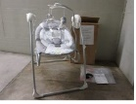
1-Jun-2023 | Italy | Perfume | Bodycare / Cosmetics | Chemical Hazard | 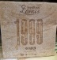
1-Jun-2023 | Italy | Perfume | Bodycare / Cosmetics | Chemical Hazard | 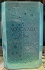
1-Jun-2023 | Italy | Perfume | Bodycare / Cosmetics | Chemical Hazard
1-Jun-2023 | Italy | Perfume | Bodycare / Cosmetics | Chemical Hazard | 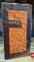
1-Jun-2023 | Sweden | Foldable Mini Fan | Electrical Appliances | Environmental Hazard | 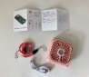
1-Jun-2023 | Sweden | Soap Bubble machine | Toys and Childcare Products | Environmental Hazard | 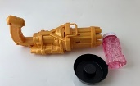
1-Jun-2023 | Sweden | Flying Spinner | Toys and Childcare Products | Chemical Hazard, Environmental Hazard | 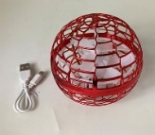
1-Jun-2023 | Sweden | Electric foot File | Electrical Appliances | Chemical Hazard, Environmental Hazard | 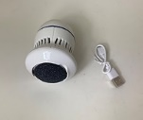
1-Jun-2023 | Czechia | Disposable Electronic cigarette | Chemicals | Chemical Hazard | 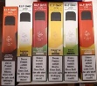
1-Jun-2023 | Czechia | Lighting chain | Electrical Appliances | Electric Shock Hazard | 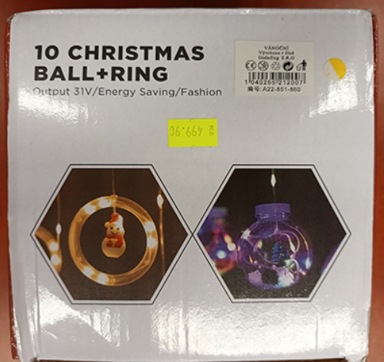
1-Jun-2023 | Denmark | Fireworks | Outdoor Living Items | Burn Hazard, Damage to Sight, Fire Hazard, Injury Hazard | 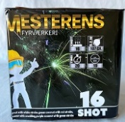
1-Jun-2023 | Germany | Circular Saw Blade | Machinery | Cut Hazard | 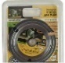
1-Jun-2023 | Finland | Soft Toy | Toys and Childcare Products | Choking Hazard | 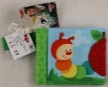
1-Jun-2023 | Czechia | Magnet Building Set | Toys and Childcare Products | Choking Hazard, Injury Hazard | 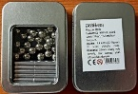
1-Jun-2023 | Hungary | Air Humidifier | Home Electrical Appliances | Microbiological Hazard | 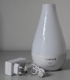
1-Jun-2023 | Czechia | Lighting Chain | Electrical Appliances | Electric Shock Hazard | 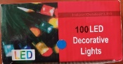
1-Jun-2023 | Czechia | Lighting Chain | Electrical Appliances | Electric Shock Hazard
1-Jun-2023 | Hungary | Toy Mask | Toys and Childcare Products | Burn Hazard | 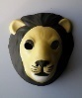
1-Jun-2023 | Czechia | Lighting Chain | Electrical Appliances | Electric Shock Hazard | 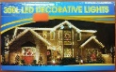
1-Jun-2023 | Czechia | Lighting Chain | Electrical Appliances | Electric Shock Hazard | 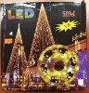
1-Jun-2023 | Czechia | Lighting Chain | Electrical Appliances | Electric Shock Hazard | 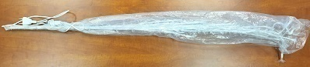
1-Jun-2023 | Slovakia | Air Purifier | Home Electrical Appliances | Home Electrical Appliances | 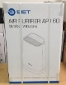
1-Jun-2023 | Hungary | Children's Bicycle | Sporting Goods / Equipment | Injury Hazard | 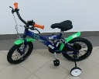
1-Jun-2023 | Sweden | Face Mask | Toys and Childcare Products | Environmental Hazard | 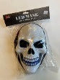
1-Jun-2023 | The Netherlands | Baby Walker | Toys and Childcare Products | Injury Hazard | 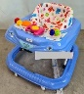
2-Jun-2023 | Italy | Children's Hoodie | Fabric / Textile / Garment / Home Textile | Entrapment Hazard, Injury Hazard, Strangulation Hazard | 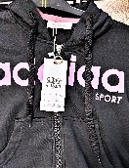
2-Jun-2023 | France | Playground | Sporting Goods / Equipment | Strangulation Hazard | 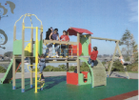  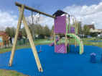
6-Jun-2023 | Finland | Perfume Kit | Toys and Childcare Products | Chemical Hazard | 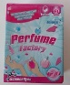
6-Jun-2023 | Czechia | Sunscreen | Bodycare / Cosmetics | Health Risk Hazard | 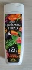
6-Jun-2023 | Germany | Jewelry Set | Jewelry | Chemical Hazard | 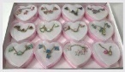
6-Jun-2023 | Hungary | Aroma Diffuser | Home Electrical Appliances | Electric shock Hazard, Microbiological Hazard | 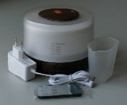
6-Jun-2023 | Estonia | Children's Bikini Set | Fabric / Textile / Garment / Home Textile | Injury Hazard, Strangulation Hazard | 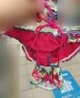
6-Jun-2023 | Czechia | Children's Sweatshirt | Fabric / Textile / Garment / Home Textile | Strangulation Hazard | 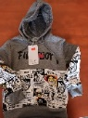
6-Jun-2023 | Malta | Deodorant Spray | Bodycare / Cosmetics | Chemical Hazard | 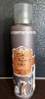
7-Jun-2023 | Czechia | Particle Filter Mask | Protective Equipment | Microbiological Hazard | 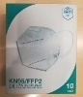
7-Jun-2023 | Denmark | Fireworks | Outdoor Living Items | Burn Hazard, Damage to Hearing, Damage to Sight | 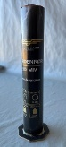
7-Jun-2023 | Germany | Particle Filter Mask | Protective Equipment | Health Risk Hazard | 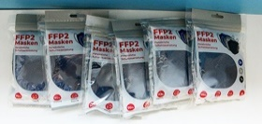
8-Jun-2023 | France | Torch | Toys and Childcare Products | Chemical Hazard, Choking Hazard | 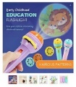
8-Jun-2023 | Sweden | LED Strip Light | Electrical Appliances | Chemical Hazard, Environmental Hazard | 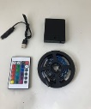
8-Jun-2023 | Czechia | Lighting Chain | Electrical Appliances | Electric Shock Hazard | 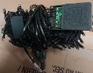
8-Jun-2023 | Czechia | Lighting Chain | Electrical Appliances | Electric Shock Hazard | 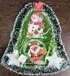
8-Jun-2023 | Sweden | Skin Lightening Cream | Bodycare / Cosmetics | Chemical Hazard | 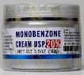
8-Jun-2023 | Ireland | Electric Blanket | Home Electrical Appliances | Electric Shock Hazard, Fire Hazard | 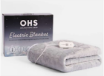
8-Jun-2023 | The Netherlands | Towel Clip | Household Items | Injury Hazard | 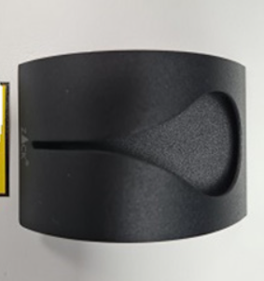
8-Jun-2023 | Ireland | Tealight Candleholder | Household Items | Burn Hazard, Fire Hazard | 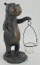
8-Jun-2023 | Germany | Necklace | Jewelry | Chemical Hazard | 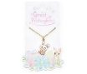
8-Jun-2023 | Slovenia | Angle Grinder | Machinery | Cut Hazard | 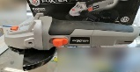
8-Jun-2023 | Germany | Necklace | Jewelry | Chemical Hazard | 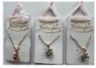
8-Jun-2023 | Finland | Gloves | Protective Equipment | Chemical Hazard | 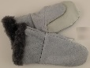
8-Jun-2023 | Czechia | Tattoo Ink | Chemicals | Chemical Hazard | 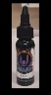
8-Jun-2023 | The Netherlands | Children's Cot | Furniture | Entrapment Hazard, Injury Hazard | 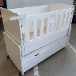
8-Jun-2023 | Hungary | Toy Scooter | Toys and Childcare Products | Injury Hazard | 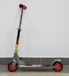
8-Jun-2023 | Czechia | Plastic Doll | Toys and Childcare Products | Chemical Hazard | 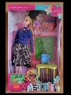
8-Jun-2023 | Hungary | Children’s Bicycle | Sporting Goods / Equipment | Injury Hazard | 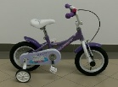
8-Jun-2023 | Cyprus | Magnetic Fishing Toy | Toys and Childcare Products | Choking Hazard, Injury Hazard | 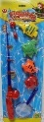
8-Jun-2023 | Malta | Deodorant Spray | Bodycare / Cosmetics | Chemical Hazard | 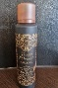
13-Jun-2023 | France | Eau De Toilette | Bodycare / Cosmetics | Chemical Hazard | 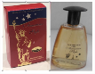
13-Jun-2023 | Belgium | Children's Hoodie | Fabric / Textile / Garment / Home Textile | Strangulation Hazard | 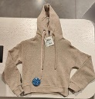
13-Jun-2023 | Germany | Hand Cream | Bodycare / Cosmetics | Chemical Hazard | 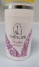
13-Jun-2023 | Germany | Belt | Accessories | Chemical Hazard | /
14-Jun-2023 | France | Soft Toy | Toys and Childcare Products | Choking Hazard | 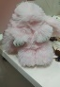
14-Jun-2023 | Ireland | Water Bottle | Toys and Childcare Products | Choking Hazard | 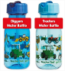
14-Jun-2023 | Cyprus | Magnetic Building Set | Toys and Childcare Products | Choking Hazard, Injury Hazard | 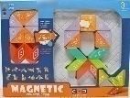
14-Jun-2023 | Finland | LED Ceiling Lamp | Electrical Appliances | Electric Shock Hazard | /
14-Jun-2023 | Poland | Fixed Lamp | Electrical Appliances | Electric Shock Hazard | 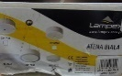
14-Jun-2023 | Lithuania | Water Heater | Home Electrical Appliances | Electric Shock Hazard | 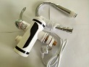
14-Jun-2023 | Germany | Baby Carrier | Toys and Childcare Products | Injury Hazard | 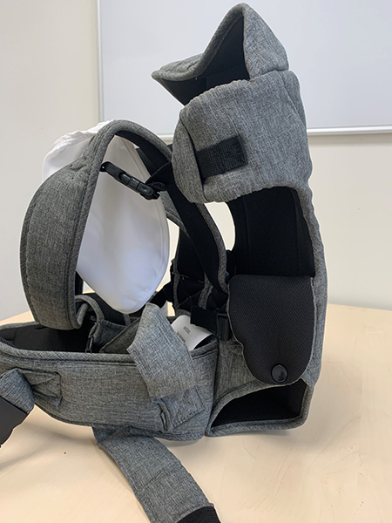
14-Jun-2023 | Denmark | LED Ceiling Lamp | Electrical Appliances | Electric Shock Hazard | 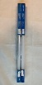
15-Jun-2023 | France | Key Ring with Soft Toy | Toys and Childcare Products | Choking Hazard | 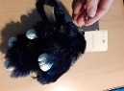
15-Jun-2023 | Sweden | Ring | Jewelry | Chemical Hazard | 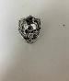
15-Jun-2023 | Sweden | Fish-Shaped Pet Toy | Pet Items | Chemical Hazard, Environmental Hazard | 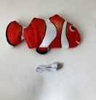
15-Jun-2023 | Sweden | 3D Pen | Electrical Appliances | Chemical Hazard, Environmental Hazard | 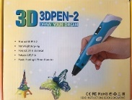
15-Jun-2023 | Ireland | Electric Heater | Home Electrical Appliances | Electric Shock Hazard, Fire Hazard | 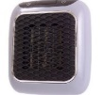
15-Jun-2023 | Sweden | Hair Curler | Home Electrical Appliances | Chemical Hazard, Environmental Hazard | 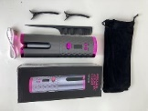
15-Jun-2023 | France | Soft Toy | Toys and Childcare Products | Choking Hazard
15-Jun-2023 | Belgium | Pushchair | Toys and Childcare Products | Injury Hazard | 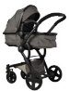
15-Jun-2023 | Ireland | Children's Shoes | Footwear | Injury Hazard | 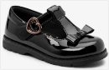
15-Jun-2023 | France | Battery-Powered Toy | Toys and Childcare Products | Chemical Hazard | /
15-Jun-2023 | France | Soft Toy | Toys and Childcare Products | Choking Hazard | 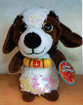
15-Jun-2023 | France | Jewelry Fastener | Jewelry | Chemical Hazard | 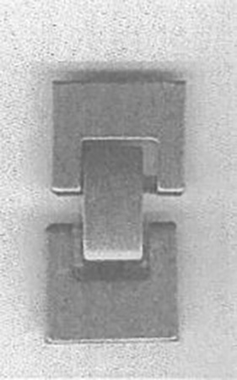
15-Jun-2023 | Germany | Wooden Toy | Toys and Childcare Products | Choking Hazard | 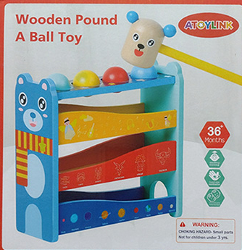
15-Jun-2023 | Cyprus | Children's Dress | Fabric / Textile / Garment / Home Textile | Injury Hazard | 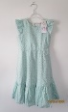
15-Jun-2023 | Poland | Toy Gun | Toys and Childcare Products | Injury Hazard | 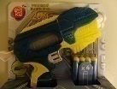
15-Jun-2023 | Lithuania | USB Charger | Electrical Appliances | Electric Shock Hazard | 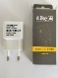
15-Jun-2023 | Bulgaria | Children's Hoodie | Fabric / Textile / Garment / Home Textile | Injury Hazard Strangulation Hazard
15-Jun-2023 | Bulgaria | Children's Hoodie | Fabric / Textile / Garment / Home Textile | Injury Hazard Strangulation Hazard
15-Jun-2023 | Bulgaria | Children's Hoodie | Fabric / Textile / Garment / Home Textile | Injury Hazard Strangulation Hazard | 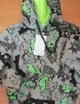
15-Jun-2023 | The Netherlands | Nesting Toy | Toys and Childcare Products | Choking Hazard | 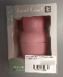
15-Jun-2023 | France | Finger Paint | Toys and Childcare Products | Chemical Hazard | 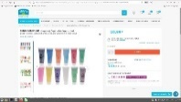
15-Jun-2023 | The Netherlands | Toy Remote Control | Toys and Childcare Products | Choking Hazard | 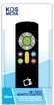
15-Jun-2023 | The Netherlands | Toy Remote Control | Toys and Childcare Products | Choking Hazard
16-Jun-2023 | The Netherlands | Laser Pointer | Electrical Appliances | Injury Hazard | 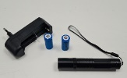
16-Jun-2023 | Poland | Plastic Doll | Toys and Childcare Products | Chemical Hazard | 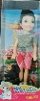
20-Jun-2023 | France | Paint Stamp | Toys and Childcare Products | Chemical Hazard, Choking Hazard | 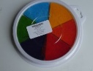
20-Jun-2023 | Germany | Extension Lead | Electrical Appliances | Electric Shock Hazard | 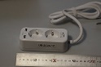
20-Jun-2023 | Croatia | Soft Toy | Toys and Childcare Products | Choking Hazard | 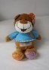
20-Jun-2023 | Croatia | Plasticine | Toys and Childcare Products | Chemical Hazard | 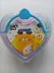
21-Jun-2023 | Italy | Children's Trousers | Fabric / Textile / Garment / Home Textile | Injury Hazard | 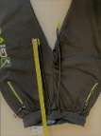
21-Jun-2023 | Poland | Plastic Ball | Toys and Childcare Products | Chemical Hazard | 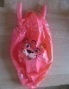
21-Jun-2023 | France | Teeth Whitening Gel | Bodycare / Cosmetics | Chemical Hazard | 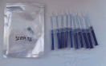
22-Jun-2023 | Italy | Children's Trousers | Fabric / Textile / Garment / Home Textile | Injury Hazard | 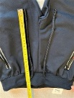
22-Jun-2023 | Italy | Children's Trousers | Fabric / Textile / Garment / Home Textile | Injury Hazard | 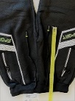
22-Jun-2023 | Germany | Concrete Screws | Construction Products | Injury Hazard | 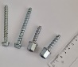
22-Jun-2023 | Spain | Mouthwash | Bodycare / Cosmetics | Microbiological Hazard | 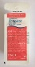
22-Jun-2023 | Germany | Particle Filter Mask | Protective Equipment | Health Risk Hazard | 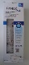
22-Jun-2023 | The Netherlands | Children`s Cot | Furniture | Entrapment Hazard, Injury Hazard, Strangulation Hazard | 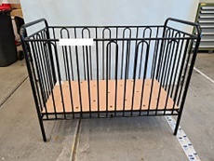
22-Jun-2023 | The Netherlands | Children`s Cot | Furniture | Entrapment Hazard, Injury Hazard, Strangulation Hazard | 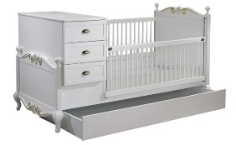
22-Jun-2023 | France | Fancy-Dress Costume | Toys and Childcare Products | Injury Hazard, Strangulation Hazard | 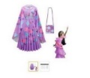
22-Jun-2023 | Croatia | Toy Slime | Toys and Childcare Products | Chemical Hazard | 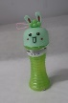
22-Jun-2023 | Estonia | Earrings | Jewelry | Chemical Hazard | 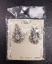
22-Jun-2023 | Ireland | Liquid For E-Cigarette in Refill Container | Chemicals | Chemical Hazard | 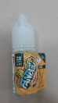
22-Jun-2023 | Hungary | Baby Walker | Toys and Childcare Products | Injury Hazard | 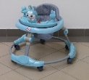
22-Jun-2023 | Hungary | Plastic Doll | Toys and Childcare Products | Chemical Hazard | 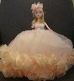
22-Jun-2023 | Italy | Shaving Foam | Bodycare / Cosmetics | Chemical Hazard | 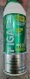
22-Jun-2023 | Italy | Liquid Hand Soap | Bodycare / Cosmetics | Chemical Hazard | 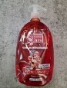
22-Jun-2023 | Italy | Perfume | Bodycare / Cosmetics | Chemical Hazard | 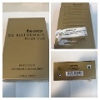
22-Jun-2023 | Italy | Perfume | Bodycare / Cosmetics | Chemical Hazard | 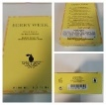
22-Jun-2023 | Italy | Protective Balm | Bodycare / Cosmetics | Chemical Hazard | 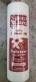
22-Jun-2023 | Italy | Deodorant Spray | Bodycare / Cosmetics | Chemical Hazard | 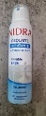
22-Jun-2023 | Italy | Perfume | Bodycare / Cosmetics | Chemical Hazard | 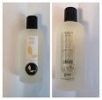
22-Jun-2023 | Italy | Deodorant Spray | Bodycare / Cosmetics | Chemical Hazard | 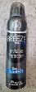
22-Jun-2023 | Italy | Bath And Shower Gel | Bodycare / Cosmetics | Chemical Hazard | 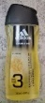
22-Jun-2023 | Italy | Shower Foam | Bodycare / Cosmetics | Chemical Hazard | 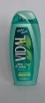
22-Jun-2023 | Italy | Shower Cream | Bodycare / Cosmetics | Chemical Hazard | 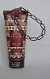  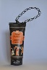
22-Jun-2023 | Italy | Deodorant Spray | Bodycare / Cosmetics | Chemical Hazard | 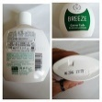
22-Jun-2023 | Italy | Hand Cream | Bodycare / Cosmetics | Chemical Hazard | 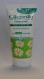
22-Jun-2023 | Italy | Perfume | Bodycare / Cosmetics | Chemical Hazard | 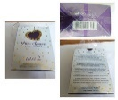
22-Jun-2023 | Italy | Shower Foam | Bodycare / Cosmetics | Chemical Hazard | 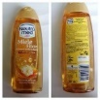
22-Jun-2023 | The Netherlands | Toy Car Keys | Toys and Childcare Products | Choking Hazard | 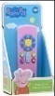  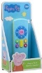
22-Jun-2023 | Estonia | Set of Children's Earrings | Jewelry | Chemical Hazard | 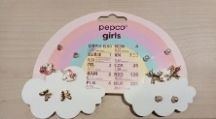
22-Jun-2023 | Sweden | Perfume | Bodycare / Cosmetics | Chemical Hazard
23-Jun-2023 | Croatia | Electric Iron | Home Electrical Appliances | Fire Hazard | 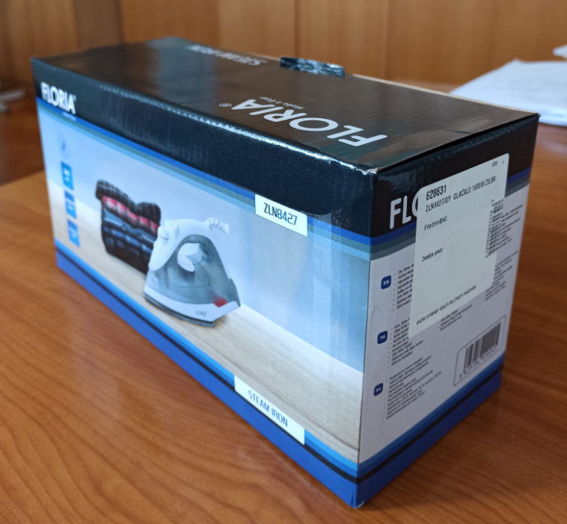
23-Jun-2023 | Germany | Portable Gas Stove | Outdoor Living Items | Chemical Hazard | 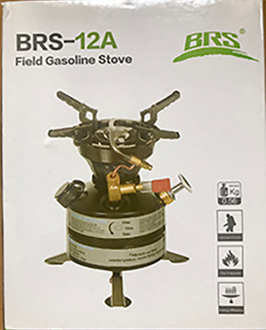
23-Jun-2023 | Belgium | Soap Bubble Toy | Toys and Childcare Products | Chemical Hazard | 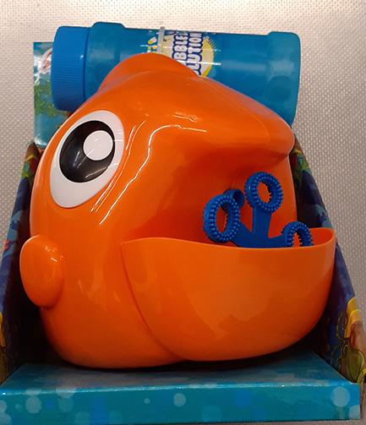
26-Jun-2023 | Italy | Children's Sweatshirt | Fabric / Textile / Garment / Home Textile | Injury Hazard, Strangulation Hazard | 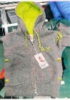
26-Jun-2023 | Italy | Children's Trousers | Fabric / Textile / Garment / Home Textile | Injury Hazard | 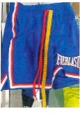
26-Jun-2023 | Cyprus | Clothing Set | Fabric / Textile / Garment / Home Textile | Injury Hazard | 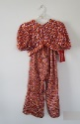
26-Jun-2023 | Cyprus | Children's Bikini | Fabric / Textile / Garment / Home Textile | Injury Hazard | 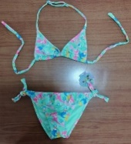
26-Jun-2023 | Sweden | Skin Lightening Cream | Bodycare / Cosmetics | Chemical Hazard | 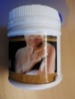
27-Jun-2023 | Italy | Bath Foam | Bodycare / Cosmetics | Chemical Hazard | 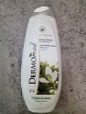
27-Jun-2023 | Italy | Deodorant Spray | Bodycare / Cosmetics | Chemical Hazard | 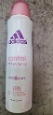
27-Jun-2023 | Italy | Deodorant Spray | Bodycare / Cosmetics | Chemical Hazard
27-Jun-2023 | Italy | Bath Foam | Bodycare / Cosmetics | Chemical Hazard | 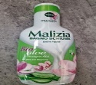
27-Jun-2023 | Italy | Perfume | Bodycare / Cosmetics | Chemical Hazard | 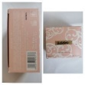
27-Jun-2023 | Italy | Eau De Toilette | Bodycare / Cosmetics | Chemical Hazard | 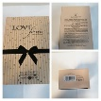
27-Jun-2023 | Italy | Eau De Toilette | Bodycare / Cosmetics | Chemical Hazard | 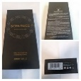
27-Jun-2023 | Italy | Hair Conditioner | Bodycare / Cosmetics | Chemical Hazard | 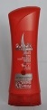
27-Jun-2023 | Italy | Eau De Toilette | Bodycare / Cosmetics | Chemical Hazard | 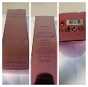
27-Jun-2023 | Italy | Eau De Toilette | Bodycare / Cosmetics | Chemical Hazard | 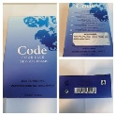
27-Jun-2023 | Italy | Eau De Toilette | Bodycare / Cosmetics | Chemical Hazard | 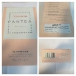
27-Jun-2023 | Italy | Body Cream | Bodycare / Cosmetics | Chemical Hazard | 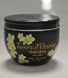  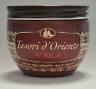
27-Jun-2023 | Italy | Sun Lotion | Bodycare / Cosmetics | Chemical Hazard | 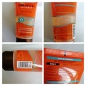
27-Jun-2023 | Italy | Perfume | Bodycare / Cosmetics | Chemical Hazard | 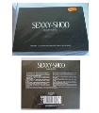
27-Jun-2023 | Italy | Deodorant Spray | Bodycare / Cosmetics | Chemical Hazard | 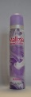  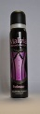
27-Jun-2023 | Italy | Hairspray | Bodycare / Cosmetics | Chemical Hazard | 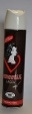
27-Jun-2023 | Italy | Perfume | Bodycare / Cosmetics | Chemical Hazard | 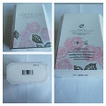
27-Jun-2023 | Italy | Hair Mousse | Bodycare / Cosmetics | Chemical Hazard | 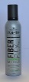
27-Jun-2023 | Italy | Perfume | Bodycare / Cosmetics | Chemical Hazard | 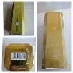
27-Jun-2023 | Italy | Perfume | Bodycare / Cosmetics | Chemical Hazard | 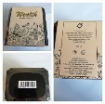
27-Jun-2023 | Italy | Cosmetic Set | Bodycare / Cosmetics | Chemical Hazard | 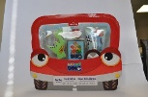
27-Jun-2023 | Italy | Spray Deodorant | Bodycare / Cosmetics | Chemical Hazard | 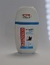  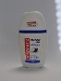
27-Jun-2023 | Italy | Perfume | Bodycare / Cosmetics | Chemical Hazard | 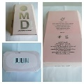
27-Jun-2023 | Italy | Eau De Toilette | Bodycare / Cosmetics | Chemical Hazard | 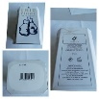
27-Jun-2023 | Italy | Shower Gel | Bodycare / Cosmetics | Chemical Hazard | 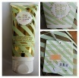
27-Jun-2023 | Sweden | Perfume | Bodycare / Cosmetics | Chemical Hazard | 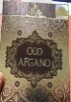
27-Jun-2023 | Sweden | Perfume | Bodycare / Cosmetics | Chemical Hazard | 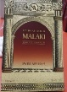
28-Jun-2023 | Italy | Eau De Toilette | Bodycare / Cosmetics | Chemical Hazard | 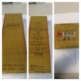
28-Jun-2023 | Germany | Concealer | Bodycare / Cosmetics | Microbiological Hazard | 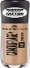
28-Jun-2023 | Sweden | Whale Toy | Toys and Childcare Products | Environmental Hazard | 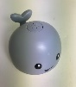
28-Jun-2023 | Hungary | Air Humidifier | Home Electrical Appliances | Microbiological Hazard | 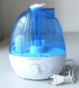
28-Jun-2023 | Sweden | Tattoo Ink | Chemical | Chemical Hazard | 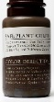  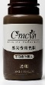  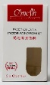
28-Jun-2023 | Czechia | Perfume | Bodycare / Cosmetics | Chemical Hazard | 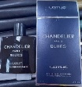
28-Jun-2023 | Sweden | Skin Lightening Shower Gel | Bodycare / Cosmetics | Chemical Hazard | 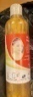
28-Jun-2023 | Italy | Perfume | Bodycare / Cosmetics | Chemical Hazard | 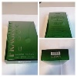
28-Jun-2023 | Italy | Hair Conditioner | Bodycare / Cosmetics | Chemical Hazard | 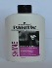  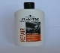
28-Jun-2023 | Italy | Beauty Set | Bodycare / Cosmetics | Chemical Hazard | 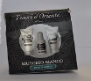  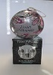
28-Jun-2023 | Italy | Hair Conditioner | Bodycare / Cosmetics | Chemical Hazard | 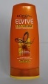
28-Jun-2023 | Italy | Children's Hoodie | Fabric / Textile / Garment / Home Textile | Injury Hazard, Strangulation Hazard | 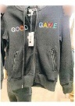
28-Jun-2023 | Italy | Shower Foam | Bodycare / Cosmetics | Chemical Hazard | 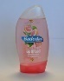  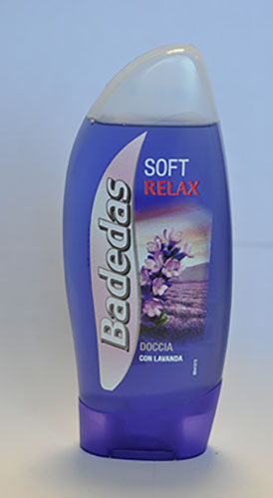
28-Jun-2023 | Italy | Soap | Bodycare / Cosmetics | Chemical Hazard | 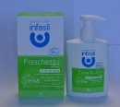  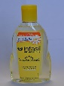
28-Jun-2023 | Italy | Hair Conditioner | Bodycare / Cosmetics | Chemical Hazard | 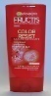  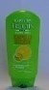  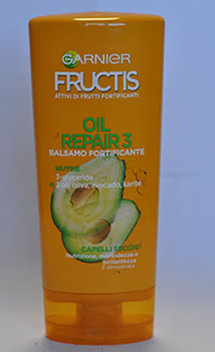  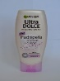
28-Jun-2023 | Italy | Perfume | Bodycare / Cosmetics | Chemical Hazard | 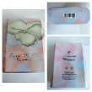  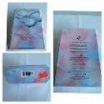
28-Jun-2023 | Italy | Sun Oil | Bodycare / Cosmetics | Chemical Hazard | 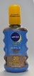
28-Jun-2023 | Italy | Perfume | Bodycare / Cosmetics | Chemical Hazard | 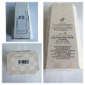  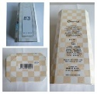
28-Jun-2023 | Italy | Perfume | Bodycare / Cosmetics | Chemical Hazard | 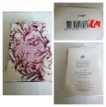
28-Jun-2023 | Italy | Perfume | Bodycare / Cosmetics | Chemical Hazard | 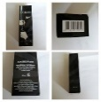
28-Jun-2023 | Italy | Perfume | Bodycare / Cosmetics | Chemical Hazard | 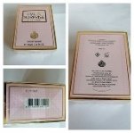
28-Jun-2023 | Italy | Perfume | Bodycare / Cosmetics | Chemical Hazard | 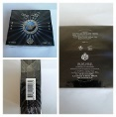
28-Jun-2023 | Italy | Perfume | Bodycare / Cosmetics | Chemical Hazard | 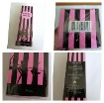
28-Jun-2023 | Sweden | Tattoo Ink | Chemicals | Chemical Hazard | 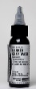
28-Jun-2023 | Malta | Shower Gel | Bodycare / Cosmetics | Chemical Hazard | 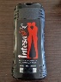
28-Jun-2023 | Malta | Deodorant Spray | Bodycare / Cosmetics | Chemical Hazard | 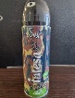
28-Jun-2023 | Malta | Deodorant Spray | Bodycare / Cosmetics | Chemical Hazard | 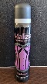
28-Jun-2023 | Lithuania | USB Charger | Electrical Appliances | Electric Shock Hazard | 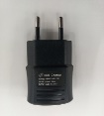
28-Jun-2023 | Czechia | Plastic Doll | Toys and Childcare Products | Chemical Hazard | 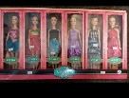  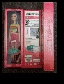
28-Jun-2023 | Sweden | Perfume | Bodycare / Cosmetics | Chemical Hazard | 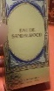
29-Jun-2023 | Italy | Liquid Soap | Bodycare / Cosmetics | Chemical Hazard | 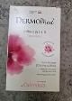
29-Jun-2023 | Italy | Hair Conditioner | Bodycare / Cosmetics | Chemical Hazard | 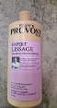
29-Jun-2023 | Italy | Perfume | Bodycare / Cosmetics | Chemical Hazard | 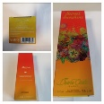
29-Jun-2023 | Italy | Make-Up Remover Wipes | Bodycare / Cosmetics | Chemical Hazard | 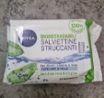
29-Jun-2023 | Italy | Perfume | Bodycare / Cosmetics | Chemical Hazard | 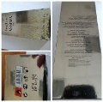
29-Jun-2023 | Italy | Skin Tonic | Bodycare / Cosmetics | Chemical Hazard | 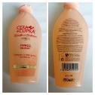
29-Jun-2023 | France | Liquid Hand Soap | Bodycare / Cosmetics | Chemical Hazard | 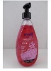
29-Jun-2023 | Italy | Perfume | Bodycare / Cosmetics | Chemical Hazard | 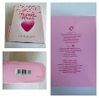
29-Jun-2023 | Italy | Perfume | Bodycare / Cosmetics | Chemical Hazard | 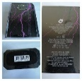
29-Jun-2023 | France | Toy Xylophone | Toys and Childcare Products | Choking Hazard | 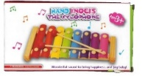
29-Jun-2023 | Sweden | Neck Fan | Electrical Appliances | Chemical Hazard, Environmental Hazard | 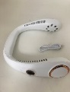
29-Jun-2023 | Sweden | Electric Fly Trap | Home Electrical Appliances | Chemical Hazard, Environmental Hazard | 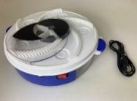
29-Jun-2023 | The Netherlands | Laser Toy | Toys and Childcare Products | Damage to Sight | 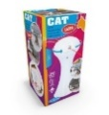
29-Jun-2023 | France | Soft Toy | Toys and Childcare Products | Choking Hazard | 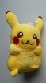
29-Jun-2023 | France | Toy Traffic Lights | Toys and Childcare Products | Chemical Hazard, Choking Hazard | 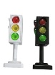
29-Jun-2023 | Hungary | Air Humidifier | Home Electrical Appliances | Microbiological Hazard | 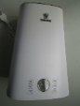
29-Jun-2023 | Denmark | LED Light | Electrical Appliances | Electric Shock Hazard | 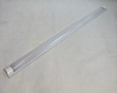
29-Jun-2023 | Hungary | Air Humidifier | Home Electrical Appliances | Microbiological Hazard | 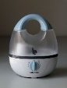
29-Jun-2023 | Italy | Perfume | Bodycare / Cosmetics | Chemical Hazard | 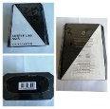
29-Jun-2023 | Italy | Hairspray | Bodycare / Cosmetics | Chemical Hazard | 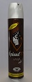
29-Jun-2023 | Italy | Deodorant Spray | Bodycare / Cosmetics | Chemical Hazard | 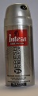
29-Jun-2023 | Italy | Deodorant Spray | Bodycare / Cosmetics | Chemical Hazard | 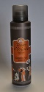
29-Jun-2023 | Italy | Eau De Toilette | Bodycare / Cosmetics | Chemical Hazard | 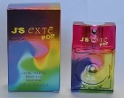
29-Jun-2023 | Austria | Helmet | Protective Equipment | Injury Hazard | 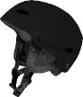
29-Jun-2023 | Sweden | Tattoo Ink | Chemicals | Chemical Hazard | 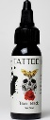
29-Jun-2023 | Sweden | Perfume | Bodycare / Cosmetics | Chemical Hazard | 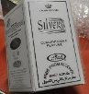
30-Jun-2023 | Italy | Sunscreen | Bodycare / Cosmetics | Chemical Hazard | 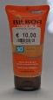
30-Jun-2023 | Italy | Perfume | Bodycare / Cosmetics | Chemical Hazard | 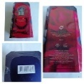
30-Jun-2023 | Denmark | Ceiling LED Lamp | Electrical Appliances | Fire Hazard | 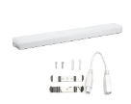
30-Jun-2023 | Czechia | Disposable Electronic Cigarette | Chemicals | Chemical Hazard | 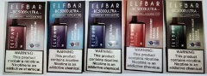
30-Jun-2023 | Germany | Toy Music Set | Toys and Childcare Products | Choking Hazard | 