Recall Cases Summary – US (Last Update Date: 30 June 2023)

Date | Product | Categories | Hazard | Image
1-Jun-2023 | Jetson Electric Bikes | Sporting Goods / Equipment | Fall Hazard
1-Jun-2023 | EGO Power+ Cordless Brushless Hedge Trimmers | Tools and Hardware | Laceration Hazard | 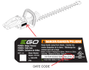  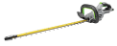
1-Jun-2023 | Power XL Self-Cleaning Juicers | Home Electrical Appliances | Laceration Hazard, Ingestion Hazard | 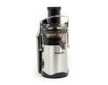  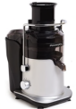
8-Jun-2023 | Narskido Infant Bath Seats | Toys and Childcare Products | Drowning Hazard | 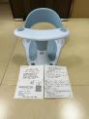
8-Jun-2023 | Kate and Laurel Mirrors | Household Items | Laceration Hazard
8-Jun-2023 | Children’s Pajamas | Fabric / Textile / Garment / Home Textile | Burn Hazard | 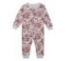  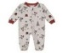  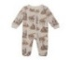  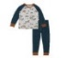  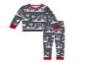  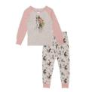  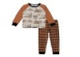
8-Jun-2023 | Children’s Pajamas and Nightdresses | Fabric / Textile / Garment / Home Textile | Burn Hazard | 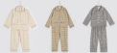  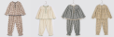
8-Jun-2023 | Party Time Power Loveseats, Sofas and Recliners | Furniture | Fire Hazard | 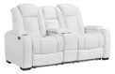  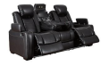  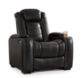
8-Jun-2023 | Giro Merit Helmets | Protective Equipment | Injury Hazard
8-Jun-2023 | Haining Degao Benches | Furniture | Fall Hazard | 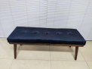  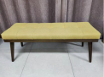
8-Jun-2023 | Armstrong Air and Air Ease Gas Furnaces | Household Items | Carbon Monoxide Poisoning Hazard | 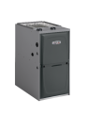  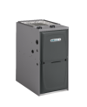
15-Jun-2023 | Promax Hydraulic Disc Brakes Sold on Trek Bicycles | Sporting Goods / Equipment | Crash Hazard | 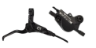  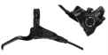
15-Jun-2023 | Oceanic SCUBA Diving Buoyancy Compensating Devices | Sporting Goods / Equipment | Drowning Hazard | 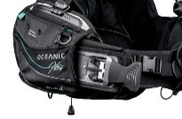
22-Jun-2023 | Poseidon M28A Dive Computers | Computer / Audio / Video / Other Electronics & Accessories | Injury Hazard | 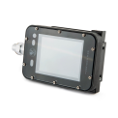
22-Jun-2023 | Iron Dietary Supplements | Pharmacy | Poisoning Hazard
22-Jun-2023 | Boost The Mood Ceramic Mugs | Food Contact Material | Fire Hazard
22-Jun-2023 | 7.5 Million Baby Shark and Mini Baby Shark Bath Toys With Hard Plastic Top Fins | Toys and Childcare Products | Laceration Hazard, Puncture Hazard | 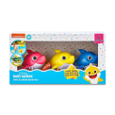  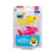  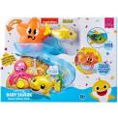  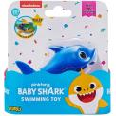  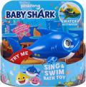  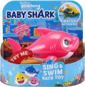  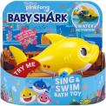
22-Jun-2023 | Children’s Multi-Purpose Helmets | Protective Equipment | Injury Hazard | 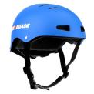  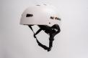  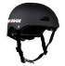  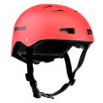  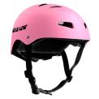
22-Jun-2023 | Steam Humidifiers | Home Electrical Appliances | Fire Hazard | 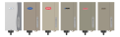
22-Jun-2023 | Concord Dual Power Recliner Chairs | Furniture | Fall Hazard | 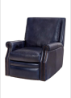
22-Jun-2023 | Zooby Video Baby Monitors for Car | Toys and Childcare Products | Fire Hazard | 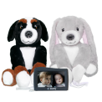  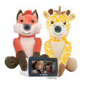
29-Jun-2023 | Bass Modules | Computer / Audio / Video / Other Electronics & Accessories | Fire Hazard | 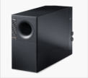  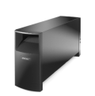  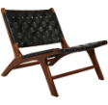
29-Jun-2023 | Bluetooth Record Players | Computer / Audio / Video / Other Electronics & Accessories | Fire Hazard | 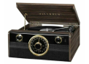
29-Jun-2023 | Leather Woven Chairs | Furniture | Fall Hazard | 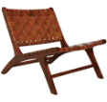
29-Jun-2023 | Canvas Baby Hammock Swings | Toys and Childcare Products | Suffocation Hazard | 