Recall Cases Summary – Australia (Last Update Date: 31 July 2023)

Date | Product | Categories | Hazard | Image
6-Jul-2023 | Kubota Generators - Various Models | Electrical Appliances | Electric Shock Hazard, Injury Hazard, Risk of Death | 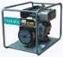  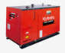  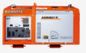  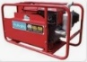  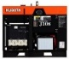
6-Jul-2023 | Wooden Rattles | Toys and Childcare Products | Choking Hazard, Suffocation Hazard, Risk of Death | 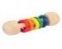  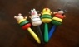  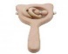  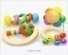  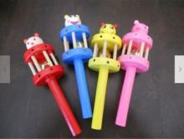
6-Jul-2023 | SCA Rust Converter 250ml | Chemicals | Damage to Skin, Damage to Sight, Risk of Difficulty Breathing | 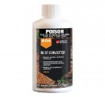
6-Jul-2023 | PETKIT LED Nail Clipper | Tools and Hardware | Choking Hazard, Burn Hazard, Risk of Death, Ingestion Hazard | 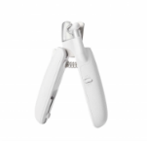
6-Jul-2023 | Super Spy HQ | Toys and Childcare Products | Choking Hazard, Burn Hazard, Risk of Death, Ingestion Hazard | 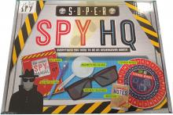
10-Jul-2023 | Ozito Petrol Inverter Generator - Model IGP-2018 | Electrical Appliances | Electric Shock Hazard, Injury Hazard, Risk of Death | 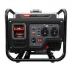
11-Jul-2023 | PETKIT LED Nail Clipper | Tools and Hardware | Choking Hazard, Burn Hazard, Risk of Death, Ingestion Hazard
12-Jul-2023 | Low Profile Car Ramps | Car Components | Injury Hazard, Risk of Death, Fall Hazard | 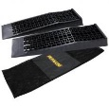
14-Jul-2023 | Home Master Flameless LED Tealight Candles | Electrical Appliances | Choking Hazard, Burn Hazard, Risk of Death, Ingestion Hazard | 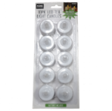
18-Jul-2023 | 1.2L Drano Max Gel Bathroom Drain Cleaner | Chemicals | Eye Irritation Risk, Risk of Difficulty Breathing, Skin Irritation Risk | 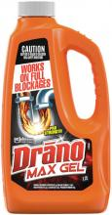
18-Jul-2023 | Baby Shark Bath Toy | Toys and Childcare Products | Laceration Hazard, Puncture Hazard | 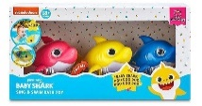
19-Jul-2023 | Certain Acoustimass, Lifestyle and Companion Bass Modules | Computer / Audio / Video / Other Electronics & Accessories | Electric Shock Hazard, Fire Hazard | 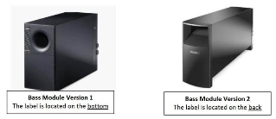
19-Jul-2023 | NERF DOG 3.25in LED Blaze Tennis Ball - Blue/Green and NERF DOG 3.5in LED Bash Ball - Blue/Orange | Pet Items | Choking Hazard, Burn Hazard, Risk of Death, Ingestion Hazard | 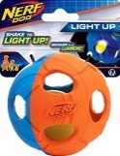  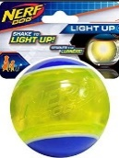
21-Jul-2023 | Pro Forge Upper Control Arm | Car Components | Injury Hazard, Risk of Death | 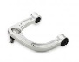  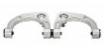
21-Jul-2023 | Novelty Pops | Toys and Childcare Products | Choking Hazard, Burn Hazard, Risk of Death, Ingestion Hazard | 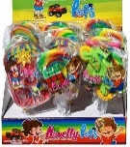
25-Jul-2023 | PowerXL Model ESWM02 (5 inch) and Model ESWM03 (7 inch) Stuffed Wafflizer Waffle Makers | Home Electrical Appliances | Burn Hazard | 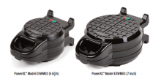
26-Jul-2023 | Double-Wick Revive Soy Candle | Household Items | Burn Hazard, Laceration Hazard | 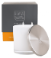  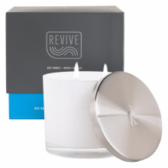  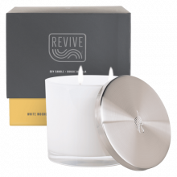  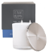  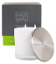
27-Jul-2023 | DeWalt Fiberglass Sledgehammers and Stanley FATMAX Fiberglass Sledgehammers | Tools and Hardware | Injury Hazard
27-Jul-2023 | Kaymar Rear Wheel Carrier for 4WD Vehicles | Car Components | Injury Hazard | 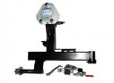  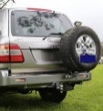
28-Jul-2023 | SCA Fire Blanket 1m x 1m | Protective Equipment | Burn Hazard | 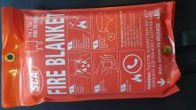
28-Jul-2023 | QLR4 Weight Pocket | Sporting Goods / Equipment | Drowning Hazard | 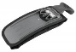  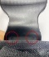  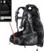
31-Jul-2023 | Anko Baby Activity Chair | Toys and Childcare Products | Choking Hazard, Suffocation Hazard, Injury Hazard, Risk of Death, Swallowing Risk | 