Recall Cases Summary – Canada (Last Update Date: 31 July 2023)

Date | Product | Categories | Hazard | Image
5-Jul-2023 | Baby Doll | Toys and Childcare Products | Chemical Hazard | 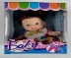  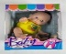  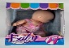  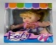  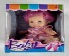  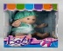
5-Jul-2023 | Ripened Organic Cheese | Food | Microbiological Hazard | /
6-Jul-2023 | Mini Fruit Jellies | Food | Choking Hazard | 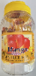  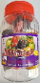  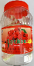  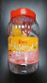  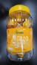  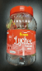  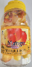  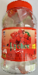  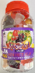
6-Jul-2023 | Husqvarna 300 Series Snow Throwers | Machinery | Injury Hazard | 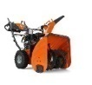
6-Jul-2023 | Woom ORIGINAL Bikes | Sporting Goods / Equipment | Fall Hazard | 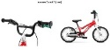  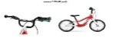  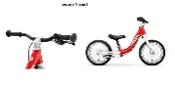  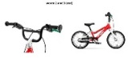
7-Jul-2023 | Mint | Food | Microbiological Hazard | /
12-Jul-2023 | WMLBK 110V 5400W Automatic Electric Instant Hot Water Shower Head Heater | Home Electrical Appliances | Electric Shock Hazard | 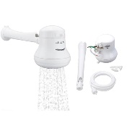
12-Jul-2023 | Various Brands of Caffeinated Drinks | Food | Chemical Hazard | 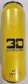  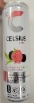  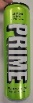  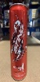
13-Jul-2023 | Seafood Snack Larb Flavour | Food | Risk of Allergy | /
14-Jul-2023 | Jameed Soup Starter Soup Base | Food | Risk of Allergy | 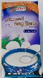
18-Jul-2023 | Raw Macadamia Nuts | Food | Microbiological Hazard | 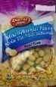
18-Jul-2023 | Chili Garlic Confit | Food | Microbiological Hazard | 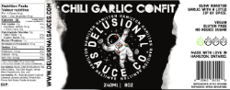
19-Jul-2023 | WATIER Age Control Supreme Sublime Advanced Day Cream | Bodycare / Cosmetics | Microbiological Hazard | 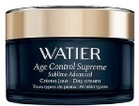
20-Jul-2023 | Wild Country Superlight Rocks | Sporting Goods / Equipment | Fall Hazard | 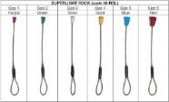
20-Jul-2023 | Dried Sweet Potato | Food | Risk of Allergy | /
21-Jul-2023 | Chicken Curry | Food | Risk of Allergy | 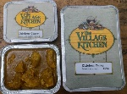
25-Jul-2023 | Be Teens Kawaii Jewelry | Jewelry | Lead Poisoning Hazard | 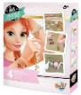  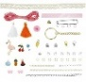
25-Jul-2023 | Be Teens Unicorn Jewelry | Jewelry | Lead Poisoning Hazard | 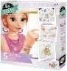  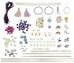
25-Jul-2023 | Shrimp Flavoured Sandwich | Food | Risk of Allergy | /
25-Jul-2023 | Squid Seafood Snacks | Food | Risk of Allergy | /
26-Jul-2023 | Frozen Par Fried Fish Cake | Food | Risk of Allergy | /
28-Jul-2023 | Mushroom (Enoki) | Food | Microbiological Hazard | 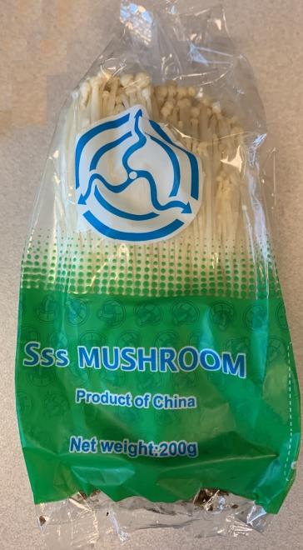  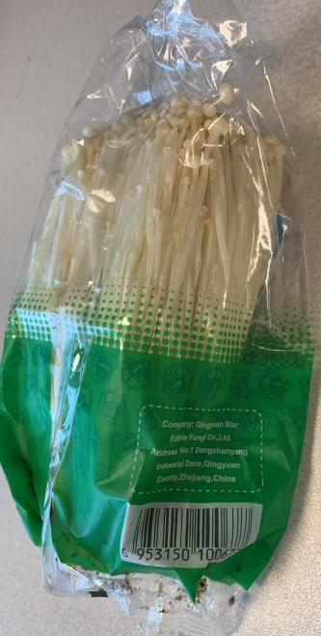
28-Jul-2023 | Various Brands of Caffeinated Drinks | Food | Chemical Hazard | 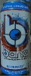  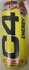  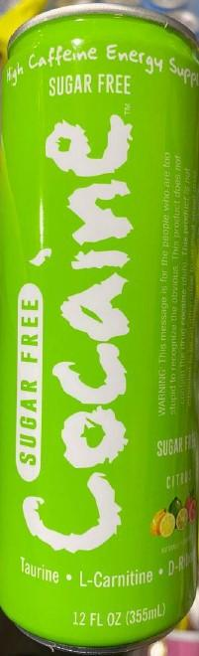  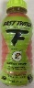  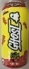  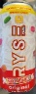
28-Jul-2023 | Multi-Purpose Helmet | Protective Equipment | Injury Hazard | 