Recall Cases Summary – China (Last Update Date: 31 July 2023)

Date | Province | Product | Categories | Hazard | Image
3-Jul-2023 | Guangxi | Single-layer Jumpsuit | Fabric / Textile / Garment / Home Textile | Injury Hazard, Safety Risk Hazard | /
5-Jul-2023 | Guangxi | Double Bear Rope Romper | Fabric / Textile / Garment / Home Textile | Entanglement Hazard, Safety Risk Hazard | /
5-Jul-2023 | Hubei | Bedside Cabinet | Furniture | Chemical Hazard, Health Risk Hazard | /
6-Jul-2023 | Shandong | Baby Cloak | Fabric / Textile / Garment / Home Textile | Entanglement Hazard, Strangulation Hazard, Suffocation Hazard, Choking Hazard | /
6-Jul-2023 | Shandong | Peach Full Print Scarf Skirt | Fabric / Textile / Garment / Home Textile | Strangulation Hazard, Suffocation Hazard | /
6-Jul-2023 | Shandong | Sports Life Short-sleeved Romper | Fabric / Textile / Garment / Home Textile | Skin Irritation Risk, Risk of Allergy, Strangulation Hazard, Suffocation Hazard | /
6-Jul-2023 | Shandong | Baby Ring Leg Apron | Fabric / Textile / Garment / Home Textile | Entanglement Hazard, Strangulation Hazard, Suffocation Hazard | /
6-Jul-2023 | Shandong | Small Square Sling Set | Fabric / Textile / Garment / Home Textile | Strangulation Hazard, Suffocation Hazard | /
7-Jul-2023 | Guangdong | Disinfection and Cleaning Cabinets | Furniture | Burn Hazard, Fire Hazard | /
7-Jul-2023 | Guangdong | Hair Dryers | Home Electrical Appliances | Fire Hazard | /
7-Jul-2023 | Guangdong | LED Lights | Electrical Appliances | Electric Shock Hazard, Safety Risk Hazard | /
7-Jul-2023 | Guangdong | Electric Ceramic Stoves | Home Electrical Appliances | Electric Shock Hazard, Safety Risk Hazard | /
7-Jul-2023 | Guangdong | Surveillance Cameras | Computer / Audio / Video / Other Electronics & Accessories | Electric Shock Hazard, Fire Hazard | /
7-Jul-2023 | Guangdong | Surveillance Cameras | Computer / Audio / Video / Other Electronics & Accessories | Electric Shock Hazard, Fire Hazard | /
7-Jul-2023 | Guangdong | Disposable Protective Masks (Non-Medical) | Protective Equipment | Health Risk Hazard | /
7-Jul-2023 | Guangdong | Disposable Protective Masks | Protective Equipment | Health Risk Hazard | /
10-Jul-2023 | Shanghai | Children's Slippers | Footwear | Chemical Hazard
10-Jul-2023 | Shandong | Baby Bellyband | Fabric / Textile / Garment / Home Textile | Strangulation Hazard, Swallowing Risk | /
10-Jul-2023 | Beijing | Air Purifiers | Home Electrical Appliances | Crushing Hazard
10-Jul-2023 | Beijing | Bicycles | Sporting Goods / Equipment | Fall Hazard | 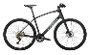
10-Jul-2023 | Beijing | Models of Window Grille Neutral Silicone Weather-resistant Adhesive | Chemicals | Health Risk Hazard | 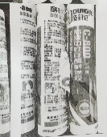
10-Jul-2023 | Shanghai | Electric Bicycle | Sporting Goods / Equipment | Safety Risk Hazard, Fire Hazard | 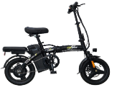
10-Jul-2023 | Shanghai | Electric Bicycle | Sporting Goods / Equipment | Safety Risk Hazard | 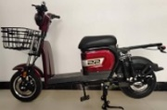
11-Jul-2023 | Anhui | Facial Tissue | Household Items | Health Risk Hazard | /
11-Jul-2023 | Jiangsu | Safety Ded Fence and Guardrail | Toys and Childcare Products | Fall Hazard, Entanglement Hazard, Swallowing Risk, Suffocation Hazard | 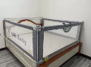
11-Jul-2023 | Yunnan | KN95 Protective Masks | Protective Equipment | Health Risk Hazard | 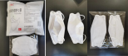
11-Jul-2023 | Yunnan | Polyethylene Blow Molding Barrels | Household Items | Injury Hazard, Safety Risk Hazard | 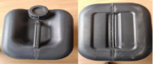
11-Jul-2023 | Anhui | Chinese Pinyin and Chinese Character Books | Stationery | Cut Hazard | /
11-Jul-2023 | Anhui | Electric Warmers | Home Electrical Appliances | Electric Shock Hazard, Fire Hazard | /
11-Jul-2023 | Anhui | Mechanical Electric Pressure Cookers | Home Electrical Appliances | Electric Shock Hazard | /
11-Jul-2023 | Anhui | Spring, Autumn and Summer Student Uniforms | Fabric / Textile / Garment / Home Textile | Skin Irritation Risk | /
11-Jul-2023 | Anhui | Solid Wood Cribs | Furniture | Fall Hazard | /
12-Jul-2023 | Hunan | Heaters | Home Electrical Appliances | Electric Shock Hazard | 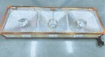
12-Jul-2023 | Anhui | Wall-mounted Room Air Conditioners | Home Electrical Appliances | Fire Hazard, Safety Risk Hazard | /
12-Jul-2023 | Hunan | Automatic Mahjong Machines | Home Electrical Appliances | Fire Hazard | 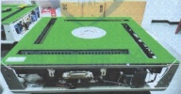
17-Jul-2023 | Shanghai | Baby Swim Seat | Sporting Goods / Equipment | Safety Risk Hazard | 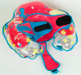
17-Jul-2023 | Shanghai | Electric Bicycles | Sporting Goods / Equipment | Fire Hazard | 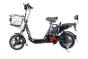  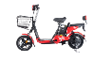
17-Jul-2023 | Shanghai | Electric Bicycles | Sporting Goods / Equipment | Safety Risk Hazard | 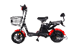  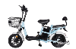
17-Jul-2023 | Shanghai | Electric Bicycles | Sporting Goods / Equipment | Electric Shock Hazard, Fire Hazard, Safety Risk Hazard | 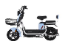
17-Jul-2023 | Inner Mongolia | Student Clothing | Fabric / Textile / Garment / Home Textile | Entanglement Hazard, Safety Risk Hazard | /
18-Jul-2023 | Jiangsu | Children's Seating | Furniture | Safety Risk Hazard | 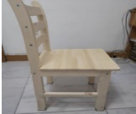
18-Jul-2023 | Guangxi | The Fake Two-piece Suit | Fabric / Textile / Garment / Home Textile | Entanglement Hazard | /
20-Jul-2023 | Shanxi | Glasses | Medical Devices | Risk of Allergy | 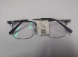
20-Jul-2023 | Shanxi | Noodle Machine | Machinery | Cut Hazard, Injury Hazard | 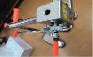
20-Jul-2023 | Shanxi | Melamine Tableware | Food Contact Material | Chemical Hazard | 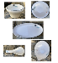
20-Jul-2023 | Shanxi | Diamond-shaped Packaging Bowls | Food Contact Material | Microbiological Hazard | 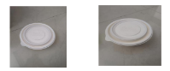
20-Jul-2023 | Shanxi | Lunch Box | Food Contact Material | Microbiological Hazard
20-Jul-2023 | Shanxi | Starch-based Lunch Boxes | Food Contact Material | Microbiological Hazard | 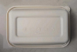
21-Jul-2023 | Hunan | Workbooks | Stationery | Eye Irritation Risk | 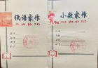
21-Jul-2023 | Jiangsu | Electric Bicycles | Sporting Goods / Equipment | Injury Hazard, Safety Risk Hazard | 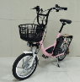
21-Jul-2023 | Beijing | Children's Desks and Chairs | Furniture | Crushing Hazard | 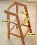  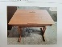
24-Jul-2023 | Inner Mongolia | Children's Shirts | Fabric / Textile / Garment / Home Textile | Swallowing Risk | /
26-Jul-2023 | Jiangsu | Solid Wood Chairs | Furniture | Health Risk Hazard | 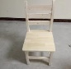
26-Jul-2023 | Hunan | A5 Leather Series Workbooks | Stationery | Cut Hazard | 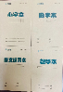
26-Jul-2023 | Jiangsu | Children's Stools | Furniture | Injury Hazard, Health Risk Hazard | 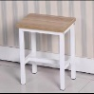
26-Jul-2023 | Zhejiang | Portable Dry Powder Fire Extinguishers | Protective Equipment | Safety Risk Hazard | 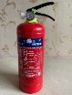
26-Jul-2023 | Zhejiang | Portable Dry Powder Fire Extinguishers | Protective Equipment | Safety Risk Hazard | 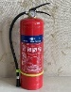
26-Jul-2023 | Zhejiang | Electric Treadmills | Sporting Goods / Equipment | Crushing Hazard | 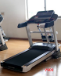
26-Jul-2023 | Zhejiang | Electric Treadmills | Sporting Goods / Equipment | Crushing Hazard | 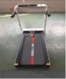
26-Jul-2023 | Zhejiang | Electric Treadmills | Sporting Goods / Equipment | Crushing Hazard | 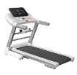
28-Jul-2023 | Jiangsu | Gel Pens | Stationery | Chemical Hazard, Health Risk Hazard | 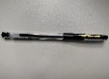
28-Jul-2023 | Jiangsu | Embedded LED Downlight | Electrical Appliances | Fire Hazard | 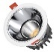
28-Jul-2023 | Jiangsu | Embedded LED Lamps | Electrical Appliances | Fire Hazard | 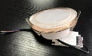
28-Jul-2023 | Beijing | Rattan Weaving Square Stool | Furniture | Chemical Hazard | 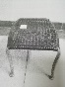
31-Jul-2023 | Shanghai | Strollers | Toys and Childcare Products | Fall Hazard, Injury Hazard | 