Recall Cases Summary – Europe (Last Update Date: 31 July 2023)

Date | Notifying Country | Product | Categories | Hazard | Image
3-Jul-2023 | Italy | Sewing Thimble | Protective Equipment | Chemical Hazard | 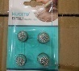
3-Jul-2023 | Malta | Deodorant | Bodycare / Cosmetics | Chemical Hazard | 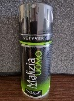
3-Jul-2023 | Malta | Malizia Uomo Skyline | Bodycare / Cosmetics | Chemical Hazard | 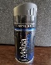
4-Jul-2023 | The Netherlands | Face Paint Set | Bodycare / Cosmetics | Chemical Hazard | 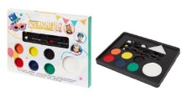
4-Jul-2023 | Italy | Children's Sweatshirt | Fabric / Textile / Garment / Home Textile | Injury Hazard, Strangulation Hazard | 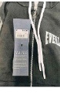
4-Jul-2023 | Italy | Children's Jacket | Fabric / Textile / Garment / Home Textile | Injury Hazard, Strangulation Hazard | 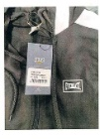
4-Jul-2023 | Italy | Children's Sweatshirt | Fabric / Textile / Garment / Home Textile | Injury Hazard, Strangulation Hazard | 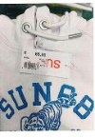
4-Jul-2023 | Italy | Children's Sweatshirt | Fabric / Textile / Garment / Home Textile | Injury Hazard, Strangulation Hazard | 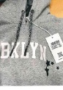
4-Jul-2023 | Italy | Children's Sweatshirt | Fabric / Textile / Garment / Home Textile | Injury Hazard, Strangulation Hazard
4-Jul-2023 | Latvia | Slime Toy | Toys and Childcare Products | Chemical Hazard | 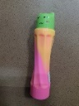
4-Jul-2023 | France | Pull-along Toy | Toys and Childcare Products | Choking Hazard | 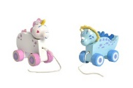
4-Jul-2023 | Sweden | Balloons | Toys and Childcare Products | Chemical Hazard | 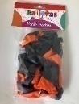
4-Jul-2023 | Malta | Deodorant | Bodycare / Cosmetics | Chemical Hazard | 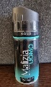
4-Jul-2023 | Portugal | USB Charger | Electrical Appliances | Electric Shock Hazard | 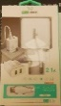
4-Jul-2023 | Portugal | USB Charger | Electrical Appliances | Electric Shock Hazard | 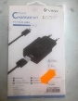
4-Jul-2023 | Cyprus | Children's Bikini | Fabric / Textile / Garment / Home Textile | Injury Hazard | 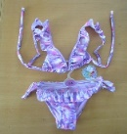  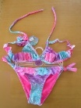
4-Jul-2023 | Czechia | Plastic Doll | Toys and Childcare Products | Chemical Hazard | 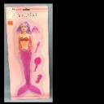
5-Jul-2023 | Italy | Children's Sweatshirt | Fabric / Textile / Garment / Home Textile | Injury Hazard, Strangulation Hazard | 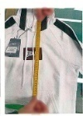
5-Jul-2023 | Italy | Hair Dye | Bodycare / Cosmetics | Chemical Hazard | 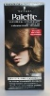  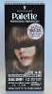  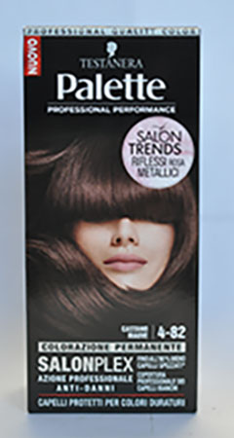  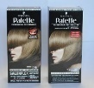  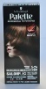
5-Jul-2023 | Ireland | Pint Glass | Food Contact Material | Cut Hazard | 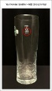
5-Jul-2023 | Italy | Outdoor Laser Projectors | Electrical Appliances | Damage to Sight | 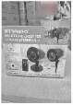
5-Jul-2023 | The Netherlands | Cosmetic Products Set | Bodycare / Cosmetics | Chemical Hazard | 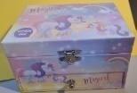
5-Jul-2023 | Cyprus | Children's Bikini | Fabric / Textile / Garment / Home Textile | Injury Hazard | 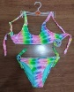
5-Jul-2023 | Ireland | Baby Monitor | Toys and Childcare Products | Asphyxiation Hazard, Choking Hazard, Environmental Hazard, Health Risk Hazard, Injury Hazard, Strangulation Hazard, Suffocation Hazard | 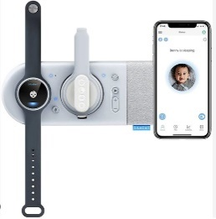
5-Jul-2023 | The Netherlands | Lamp Holder | Electrical Appliances | Electric Shock Hazard | 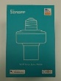  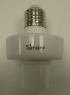
5-Jul-2023 | The Netherlands | Lamp Holder | Electrical Appliances | Electric Shock Hazard | 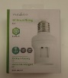  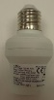
5-Jul-2023 | Czechia | Disposable Electronic Cigarette | Chemicals | Chemical Hazard | 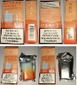
5-Jul-2023 | Sweden | Electric Neck Fan | Electrical Appliances | Chemical Hazard, Environmental Hazard | 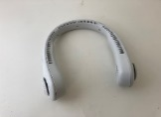
5-Jul-2023 | Hungary | Toy Scooter | Toys and Childcare Products | Injury Hazard | 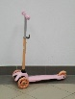
5-Jul-2023 | Latvia | Plastic Doll | Toys and Childcare Products | Chemical Hazard | 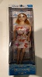
5-Jul-2023 | Ireland | Baby Self-feeding Pillow | Toys and Childcare Products | Choking Hazard | 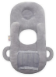
5-Jul-2023 | Ireland | Baby Self-feeding Pillow | Toys and Childcare Products | Choking Hazard | 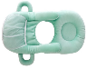
5-Jul-2023 | Denmark | Ceiling LED Lamp | Electrical Appliances | Electric Shock Hazard | 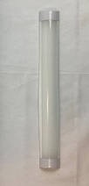
5-Jul-2023 | Denmark | Ceiling LED Lamp | Electrical Appliances | Electric Shock Hazard | 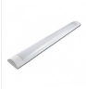
5-Jul-2023 | Latvia | Plastic Doll | Toys and Childcare Products | Chemical Hazard | 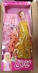
6-Jul-2023 | Italy | Children's Trousers | Fabric / Textile / Garment / Home Textile | Injury Hazard | 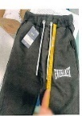
6-Jul-2023 | Italy | Sun Cream | Bodycare / Cosmetics | Chemical Hazard | 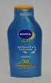  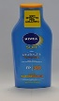  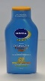
6-Jul-2023 | Italy | Eau De Toilette | Bodycare / Cosmetics | Chemical Hazard | 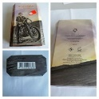
6-Jul-2023 | Italy | Eau De Toilette | Bodycare / Cosmetics | Chemical Hazard | 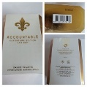
6-Jul-2023 | France | Shower Column | Tools and Hardware | Cut Hazard, Injury Hazard | 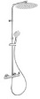  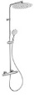  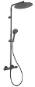  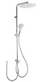
6-Jul-2023 | France | Key Ring | Toys and Childcare Products | Choking Hazard | 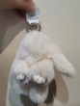  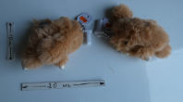
6-Jul-2023 | Sweden | Headphones | Computer / Audio / Video / Other Electronics & Accessories | Chemical Hazard, Environmental Hazard | 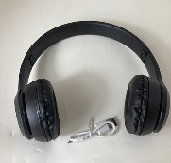
6-Jul-2023 | The Netherlands | Cosmetic Products Set | Bodycare / Cosmetics | Chemical Hazard | 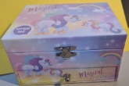
6-Jul-2023 | Germany | Vehicle Part | Car Components | Injury Hazard | 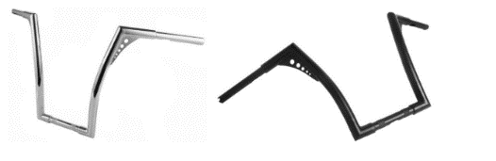
6-Jul-2023 | Sweden | Skin Lightening Oil | Bodycare / Cosmetics | Chemical Hazard | 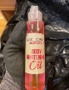
6-Jul-2023 | France | Fancy-Dress Costume | Toys and Childcare Products | Chemical Hazard | 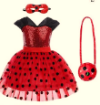
6-Jul-2023 | Hungary | Toy Mask | Toys and Childcare Products | Burn Hazard | 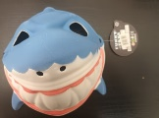
6-Jul-2023 | Hungary | Fancy Dress Wig | Toys and Childcare Products | Burn Hazard | 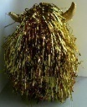
6-Jul-2023 | Latvia | Magnetic Toy | Toys and Childcare Products | Injury Hazard | 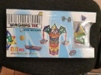  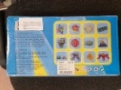
6-Jul-2023 | Germany | Jewelry Set | Jewelry | Chemical Hazard | 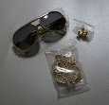
6-Jul-2023 | The Netherlands | Plastic Doll | Toys and Childcare Products | Strangulation Hazard | 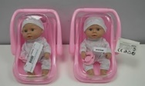
6-Jul-2023 | Sweden | Veterinarian Toy Set | Toys and Childcare Products | Strangulation Hazard, Injury Hazard | 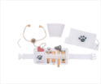
6-Jul-2023 | Cyprus | Perfume | Bodycare / Cosmetics | Chemical Hazard | 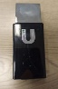
6-Jul-2023 | Germany | Shoes | Footwear | Chemical Hazard | 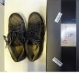  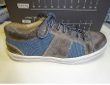  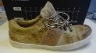
6-Jul-2023 | Finland | Soft Toy | Toys and Childcare Products | Choking Hazard | 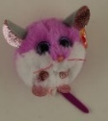
6-Jul-2023 | Sweden | Skin Lightening Cream | Bodycare / Cosmetics | Chemical Hazard | 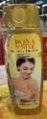
6-Jul-2023 | Sweden | Skin Lightening Cream | Bodycare / Cosmetics | Chemical Hazard | 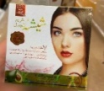
6-Jul-2023 | Sweden | Skin Lightening Cream | Bodycare / Cosmetics | Chemical Hazard | 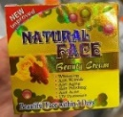
7-Jul-2023 | France | Electric Insect Trap | Electrical Appliances | Electric Shock Hazard | 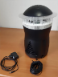
11-Jul-2023 | Italy | Children's Sweatshirt | Fabric / Textile / Garment / Home Textile | Injury Hazard, Strangulation Hazard | 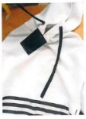
11-Jul-2023 | France | Fancy Dress Costume | Toys and Childcare Products | Choking Hazard | 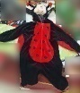
11-Jul-2023 | Germany | Baby Carrier | Toys and Childcare Products | Injury Hazard, Fall Hazard | 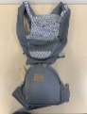
11-Jul-2023 | Germany | Baby Carrier | Toys and Childcare Products | Injury Hazard, Fall Hazard | 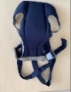
11-Jul-2023 | Germany | Baby Carrier | Toys and Childcare Products | Injury Hazard, Fall Hazard | 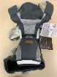
12-Jul-2023 | France | Fragrance Diffuser | Bodycare / Cosmetics | Chemical Hazard | 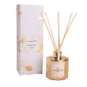
12-Jul-2023 | Malta | Shampoo | Bodycare / Cosmetics | Chemical Hazard | 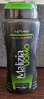
12-Jul-2023 | Ireland | Disposable Electronic Cigarette | Chemicals | Chemical Hazard | 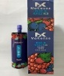  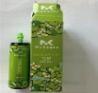
12-Jul-2023 | Hungary | Perfume | Bodycare / Cosmetics | Chemical Hazard
12-Jul-2023 | Hungary | Perfume | Bodycare / Cosmetics | Chemical Hazard | 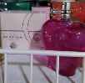
13-Jul-2023 | France | Hair Dryer | Home Electrical Appliances | Electric Shock Hazard | 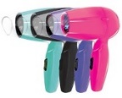
13-Jul-2023 | Italy | Sunscreen | Bodycare / Cosmetics | Chemical Hazard | 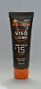
13-Jul-2023 | Italy | Mini Laser Projector | Electrical Appliances | Damage to Sight | 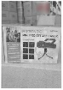
13-Jul-2023 | Austria | Helmet | Protective Equipment | Injury Hazard | 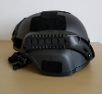
13-Jul-2023 | The Netherlands | Lamp Holder | Electrical Appliances | Electric Shock Hazard | 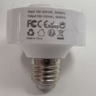
13-Jul-2023 | The Netherlands | Lamp Holder | Electrical Appliances | Electric Shock Hazard | 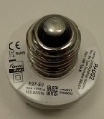
13-Jul-2023 | Luxembourg | Plastic Doll with Accessories | Toys and Childcare Products | Chemical Hazard | 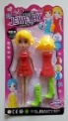
13-Jul-2023 | Lithuania | USB Charger | Electrical Appliances | Electric Shock Hazard | 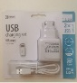
13-Jul-2023 | Cyprus | Children's Bikini | Fabric / Textile / Garment / Home Textile | Injury Hazard | 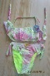  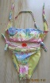  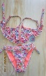  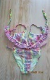
13-Jul-2023 | France | Glow Stick | Toys and Childcare Products | Chemical Hazard, Choking Hazard, Swallowing Risk | 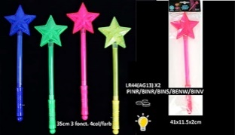
13-Jul-2023 | Hungary | Puffer Ball | Toys and Childcare Products | Choking Hazard, Damage to Hearing, Strangulation Hazard | 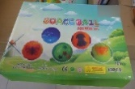  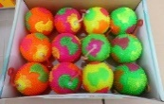
13-Jul-2023 | France | Children's Backpack | Toys and Childcare Products | Choking Hazard | 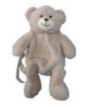
13-Jul-2023 | Cyprus | Children's Bikini | Fabric / Textile / Garment / Home Textile | Injury Hazard | 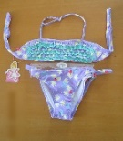
13-Jul-2023 | Sweden | Skin Lightening Cream | Bodycare / Cosmetics | Chemical Hazard | 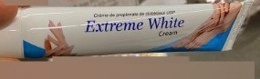
13-Jul-2023 | Cyprus | Children's Dress | Fabric / Textile / Garment / Home Textile | Injury Hazard, Strangulation Hazard | 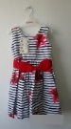
13-Jul-2023 | Finland | Plush Toy | Toys and Childcare Products | Choking Hazard | 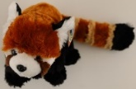
13-Jul-2023 | Poland | Lamp Holder | Electrical Appliances | Electric Shock Hazard | 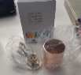
13-Jul-2023 | Cyprus | Children's Bikini | Fabric / Textile / Garment / Home Textile | Injury Hazard | 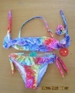
13-Jul-2023 | Germany | Baby Carrier | Toys and Childcare Products | Injury Hazard | 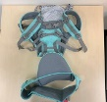
13-Jul-2023 | Estonia | Earrings | Jewelry | Chemical Hazard | 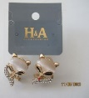
13-Jul-2023 | Hungary | Perfume | Bodycare / Cosmetics | Chemical Hazard
13-Jul-2023 | Hungary | Eau De Toilette | Bodycare / Cosmetics | Chemical Hazard | 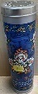
13-Jul-2023 | Hungary | Body Lotion | Bodycare / Cosmetics | Chemical Hazard | 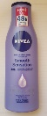
17-Jul-2023 | Hungary | Eau De Toilette | Bodycare / Cosmetics | Chemical Hazard | 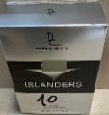  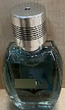
17-Jul-2023 | Hungary | Hand Cream | Bodycare / Cosmetics | Chemical Hazard | 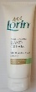
17-Jul-2023 | Hungary | Hairspray | Bodycare / Cosmetics | Chemical Hazard | 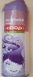
18-Jul-2023 | France | Soft Toy | Toys and Childcare Products | Choking Hazard | 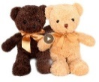
18-Jul-2023 | France | Button Batteries | Electrical Appliances | Chemical Hazard, Choking Hazard, Swallowing Risk | 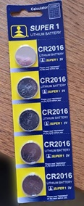
18-Jul-2023 | France | Soother Holder | Toys and Childcare Products | Strangulation Hazard | 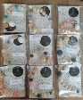
18-Jul-2023 | Sweden | Earrings | Jewelry | Chemical Hazard | 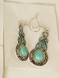
18-Jul-2023 | Hungary | Toy Mask | Toys and Childcare Products | Burn Hazard | 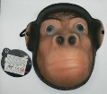  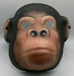
18-Jul-2023 | Bulgaria | Disposable Electronic Cigarette | Chemicals | Chemical Hazard | 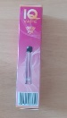  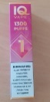
18-Jul-2023 | The Netherlands | Toy Gun | Toys and Childcare Products | Damage to Sight | 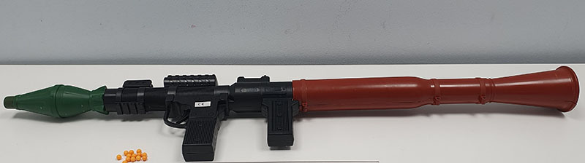
18-Jul-2023 | Hungary | Toy Mask | Toys and Childcare Products | Burn Hazard | 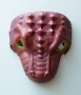
20-Jul-2023 | Ireland | Baby Sleeping Bag | Fabric / Textile / Garment / Home Textile | Skin Irritation Risk | 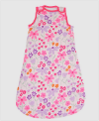  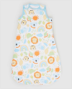  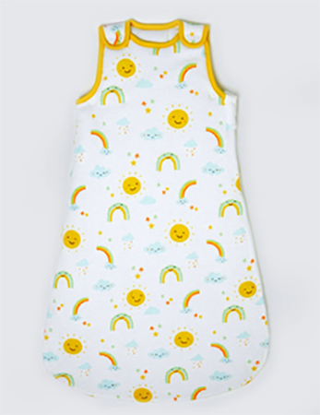
20-Jul-2023 | Malta | Play Dough | Toys and Childcare Products | Choking Hazard | 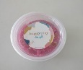  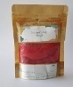
20-Jul-2023 | France | Soft Toy | Toys and Childcare Products | Choking Hazard
20-Jul-2023 | France | Finger Paint | Toys and Childcare Products | Chemical Hazard | 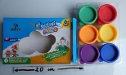
20-Jul-2023 | Finland | Pencil Case | Toys and Childcare Products | Choking Hazard | 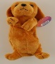  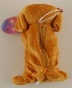  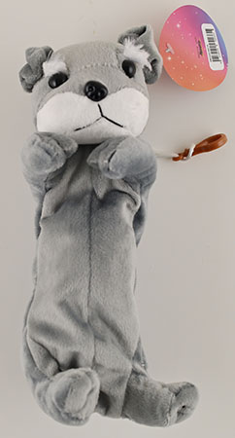  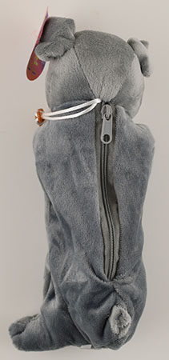
20-Jul-2023 | Austria | Balance Bike | Sporting Goods / Equipment | Injury Hazard | 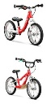
20-Jul-2023 | France | Key Ring | Toys and Childcare Products | Choking Hazard, Suffocation Hazard | 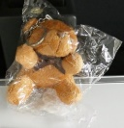
20-Jul-2023 | Sweden | Inflatable Ball | Toys and Childcare Products | Chemical Hazard | 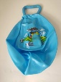
20-Jul-2023 | Sweden | Sandals | Footwear | Chemical Hazard | 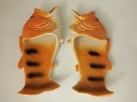
20-Jul-2023 | Sweden | Shoe Cover | Footwear | Chemical Hazard | 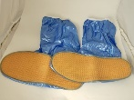
20-Jul-2023 | Hungary | Air Humidifier | Home Electrical Appliances | Microbiological Hazard | 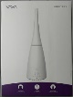
20-Jul-2023 | Hungary | Fancy-dress Wig | Toys and Childcare Products | Burn Hazard | 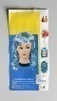  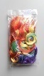
20-Jul-2023 | Hungary | Children's Fancy Dress | Toys and Childcare Products | Burn Hazard | 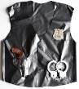
20-Jul-2023 | Hungary | Flail-type Cutting Attachment for Brush Cutter | Machinery | Injury Hazard | 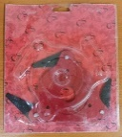
20-Jul-2023 | Sweden | Toiletry Bag | Fabric / Textile / Garment / Home Textile | Chemical Hazard | 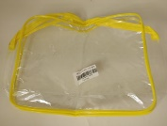
20-Jul-2023 | Cyprus | Children's Bikini | Fabric / Textile / Garment / Home Textile | Injury Hazard, Strangulation Hazard | 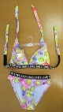
20-Jul-2023 | Germany | Baby Carrier | Toys and Childcare Products | Injury Hazard | 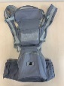
20-Jul-2023 | Germany | Ring | Jewelry | Chemical Hazard | 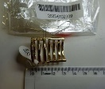
20-Jul-2023 | The Netherlands | Toy Gun | Toys and Childcare Products | Damage to Sight | 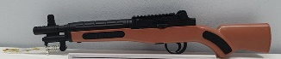
20-Jul-2023 | Finland | Soft Toy | Toys and Childcare Products | Choking Hazard | 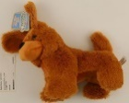
20-Jul-2023 | Hungary | Beauty Set | Bodycare / Cosmetics | Chemical Hazard | 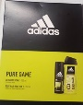
20-Jul-2023 | Hungary | Shaving Foam | Bodycare / Cosmetics | Chemical Hazard | 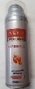
20-Jul-2023 | Hungary | After Shave | Bodycare / Cosmetics | Chemical Hazard | 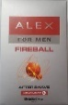
20-Jul-2023 | Hungary | Shower Gel | Bodycare / Cosmetics | Chemical Hazard | 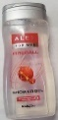
20-Jul-2023 | Hungary | Deodorant | Bodycare / Cosmetics | Chemical Hazard | 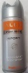
20-Jul-2023 | Hungary | After Shave | Bodycare / Cosmetics | Chemical Hazard | 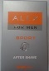
20-Jul-2023 | Belgium | Snowmobile | Machinery | Burn Hazard, Fire Hazard, Injury Hazard | 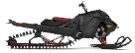  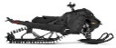  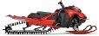
24-Jul-2023 | France | Soft Toy | Toys and Childcare Products | Choking Hazard | 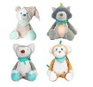  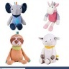
24-Jul-2023 | Portugal | Gas-fired Appliance | Outdoor Living Items | Burn Hazard, Fire Hazard, Explosion Hazard | 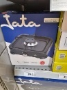  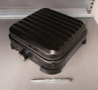
24-Jul-2023 | Portugal | Tumble Dryer | Home Electrical Appliances | Fire Hazard | 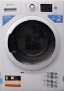
25-Jul-2023 | Finland | Toy Police Set | Toys and Childcare Products | Chemical Hazard | 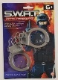
25-Jul-2023 | Spain | Beauty Sets | Bodycare / Cosmetics | Chemical Hazard | 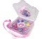  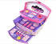  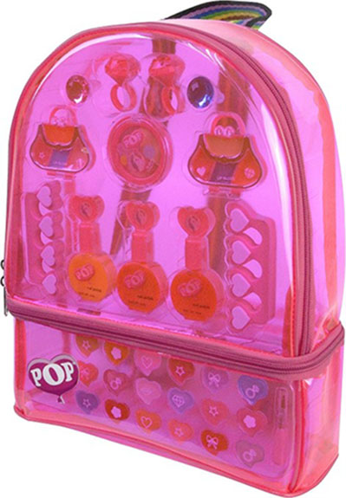  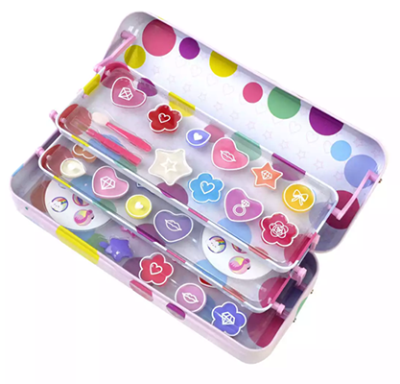  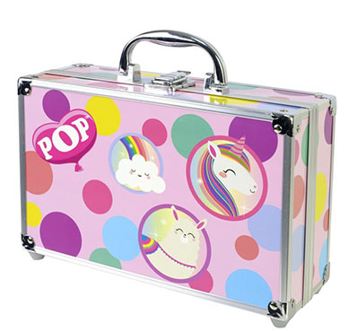  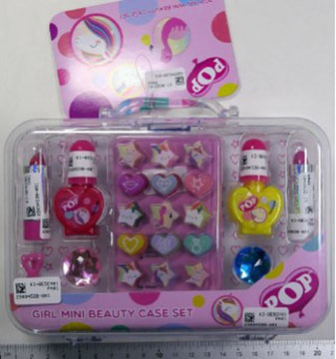  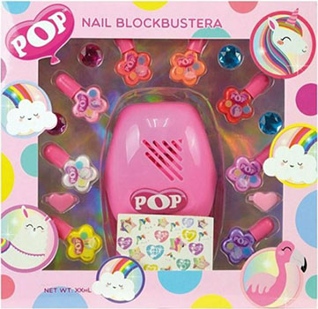
25-Jul-2023 | Germany | Baby Carrier | Toys and Childcare Products | Injury Hazard | 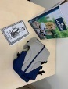
25-Jul-2023 | Hungary | Hair Care Tonic | Bodycare / Cosmetics | Chemical Hazard | 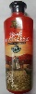
25-Jul-2023 | Hungary | Hair Care Tonic | Bodycare / Cosmetics | Chemical Hazard | 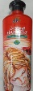
25-Jul-2023 | Hungary | After Sun Gel | Bodycare / Cosmetics | Chemical Hazard | 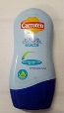
25-Jul-2023 | Hungary | Eau De Toilette | Bodycare / Cosmetics | Chemical Hazard | 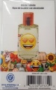
26-Jul-2023 | Portugal | USB Charger | Electrical Appliances | Electric Shock Hazard | 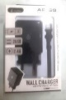  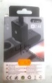
26-Jul-2023 | Hungary | Perfume | Bodycare / Cosmetics | Chemical Hazard | 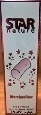
26-Jul-2023 | Hungary | Perfume | Bodycare / Cosmetics | Chemical Hazard
26-Jul-2023 | Hungary | Eau De Toilette | Bodycare / Cosmetics | Chemical Hazard | 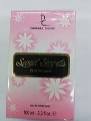
26-Jul-2023 | Hungary | Perfume | Bodycare / Cosmetics | Chemical Hazard | 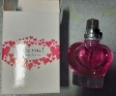
26-Jul-2023 | Unknown | Flail-type Cutting Attachments for Brush Cutters | Machinery | Injury Hazard | 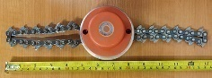
27-Jul-2023 | France | Heat-able Soft Toy | Toys and Childcare Products | Burn Hazard, Fire Hazard | 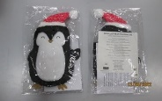
27-Jul-2023 | Portugal | Gas Heater | Electrical Appliances | Burn Hazard | 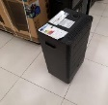
27-Jul-2023 | Sweden | Fishing Game | Toys and Childcare Products | Choking Hazard | 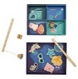
27-Jul-2023 | France | Bicycle Helmet | Protective Equipment | Injury Hazard | 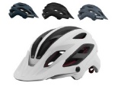
27-Jul-2023 | Portugal | Tumble Dryer | Home Electrical Appliances | Fire Hazard | 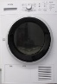
27-Jul-2023 | France | Button Batteries | Electrical Appliances | Chemical Hazard, Choking Hazard | 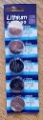
27-Jul-2023 | Sweden | Toy Mouse With Remote Control | Toys and Childcare Products | Environmental Hazard | 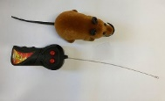
27-Jul-2023 | Sweden | Remote Control | Computer / Audio / Video / Other Electronics & Accessories | Environmental Hazard | 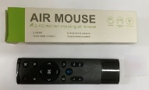
27-Jul-2023 | Sweden | Mini USB Fan | Electrical Appliances | Environmental Hazard | 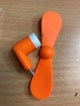
27-Jul-2023 | Sweden | Induction Headlamp | Electrical Appliances | Environmental Hazard | 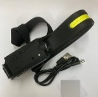  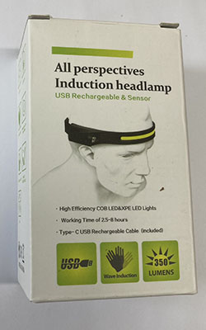
27-Jul-2023 | France | Button Batteries | Electrical Appliances | Chemical Hazard, Choking Hazard | 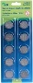  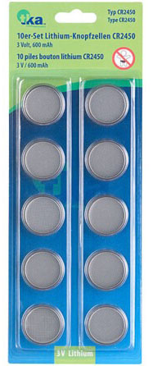  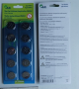  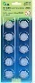
27-Jul-2023 | Sweden | USB Charger | Electrical Appliances | Environmental Hazard | 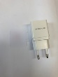
27-Jul-2023 | Sweden | Alarm Clock | Home Electrical Appliances | Environmental Hazard | 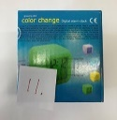
27-Jul-2023 | Sweden | Projector Light | Electrical Appliances | Environmental Hazard | 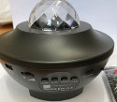
27-Jul-2023 | Sweden | USB Flash Drive | Computer / Audio / Video / Other Electronics & Accessories | Chemical Hazard, Environmental Hazard | 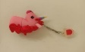
27-Jul-2023 | Austria | Bicycle | Sporting Goods / Equipment | Injury Hazard | 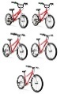
27-Jul-2023 | Austria | Children's Fancy Dress | Fabric / Textile / Garment / Home Textile | Burn Hazard | 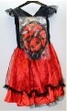
27-Jul-2023 | Sweden | Key Chain | Accessories | Chemical Hazard | 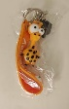
27-Jul-2023 | France | Mirror | Household Items | Cut Hazard, Injury Hazard | /
27-Jul-2023 | Germany | Toy Bus | Toys and Childcare Products | Choking Hazard | 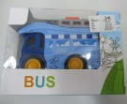
27-Jul-2023 | France | UV Insect Killer | Home Electrical Appliances | Electric Shock Hazard, Fire Hazard | 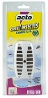
27-Jul-2023 | Hungary | Ponytail Artificial Hair | Toys and Childcare Products | Burn Hazard | 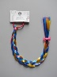
27-Jul-2023 | France | Fire Extinguisher | Protective Equipment | Injury Hazard | 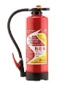  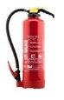
27-Jul-2023 | Norway | Firefighting Nozzle | Protective Equipment | Burn Hazard, Injury Hazard | 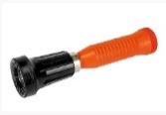
27-Jul-2023 | France | Children’s Flip-flops | Fabric / Textile / Garment / Home Textile | Chemical Hazard | 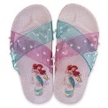
27-Jul-2023 | Hungary | Air Humidifier | Home Electrical Appliances | Microbiological Hazard | 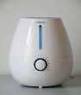
27-Jul-2023 | Hungary | Shaving Foam | Bodycare / Cosmetics | Chemical Hazard | 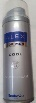
27-Jul-2023 | Hungary | Baby Walker | Toys and Childcare Products | Injury Hazard | 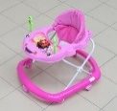
27-Jul-2023 | Finland | Badminton Set | Sporting Goods / Equipment | Chemical Hazard | 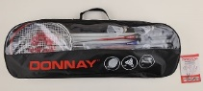
27-Jul-2023 | Finland | Leather Neckband | Jewelry | Chemical Hazard | 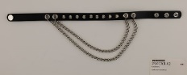
27-Jul-2023 | Hungary | Eau De Toilette and Deodorant | Bodycare / Cosmetics | Chemical Hazard | 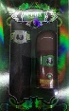
27-Jul-2023 | Austria | Helmet | Protective Equipment | Injury Hazard | 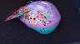  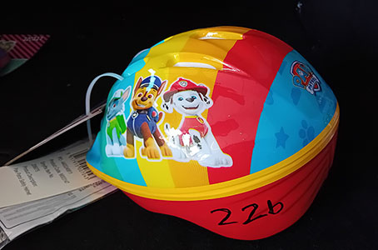
27-Jul-2023 | Poland | Disposable Barbecue Grill | Outdoor Living Items | Burn Hazard, Fire Hazard | 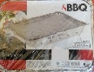
28-Jul-2023 | Czechia | Children's Particle Filter Mask | Protective Equipment | Health Risk Hazard | 