Recall Cases Summary – US (Last Update Date: 31 July 2023)

Date | Product | Categories | Hazard | Image
6-Jul-2023 | Woom ORIGINAL Kids’ Bicycles | Sporting Goods / Equipment | Fall Hazard | 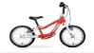  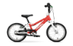  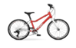  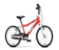  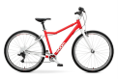
6-Jul-2023 | VRURC Portable Chargers | Electrical Appliances | Fire Hazard | 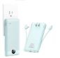  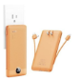  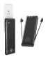  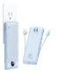
6-Jul-2023 | Residential 300 Series Snow Blowers | Machinery | Injury Hazard | 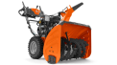
13-Jul-2023 | Frigidaire Gas Laundry Centers | Home Electrical Appliances | Fire Hazard | 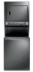
13-Jul-2023 | Gas-Fired Hot Water Residential Boiler | Home Electrical Appliances | Risk of Exposure to Combustion Flue Gas  , Carbon Monoxide Poisoning Hazard | 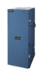  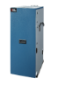  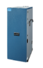  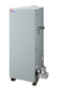  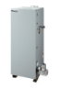  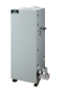
20-Jul-2023 | Wild Country Superlight Rocks Cable Wire Chocks Used for Climbing | Sporting Goods / Equipment | Fall Hazard | 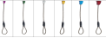
20-Jul-2023 | CUPKIN Stainless Steel Children’s Cup | Food Contact Material | Lead Poisoning Hazard | 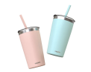  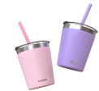
20-Jul-2023 | Penny Convertible Cribs | Furniture | Laceration Hazard | 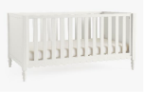
27-Jul-2023 | Showrunner II Consoles Sold with Fitness Equipment | Sporting Goods / Equipment | Fire Hazard | 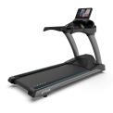  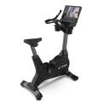  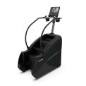  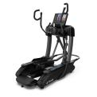
27-Jul-2023 | Sky Wheels | Sporting Goods / Equipment | Fall Hazard, Injury Hazard | 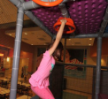  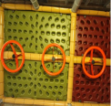
27-Jul-2023 | Timberline Solar Energy Shingles | Electrical Appliances | Fire Hazard | 