Recall Cases Summary – Australia (Last Update Date: 31 August 2023)

Date | Product | Categories | Hazard | Image
3-Aug-2023 | Maxi Trac Digital Tyre Gauge | Machinery | Choking Hazard, Burn Hazard, Risk of Death | 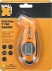
7-Aug-2023 | Mercury Marine 7.6L V12 500 hp SeaPro Marine Outboard Engine and V12 600 hp Verado Marine Outboard Engine | Machinery | Injury Hazard, Crash Hazard | 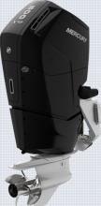  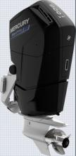
7-Aug-2023 | Large Light-Up Christmas Poptube – Santa | Household Items | Burn Hazard, Risk of Death, Choking Hazard, Swallowing Risk | 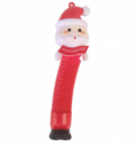
8-Aug-2023 | 4 Ducks Kids Bath Toy Set | Toys and Childcare Products | Choking Hazard, Suffocation Hazard, Risk of Death, Swallowing Risk | 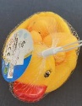
8-Aug-2023 | Bean Bag Cover | Fabric / Textile / Garment / Home Textile | Choking Hazard, Suffocation Hazard, Risk of Death, Injury Hazard | 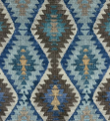  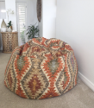
14-Aug-2023 | Flo Smart Water Monitor Lithium-ion Battery Backup | Electrical Appliances | Injury Hazard, Fire Hazard | 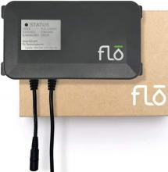
15-Aug-2023 | Gasmate Portable Diesel Heater DH203 | Electrical Appliances | Electric Shock Hazard, Injury Hazard, Risk of Death | 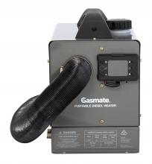
15-Aug-2023 | Handmade Montessori Star Rattle | Toys and Childcare Products | Choking Hazard, Suffocation Hazard, Risk of Death | 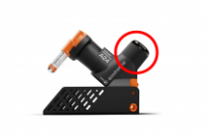  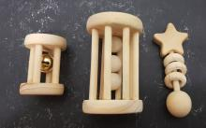
15-Aug-2023 | Goodnature Smart Cap | Electrical Appliances | Choking Hazard, Burn Hazard, Risk of Death, Swallowing Risk
16-Aug-2023 | 4WD Recovery Snatch Straps | Car Components | Injury Hazard, Risk of Death | 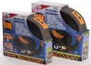  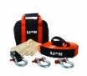
16-Aug-2023 | HRN216 and HRX217 Lawn Mowers (all models) | Machinery | Injury Hazard | 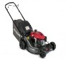  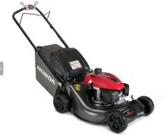  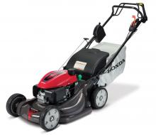  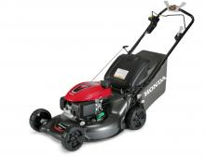
17-Aug-2023 | Kids Beach Oodie | Fabric / Textile / Garment / Home Textile | Burn Hazard | 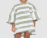  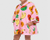  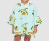  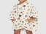
17-Aug-2023 | PowerXL Model SHL96 Self-Cleaning Juicer | Home Electrical Appliances | Injury Hazard, Laceration Hazard | 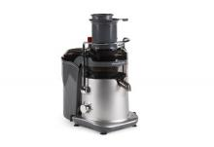
23-Aug-2023 | 5 mm Neodymium Magnetic 216 Balls | Toys and Childcare Products | Injury Hazard, Risk of Death, Choking Hazard | 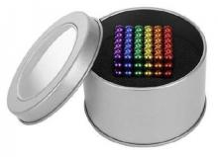
29-Aug-2023 | Windshield Set To Suit Thetford Brand Gas Stoves | Outdoor Living Items | Burn Hazard | 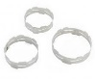  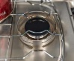  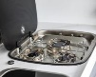
29-Aug-2023 | 10000mAh 20W USB-A & USB-C Magnetic Wireless Power Bank | Electrical Appliances | Burn Hazard, Fire Hazard | 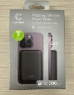
29-Aug-2023 | Gardena Aqua Count Water-Meter 18350-20 | Electrical Appliances | Choking Hazard, Burn Hazard, Risk of Death, Swallowing Risk | 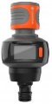
30-Aug-2023 | Detroit 5 Metre 10 Amp Heavy Duty LED Indicator Extension Lead | Electrical Appliances | Electric Shock Hazard, Injury Hazard, Fire Hazard, Burn Hazard | 