Recall Cases Summary – China (Last Update Date: 31 August 2023)

Date | Province | Product | Categories | Hazard | Image
2-Aug-2023 | Tianjin | Electric Bicycles | Sporting Goods / Equipment | Fire Hazard, Explosion Hazard | /
2-Aug-2023 | Tianjin | Electric Bicycles | Sporting Goods / Equipment | Fire Hazard, Burn Hazard | /
2-Aug-2023 | Zhejiang | Electric Bicycles Products | Sporting Goods / Equipment | Safety Risk Hazard | 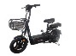
2-Aug-2023 | Zhejiang | Electric Bicycles Products | Sporting Goods / Equipment | Fire Hazard | 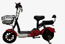
2-Aug-2023 | Zhejiang | Electric Bicycles Products | Sporting Goods / Equipment | Fire Hazard, Safety Risk Hazard, Explosion Hazard | 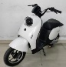
2-Aug-2023 | Zhejiang | Electric Bicycles Products | Sporting Goods / Equipment | Fire Hazard, Safety Risk Hazard, Explosion Hazard | 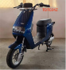
2-Aug-2023 | Zhejiang | Electric Bicycles Products | Sporting Goods / Equipment | Safety Risk Hazard
2-Aug-2023 | Zhejiang | Electric Bicycles Products | Sporting Goods / Equipment | Safety Risk Hazard
2-Aug-2023 | Zhejiang | Electric Bicycles Products | Sporting Goods / Equipment | Fire Hazard, Safety Risk Hazard | 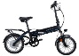
2-Aug-2023 | Zhejiang | Electric Bicycles Products | Sporting Goods / Equipment | Safety Risk Hazard
2-Aug-2023 | Zhejiang | Electric Bicycles Products | Sporting Goods / Equipment | Fire Hazard, Explosion Hazard | 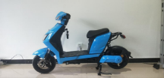
2-Aug-2023 | Zhejiang | Electric Bicycles Products | Sporting Goods / Equipment | Fire Hazard, Safety Risk Hazard | 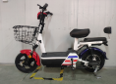
2-Aug-2023 | Zhejiang | Electric Bicycles Products | Sporting Goods / Equipment | Electric Shock Hazard, Fire Hazard, Safety Risk Hazard | 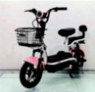
2-Aug-2023 | Zhejiang | Electric Bicycles Products | Sporting Goods / Equipment | Safety Risk Hazard
2-Aug-2023 | Shandong | Electric Bicycles Products | Sporting Goods / Equipment | Safety Risk Hazard | /
4-Aug-2023 | Zhejiang | Electric Bicycles Products | Sporting Goods / Equipment | Electric Shock Hazard, Fire Hazard, Safety Risk Hazard | 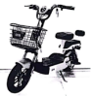
4-Aug-2023 | Zhejiang | Electric Bicycles Products | Sporting Goods / Equipment | Fall Hazard, Injury Hazard, Safety Risk Hazard | 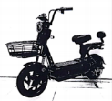
4-Aug-2023 | Zhejiang | Electric Bicycles Products | Sporting Goods / Equipment | Fall Hazard, Injury Hazard, Safety Risk Hazard | 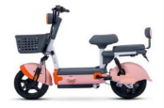
4-Aug-2023 | Zhejiang | Electric Bicycles Products | Sporting Goods / Equipment | Fire Hazard, Safety Risk Hazard
4-Aug-2023 | Zhejiang | Electric Bicycles Products | Sporting Goods / Equipment | Fire Hazard, Safety Risk Hazard
4-Aug-2023 | Zhejiang | Electric Bicycles Products | Sporting Goods / Equipment | Safety Risk Hazard | 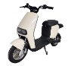
4-Aug-2023 | Zhejiang | Electric Bicycles Products | Sporting Goods / Equipment | Crash Hazard, Safety Risk Hazard | 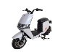
4-Aug-2023 | Zhejiang | Electric Bicycles Products | Sporting Goods / Equipment | Safety Risk Hazard
4-Aug-2023 | Zhejiang | Electric Bicycles Products | Sporting Goods / Equipment | Safety Risk Hazard | 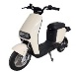
4-Aug-2023 | Zhejiang | Electric Bicycles Products | Sporting Goods / Equipment | Safety Risk Hazard
4-Aug-2023 | Zhejiang | Electric Bicycles Products | Sporting Goods / Equipment | Safety Risk Hazard | 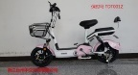
4-Aug-2023 | Zhejiang | Electric Bicycles Products | Sporting Goods / Equipment | Fire Hazard, Safety Risk Hazard | 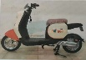
4-Aug-2023 | Zhejiang | Electric Bicycles | Sporting Goods / Equipment | Safety Risk Hazard, Fire Hazard, Explosion Hazard | 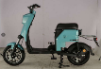
4-Aug-2023 | Zhejiang | Electric Bicycles Products | Sporting Goods / Equipment | Safety Risk Hazard | 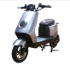
4-Aug-2023 | Zhejiang | Electric Bicycles Products | Sporting Goods / Equipment | Safety Risk Hazard
4-Aug-2023 | Zhejiang | Electric Bicycles Products | Sporting Goods / Equipment | Safety Risk Hazard
4-Aug-2023 | Fujian | Tissue | Household Items | Health Risk Hazard
4-Aug-2023 | Fujian | Cartoon Children's Sandals | Footwear | Chemical Hazard | 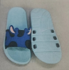
4-Aug-2023 | Fujian | Skin-friendly Coreless Toilet Paper | Household Items | Microbiological Hazard
4-Aug-2023 | Chongqing | Diesel Engine Water Pump Direct-coupled Unit | Machinery | Burn Hazard | /
4-Aug-2023 | Chongqing | School Uniforms | Fabric / Textile / Garment / Home Textile | Entanglement Hazard, Strangulation Hazard, Suffocation Hazard | /
4-Aug-2023 | Chongqing | Corn Thresher | Machinery | Injury Hazard | /
7-Aug-2023 | Henan | Erasers | Stationery | Chemical Hazard | /
7-Aug-2023 | Henan | Portable Dry Powder Fire Extinguishers | Protective Equipment | Safety Risk Hazard | /
8-Aug-2023 | Shanghai | Massager | Home Electrical Appliances | Electric Shock Hazard, Fire Hazard, Safety Risk Hazard | 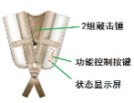
8-Aug-2023 | Anhui | Denim Washed Fisherman Hat | Fabric / Textile / Garment / Home Textile | Cut Hazard, Safety Risk Hazard | /
8-Aug-2023 | Anhui | Electric Hand Warmer | Home Electrical Appliances | Safety Risk Hazard | /
8-Aug-2023 | Anhui | Bathroom Master | Home Electrical Appliances | Electric Shock Hazard, Safety Risk Hazard | /
8-Aug-2023 | Anhui | Arithmetic Books | Stationery | Cut Hazard, Safety Risk Hazard | /
8-Aug-2023 | Anhui | Tissue | Household Items | Microbiological Hazard, Safety Risk Hazard | /
8-Aug-2023 | Anhui | Children's Dresses | Fabric / Textile / Garment / Home Textile | Entanglement Hazard, Safety Risk Hazard | /
8-Aug-2023 | Anhui | Facial Tissues | Household Items | Microbiological Hazard, Safety Risk Hazard | /
8-Aug-2023 | Anhui | Portable Dry Powder Fire Extinguishers | Protective Equipment | Safety Risk Hazard | /
8-Aug-2023 | Anhui | Facial Tissues | Household Items | Microbiological Hazard, Safety Risk Hazard | /
8-Aug-2023 | Anhui | Double-layer Glasses | Food Contact Material | Burn Hazard | /
8-Aug-2023 | Anhui | Plush Toys | Toys and Childcare Products | Swallowing Risk | /
9-Aug-2023 | Anhui | Disposable Bamboo Chopsticks | Food Contact Material | Cut Hazard, Health Risk Hazard | /
9-Aug-2023 | Anhui | Urea Solution for Vehicles | Chemicals | Safety Risk Hazard | /
9-Aug-2023 | Anhui | Special Packs of High-end Paper Tissue | Household Items | Chemical Hazard | /
9-Aug-2023 | Anhui | Medicine Cutting Machine | Machinery | Safety Risk Hazard | /
9-Aug-2023 | Anhui | High-grade Environmental- friendly Injection Packaging Box | Food Contact Material | Burn Hazard, Cut Hazard, Injury Hazard | /
10-Aug-2023 | Hunan | Lighters | Household Items | Safety Risk Hazard | 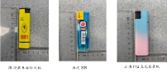
10-Aug-2023 | Hunan | Windproof Lighters | Household Items | Safety Risk Hazard | 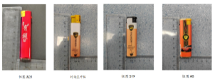
10-Aug-2023 | Hunan | Lighters | Household Items | Safety Risk Hazard | 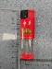
16-Aug-2023 | Jiangsu | Electric Bicycles | Sporting Goods / Equipment | Injury Hazard, Fire Hazard | 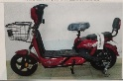
16-Aug-2023 | Hunan | Lighters | Household Items | Safety Risk Hazard | 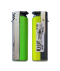
16-Aug-2023 | Hunan | Lighters | Household Items | Safety Risk Hazard | 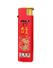
16-Aug-2023 | Jilin | No-tillage Precision Fertilization Seeder | Machinery | Safety Risk Hazard | /
16-Aug-2023 | Henan | TDT71Z Electric Bicycles | Sporting Goods / Equipment | Safety Risk Hazard | /
16-Aug-2023 | Henan | TDT1944Z Electric Bicycles | Sporting Goods / Equipment | Fire Hazard, Safety Risk Hazard | /
16-Aug-2023 | Henan | Sundele Smart Quick-drying Clothes Dryers/Tulip Smart Health Clothes Dryers | Home Electrical Appliances | Fire Hazard, Electric Shock Hazard, Safety Risk Hazard | /
16-Aug-2023 | Henan | Electric Bicycles | Sporting Goods / Equipment | Safety Risk Hazard | /
21-Aug-2023 | Henan | Children's Protective Masks | Protective Equipment | Health Risk Hazard | /
21-Aug-2023 | Henan | Children's Learning Chairs | Furniture | Injury Hazard, Crushing Hazard, Fall Hazard | /
21-Aug-2023 | Inner Mongolia | Student Uniforms for Spring and Autumn | Fabric / Textile / Garment / Home Textile | Safety Risk Hazard | /
22-Aug-2023 | Jiangsu | Children's Leather Shoes | Footwear | Lead Poisoning Hazard | 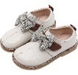
22-Aug-2023 | Jiangsu | Summer Sports Shoes | Footwear | Chemical Hazard | 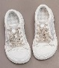
22-Aug-2023 | Jiangsu | Sheep Cotton Candy (Toys) | Toys and Childcare Products | Suffocation Hazard
22-Aug-2023 | Jiangsu | Electric Bicycles | Sporting Goods / Equipment | Fire Hazard, Safety Risk Hazard | 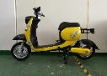
23-Aug-2023 | Shanghai | Boss Subwoofers | Computer / Audio / Video / Other Electronics & Accessories | Fire Hazard | 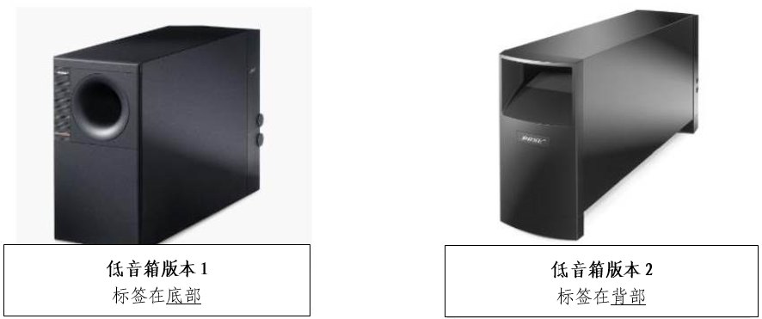
23-Aug-2023 | Inner Mongolia | Student Spring and Autumn Clothing | Fabric / Textile / Garment / Home Textile | Safety Risk Hazard | /
24-Aug-2023 | Jiangsu | Electric Bicycles | Sporting Goods / Equipment | Fire Hazard, Safety Risk Hazard | 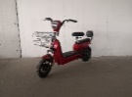
25-Aug-2023 | Chongqing | 5G Digital Mobile Phones and 4G Digital Mobile Phones | Computer / Audio / Video / Other Electronics & Accessories | Safety Risk Hazard | /
28-Aug-2023 | Hunan | Electric Bicycles | Sporting Goods / Equipment | Safety Risk Hazard
28-Aug-2023 | Henan | Melamine Plastic Tableware (Plates) | Food Contact Material | Safety Risk Hazard | /
28-Aug-2023 | Henan | Induction Cookers | Home Electrical Appliances | Laceration Hazard, Electric Shock Hazard | /
28-Aug-2023 | Henan | Automatic Rice Cookers | Home Electrical Appliances | Electric Shock Hazard, Safety Risk Hazard | /
28-Aug-2023 | Henan | Induction Cookers | Home Electrical Appliances | Electric Shock Hazard, Fire Hazard, Safety Risk Hazard | /
29-Aug-2023 | Jiangsu | Electric Bicycles | Sporting Goods / Equipment | Injury Hazard, Safety Risk Hazard | 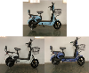
29-Aug-2023 | Tianjin | Electric Bicycles | Sporting Goods / Equipment | Safety Risk Hazard | /
29-Aug-2023 | Tianjin | Electric Bicycles | Sporting Goods / Equipment | Fire Hazard, Explosion Hazard, Safety Risk Hazard | /
29-Aug-2023 | Tianjin | Electric Bicycles | Sporting Goods / Equipment | Safety Risk Hazard | /
30-Aug-2023 | Inner Mongolia | Student Clothes | Fabric / Textile / Garment / Home Textile | Safety Risk Hazard | /
31-Aug-2023 | Hunan | Summer Homework Series Homework Books | Stationery | Injury Hazard, Laceration Hazard | 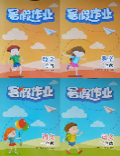
31-Aug-2023 | Inner Mongolia | School Uniform Spring and Autumn Suits | Fabric / Textile / Garment / Home Textile | Safety Risk Hazard | /

