Recall Cases Summary – Europe (Last Update Date: 31 August 2023)

Date | Notifying Country | Product | Categories | Hazard | Image
1-Aug-2023 | Cyprus | Children's Dress | Fabric / Textile / Garment / Home Textile | Injury Hazard | 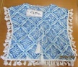  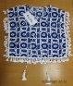  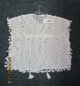
1-Aug-2023 | Ireland | Furniture Bench Set | Furniture | Injury Hazard
1-Aug-2023 | Austria | Skin Lightening Cream | Bodycare / Cosmetics | Chemical Hazard | 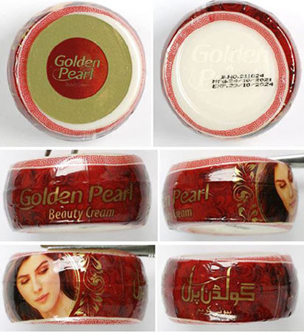
1-Aug-2023 | Denmark | Suspension Kit for Electric Scooter | Tools and Hardware | Injury Hazard | 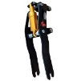
1-Aug-2023 | Austria | Toy Whistle | Toys and Childcare Products | Damage to Hearing | 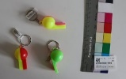
2-Aug-2023 | Cyprus | Swim Seat | Sporting Goods / Equipment | Drowning Hazard | 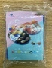
2-Aug-2023 | Ireland | Children's Swimming Jacket | Protective Equipment | Drowning Hazard | 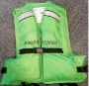
2-Aug-2023 | Cyprus | Children's Dress | Fabric / Textile / Garment / Home Textile | Injury Hazard, Strangulation Hazard | 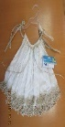
3-Aug-2023 | Portugal | Gas Heater | Household Items | Burn Hazard
3-Aug-2023 | France | Heatable Soft Toy | Toys and Childcare Products | Burn Hazard, Fire Hazard | 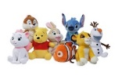
3-Aug-2023 | Sweden | Stapler | Stationery | Environmental Hazard | 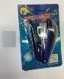
3-Aug-2023 | France | Electric Heating Cushion | Home Electrical Appliances | Burn Hazard, Fire Hazard | 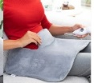  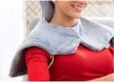
3-Aug-2023 | Germany | Baby Carrier | Toys and Childcare Products | Injury Hazard | 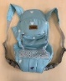
3-Aug-2023 | Austria | Skin Lightening Cream | Bodycare / Cosmetics | Chemical Hazard
3-Aug-2023 | Germany | Particle Filter Mask | Protective Equipment | Microbiological Hazard | 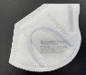
3-Aug-2023 | Czechia | Particle Filter Mask | Protective Equipment | Health Risk Hazard | 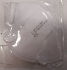
3-Aug-2023 | Finland | Earrings | Jewelry | Chemical Hazard | 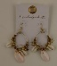
3-Aug-2023 | Poland | Soft Toy | Toys and Childcare Products | Choking Hazard | 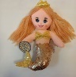
3-Aug-2023 | Poland | Power Supply | Electrical Appliances | Electric Shock Hazard | 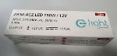
3-Aug-2023 | Czechia | Hand And Nail Cream Set | Bodycare / Cosmetics | Chemical Hazard | 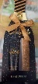
3-Aug-2023 | Poland | Power Supply | Electrical Appliances | Environmental Hazard | 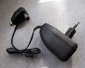
3-Aug-2023 | Poland | Plastic Toy Set | Toys and Childcare Products | Choking Hazard | 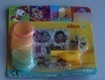
3-Aug-2023 | Germany | Aluminium Rim | Car Components | Injury Hazard | 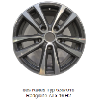
3-Aug-2023 | Latvia | Liquid Fire Starter | Chemicals | Chemical Hazard | 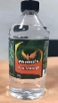
3-Aug-2023 | France | Floor Lamp | Electrical Appliances | Cut Hazard, Injury Hazard | 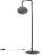
3-Aug-2023 | Lithuania | Children's Jacket | Fabric / Textile / Garment / Home Textile | Injury Hazard, Strangulation Hazard | 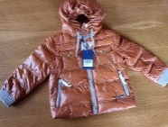
3-Aug-2023 | Lithuania | Children's Jumper | Fabric / Textile / Garment / Home Textile | Injury Hazard, Strangulation Hazard | 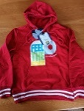
3-Aug-2023 | Lithuania | Children's Jumper | Fabric / Textile / Garment / Home Textile | Injury Hazard, Strangulation Hazard | 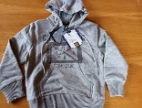
3-Aug-2023 | Lithuania | Children's Jacket | Fabric / Textile / Garment / Home Textile | Injury Hazard, Strangulation Hazard | 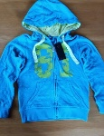
3-Aug-2023 | Lithuania | Sports Outfit | Fabric / Textile / Garment / Home Textile | Injury Hazard, Strangulation Hazard | 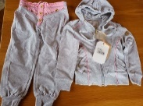
3-Aug-2023 | Lithuania | Children's Jumper | Fabric / Textile / Garment / Home Textile | Injury Hazard, Strangulation Hazard | 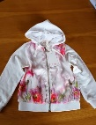
3-Aug-2023 | Lithuania | Children's Jumpsuit | Fabric / Textile / Garment / Home Textile | Injury Hazard | 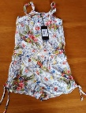
4-Aug-2023 | Germany | Children's Snorkel Mask | Protective Equipment | Suffocation Hazard | 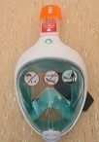
4-Aug-2023 | Czechia | Plastic Doll | Toys and Childcare Products | Chemical Hazard | 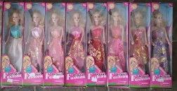
8-Aug-2023 | The Netherlands | Fireworks | Outdoor Living Items | Injury Hazard | 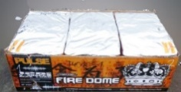
8-Aug-2023 | The Netherlands | Fireworks | Outdoor Living Items | Burn Hazard, Injury Hazard | 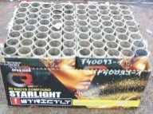
8-Aug-2023 | The Netherlands | Fireworks | Outdoor Living Items | Burn Hazard, Injury Hazard | 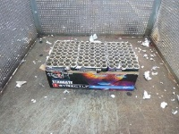
8-Aug-2023 | The Netherlands | Fireworks | Outdoor Living Items | Burn Hazard, Injury Hazard | 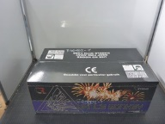
8-Aug-2023 | Cyprus | Children's Bikini | Fabric / Textile / Garment / Home Textile | Injury Hazard | 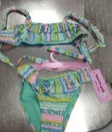
8-Aug-2023 | Lithuania | Liquid Fire Starter | Chemicals | Chemical Hazard | 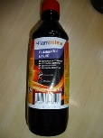
8-Aug-2023 | Cyprus | Children's Dress | Fabric / Textile / Garment / Home Textile | Injury Hazard, Strangulation Hazard | 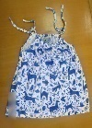
8-Aug-2023 | Lithuania | Children's Hoodie | Fabric / Textile / Garment / Home Textile | Injury Hazard, Strangulation Hazard | 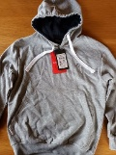
8-Aug-2023 | Poland | Loudspeakers | Computer / Audio / Video / Other Electronics & Accessories | Environmental Hazard | 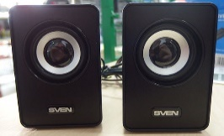
8-Aug-2023 | The Netherlands | Toy Car Keys | Toys and Childcare Products | Choking Hazard | 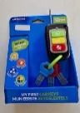
9-Aug-2023 | The Netherlands | Fireworks | Outdoor Living Items | Injury Hazard | 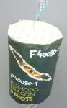
9-Aug-2023 | France | Shampoo | Bodycare / Cosmetics | Microbiological Hazard | 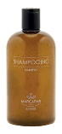
9-Aug-2023 | Hungary | Soft Toy | Toys and Childcare Products | Chemical Hazard, Choking Hazard | 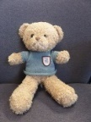
9-Aug-2023 | Lithuania | Grill and Fireplace Cleaner | Chemicals | Chemical Hazard | 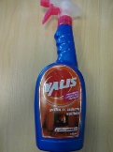
9-Aug-2023 | Lithuania | Children's Jumper | Fabric / Textile / Garment / Home Textile | Injury Hazard, Strangulation Hazard | 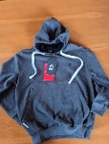
9-Aug-2023 | Lithuania | Hair Shampoo and Conditioner | Bodycare / Cosmetics | Chemical Hazard | 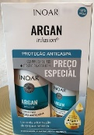
10-Aug-2023 | Hungary | Perfume | Bodycare / Cosmetics | Chemical Hazard | 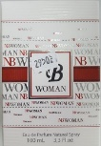
10-Aug-2023 | France | Soft Toy | Toys and Childcare Products | Choking Hazard
16-Aug-2023 | Hungary | Eau De Toilette | Bodycare / Cosmetics | Chemical Hazard | 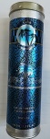
16-Aug-2023 | Hungary | Body Spray | Bodycare / Cosmetics | Chemical Hazard
16-Aug-2023 | Hungary | Deodorant | Bodycare / Cosmetics | Chemical Hazard | 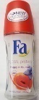
16-Aug-2023 | Lithuania | Construction Waste Cleaner | Chemicals | Chemical Hazard | 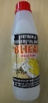
16-Aug-2023 | Poland | Toy Gun Set | Toys and Childcare Products | Damage to Sight | 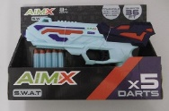
16-Aug-2023 | Norway | Eyelash Curler | Home Electrical Appliances | Environmental Hazard | 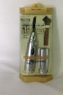
16-Aug-2023 | Bulgaria | Children’s Short Pants | Fabric / Textile / Garment / Home Textile | Injury Hazard | 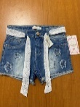
16-Aug-2023 | Bulgaria | Children’s Clothing Set | Fabric / Textile / Garment / Home Textile | Injury Hazard, Strangulation Hazard | 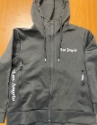  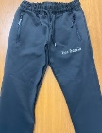
16-Aug-2023 | Bulgaria | Children’s Clothing Set | Fabric / Textile / Garment / Home Textile | Injury Hazard, Strangulation Hazard | 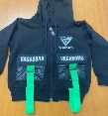  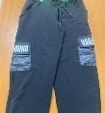
17-Aug-2023 | Hungary | Shower Gel | Bodycare / Cosmetics | Chemical Hazard | 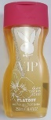
17-Aug-2023 | Hungary | Perfume | Bodycare / Cosmetics | Chemical Hazard | 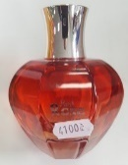
17-Aug-2023 | Hungary | Eau De Toilette | Bodycare / Cosmetics | Chemical Hazard | 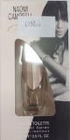
17-Aug-2023 | Germany | Single-use Electronic Cigarette | Chemicals | Chemical Hazard | 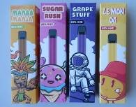
17-Aug-2023 | Cyprus | Children's Dress | Fabric / Textile / Garment / Home Textile | Injury Hazard, Strangulation Hazard | 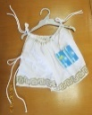
17-Aug-2023 | Hungary | Soap | Bodycare / Cosmetics | Chemical Hazard | 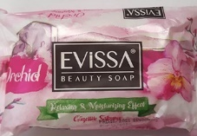
17-Aug-2023 | France | Soft Toy | Toys and Childcare Products | Choking Hazard | 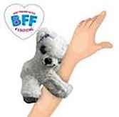
17-Aug-2023 | Austria | Push Along Toy | Toys and Childcare Products | Choking Hazard | 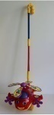
17-Aug-2023 | Poland | Soldering Iron | Home Electrical Appliances | Electric Shock Hazard | 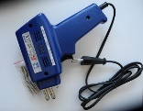
17-Aug-2023 | Poland | Fireworks | Outdoor Living Items | Burn Hazard, Fire Hazard | 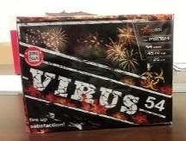
17-Aug-2023 | Poland | USB Charger | Electrical Appliances | Electric Shock Hazard, Fire Hazard
17-Aug-2023 | Poland | Soft Toy | Toys and Childcare Products | Choking Hazard | 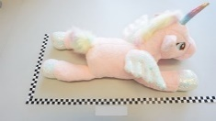
17-Aug-2023 | The Netherlands | Boiler, Heat Exchanger | Home Electrical Appliances | Microbiological Hazard | 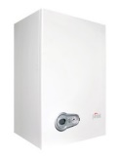
17-Aug-2023 | Lithuania | Mould Cleaner | Chemicals | Chemical Hazard | 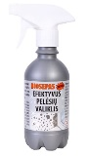
17-Aug-2023 | Czechia | Plastic Doll | Toys and Childcare Products | Chemical Hazard | 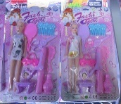
17-Aug-2023 | Bulgaria | Children’s Dress | Fabric / Textile / Garment / Home Textile | Injury Hazard, Strangulation Hazard | 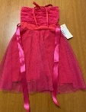
17-Aug-2023 | Bulgaria | Children’s Clothing Set | Fabric / Textile / Garment / Home Textile | Injury Hazard, Strangulation Hazard | 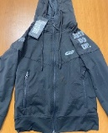  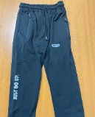
18-Aug-2023 | France | Air Conditioner | Home Electrical Appliances | Fire Hazard | 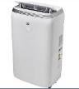
22-Aug-2023 | Iceland | Children's Hoodie | Fabric / Textile / Garment / Home Textile | Injury Hazard, Strangulation Hazard | 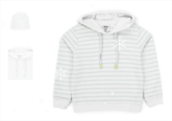
22-Aug-2023 | Iceland | Children's Hoodie | Fabric / Textile / Garment / Home Textile | Injury Hazard, Strangulation Hazard
22-Aug-2023 | Hungary | Sunscreen Lotion | Bodycare / Cosmetics | Chemical Hazard | 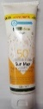
22-Aug-2023 | Hungary | Hairspray | Bodycare / Cosmetics | Chemical Hazard | 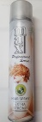
22-Aug-2023 | Hungary | Hair Spray | Bodycare / Cosmetics | Chemical Hazard | 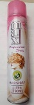
22-Aug-2023 | Hungary | Hand Disinfectant | Bodycare / Cosmetics | Chemical Hazard | 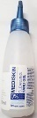
22-Aug-2023 | Hungary | Sunscreen Lotion | Bodycare / Cosmetics | Chemical Hazard | 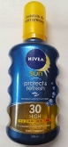
22-Aug-2023 | Hungary | After Sun Lotion | Bodycare / Cosmetics | Chemical Hazard | 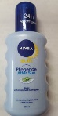
22-Aug-2023 | Hungary | Face Cream | Bodycare / Cosmetics | Chemical Hazard | 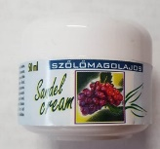
22-Aug-2023 | Hungary | Hair Mousse | Bodycare / Cosmetics | Chemical Hazard | 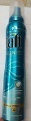
22-Aug-2023 | France | Soft Toy | Toys and Childcare Products | Choking Hazard | 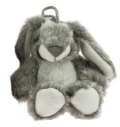
22-Aug-2023 | France | Soft Toy | Toys and Childcare Products | Choking Hazard | 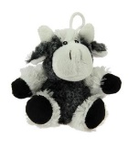
22-Aug-2023 | France | Soft Toy | Toys and Childcare Products | Choking Hazard
22-Aug-2023 | Finland | Plush Toy | Toys and Childcare Products | Choking Hazard | 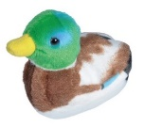
22-Aug-2023 | Poland | Toy Gun Set | Toys and Childcare Products | Damage to Sight | 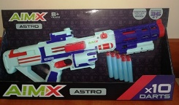
22-Aug-2023 | Hungary | Perfume | Bodycare / Cosmetics | Chemical Hazard | 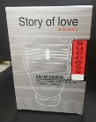
22-Aug-2023 | Germany | Baby Sleep Bags | Fabric / Textile / Garment / Home Textile | Suffocation Hazard | 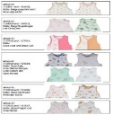  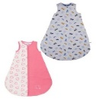
22-Aug-2023 | Hungary | Eau De Toilette | Bodycare / Cosmetics | Chemical Hazard | 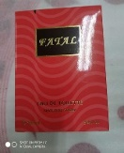
22-Aug-2023 | Austria | Children's Hoodie | Fabric / Textile / Garment / Home Textile | Injury Hazard, Strangulation Hazard | 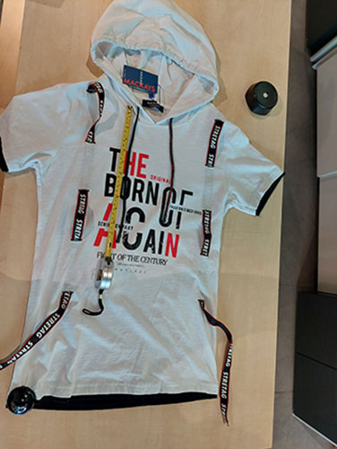
22-Aug-2023 | Hungary | Toy Scooter | Toys and Childcare Products | Injury Hazard | 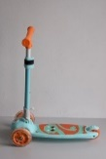
22-Aug-2023 | Finland | Headlamp | Electrical Appliances | Electric Shock Hazard | 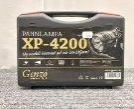  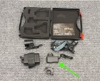
23-Aug-2023 | Iceland | Children's Dress | Fabric / Textile / Garment / Home Textile | Injury Hazard, Strangulation Hazard | 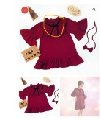
23-Aug-2023 | Hungary | Body Care Set | Bodycare / Cosmetics | Chemical Hazard | 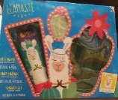
23-Aug-2023 | Hungary | Baby Lotion | Bodycare / Cosmetics | Chemical Hazard | 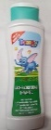
23-Aug-2023 | Hungary | Shampoo | Bodycare / Cosmetics | Chemical Hazard | 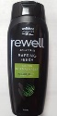
23-Aug-2023 | Germany | Particle Filter Mask | Protective Equipment | Health Risk Hazard | 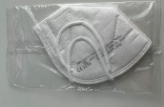
23-Aug-2023 | Germany | Skin-lightening Body Lotion | Bodycare / Cosmetics | Chemical Hazard | 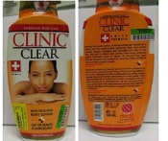
23-Aug-2023 | Germany | Water Electrolysis Device | Electrical Appliances | Electric Shock Hazard | 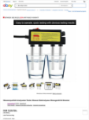  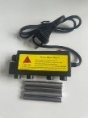
23-Aug-2023 | Poland | Soft Toy | Toys and Childcare Products | Choking Hazard
23-Aug-2023 | Ireland | Baby Self-feeding Pillow | Toys and Childcare Products | Choking Hazard | 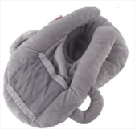
23-Aug-2023 | Austria | Children's Hoodie | Fabric / Textile / Garment / Home Textile | Injury Hazard, Strangulation Hazard | 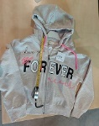
23-Aug-2023 | Hungary | Flail-type Cutting Attachment for Brush Cutter | Machinery | Injury Hazard | 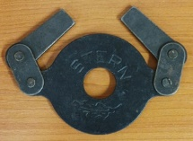
23-Aug-2023 | Hungary | Flail-type Cutting Attachment for Brush Cutter | Machinery | Injury Hazard | 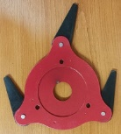
23-Aug-2023 | Hungary | Flail-type Cutting Attachments for Brush Cutter | Machinery | Injury Hazard | 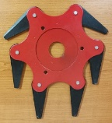
23-Aug-2023 | Poland | Power Supply | Electrical Appliances | Environmental Hazard | 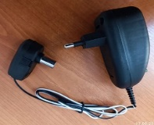
24-Aug-2023 | Iceland | Children's Hoodie | Fabric / Textile / Garment / Home Textile | Injury Hazard, Strangulation Hazard | 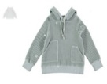  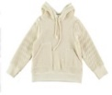
24-Aug-2023 | Iceland | Children's Hoodie | Fabric / Textile / Garment / Home Textile | Injury Hazard, Strangulation Hazard | 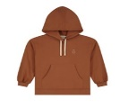  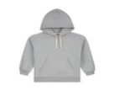
24-Aug-2023 | Iceland | Children's Dress | Fabric / Textile / Garment / Home Textile | Injury Hazard, Strangulation Hazard
24-Aug-2023 | Italy | Perfume | Bodycare / Cosmetics | Chemical Hazard | 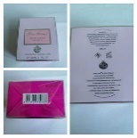
24-Aug-2023 | Italy | Perfume | Bodycare / Cosmetics | Chemical Hazard | 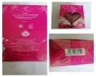  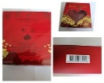
24-Aug-2023 | Italy | Perfume | Bodycare / Cosmetics | Chemical Hazard | 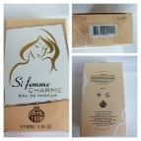
24-Aug-2023 | Italy | Perfume | Bodycare / Cosmetics | Chemical Hazard | 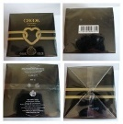
24-Aug-2023 | Iceland | Children's Hoodie | Fabric / Textile / Garment / Home Textile | Injury Hazard, Strangulation Hazard | 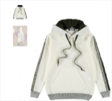
24-Aug-2023 | Hungary | Hair Mousse | Bodycare / Cosmetics | Chemical Hazard | 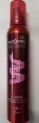
24-Aug-2023 | Italy | Eau De Toilette | Bodycare / Cosmetics | Chemical Hazard | 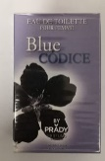
24-Aug-2023 | Italy | Eau De Toilette | Bodycare / Cosmetics | Chemical Hazard | 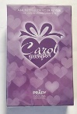
24-Aug-2023 | Italy | Perfume | Bodycare / Cosmetics | Chemical Hazard | 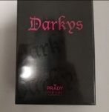
24-Aug-2023 | Italy | Eau De Toilette | Bodycare / Cosmetics | Chemical Hazard | 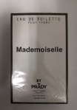
24-Aug-2023 | Italy | Eau De Toilette | Bodycare / Cosmetics | Chemical Hazard
24-Aug-2023 | Italy | Eau De Toilette | Bodycare / Cosmetics | Chemical Hazard | 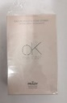
24-Aug-2023 | Italy | Eau De Toilette | Bodycare / Cosmetics | Chemical Hazard | 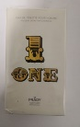
24-Aug-2023 | Italy | Eau De Toilette | Bodycare / Cosmetics | Chemical Hazard | 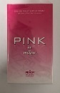
24-Aug-2023 | Hungary | Perfume | Bodycare / Cosmetics | Chemical Hazard | 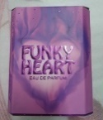
24-Aug-2023 | Italy | Eau De Toilette | Bodycare / Cosmetics | Chemical Hazard | 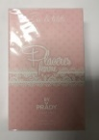
24-Aug-2023 | Italy | Perfume | Bodycare / Cosmetics | Chemical Hazard | 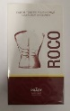
24-Aug-2023 | Poland | Set of Children's Earrings | Jewelry | Chemical Hazard | 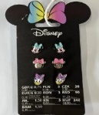
24-Aug-2023 | Italy | Eau De Toilette | Bodycare / Cosmetics | Chemical Hazard | 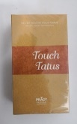
24-Aug-2023 | Italy | Eau De Toilette | Bodycare / Cosmetics | Chemical Hazard | 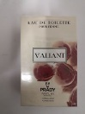
24-Aug-2023 | Poland | Wireless Headphones | Computer / Audio / Video / Other Electronics & Accessories | Environmental Hazard | 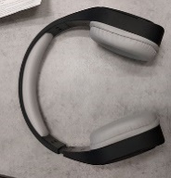
24-Aug-2023 | Hungary | Perfume | Bodycare / Cosmetics | Chemical Hazard | 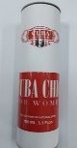
25-Aug-2023 | Sweden | Skin Lightening Cream | Bodycare / Cosmetics | Chemical Hazard | 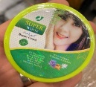
29-Aug-2023 | Italy | Shower Foam | Bodycare / Cosmetics | Chemical Hazard | 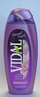
29-Aug-2023 | Italy | Shampoo | Bodycare / Cosmetics | Chemical Hazard | 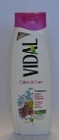
29-Aug-2023 | Italy | Shampoo | Bodycare / Cosmetics | Chemical Hazard | 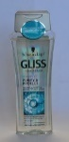
29-Aug-2023 | Italy | Perfume | Bodycare / Cosmetics | Chemical Hazard | 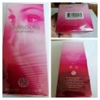
29-Aug-2023 | Italy | Hair Conditioner | Bodycare / Cosmetics | Chemical Hazard | 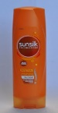  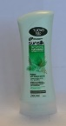  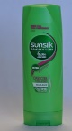
29-Aug-2023 | Italy | Hair Conditioner | Bodycare / Cosmetics | Chemical Hazard | 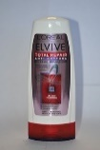
29-Aug-2023 | Italy | Shower Gel | Bodycare / Cosmetics | Chemical Hazard | 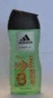
29-Aug-2023 | Italy | Perfume | Bodycare / Cosmetics | Chemical Hazard | 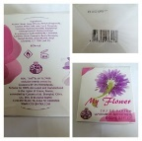
29-Aug-2023 | Italy | Eau De Toilette | Bodycare / Cosmetics | Chemical Hazard | 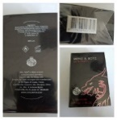
29-Aug-2023 | Italy | Perfume | Bodycare / Cosmetics | Chemical Hazard | 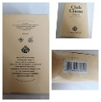
29-Aug-2023 | Italy | Perfume | Bodycare / Cosmetics | Chemical Hazard | 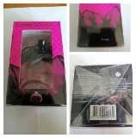
29-Aug-2023 | Italy | Hair Conditioner | Bodycare / Cosmetics | Chemical Hazard | 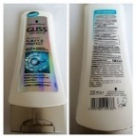
29-Aug-2023 | Italy | Bath and Shower Cream | Bodycare / Cosmetics | Chemical Hazard | 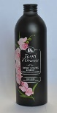
29-Aug-2023 | Italy | Eau De Toilette | Bodycare / Cosmetics | Chemical Hazard | 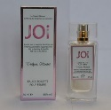
29-Aug-2023 | Italy | Shampoo | Bodycare / Cosmetics | Chemical Hazard | 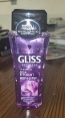
29-Aug-2023 | Italy | Shampoo | Bodycare / Cosmetics | Chemical Hazard | 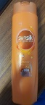  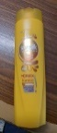  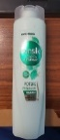  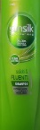  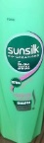
29-Aug-2023 | Italy | Shampoo | Bodycare / Cosmetics | Chemical Hazard | 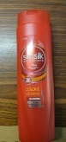
29-Aug-2023 | Italy | Bath Foam | Bodycare / Cosmetics | Chemical Hazard | 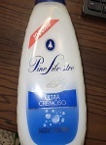
29-Aug-2023 | Italy | Shower Foam | Bodycare / Cosmetics | Chemical Hazard | 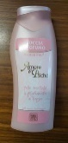
29-Aug-2023 | Italy | Liquid Soap | Bodycare / Cosmetics | Chemical Hazard | 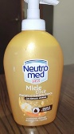
29-Aug-2023 | Italy | Shower Gel | Bodycare / Cosmetics | Chemical Hazard | 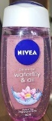
29-Aug-2023 | Italy | Shower Foam | Bodycare / Cosmetics | Chemical Hazard | 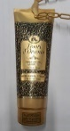
29-Aug-2023 | Italy | Cream | Bodycare / Cosmetics | Chemical Hazard | 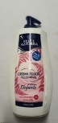
29-Aug-2023 | Italy | Bath Foam | Bodycare / Cosmetics | Chemical Hazard | 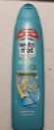  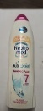  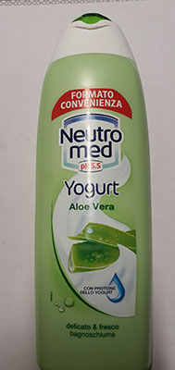  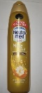  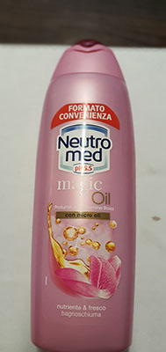
29-Aug-2023 | Italy | Bath and Shower Gel | Bodycare / Cosmetics | Chemical Hazard | 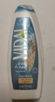
29-Aug-2023 | Italy | Shower Gel | Bodycare / Cosmetics | Chemical Hazard | 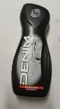
29-Aug-2023 | Italy | Shower Foam | Bodycare / Cosmetics | Chemical Hazard | 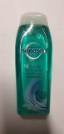
29-Aug-2023 | Italy | Face Tonic | Bodycare / Cosmetics | Chemical Hazard | 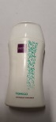
29-Aug-2023 | Italy | Hair Mousse | Bodycare / Cosmetics | Chemical Hazard | 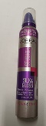
29-Aug-2023 | Italy | Bath and Shower Cream | Bodycare / Cosmetics | Chemical Hazard | 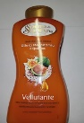  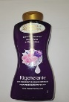
29-Aug-2023 | Italy | Shampoo | Bodycare / Cosmetics | Chemical Hazard | 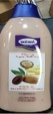
29-Aug-2023 | Italy | Deodorant | Bodycare / Cosmetics | Chemical Hazard | 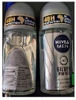
29-Aug-2023 | Italy | Eau De Toilette | Bodycare / Cosmetics | Chemical Hazard | 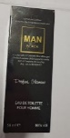
29-Aug-2023 | Italy | Eau De Toilette | Bodycare / Cosmetics | Chemical Hazard | 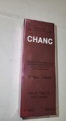
29-Aug-2023 | Italy | Eau De Toilette | Bodycare / Cosmetics | Chemical Hazard | 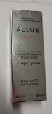
29-Aug-2023 | Italy | Eau De Toilette | Bodycare / Cosmetics | Chemical Hazard | 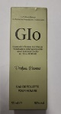
29-Aug-2023 | Italy | Eau De Toilette | Bodycare / Cosmetics | Chemical Hazard
29-Aug-2023 | Italy | Eau De Toilette | Bodycare / Cosmetics | Chemical Hazard | 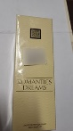
29-Aug-2023 | Italy | Varnish | Chemicals | Chemical Hazard | 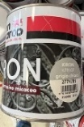  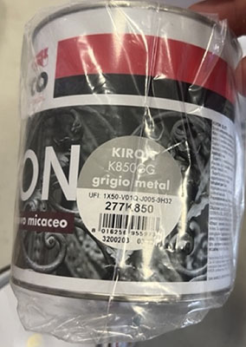
29-Aug-2023 | Italy | Deodorant | Bodycare / Cosmetics | Chemical Hazard | 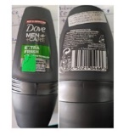
29-Aug-2023 | Italy | Deodorant | Bodycare / Cosmetics | Chemical Hazard | 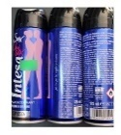
29-Aug-2023 | Italy | Aftershave | Bodycare / Cosmetics | Chemical Hazard | 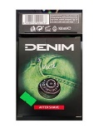
29-Aug-2023 | Italy | Varnish | Chemicals | Chemical Hazard | 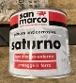
29-Aug-2023 | Italy | Varnish | Chemicals | Chemical Hazard | 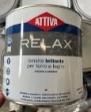  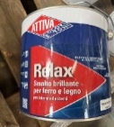
29-Aug-2023 | Italy | Varnish | Chemicals | Chemical Hazard | 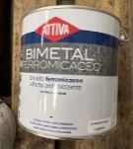
29-Aug-2023 | Italy | Eau De Toilette | Bodycare / Cosmetics | Chemical Hazard
29-Aug-2023 | Italy | Eau De Toilette | Bodycare / Cosmetics | Chemical Hazard | 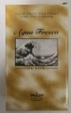
29-Aug-2023 | Italy | Eau De Toilette | Bodycare / Cosmetics | Chemical Hazard | 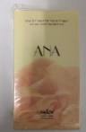
29-Aug-2023 | Italy | Perfume | Bodycare / Cosmetics | Chemical Hazard | 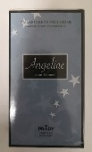
29-Aug-2023 | Italy | Varnish | Chemicals | Chemical Hazard | 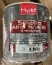  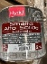  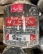  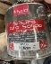  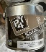  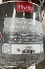
29-Aug-2023 | Italy | Varnish | Chemicals | Chemical Hazard | 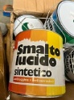  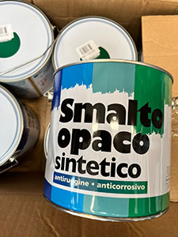  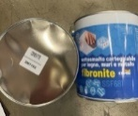
29-Aug-2023 | Italy | Varnish | Chemicals | Chemical Hazard | 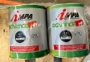  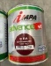  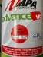  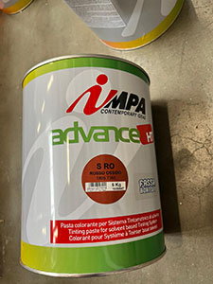  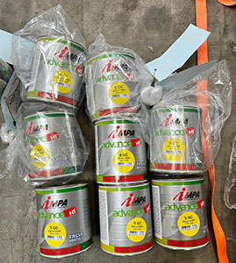
29-Aug-2023 | Italy | Eau De Toilette | Bodycare / Cosmetics | Chemical Hazard | 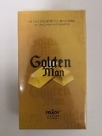
29-Aug-2023 | Italy | Eau De Toilette | Bodycare / Cosmetics | Chemical Hazard
29-Aug-2023 | Italy | Eau De Toilette | Bodycare / Cosmetics | Chemical Hazard | 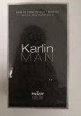
29-Aug-2023 | Italy | Eau De Toilette | Bodycare / Cosmetics | Chemical Hazard | 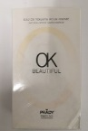
29-Aug-2023 | Italy | Eau De Toilette | Bodycare / Cosmetics | Chemical Hazard
29-Aug-2023 | Germany | Fall Arrester | Protective Equipment | Injury Hazard | 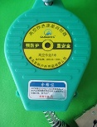
29-Aug-2023 | Italy | Eau De Toilette | Bodycare / Cosmetics | Chemical Hazard | 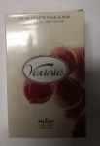
29-Aug-2023 | Cyprus | Shoes | Footwear | Chemical Hazard | 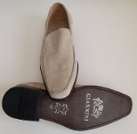
29-Aug-2023 | France | Folding Electric Bicycle | Sporting Goods / Equipment | Injury Hazard | 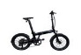  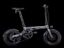  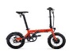  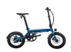  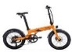
29-Aug-2023 | Czechia | Shower Gel | Bodycare / Cosmetics | Chemical Hazard | 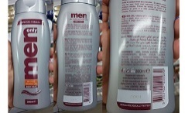
29-Aug-2023 | Germany | Bracelet | Jewelry | Chemical Hazard | 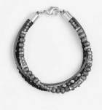
29-Aug-2023 | Hungary | Perfume | Bodycare / Cosmetics | Chemical Hazard | 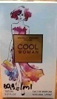
29-Aug-2023 | Germany | Shampoo | Bodycare / Cosmetics | Chemical Hazard | 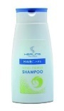
29-Aug-2023 | Hungary | Hair Dryer | Home Electrical Appliances | Electric Shock Hazard | 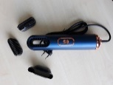
29-Aug-2023 | Czechia | Disposable Electronic Cigarette | Chemicals | Chemical Hazard | 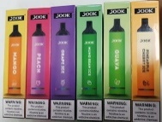
29-Aug-2023 | Czechia | Plastic Doll | Toys and Childcare Products | Chemical Hazard | 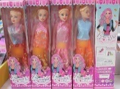
29-Aug-2023 | Hungary | Perfume | Bodycare / Cosmetics | Chemical Hazard | 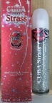
29-Aug-2023 | Hungary | Eau De Toilette | Bodycare / Cosmetics | Chemical Hazard | 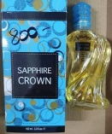
29-Aug-2023 | Hungary | Eau De Toilette | Bodycare / Cosmetics | Chemical Hazard | 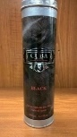
29-Aug-2023 | Hungary | Perfume | Bodycare / Cosmetics | Chemical Hazard | 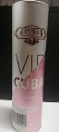
29-Aug-2023 | Hungary | Eau De Toilette | Bodycare / Cosmetics | Chemical Hazard | 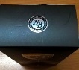  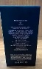
29-Aug-2023 | Poland | Earrings | Jewelry | Chemical Hazard | 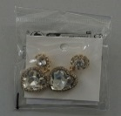
29-Aug-2023 | Poland | Jewelry | Jewelry | Chemical Hazard | 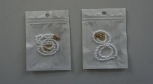
29-Aug-2023 | Poland | Earrings | Jewelry | Chemical Hazard | 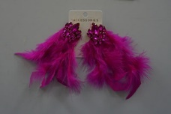
29-Aug-2023 | Poland | Necklace | Jewelry | Chemical Hazard | 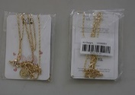
29-Aug-2023 | Poland | Brooch | Jewelry | Chemical Hazard
29-Aug-2023 | Poland | Brooch | Jewelry | Chemical Hazard | 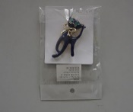
29-Aug-2023 | Poland | Earrings | Jewelry | Chemical Hazard | 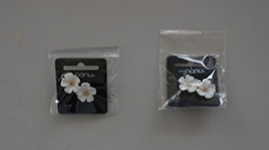
30-Aug-2023 | Italy | Bath and Shower Gel | Bodycare / Cosmetics | Chemical Hazard | 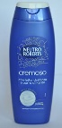
30-Aug-2023 | Italy | Perfume | Bodycare / Cosmetics | Chemical Hazard | 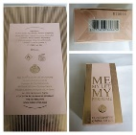
30-Aug-2023 | Italy | Hair Conditioner | Bodycare / Cosmetics | Chemical Hazard | 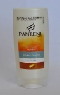  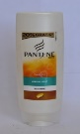
30-Aug-2023 | France | Latex Gloves | Protective Equipment | Chemical Hazard | 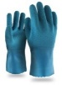  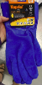
30-Aug-2023 | Italy | Eau De Toilette | Bodycare / Cosmetics | Chemical Hazard | 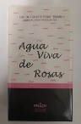
30-Aug-2023 | Italy | Eau De Toilette | Bodycare / Cosmetics | Chemical Hazard
30-Aug-2023 | Ireland | Baby Self-feeding Pillow | Toys and Childcare Products | Choking Hazard | 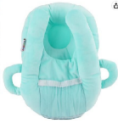
30-Aug-2023 | Hungary | Perfume | Bodycare / Cosmetics | Chemical Hazard | 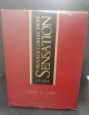
30-Aug-2023 | Hungary | Eau De Toilette | Bodycare / Cosmetics | Chemical Hazard | 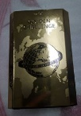
30-Aug-2023 | Hungary | Perfume | Bodycare / Cosmetics | Chemical Hazard | 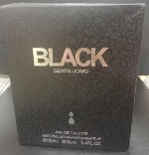
30-Aug-2023 | Hungary | Perfume | Bodycare / Cosmetics | Chemical Hazard | 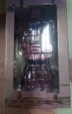
30-Aug-2023 | Hungary | Perfume | Bodycare / Cosmetics | Chemical Hazard | 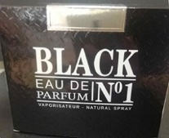
30-Aug-2023 | Hungary | Perfume | Bodycare / Cosmetics | Chemical Hazard | 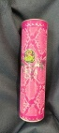
30-Aug-2023 | Hungary | Eau De Toilette | Bodycare / Cosmetics | Chemical Hazard | 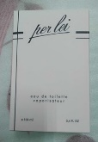
30-Aug-2023 | Hungary | Eau De Toilette | Bodycare / Cosmetics | Chemical Hazard | 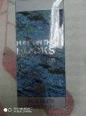
30-Aug-2023 | Finland | LED Lamp | Electrical Appliances | Electric Shock Hazard | 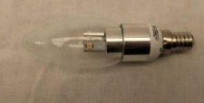
30-Aug-2023 | Hungary | Perfume | Bodycare / Cosmetics | Chemical Hazard | 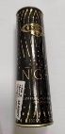
30-Aug-2023 | Hungary | Perfume | Bodycare / Cosmetics | Chemical Hazard | 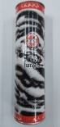
30-Aug-2023 | Hungary | Toy Scooter | Toys and Childcare Products | Injury Hazard | 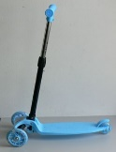
30-Aug-2023 | Hungary | Toy Scooter | Toys and Childcare Products | Injury Hazard | 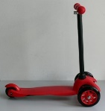
30-Aug-2023 | Hungary | Dart Set | Toys and Childcare Products | Choking Hazard, Injury Hazard | 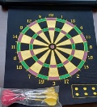
30-Aug-2023 | Italy | Liquid Hand Soap | Bodycare / Cosmetics | Chemical Hazard | 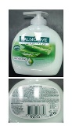
30-Aug-2023 | Italy | Shower Foam | Bodycare / Cosmetics | Chemical Hazard | 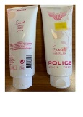
30-Aug-2023 | Italy | Eau De Toilette | Bodycare / Cosmetics | Chemical Hazard | 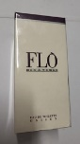
30-Aug-2023 | Lithuania | Rodenticide | Chemicals | Chemical Hazard | 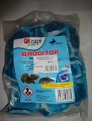
31-Aug-2023 | Sweden | Skin Lightening Cream | Bodycare / Cosmetics | Chemical Hazard | 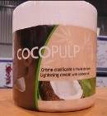
31-Aug-2023 | Slovakia | Flail-type Cutting Attachment for Brush Cutters | Machinery | Injury Hazard | 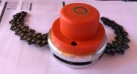
31-Aug-2023 | Italy | Varnish | Chemicals | Chemical Hazard | 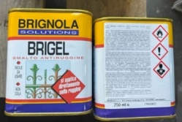
31-Aug-2023 | Latvia | Toy Gun with Projectiles | Toys and Childcare Products | Injury Hazard
31-Aug-2023 | Ireland | Baby Self-feeding Pillow | Toys and Childcare Products | Choking Hazard | 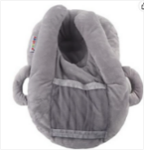
31-Aug-2023 | Ireland | Baby Self-feeding Pillow | Toys and Childcare Products | Choking Hazard | 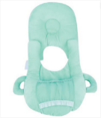
31-Aug-2023 | Ireland | Baby Self-feeding Pillow | Toys and Childcare Products | Choking Hazard | 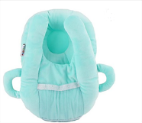
31-Aug-2023 | France | Paint Stripper | Chemicals | Chemical Hazard | 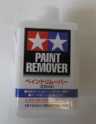
31-Aug-2023 | Hungary | Rotary Cutting Head with Two Chains - Brushcutters | Machinery | Injury Hazard | 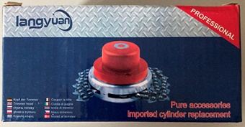
31-Aug-2023 | Sweden | Exercise Ball | Sporting Goods / Equipment | Chemical Hazard | 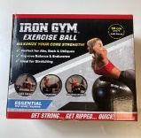
31-Aug-2023 | Hungary | Rotary Cutting Head with Two Chains - Brushcutters | Machinery | Injury Hazard | 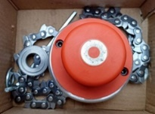
31-Aug-2023 | Hungary | Rotary Cutting Head with Six Knifes - Brushcutters | Machinery | Injury Hazard | 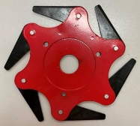
31-Aug-2023 | Hungary | Hair Dryer | Home Electrical Appliances | Electric Shock Hazard | 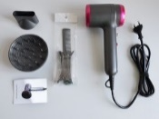  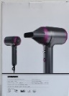
31-Aug-2023 | Italy | Shower Oil | Bodycare / Cosmetics | Chemical Hazard | 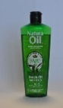  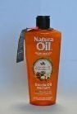
31-Aug-2023 | Italy | Perfume | Bodycare / Cosmetics | Chemical Hazard | 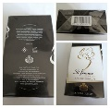
31-Aug-2023 | Italy | Perfume | Bodycare / Cosmetics | Chemical Hazard | 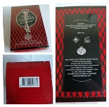
31-Aug-2023 | Italy | Perfume | Bodycare / Cosmetics | Chemical Hazard | 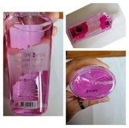
31-Aug-2023 | Italy | Body Care Set | Bodycare / Cosmetics | Chemical Hazard | 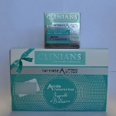
31-Aug-2023 | Italy | Liquid Soap | Bodycare / Cosmetics | Chemical Hazard | 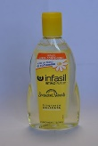
31-Aug-2023 | Italy | Deodorant Spray | Bodycare / Cosmetics | Chemical Hazard | 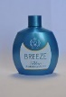  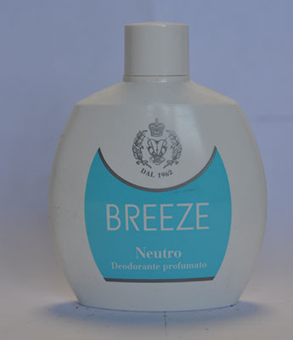  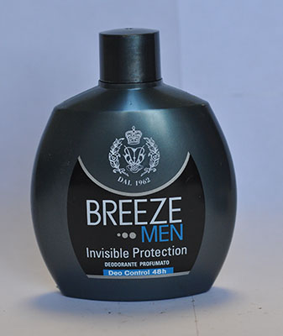
31-Aug-2023 | Italy | Shampoo | Bodycare / Cosmetics | Chemical Hazard | 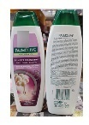
31-Aug-2023 | Italy | Shampoo | Bodycare / Cosmetics | Chemical Hazard | 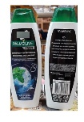
31-Aug-2023 | Italy | Deodorant Spray | Bodycare / Cosmetics | Chemical Hazard | 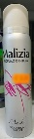
31-Aug-2023 | France | Lip Balm | Bodycare / Cosmetics | Chemical Hazard, Choking Hazard | 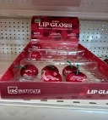  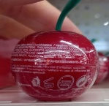
31-Aug-2023 | Italy | Hair Mousse | Bodycare / Cosmetics | Chemical Hazard | 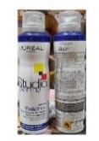
31-Aug-2023 | Italy | Shaving Foam | Bodycare / Cosmetics | Chemical Hazard | 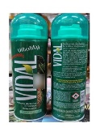
31-Aug-2023 | Italy | Shaving Foam | Bodycare / Cosmetics | Chemical Hazard | 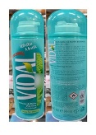
31-Aug-2023 | Italy | Deodorant | Bodycare / Cosmetics | Chemical Hazard | 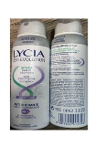
31-Aug-2023 | Italy | Shower Foam | Bodycare / Cosmetics | Chemical Hazard | 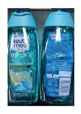
31-Aug-2023 | Italy | Liquid Soap | Bodycare / Cosmetics | Chemical Hazard | 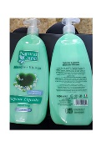
31-Aug-2023 | Italy | Liquid Soap | Bodycare / Cosmetics | Chemical Hazard | 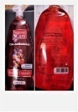
31-Aug-2023 | Italy | Hair Styling Gel | Bodycare / Cosmetics | Chemical Hazard | 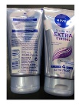
31-Aug-2023 | Italy | Perfume | Bodycare / Cosmetics | Chemical Hazard | 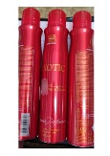
31-Aug-2023 | Italy | Deodorant Spray | Bodycare / Cosmetics | Chemical Hazard | 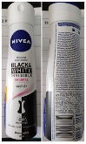
31-Aug-2023 | Italy | Facial Toner | Bodycare / Cosmetics | Chemical Hazard | 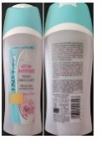
31-Aug-2023 | Italy | Deodorant | Bodycare / Cosmetics | Chemical Hazard | 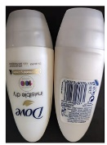
31-Aug-2023 | Italy | Varnish | Chemicals | Chemical Hazard | 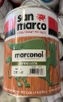  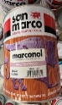  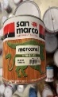  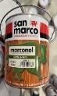  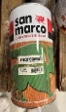
31-Aug-2023 | Italy | Varnish | Chemicals | Chemical Hazard | 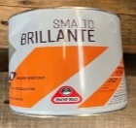  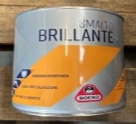
31-Aug-2023 | Italy | Varnish | Chemicals | Chemical Hazard | 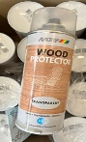  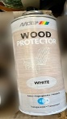  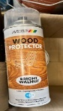
31-Aug-2023 | Hungary | Baby Walker | Toys and Childcare Products | Injury Hazard | 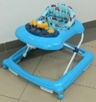
31-Aug-2023 | Poland | Earrings | Jewelry | Chemical Hazard | 