Recall Cases Summary – US (Last Update Date: 31 August 2023)

Date | Product | Categories | Hazard | Image
3-Aug-2023 | Digital Video Baby Monitors | Computer / Audio / Video / Other Electronics & Accessories | Burn Hazard | 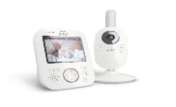
3-Aug-2023 | Portable Generators | Electrical Appliances | Fire Hazard | 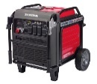
3-Aug-2023 | Air Conditioners and Heat Pumps | Home Electrical Appliances | Burn Hazard, Fire Hazard | 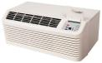
3-Aug-2023 | Table Lamps | Home Electrical Appliances | Fire Hazard
3-Aug-2023 | Aerosol Bed Bug & Flea Killer Cans | Chemicals | Injury Hazard, Laceration Hazard, Eye Irritation Risk | 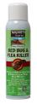
10-Aug-2023 | 2.2 Million Threshold Candles | Household Items | Laceration Hazard, Burn Hazard | 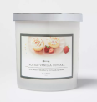
10-Aug-2023 | Bella, Bella Pro Series, Cooks and Crux Electric and Stovetop Pressure Cookers | Home Electrical Appliances | Burn Hazard | 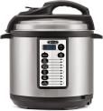  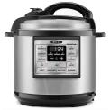  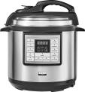  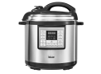  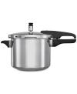
10-Aug-2023 | Two Styles of Baby and Toddler Boy Basic Stretch Straight Leg Jeans | Fabric / Textile / Garment / Home Textile | Choking Hazard | 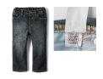  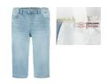
10-Aug-2023 | Room & Board Crib Mattresses | Furniture | Suffocation Hazard | 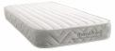  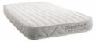
10-Aug-2023 | Carboys | Household Items | Laceration Hazard | 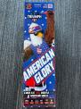  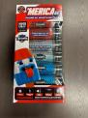  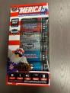  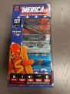  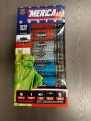  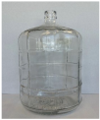
10-Aug-2023 | Red Apple Fireworks Brand “American Glory” and “Merica AF” Fireworks | Outdoor Living Items | Explosion Hazard, Burn Hazard
16-Aug-2023 | Dehumidifiers | Home Electrical Appliances | Fire Hazard, Burn Hazard | 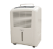  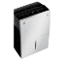  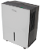  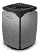  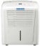  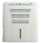  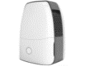  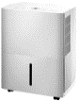
17-Aug-2023 | Convertible House Bed Frames and Montessori Floor Beds | Furniture | Entrapment Hazard, Strangulation Hazard | 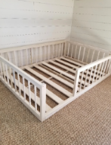
17-Aug-2023 | Toddler Towers | Furniture | Fall Hazard, Injury Hazard | 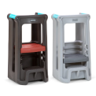
17-Aug-2023 | Sodium Hydroxide Products | Chemicals | Chemical Hazard, Skin Irritation Risk, Eye Irritation Risk | 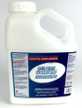
17-Aug-2023 | Ubio Labs Power Banks | Electrical Appliances | Fire Hazard | 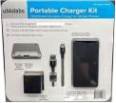
24-Aug-2023 | Aiper Elite Pro Cordless Robotic Pool Vacuum Cleaners | Home Electrical Appliances | Burn Hazard, Fire Hazard | 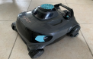
24-Aug-2023 | Multi-Purpose Kids Bike Helmets | Protective Equipment | Injury Hazard | 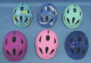
31-Aug-2023 | Frigidaire Gas Cooktops | Household Items | Risk of Exposure to Combustion Flue Gas, Fire Hazard | 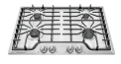
31-Aug-2023 | Electric Scooters | Sporting Goods / Equipment | Fall Hazard, Injury Hazard | 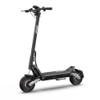
31-Aug-2023 | Glass Doorknobs | Tools and Hardware | Laceration Hazard | 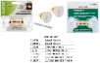
31-Aug-2023 | Boon Flair and Flair Elite Highchairs | Toys and Childcare Products | Fall Hazard | 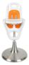  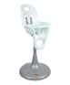  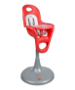  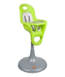  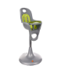
31-Aug-2023 | DIYChemicals Potassium and Sodium Hydroxide Products | Chemicals | Chemical Hazard, Skin Irritation Risk, Eye Irritation Risk | 