Title | Australia Recalls Summary (01 September 2023 to 30 September 2023)
Abstract | In Australia, when hazards are identified in consumer products, they will be recalled and published in the Recalls and Safety Alerts Database on the Australian Competition & Consumer Commission website, which is updated daily. The Australia recalls from 01 September 2023 to 30 September 2023 are summarized below:

Recall Cases Summary – Australia (Last Update Date: 30 September 2023)

Date | Product | Categories | Hazard | Image
1-Sept-2023 | AERE Square Toe Leather Ankle Boots in Brown, Black and Beige | Footwear | Fall Hazard, Injury Hazard | 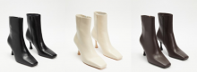
1-Sept-2023 | Adria Altea 402PH Heat Shield | Car Components | Fire Hazard, Explosion Hazard, Risk of Exposure to Combustion Flue Gas
6-Sept-2023 | Filter - Fuel Water Separating | Tools and Hardware | Burn Hazard, Fire Hazard | 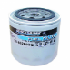  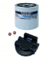  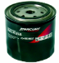
7-Sept-2023 | Australian Souvenir Clocks | Electrical Appliances | Choking Hazard, Swallowing Risk, Injury Hazard, Risk of Death, Burn Hazard | 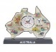  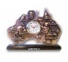  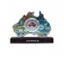  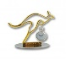
7-Sept-2023 | Narva Electronic Fuse Tester | Tools and Hardware | Choking Hazard, Swallowing Risk, Injury Hazard, Risk of Death, Burn Hazard | 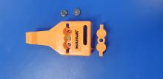
8-Sept-2023 | 18650 Battery Charger Supplied with Bigblue AL1300 Lumen Dive Torch | Electrical Appliances | Injury Hazard, Risk of Death , Electric Shock Hazard , Fire Hazard | 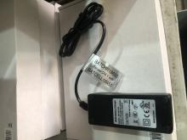  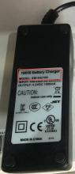
8-Sept-2023 | Various Novelty Items Containing Button Batteries | Household Items | Choking Hazard, Swallowing Risk, Injury Hazard, Risk of Death, Burn Hazard | 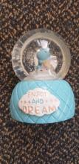  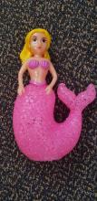  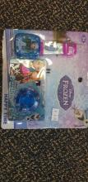  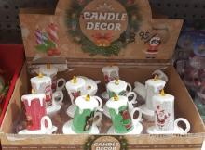
8-Sept-2023 | Boon Flair Highchair | Toys and Childcare Products | Injury Hazard, Fall Hazard | 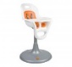  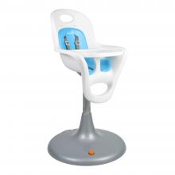  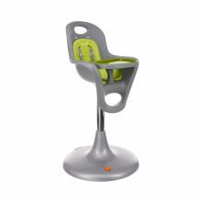  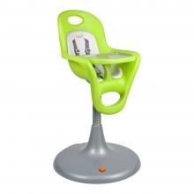  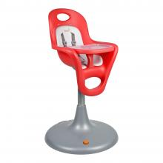
12-Sept-2023 | Hotflo Gas Storage Water Heater 135 Litre Capacity | Electrical Appliances | Burn Hazard, Injury Hazard | 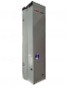
13-Sept-2023 | 28-622 P ZERO Race TLR and TLR Classic Bicycle Tyres | Sporting Goods / Equipment | Injury Hazard, Risk of Death | 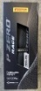  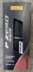  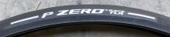  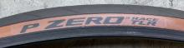
15-Sept-2023 | IGP Sports HR40 Heart Rate Monitor | Sporting Goods / Equipment | Choking Hazard, Swallowing Risk, Risk of Death, Burn Hazard | 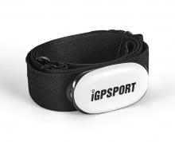
15-Sept-2023 | Fastener (Part Number 942) and Accessory Rear Suspension Kits for Certain Softail Motorcycles (Part Number 54000134 and 54000294) | Car Components | Injury Hazard | 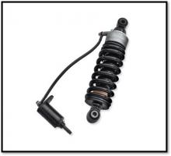
15-Sept-2023 | Double USB Powerpoint | Electrical Appliances | Injury Hazard, Fire Hazard, Electric Shock Hazard, Risk of Death | 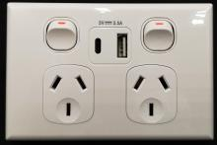  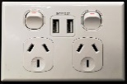
20-Sept-2023 | Kids & Toddler Custom Face Artwork Hoodie Blanket | Fabric / Textile / Garment / Home Textile | Burn Hazard | 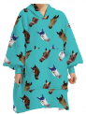
20-Sept-2023 | Risk Racing Lock-N-Load Pro Moto Transport System | Sporting Goods / Equipment | Injury Hazard | 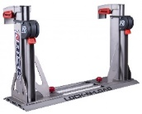
20-Sept-2023 | Satincrome 309Mo-17 Electrode Welding Rods | Tools and Hardware | Injury Hazard | 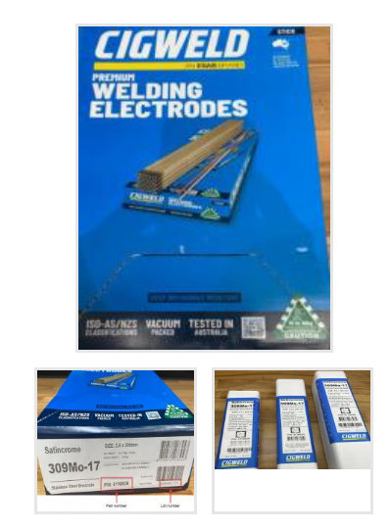
22-Sept-2023 | Helga Entertainment Unit and Helga Buffet Unit | Home Electrical Appliances | Risk of Death, Injury Hazard, Electric Shock Hazard | 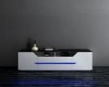  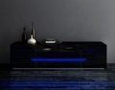
22-Sept-2023 | Father's Day Giant Mug | Food Contact Material | Injury Hazard, Burn Hazard, Laceration Hazard | 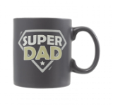  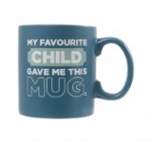
26-Sept-2023 | BF175D/BF200D/BF225D/BF250D Outboard Motors | Tools and Hardware | Injury Hazard, Risk of Death, Crash Hazard | 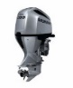  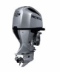  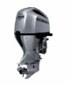
26-Sept-2023 | SIMU DMI6 Hz Motors Operating Roller Shutters, Blinds, and Awnings | Tools and Hardware | Injury Hazard, Risk of Death, Electric Shock Hazard | 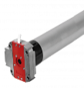  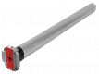
26-Sept-2023 | Alemlube Tyre Gauge Digital | Tools and Hardware | Choking Hazard, Swallowing Risk, Injury Hazard, Risk of Death | 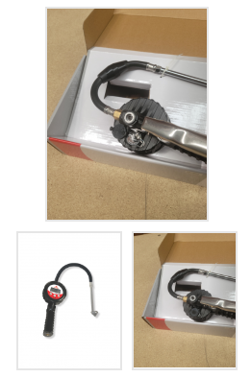
27-Sept-2023 | Brooklyn Rechargeable Mini Food Chopper BMC-300 | Home Electrical Appliances | Laceration Hazard, Injury Hazard | 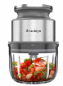
27-Sept-2023 | Hemmingway Leather Armchair | Furniture | Laceration Hazard, Injury Hazard | 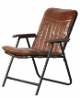
29-Sept-2023 | LG ESS Home Energy Storage System Batteries | Electrical Appliances | Fire Hazard, Injury Hazard, Risk of Death | 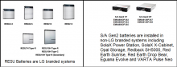
29-Sept-2023 | Novelty Products | Toys and Childcare Products | Choking Hazard, Burn Hazard, Risk of Death, Swallowing Risk | 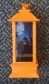  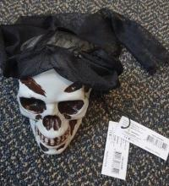  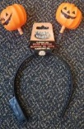
29-Sept-2023 | Hollowtech Cranksets for Certain Shimano Ultegra and Dura-Ace Models | Sporting Goods / Equipment | Fall Hazard, Crash Hazard, Injury Hazard, Laceration Hazard | 