Title | Canada Recalls Summary (01 September 2023 to 30 September 2023)
Abstract | In Canada, when hazards are identified in consumer products, they will be recalled and published in the Recalls and Safety Alerts Database on the Health Canada website, which is updated daily. The Canada recalls from 01 September 2023 to 30 September 2023 are summarized below:

Recall Cases Summary – Canada (Last Update Date: 30 September 2023)

Date | Product | Categories | Hazard | Image
01-Sept-2023 | Big Game Hunters and Garden Games Sanford Croquet Set | Sporting Goods / Equipment | Lead Poisoning Hazard, Chemical Hazard | 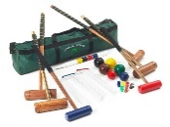
07-Sept-2023 | Certain Pirelli 28-622 P ZERO TM Race TLR Bicycle Tires | Sporting Goods / Equipment | Fall Hazard, Injury Hazard | 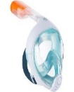  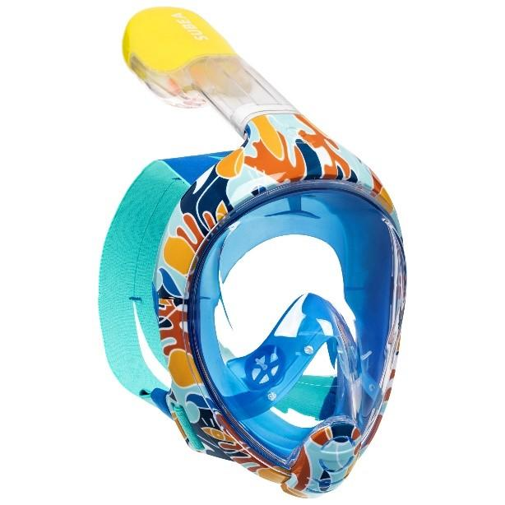  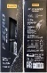  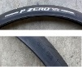  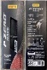  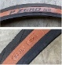
08-Sept-2023 | SUBEA Easybreath Children's Snorkel | Sporting Goods / Equipment | Suffocation Hazard, Injury Hazard, Drowning Hazard, Risk of Death
08-Sept-2023 | Sovereign Opal 2022 | Food | Microbiological Hazard | /
09-Sept-2023 | Paqui Brand 2023 One Chip Challenge | Food | Health Risk Hazard | 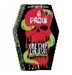  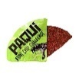  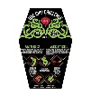
11-Sept-2023 | Assorted Joe Fresh Hair Elastic and Jewelry Products | Jewelry | Laceration Hazard | 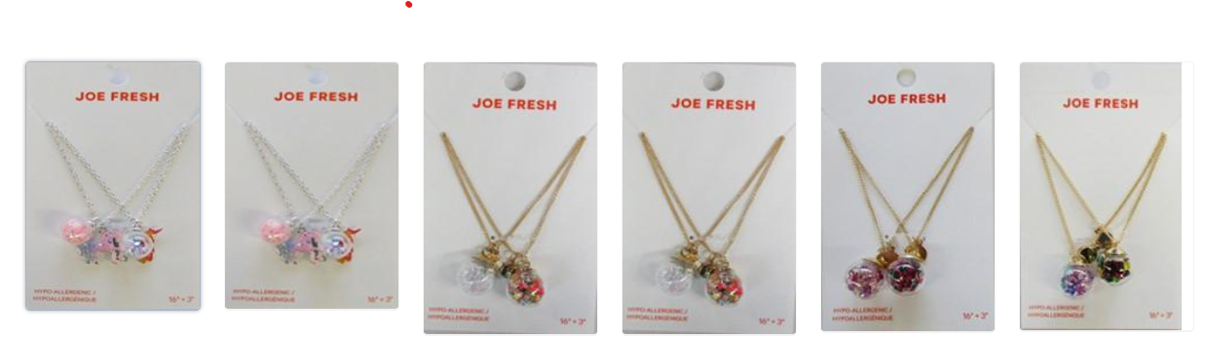  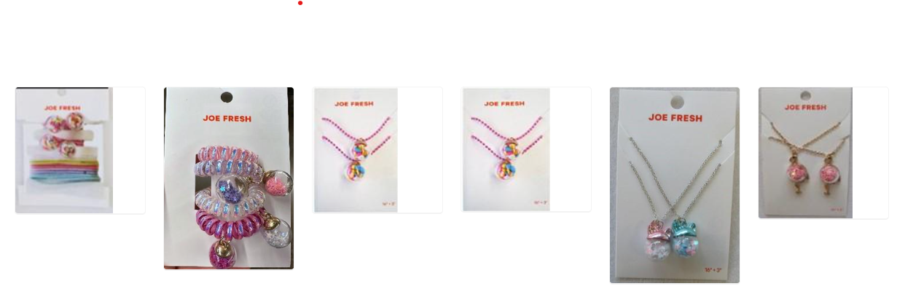  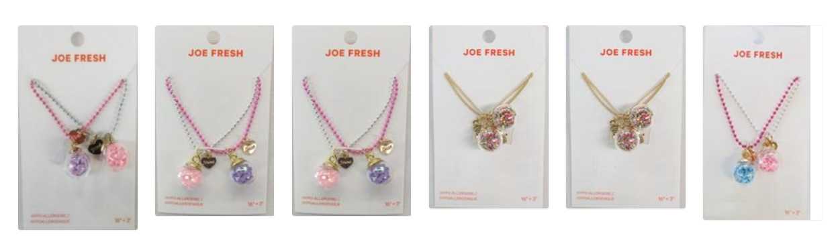  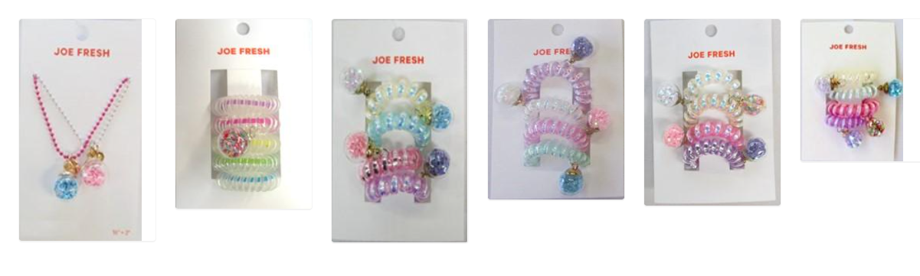  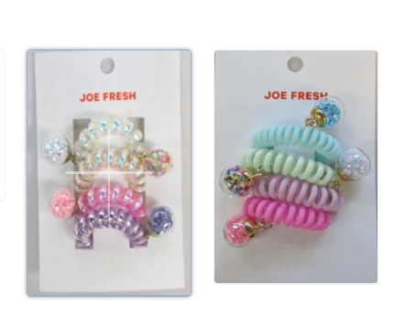
13-Sept-2023 | IKEA LETTAN Mirror | Household Items | Injury Hazard
13-Sept-2023 | Fatima Dry Stout (Beer) | Food | Safety Risk Hazard | /
14-Sept-2023 | Magnetic Dart Board | Toys and Childcare Products | Ingestion Hazard, Swallowing Risk | 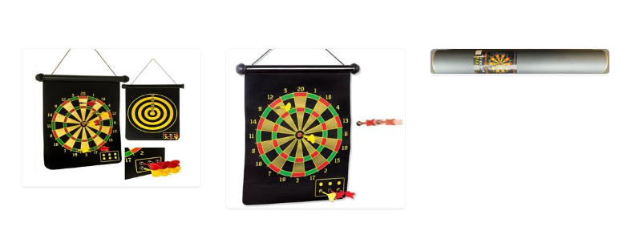
14-Sept-2023 | Generac Portable Generators | Machinery | Fire Hazard, Burn Hazard | 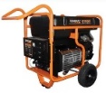  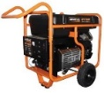
15-Sept-2023 | 3-in-1 LEA Baby Luna – White and Natural Cribs | Furniture | Entrapment Hazard, Injury Hazard | 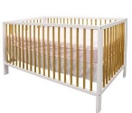
15-Sept-2023 | 3-Piece and 5-Piece Tan Bistro Sets | Outdoor Living Items | Fall Hazard | 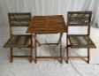
15-Sept-2023 | Netic Pen - The Transformable Magnetic Pen | Stationery | Ingestion Hazard, Swallowing Risk | 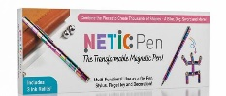
15-Sept-2023 | Mild Pepperonistix | Food | Microbiological Hazard | 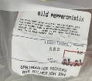
16-Sept-2023 | Enoki Mushroom | Food | Microbiological Hazard | 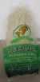
18-Sept-2023 | Double-Walled Stainless Steel Children's Cups | Food Contact Material | Lead Poisoning Hazard, Risk of Death, Health Risk Hazard | 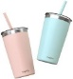  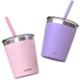  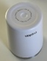
19-Sept-2023 | ZDZBLX Magnets | Toys and Childcare Products | Ingestion Hazard, Swallowing Risk | 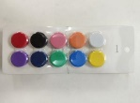
19-Sept-2023 | Enoki Mushroom | Food | Microbiological Hazard | 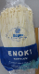
19-Sept-2023 | Caffeinated Energy Drinks and Mixes | Food | Chemical Hazard | 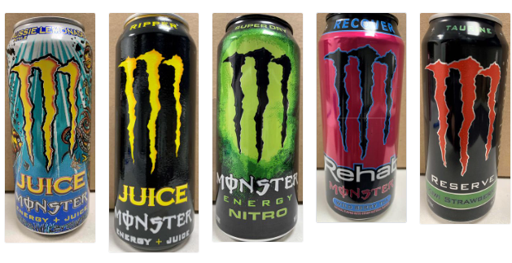
20-Sept-2023 | Infant Formula Products Made with Natural Goat Milk | Food | Chemical Hazard | 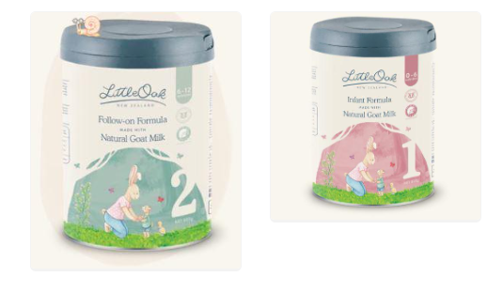
20-Sept-2023 | Rojada Child Safety Seats | Toys and Childcare Products | Injury Hazard | 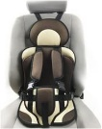
21-Sept-2023 | Various Rainbow Road Board Books | Toys and Childcare Products | Choking Hazard | 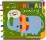  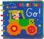  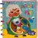  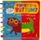  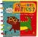  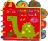  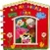  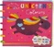  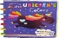  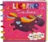
21-Sept-2023 | DR Power Equipment Chipper Shredders | Machinery | Laceration Hazard | 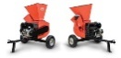  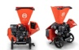  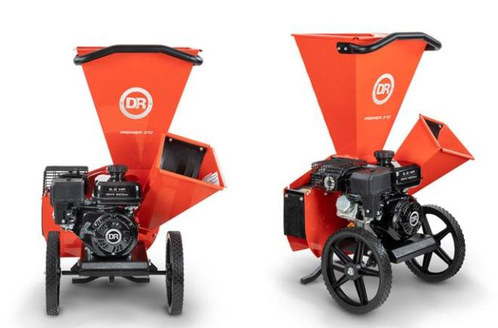
21-Sept-2023 | Shimano 11-Speed Bonded Hollowtech II Road Cranksets | Sporting Goods / Equipment | Crash Hazard | 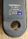  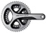
21-Sept-2023 | Metaflux 70-81 Titanium Spray in Aerosol | Chemicals | Injury Hazard, Risk of Death | 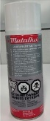
22-Sept-2023 | X-Lite Multi-Purpose Lighter | Tools and Hardware | Fire Hazard, Burn Hazard | 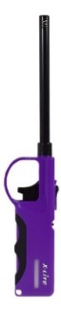
22-Sept-2023 | Mountain Equipment Company (MEC) Tremblant Youth Jacket | Fabric / Textile / Garment / Home Textile | Strangulation Hazard, Entanglement Hazard | 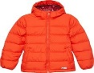  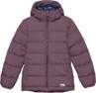  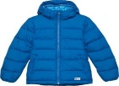
22-Sept-2023 | Ultra High Strength Magnets | Toys and Childcare Products | Ingestion Hazard, Swallowing Risk | 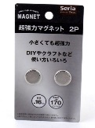
24-Sept-2023 | Tahina | Food | Microbiological Hazard | 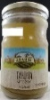
25-Sept-2023 | Honda EU7000is Portable Generators | Machinery | Fire Hazard | 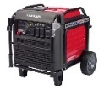
25-Sept-2023 | Latex-Free Magnetic Re-Usable Water Balloons | Toys and Childcare Products | Ingestion Hazard, Swallowing Risk | 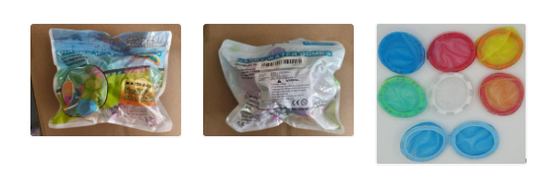
26-Sept-2023 | Emporia’s North America Smart Plugs | Electrical Appliances | Electric Shock Hazard | 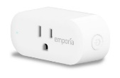
26-Sept-2023 | Ascorbic Acid | Chemicals | Chemical Hazard | /
27-Sept-2023 | STAX Insane Magnetic Building Blocks | Toys and Childcare Products | Ingestion Hazard, Swallowing Risk | 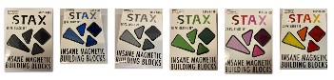
29-Sept-2023 | Cantaloupe | Food | Microbiological Hazard | /

