Title | Europe Recalls Summary (01 September 2023 to 30 September 2023)
Abstract | In Europe, when hazards are identified in non-food consumer products, the products will be recalled and published in the Safety Gate system, which is updated weekly. The European recalls from 01 September 2023 to 30 September 2023 are summarized below:

Recall Cases Summary – Europe (Last Update Date: 30 September 2023)

Date | Notifying Country | Product | Categories | Hazard | Image
1-Sep-2023 | Sweden | Skin Lightening Cream | Bodycare / Cosmetics | Chemical Hazard | 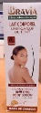
1-Sep-2023 | Sweden | Skin Lightening Body Oil | Bodycare / Cosmetics | Chemical Hazard | 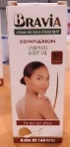
1-Sep-2023 | Ireland | Travel Adaptor | Electrical Appliances | Electric Shock Hazard | 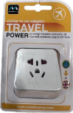
5-Sep-2023 | Italy | Perfume | Bodycare / Cosmetics | Chemical Hazard | 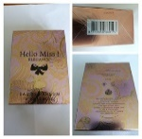
5-Sep-2023 | Italy | Shower Cream | Bodycare / Cosmetics | Chemical Hazard | 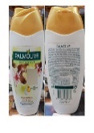
5-Sep-2023 | Italy | Shampoo | Bodycare / Cosmetics | Chemical Hazard | 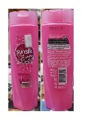
5-Sep-2023 | Italy | Hair Conditioner | Bodycare / Cosmetics | Chemical Hazard | 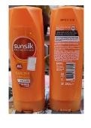
5-Sep-2023 | Italy | Body Oil | Bodycare / Cosmetics | Chemical Hazard | 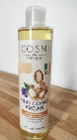
5-Sep-2023 | Italy | Hairspray | Bodycare / Cosmetics | Chemical Hazard | 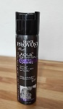
5-Sep-2023 | Italy | Shampoo | Bodycare / Cosmetics | Chemical Hazard | 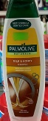
5-Sep-2023 | Italy | Shampoo | Bodycare / Cosmetics | Chemical Hazard | 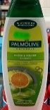
5-Sep-2023 | Italy | Body Cream | Bodycare / Cosmetics | Chemical Hazard | 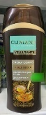
5-Sep-2023 | Italy | Perfume | Bodycare / Cosmetics | Chemical Hazard | 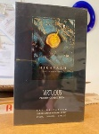
5-Sep-2023 | Sweden | Earrings | Jewelry | Chemical Hazard | 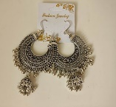
5-Sep-2023 | Italy | Soap | Bodycare / Cosmetics | Chemical Hazard | 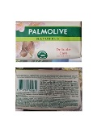
5-Sep-2023 | Italy | Deodorant Spray | Bodycare / Cosmetics | Chemical Hazard | 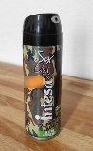
5-Sep-2023 | Italy | Liquid Soap | Bodycare / Cosmetics | Chemical Hazard | 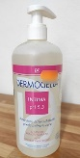
5-Sep-2023 | Italy | Perfume | Bodycare / Cosmetics | Chemical Hazard | 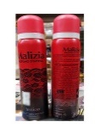
5-Sep-2023 | Italy | Shampoo | Bodycare / Cosmetics | Chemical Hazard | 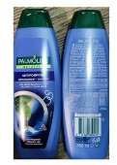
5-Sep-2023 | Italy | Hair Mousse | Bodycare / Cosmetics | Chemical Hazard | 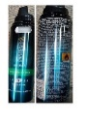
5-Sep-2023 | Italy | Shower Oil Foam | Bodycare / Cosmetics | Chemical Hazard | 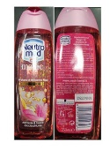
5-Sep-2023 | Italy | Bath Foam | Bodycare / Cosmetics | Chemical Hazard | 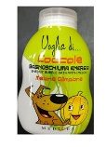
5-Sep-2023 | France | Fancy-dress Costume | Toys and Childcare Products | Burn Hazard | 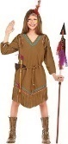
5-Sep-2023 | Germany | Set of Bracelets | Jewelry | Chemical Hazard | 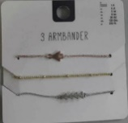
5-Sep-2023 | Hungary | Eau De Toilette | Bodycare / Cosmetics | Chemical Hazard | 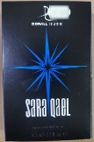
5-Sep-2023 | Hungary | Eau De Toilette | Bodycare / Cosmetics | Chemical Hazard | 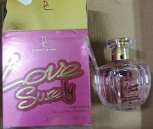
5-Sep-2023 | Hungary | Perfume | Bodycare / Cosmetics | Chemical Hazard | 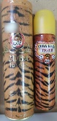
5-Sep-2023 | Hungary | Perfume | Bodycare / Cosmetics | Chemical Hazard | 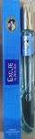
5-Sep-2023 | Hungary | Eau De Toilette | Bodycare / Cosmetics | Chemical Hazard | 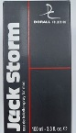
5-Sep-2023 | Hungary | Eau De Toilette | Bodycare / Cosmetics | Chemical Hazard | 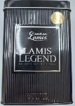
5-Sep-2023 | Poland | Jewelry | Jewelry | Chemical Hazard | 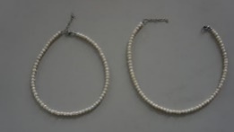
5-Sep-2023 | Poland | Bracelet | Jewelry | Chemical Hazard | 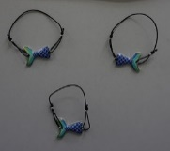
5-Sep-2023 | Poland | Necklace | Jewelry | Chemical Hazard | 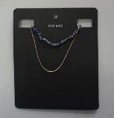
5-Sep-2023 | Hungary | Eau De Toilette | Bodycare / Cosmetics | Chemical Hazard | 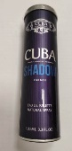
5-Sep-2023 | Hungary | Perfume | Bodycare / Cosmetics | Chemical Hazard | 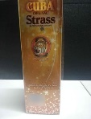
5-Sep-2023 | Hungary | Perfume | Bodycare / Cosmetics | Chemical Hazard
5-Sep-2023 | Hungary | Perfume | Bodycare / Cosmetics | Chemical Hazard | 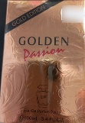
5-Sep-2023 | Hungary | Perfume | Bodycare / Cosmetics | Chemical Hazard | 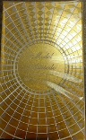
5-Sep-2023 | Hungary | Eau De Toilette | Bodycare / Cosmetics | Chemical Hazard | 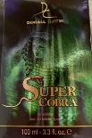
5-Sep-2023 | Hungary | Eau De Toilette | Bodycare / Cosmetics | Chemical Hazard | 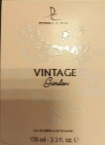
5-Sep-2023 | Finland | Inverter Generator | Machinery | Electric Shock Hazard | 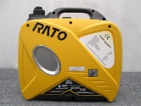
5-Sep-2023 | Hungary | Eau De Toilette | Bodycare / Cosmetics | Chemical Hazard | 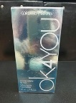
5-Sep-2023 | Hungary | Eau De Toilette | Bodycare / Cosmetics | Chemical Hazard | 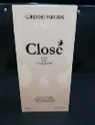
5-Sep-2023 | Hungary | Body Fragrance | Bodycare / Cosmetics | Chemical Hazard | 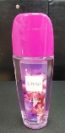
5-Sep-2023 | Germany | Cleansing Balm | Bodycare / Cosmetics | Microbiological Hazard | 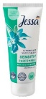
5-Sep-2023 | Germany | Skin Lightening Lotion | Bodycare / Cosmetics | Chemical Hazard | 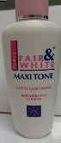
6-Sep-2023 | Italy | Aftershave | Bodycare / Cosmetics | Chemical Hazard | 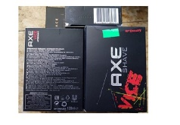
6-Sep-2023 | Italy | Aftershave | Bodycare / Cosmetics | Chemical Hazard | 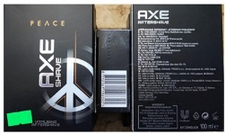
6-Sep-2023 | Italy | Aftershave | Bodycare / Cosmetics | Chemical Hazard | 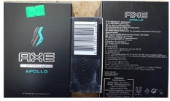
7-Sep-2023 | Italy | Body Milk | Bodycare / Cosmetics | Chemical Hazard | 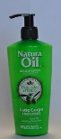
7-Sep-2023 | Sweden | Yoga Mat | Sporting Goods / Equipment | Environmental Hazard | 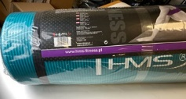
7-Sep-2023 | Italy | Perfume | Bodycare / Cosmetics | Chemical Hazard | 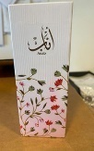
7-Sep-2023 | Sweden | Skin Lightening Cream | Bodycare / Cosmetics | Chemical Hazard | 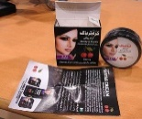
7-Sep-2023 | Italy | Hair Conditioner | Bodycare / Cosmetics | Chemical Hazard | 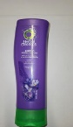
7-Sep-2023 | Italy | Perfume | Bodycare / Cosmetics | Chemical Hazard | 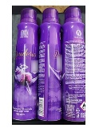
7-Sep-2023 | Italy | Varnish | Chemicals | Chemical Hazard | 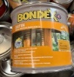  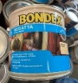  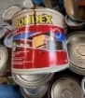  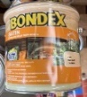
7-Sep-2023 | France | Fancy-dress Costume | Toys and Childcare Products | Chemical Hazard, Entrapment Hazard, Injury Hazard | 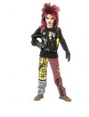
7-Sep-2023 | France | Fancy-dress Costume | Toys and Childcare Products | Chemical Hazard | 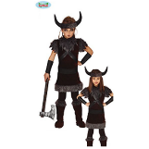
7-Sep-2023 | France | Air Conditioner | Home Electrical Appliances | Fire Hazard | 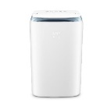
7-Sep-2023 | Finland | Lifejacket | Protective Equipment | Drowning Hazard | 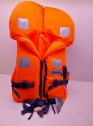
7-Sep-2023 | France | Toy Backpack | Toys and Childcare Products | Choking Hazard | 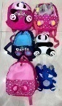
7-Sep-2023 | Germany | Single-use Electronic Cigarette | Chemicals | Chemical Hazard | 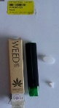
7-Sep-2023 | Hungary | Eau De Toilette | Bodycare / Cosmetics | Chemical Hazard | 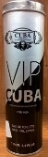
7-Sep-2023 | Hungary | Perfume | Bodycare / Cosmetics | Chemical Hazard | 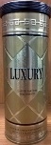
7-Sep-2023 | France | Riding Helmet | Protective Equipment | Cut Hazard | 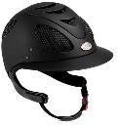  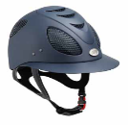  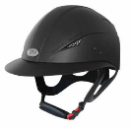
7-Sep-2023 | Hungary | Perfume | Bodycare / Cosmetics | Chemical Hazard | 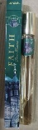
7-Sep-2023 | Poland | Jewelry Set | Jewelry | Chemical Hazard | 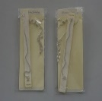  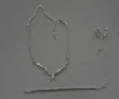
7-Sep-2023 | Poland | Jewelry Set | Jewelry | Chemical Hazard | 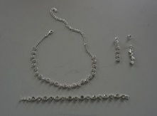
7-Sep-2023 | Hungary | Eau De Toilette | Bodycare / Cosmetics | Chemical Hazard | 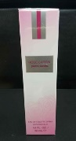
7-Sep-2023 | Lithuania | Toy Slime | Toys and Childcare Products | Chemical Hazard | 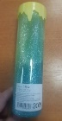
7-Sep-2023 | Lithuania | Toy Slime | Toys and Childcare Products | Chemical Hazard | 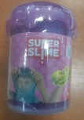
7-Sep-2023 | Lithuania | Toy Slime | Toys and Childcare Products | Chemical Hazard | 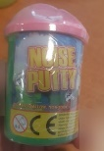
7-Sep-2023 | The Netherlands | Toy Truck | Toys and Childcare Products | Choking Hazard | 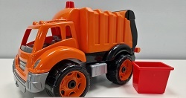
7-Sep-2023 | Italy | Shampoo | Bodycare / Cosmetics | Chemical Hazard | 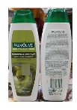
7-Sep-23 | Italy | Conditioner | Bodycare / Cosmetics | Chemical Hazard | 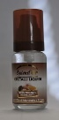
7-Sep-23 | Italy | Eau De Toilette | Bodycare / Cosmetics | Chemical Hazard | 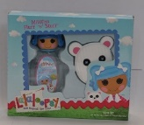
7-Sep-23 | Italy | Tonic | Bodycare / Cosmetics | Chemical Hazard | 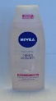  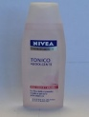
7-Sep-23 | Italy | Hair Conditioner | Bodycare / Cosmetics | Chemical Hazard | 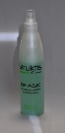
7-Sep-23 | Italy | Hair-removal Cream | Bodycare / Cosmetics | Chemical Hazard | 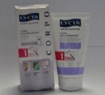
7-Sep-23 | Italy | Eau De Toilette | Bodycare / Cosmetics | Chemical Hazard | 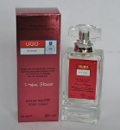
7-Sep-23 | Italy | Eau De Toilette | Bodycare / Cosmetics | Chemical Hazard | 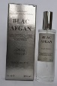
7-Sep-23 | Italy | Eau De Toilette | Bodycare / Cosmetics | Chemical Hazard | 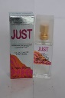
7-Sep-23 | Italy | Eau De Toilette | Bodycare / Cosmetics | Chemical Hazard | 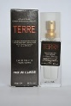
7-Sep-23 | Italy | Eau De Toilette | Bodycare / Cosmetics | Chemical Hazard | 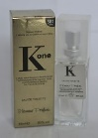
7-Sep-23 | Italy | Eau De Toilette | Bodycare / Cosmetics | Chemical Hazard | 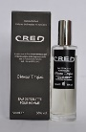
7-Sep-23 | Italy | Eau De Toilette | Bodycare / Cosmetics | Chemical Hazard | 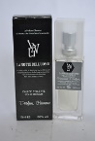
7-Sep-23 | Italy | Eau De Toilette | Bodycare / Cosmetics | Chemical Hazard | 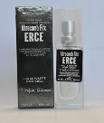
7-Sep-23 | Italy | Eau De Toilette | Bodycare / Cosmetics | Chemical Hazard | 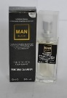
7-Sep-23 | Italy | Aftershave | Bodycare / Cosmetics | Chemical Hazard | 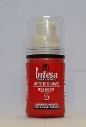
7-Sep-23 | Italy | Moisturizing Cream | Bodycare / Cosmetics | Chemical Hazard | 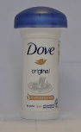
7-Sep-23 | Italy | Roll-on Deodorant | Bodycare / Cosmetics | Chemical Hazard | 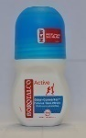
7-Sep-23 | Italy | Shower Gel | Bodycare / Cosmetics | Chemical Hazard | 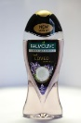
7-Sep-23 | Italy | Shampoo | Bodycare / Cosmetics | Chemical Hazard | 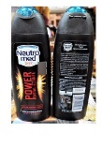
7-Sep-23 | Italy | Shower Foam | Bodycare / Cosmetics | Chemical Hazard | 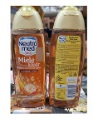
7-Sep-23 | Italy | Shower Foam | Bodycare / Cosmetics | Chemical Hazard | 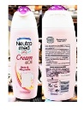
7-Sep-23 | Sweden | Earrings | Jewelry | Chemical Hazard | 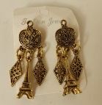
7-Sep-23 | Sweden | Earrings | Jewelry | Chemical Hazard | 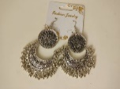
7-Sep-23 | France | Baby-changing Table with Pull-out Bath | Toys and Childcare Products | Entrapment Hazard, Injury Hazard | 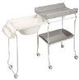  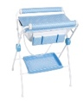
7-Sep-23 | Italy | Hair Styling Oil | Bodycare / Cosmetics | Chemical Hazard | 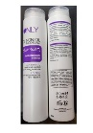
7-Sep-23 | Italy | Hand Cream | Bodycare / Cosmetics | Chemical Hazard | 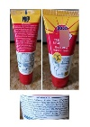
7-Sep-23 | Hungary | Eau De Toilette | Bodycare / Cosmetics | Chemical Hazard | 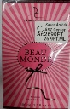
7-Sep-23 | Hungary | Eau De Toilette | Bodycare / Cosmetics | Chemical Hazard | 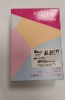
7-Sep-23 | Hungary | Eau De Toilette Set | Bodycare / Cosmetics | Chemical Hazard | 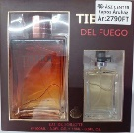
8-Sep-23 | Hungary | Eau De Toilette | Bodycare / Cosmetics | Chemical Hazard | 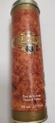
12-Sep-23 | Italy | Shampoo | Bodycare / Cosmetics | Chemical Hazard | 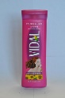
12-Sep-23 | Italy | Aftershave | Bodycare / Cosmetics | Chemical Hazard | 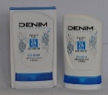
12-Sep-23 | Italy | Face Tonic | Bodycare / Cosmetics | Chemical Hazard | 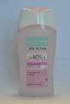
12-Sep-23 | Italy | Eau De Toilette | Bodycare / Cosmetics | Chemical Hazard | 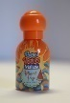
12-Sep-23 | Italy | Bath Milk | Bodycare / Cosmetics | Chemical Hazard | 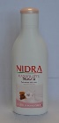
12-Sep-23 | Italy | Talcum Powder | Bodycare / Cosmetics | Chemical Hazard | 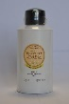
12-Sep-23 | Italy | Shower Gel | Bodycare / Cosmetics | Chemical Hazard | 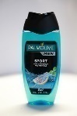
12-Sep-23 | Italy | Eau De Toilette | Bodycare / Cosmetics | Chemical Hazard | 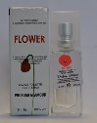
12-Sep-23 | Italy | Eau De Toilette | Bodycare / Cosmetics | Chemical Hazard | 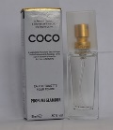
12-Sep-23 | Italy | Shower Gel | Bodycare / Cosmetics | Chemical Hazard | 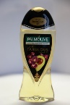
12-Sep-23 | Italy | Shower Cream | Bodycare / Cosmetics | Chemical Hazard | 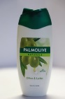
12-Sep-23 | Hungary | Eau De Toilette | Bodycare / Cosmetics | Chemical Hazard | 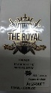
12-Sep-23 | Sweden | Dual Cable Adaptor | Computer / Audio / Video / Other Electronics & Accessories | Environmental Hazard | 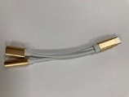
12-Sep-23 | Poland | Power Supply | Electrical Appliances | Environmental Hazard | 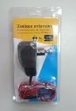
12-Sep-23 | Poland | Wireless Speaker | Computer / Audio / Video / Other Electronics & Accessories | Environmental Hazard | 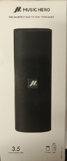
12-Sep-23 | The Netherlands | Activity Cube | Toys and Childcare Products | Choking Hazard | 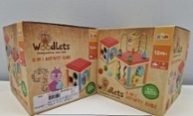
13-Sep-23 | Italy | Beauty Set | Bodycare / Cosmetics | Chemical Hazard | 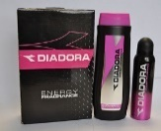
13-Sep-23 | Italy | Eau De Toilette | Bodycare / Cosmetics | Chemical Hazard | 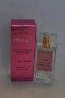
13-Sep-23 | Italy | Styling Mousse | Bodycare / Cosmetics | Chemical Hazard | 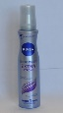
13-Sep-23 | Italy | Face Cream | Bodycare / Cosmetics | Chemical Hazard | 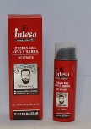
13-Sep-23 | Italy | Perfume | Bodycare / Cosmetics | Chemical Hazard | 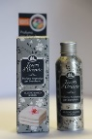
13-Sep-23 | Italy | Bath Cream | Bodycare / Cosmetics | Chemical Hazard | 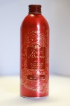
13-Sep-23 | Italy | Eau De Toilette | Bodycare / Cosmetics | Chemical Hazard | 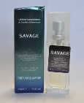
13-Sep-23 | Italy | Eau De Toilette | Bodycare / Cosmetics | Chemical Hazard | 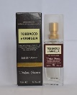
13-Sep-23 | Italy | Eau De Toilette | Bodycare / Cosmetics | Chemical Hazard | 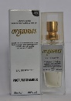
13-Sep-23 | Italy | Eau De Toilette | Bodycare / Cosmetics | Chemical Hazard | 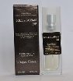
13-Sep-23 | Italy | Eau De Toilette | Bodycare / Cosmetics | Chemical Hazard | 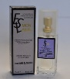
13-Sep-23 | Italy | Hair Mousse | Bodycare / Cosmetics | Chemical Hazard | 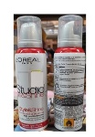
13-Sep-23 | Hungary | Eau De Toilette | Bodycare / Cosmetics | Chemical Hazard
13-Sep-23 | Hungary | Eau De Toilette | Bodycare / Cosmetics | Chemical Hazard | 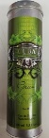
14-Sep-23 | Italy | Moisturising Milk | Bodycare / Cosmetics | Chemical Hazard | 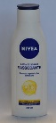
14-Sep-23 | Italy | Shower Cream | Bodycare / Cosmetics | Chemical Hazard | 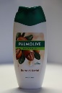
14-Sep-23 | Sweden | Gym Ball | Sporting Goods / Equipment | Chemical Hazard | 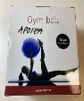  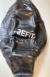
14-Sep-23 | Sweden | SpongeBob Figures | Toys and Childcare Products | Chemical Hazard | 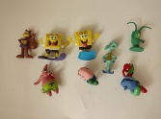
14-Sep-23 | Sweden | Key Chain | Accessories | Chemical Hazard | 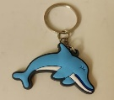
14-Sep-23 | Sweden | USB Cable | Computer / Audio / Video / Other Electronics & Accessories | Chemical Hazard, Environmental Hazard | 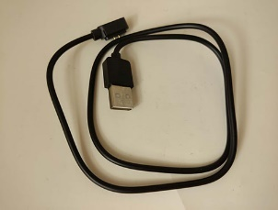
14-Sep-23 | Sweden | Cosmetic Bag | Fabric / Textile / Garment / Home Textile | Chemical Hazard, Environmental Hazard | 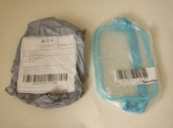
14-Sep-23 | Sweden | Skin Lightening Cream | Bodycare / Cosmetics | Chemical Hazard | 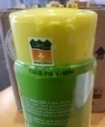
14-Sep-23 | Sweden | Skin Lightening Cream | Bodycare / Cosmetics | Chemical Hazard | 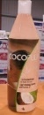
14-Sep-23 | Germany | Portable Power Station | Machinery | Burn Hazard, Fire Hazard | 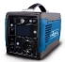  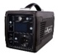  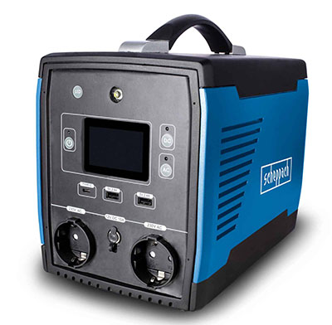  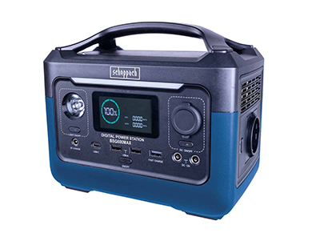  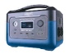
14-Sep-23 | Germany | Portable Power Station | Machinery | Burn Hazard, Fire Hazard | 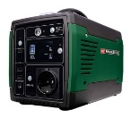
14-Sep-23 | France | Inflatable Swimming Float | Sporting Goods / Equipment | Drowning Hazard | 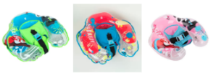
14-Sep-23 | France | Powder for Oral Hygiene | Bodycare / Cosmetics | Microbiological Hazard | 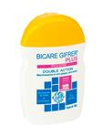
14-Sep-23 | Italy | Make-up Removal Wipes | Bodycare / Cosmetics | Chemical Hazard | 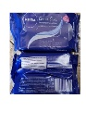
14-Sep-23 | The Netherlands | Wooden Car Track | Toys and Childcare Products | Choking Hazard | 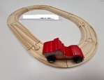  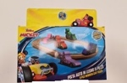
14-Sep-23 | Hungary | Hair Dryer | Home Electrical Appliances | Burn Hazard, Fire Hazard | 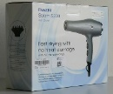  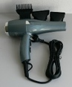
14-Sep-23 | Poland | Electric Toy | Toys and Childcare Products | Environmental Hazard | 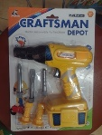
14-Sep-23 | Hungary | Magnetic Toy Figure | Toys and Childcare Products | Choking Hazard, Injury Hazard | 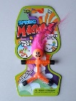
14-Sep-23 | Germany | Battery Safety Terminals / Vehicle Part | Car Components | Fire Hazard | 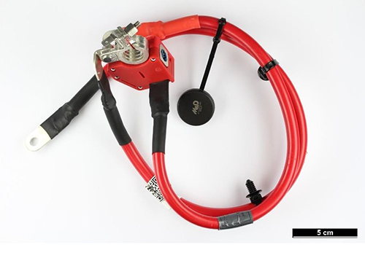
14-Sep-23 | Italy | Perfume | Bodycare / Cosmetics | Chemical Hazard | 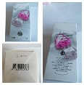
14-Sep-23 | Italy | Eau De Toilette | Bodycare / Cosmetics | Chemical Hazard | 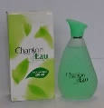
14-Sep-23 | Italy | Eau De Toilette | Bodycare / Cosmetics | Chemical Hazard | 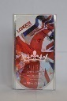
14-Sep-23 | Italy | Deodorant Spray | Bodycare / Cosmetics | Chemical Hazard | 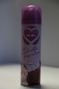
14-Sep-23 | Italy | Deodorant Spray | Bodycare / Cosmetics | Chemical Hazard | 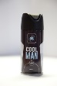
14-Sep-23 | Italy | Laundry Perfume | Bodycare / Cosmetics | Chemical Hazard | 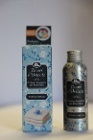
14-Sep-23 | Italy | Hair and Body Wash | Bodycare / Cosmetics | Chemical Hazard | 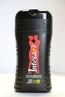
14-Sep-23 | Ireland | Baby Teether | Toys and Childcare Products | Choking Hazard | 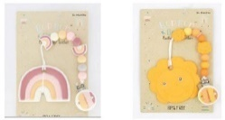
14-Sep-23 | Hungary | Eau De Toilette | Bodycare / Cosmetics | Chemical Hazard | 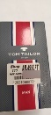
14-Sep-23 | Hungary | Eau De Toilette | Bodycare / Cosmetics | Chemical Hazard | 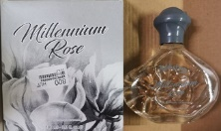
14-Sep-23 | Hungary | Eau De Toilette | Bodycare / Cosmetics | Chemical Hazard | 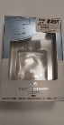
14-Sep-23 | Hungary | Eau De Toilette | Bodycare / Cosmetics | Chemical Hazard | 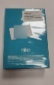
14-Sep-23 | Czechia | Plastic Doll | Toys and Childcare Products | Chemical Hazard
19-Sep-23 | Ireland | Electric Toaster | Home Electrical Appliances | Burn Hazard, Fire Hazard | 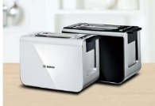
19-Sep-23 | Ireland | Travel Adaptor | Electrical Appliances | Electric Shock Hazard | 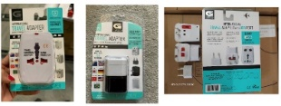
19-Sep-23 | Hungary | Perfume | Bodycare / Cosmetics | Chemical Hazard | 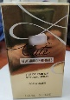
19-Sep-23 | Hungary | Perfume | Bodycare / Cosmetics | Chemical Hazard | 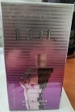
19-Sep-23 | Hungary | Perfume | Bodycare / Cosmetics | Chemical Hazard
19-Sep-23 | Hungary | Perfume | Bodycare / Cosmetics | Chemical Hazard | 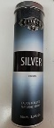
19-Sep-23 | Hungary | Perfume Set | Bodycare / Cosmetics | Chemical Hazard | 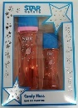
19-Sep-23 | Poland | Magnetic Toy | Toys and Childcare Products | Injury Hazard | 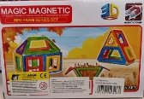
20-Sep-23 | Denmark | Power Adaptor | Electrical Appliances | Electric Shock Hazard | 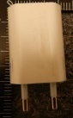
20-Sep-23 | France | Toy Modelling Kit | Toys and Childcare Products | Microbiological Hazard | 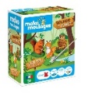  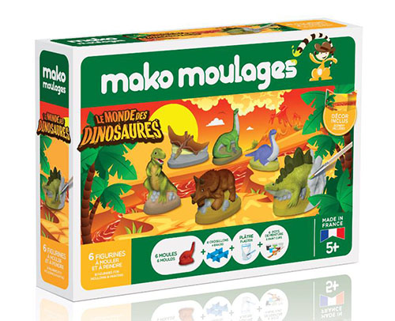  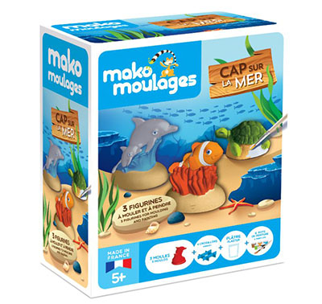
20-Sep-23 | Norway | Electric Scooter | Sporting Goods / Equipment | Environmental Hazard | 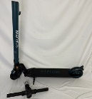
20-Sep-23 | Hungary | Attachment for Brushcutters | Machinery | Injury Hazard
20-Sep-23 | Poland | Soldering Iron | Electrical Appliances | Electric Shock Hazard | 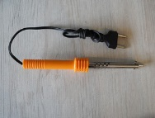
20-Sep-23 | Ireland | Baby Self-feeding Pillow | Toys and Childcare Products | Choking Hazard
20-Sep-23 | Ireland | Baby Self-feeding Pillow | Toys and Childcare Products | Choking Hazard | 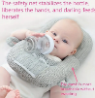
20-Sep-23 | Ireland | Baby Self-feeding Pillow | Toys and Childcare Products | Choking Hazard | 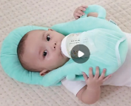
20-Sep-23 | Ireland | Baby Self-feeding Pillow | Toys and Childcare Products | Choking Hazard
20-Sep-23 | Germany | Trailer | Car Components | Injury Hazard | 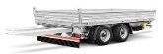  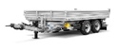  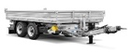
20-Sep-23 | Germany | Baby Powder | Bodycare / Cosmetics | Chemical Hazard | 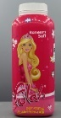
21-Sep-23 | France | Soft Toy | Toys and Childcare Products | Choking Hazard | 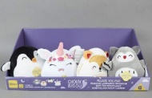
21-Sep-23 | Ireland | USB Charger | Electrical Appliances | Electric Shock Hazard, Fire Hazard | 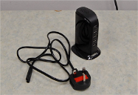
21-Sep-23 | Ireland | Baby Self-feeding Pillow | Toys and Childcare Products | Choking Hazard
21-Sep-23 | Ireland | Baby Self-feeding Pillow | Toys and Childcare Products | Choking Hazard | 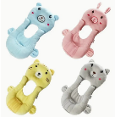
21-Sep-23 | Ireland | Baby Self-feeding Pillow | Toys and Childcare Products | Choking Hazard | 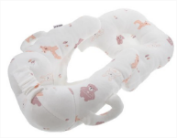
21-Sep-23 | Ireland | Baby Self-feeding Pillow | Toys and Childcare Products | Choking Hazard | 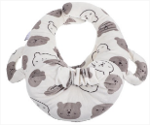
21-Sep-23 | Ireland | Baby Self-feeding Pillow | Toys and Childcare Products | Choking Hazard | 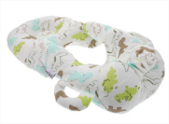
21-Sep-23 | France | Soft Toy | Toys and Childcare Products | Choking Hazard | 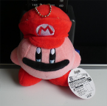
21-Sep-23 | Germany | Safety Vest | Protective Equipment | Injury Hazard | 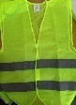
21-Sep-23 | Germany | Safety Vest | Protective Equipment | Injury Hazard | 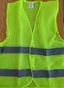
21-Sep-23 | Hungary | Lamp Holder Adaptor | Tools and Hardware | Burn Hazard, Electric Shock Hazard, Fire Hazard | 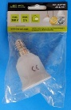
21-Sep-23 | Hungary | Hair Dryer | Home Electrical Appliances | Burn Hazard, Electric Shock Hazard, Fire Hazard | 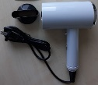
21-Sep-23 | Hungary | Hair Dryer | Home Electrical Appliances | Burn Hazard, Electric Shock Hazard, Fire Hazard | 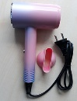
21-Sep-23 | Italy | Balm Cream | Bodycare / Cosmetics | Chemical Hazard | 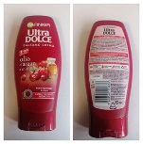
21-Sep-23 | Italy | Perfume | Bodycare / Cosmetics | Chemical Hazard | 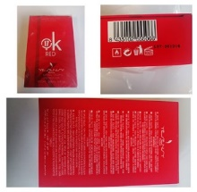
21-Sep-23 | Italy | Shower Gel | Bodycare / Cosmetics | Chemical Hazard | 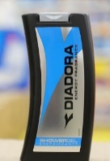
21-Sep-23 | Italy | Bath Oil | Bodycare / Cosmetics | Chemical Hazard | 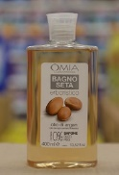
21-Sep-23 | Italy | Deodorant | Bodycare / Cosmetics | Chemical Hazard | 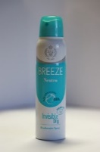
21-Sep-23 | Germany | Concrete Screw | Construction Products | Injury Hazard | 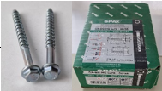
21-Sep-23 | Germany | Concrete Screw | Construction Products | Injury Hazard | /
21-Sep-23 | Germany | Concrete Screw | Construction Products | Injury Hazard | /
21-Sep-23 | Hungary | Eau De Toilette | Bodycare / Cosmetics | Chemical Hazard | 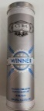
21-Sep-23 | Italy | Perfume | Bodycare / Cosmetics | Chemical Hazard | 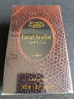
21-Sep-23 | Italy | Aftershave and Deodorant Set | Bodycare / Cosmetics | Chemical Hazard | 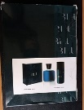
21-Sep-23 | Italy | Eau De Toilette | Bodycare / Cosmetics | Chemical Hazard | 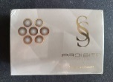
21-Sep-23 | Italy | Beauty Set | Bodycare / Cosmetics | Chemical Hazard | 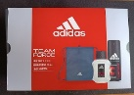  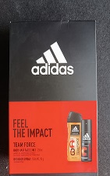
21-Sep-23 | Slovakia | Children's Pajamas | Fabric / Textile / Garment / Home Textile | Choking Hazard | 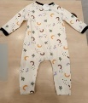
21-Sep-23 | Poland | Toy Car | Toys and Childcare Products | Burn Hazard, Fire Hazard | 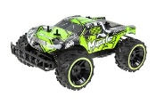
21-Sep-23 | Poland | Soft Toy | Toys and Childcare Products | Choking Hazard
21-Sep-23 | Poland | Soft Toy | Toys and Childcare Products | Choking Hazard
21-Sep-23 | Sweden | LED Hoverball | Toys and Childcare Products | Environmental Hazard | 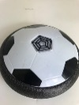
22-Sep-23 | Belgium | Football goal | Sporting Goods / Equipment | Entrapment Hazard | 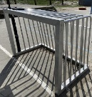
26-Sep-23 | The Netherlands | Shaver | Electrical Appliances | Electric Shock Hazard | 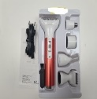
26-Sep-23 | Lithuania | Extension Lead | Electrical Appliances | Electric Shock Hazard | 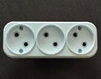  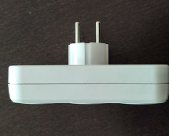
26-Sep-23 | Poland | Power Supply | Electrical Appliances | Electric Shock Hazard | 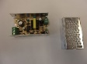  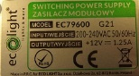
26-Sep-23 | Germany | Explosion-proof Tablet | Computer / Audio / Video / Other Electronics & Accessories | Burn Hazard | 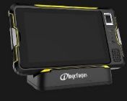
26-Sep-23 | Germany | Explosion-proof Smartphone | Computer / Audio / Video / Other Electronics & Accessories | Burn Hazard | 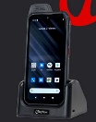
26-Sep-23 | Hungary | Eau De Toilette | Bodycare / Cosmetics | Chemical Hazard | 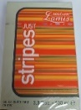
26-Sep-23 | Hungary | Perfume | Bodycare / Cosmetics | Chemical Hazard | 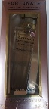
26-Sep-23 | Hungary | Perfume | Bodycare / Cosmetics | Chemical Hazard | 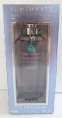
26-Sep-23 | Hungary | Perfume | Bodycare / Cosmetics | Chemical Hazard | 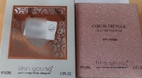
27-Sep-23 | Italy | Hand Soap | Bodycare / Cosmetics | Chemical Hazard | 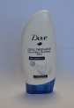
27-Sep-23 | Italy | Deodorant Stick | Bodycare / Cosmetics | Chemical Hazard | 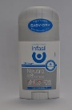
27-Sep-23 | Italy | Liquid Hand Soap | Bodycare / Cosmetics | Chemical Hazard | 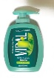  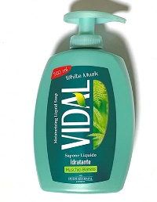
27-Sep-23 | Italy | Shower Cream and Intimate Wash | Bodycare / Cosmetics | Chemical Hazard | 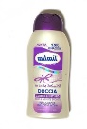
27-Sep-23 | Italy | Shower Gel | Bodycare / Cosmetics | Chemical Hazard | 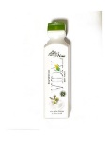
27-Sep-23 | Italy | Wet Wipes for Babies | Bodycare / Cosmetics | Chemical Hazard | 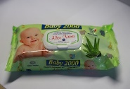
27-Sep-23 | Italy | Deodorant and Cream Set | Bodycare / Cosmetics | Chemical Hazard | 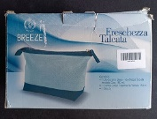
27-Sep-23 | Germany | Electric Lunch Box | Electrical Appliances | Electric Shock Hazard | 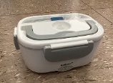
27-Sep-23 | Italy | Hair Conditioner | Bodycare / Cosmetics | Chemical Hazard | 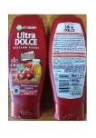
27-Sep-23 | Italy | Hair Conditioner | Bodycare / Cosmetics | Chemical Hazard | 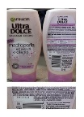
27-Sep-23 | Italy | Shower Gel | Bodycare / Cosmetics | Chemical Hazard | 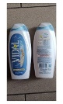
27-Sep-23 | Italy | Shower Foam | Bodycare / Cosmetics | Chemical Hazard | 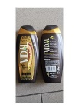
27-Sep-23 | Italy | Soap Bar | Bodycare / Cosmetics | Chemical Hazard | 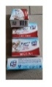
27-Sep-23 | Italy | Deodorant | Bodycare / Cosmetics | Chemical Hazard | 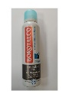
27-Sep-23 | Italy | Shower Foam | Bodycare / Cosmetics | Chemical Hazard | 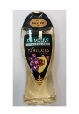
27-Sep-23 | Italy | Soap Bar | Bodycare / Cosmetics | Chemical Hazard | 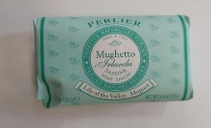
27-Sep-23 | Italy | Shower Foam | Bodycare / Cosmetics | Chemical Hazard | 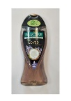
27-Sep-23 | Ireland | Travel Adaptor | Electrical Appliances | Electric Shock Hazard | 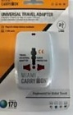
28-Sep-23 | Italy | Deodorant | Bodycare / Cosmetics | Chemical Hazard | 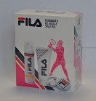
28-Sep-23 | Ireland | Tealight Candle Holder | Household Items | Burn Hazard, Fire Hazard | 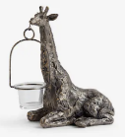
28-Sep-23 | Ireland | Tealight Candle Holder | Household Items | Burn Hazard, Fire Hazard | 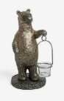
28-Sep-23 | Ireland | USB Charger | Electrical Appliances | Electric Shock Hazard | 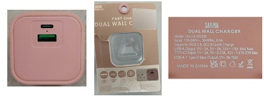
28-Sep-23 | Ireland | Travel Adaptor | Electrical Appliances | Electric Shock Hazard | 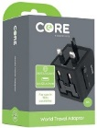
28-Sep-23 | Ireland | Baby Self-feeding Pillow | Toys and Childcare Products | Choking Hazard | 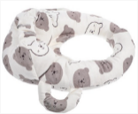
28-Sep-23 | Germany | Concrete Screw | Construction Products | Injury Hazard | /
28-Sep-23 | Germany | Concrete Screw | Construction Products | Injury Hazard | /
28-Sep-23 | Hungary | Toy Car | Toys and Childcare Products | Chemical Hazard, Choking Hazard | 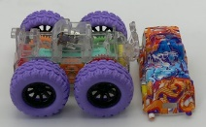
28-Sep-23 | Hungary | Eau De Toilette | Bodycare / Cosmetics | Chemical Hazard | 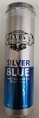
28-Sep-23 | Slovakia | Attachment for Brush Cutters | Machinery | Injury Hazard | 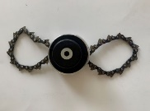
28-Sep-23 | Slovakia | Attachment for Brush Cutters | Machinery | Injury Hazard | 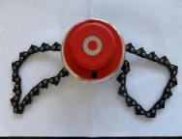
28-Sep-23 | Germany | Car Windscreen Washing Fluid | Chemicals | Chemical Hazard | 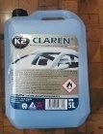
28-Sep-23 | Slovakia | Attachment for Brush Cutters | Machinery | Injury Hazard | 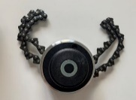
28-Sep-23 | Czechia | Eau De Parfum | Bodycare / Cosmetics | Chemical Hazard | 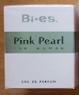  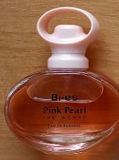
28-Sep-23 | Czechia | Plastic Doll | Toys and Childcare Products | Chemical Hazard | 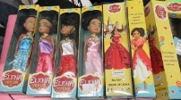
28-Sep-23 | Italy | Deodorant Spray | Bodycare / Cosmetics | Chemical Hazard | 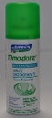
28-Sep-23 | Italy | Aftershave | Bodycare / Cosmetics | Chemical Hazard | 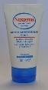
28-Sep-23 | Italy | Bath Cream | Bodycare / Cosmetics | Chemical Hazard | 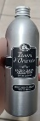
28-Sep-23 | Italy | Hairspray | Bodycare / Cosmetics | Chemical Hazard | 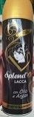
28-Sep-23 | Italy | Perfume | Bodycare / Cosmetics | Chemical Hazard | 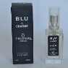  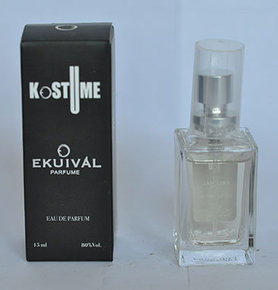  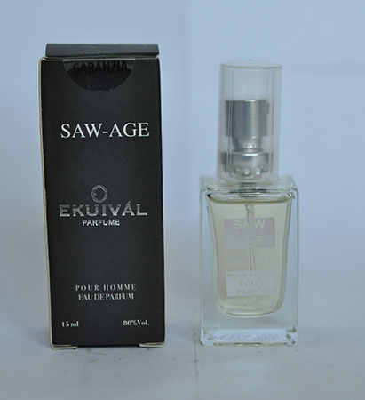  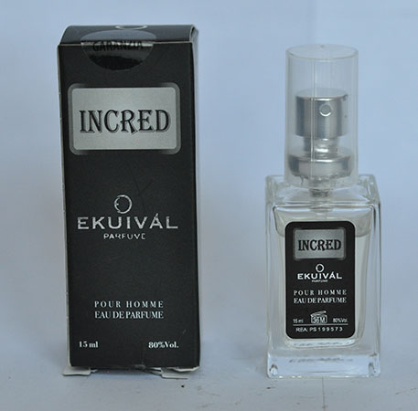
28-Sep-23 | Ireland | Roller Skates for Toy | Toys and Childcare Products | Cut Hazard, Injury Hazard | 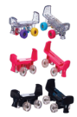
28-Sep-23 | The Netherlands | Wooden Puzzle | Toys and Childcare Products | Choking Hazard | 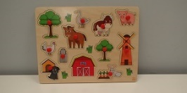
28-Sep-23 | Poland | Plastic Doll | Toys and Childcare Products | Chemical Hazard
28-Sep-23 | Hungary | Eau De Toilette | Bodycare / Cosmetics | Chemical Hazard | 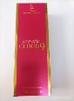
28-Sep-23 | Lithuania | Children's Hoodie | Fabric / Textile / Garment / Home Textile | Injury Hazard, Strangulation Hazard | 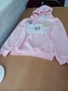
28-Sep-23 | Hungary | Eau De Toilette | Bodycare / Cosmetics | Chemical Hazard | 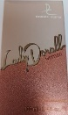
28-Sep-23 | France | Water Spray | Bodycare / Cosmetics | Microbiological Hazard | 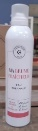
29-Sep-23 | Hungary | Eau De Toilette | Bodycare / Cosmetics | Chemical Hazard | 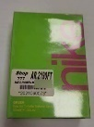
29-Sep-23 | Hungary | Eau De Toilette | Bodycare / Cosmetics | Chemical Hazard | 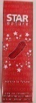
29-Sep-23 | Sweden | Pendant | Jewelry | Chemical Hazard | 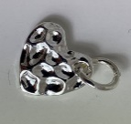
29-Sep-23 | Sweden | LED Lamp | Electrical Appliances | Environmental Hazard

