Title | United States (US) Recalls Summary (01 September 2023 to 30 September 2023)
Abstract | In the US, when hazards are identified in consumer products, they will be recalled and published in the Consumer Product Safety Commission (CPSC) Recent Recalls on the CPSC website, which is updated daily. The US recalls from 01 September 2023 to 30 September 2023 are summarized below:

Recall Cases Summary – US (Last Update Date: 30 September 2023)

Date | Product | Categories | Hazard | Image
7-Sep-2023 | North America Smart Plugs | Electrical Appliances | Electric Shock Hazard
7-Sep-2023 | LP Gas Compact Regulators | Tools and Hardware | Fire Hazard, Risk of Exposure to Combustion Flue Gas | 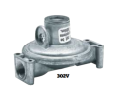
7-Sep-2023 | P ZERO Race TLR Bicycle Tires | Sporting Goods / Equipment | Fall Hazard | 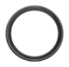  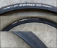
7-Sep-2023 | Stacked Commercial Clothes Dryers Sold Under the ADC Brand | Electrical Appliances | Fire Hazard | 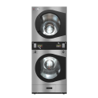  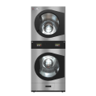  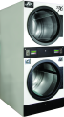
7-Sep-2023 | Disc Brake Calipers Sold on Lectric E-Bicycles | Sporting Goods / Equipment | Crash Hazard, Injury Hazard | 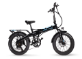  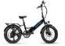  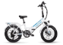  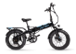  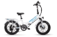  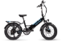
14-Sep-2023 | Chuckle & Roar Ultimate Water Beads Activity Kits | Toys and Childcare Products | Ingestion Hazard, Choking Hazard, Risk of Death | 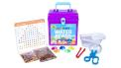
14-Sep-2023 | Foldable Bistro Set Chairs | Furniture | Fall Hazard | 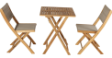  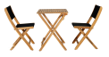
14-Sep-2023 | MSA 300 Chain Saws | Machinery | Laceration Hazard | 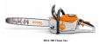
14-Sep-2023 | Lawnmowers and Pressure Washer Engines | Machinery | Injury Hazard | 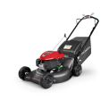  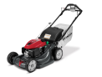  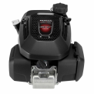
14-Sep-2023 | Portable Generators | Machinery | Fire Hazard, Burn Hazard | 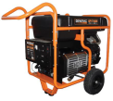
14-Sep-2023 | Insignia and Yardbird Fire Tables with Lava Rocks | Outdoor Living Items | Burn Hazard, Impact Hazard, Injury Hazard | 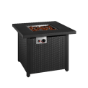  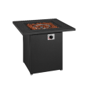  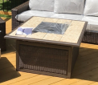
21-Sep-2023 | Infant Swings | Toys and Childcare Products | Risk of Death | 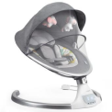  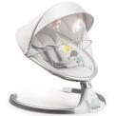
21-Sep-2023 | DR Power Chipper Shredders | Machinery | Laceration Hazard | 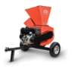  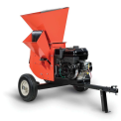  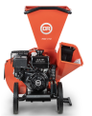  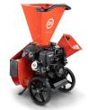
21-Sep-2023 | Seven Rainbow Road Board Books | Toys and Childcare Products | Choking Hazard | 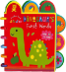  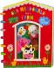  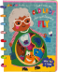  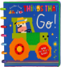  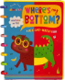  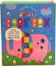
21-Sep-2023 | Men’s Clasp Beaded Bracelets | Jewelry | Lead Poisoning Hazard, Risk of Death, Ingestion Hazard | 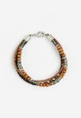
21-Sep-2023 | Novaform ComfortGrande and DreamAway Mattresses | Furniture | Health Risk Hazard, Risk of Allergy | 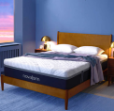  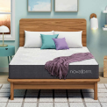
21-Sep-2023 | Cranksets for Bicycles | Sporting Goods / Equipment | Crash Hazard | 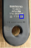
28-Sep-2023 | Allant+ 7 Bicycles | Sporting Goods / Equipment | Crash Hazard | 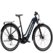  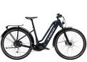  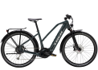  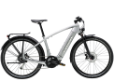
28-Sep-2023 | Zevo Fly, Gnat and Fruit Fly Insect Spray | Chemicals | Injury Hazard, Laceration Hazard | 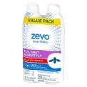
28-Sep-2023 | Solaray Liposomal Multivitamins | Pharmacy | Poisoning Hazard | 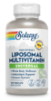  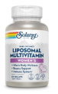  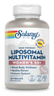
28-Sep-2023 | Fluorescent Pink Spray Paint | Chemicals | Injury Hazard | 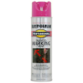  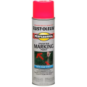
28-Sep-2023 | Air Fryers | Home Electrical Appliances | Fire Hazard, Burn Hazard | 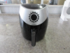  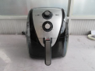
29-Sep-2023 | Onewheel Self-Balancing Electric Skateboards | Sporting Goods / Equipment | Crash Hazard, Injury Hazard, Risk of Death | 