Recall Cases Summary – Australia (Last Update Date: 31 October 2023)

Date | Product | Categories | Hazard | Image
4-Oct-2023 | Various Bamboo Ukes | Electrical Appliances | Choking Hazard, Burn Hazard, Risk of Death, Swallowing Risk, Injury Hazard, Ingestion Hazard | 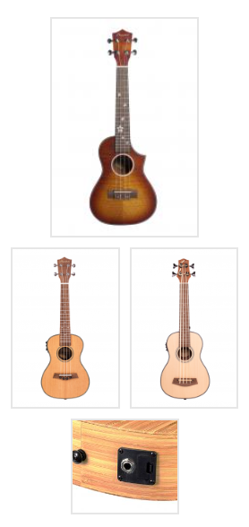
5-Oct-2023 | QFES Dynamo Torch | Electrical Appliances | Choking Hazard, Burn Hazard, Risk of Death, Swallowing Risk, Injury Hazard, Ingestion Hazard | 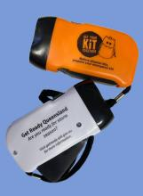
5-Oct-2023 | Electric Retractable Tonneau Cover | Car Components | Choking Hazard, Burn Hazard, Risk of Death, Swallowing Risk, Injury Hazard | 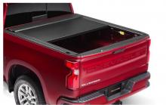
5-Oct-2023 | Rainbow Road Board Book Series - Eight Different Titles and A Book Gift Box | Toys and Childcare Products | Choking Hazard | 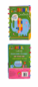  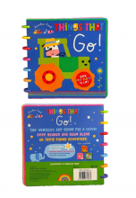  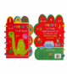  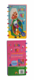  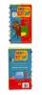  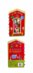  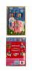
6-Oct-2023 | Aiper Elite Pro GS 100 Cordless Robotic Vacuum Pool Cleaner | Electrical Appliances | Injury Hazard, Fire Hazard | 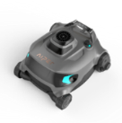
6-Oct-2023 | Temporary Colour Hair Spray | Bodycare / Cosmetics | Risk of Allergy | 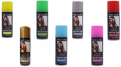
9-Oct-2023 | Garmin Venu 2 Plus and Garmin D2 Air X10 Smartwatches | Computer / Audio / Video / Other Electronics & Accessories | Skin Irritation Risk | 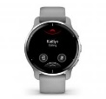  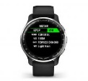
10-Oct-2023 | LED Flashlight Rechargeable Strobe Torch with Strap - USB Cable | Electrical Appliances | Burn Hazard, Risk of Death, Fire Hazard | 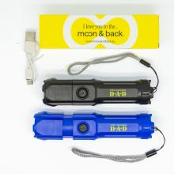
12-Oct-2023 | Electronic Tyre Pressure Gauge | Electrical Appliances | Choking Hazard, Injury Hazard, Swallowing Risk, Risk of Death | 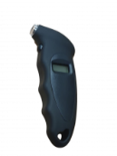
13-Oct-2023 | Janod Cocoon Activity Table | Toys and Childcare Products | Choking Hazard, Suffocation Hazard, Risk of Death | 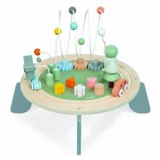
18-Oct-2023 | Rubber Park Swing | Outdoor Living Items | Injury Hazard | 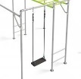
18-Oct-2023 | OTTO Digital Bamboo Desk Clock | Home Electrical Appliances | Choking Hazard, Burn Hazard, Risk of Death, Swallowing Risk, Injury Hazard, Ingestion Hazard | 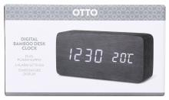
18-Oct-2023 | Rainbow Neon LED Light Up Tutu | Fabric / Textile / Garment / Home Textile | Choking Hazard, Burn Hazard, Risk of Death, Swallowing Risk, Injury Hazard, Ingestion Hazard | 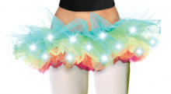
19-Oct-2023 | 3PHVL-17XX Cable Replacement Kits and Associated Kits | Tools and Hardware | Injury Hazard, Risk of Death, Electric Shock Hazard | 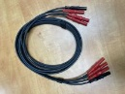
19-Oct-2023 | Nite Ize Slidelock Carabiner Bungee | Tools and Hardware | Injury Hazard | 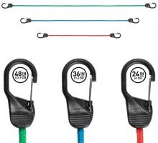
26-Oct-2023 | Magnetic Balls | Toys and Childcare Products | Injury Hazard, Risk of Death, Swallowing Risk, Choking Hazard
26-Oct-2023 | Plastic LED Tealight Candles | Household Items | Injury Hazard, Risk of Death, Swallowing Risk, Choking Hazard, Burn Hazard, Ingestion Hazard | 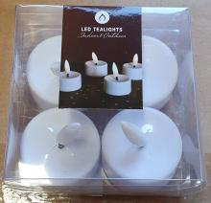
26-Oct-2023 | Remote Control Supplied with Heatstrip Outdoor Heaters | Electrical Appliances | Choking Hazard, Injury Hazard, Swallowing Risk, Risk of Death | 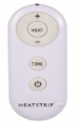  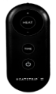
27-Oct-2023 | Electric Oil Burners | Home Electrical Appliances | Electric Shock Hazard , Injury Hazard, Risk of Death, Burn Hazard, Fire Hazard | 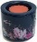  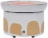  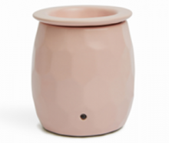  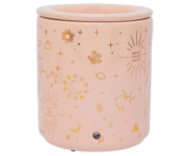  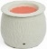  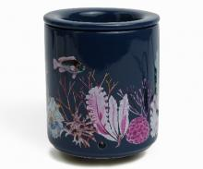  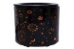  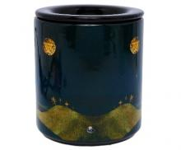  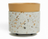  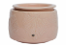
27-Oct-2023 | Lower Control Arm Ball Joint | Car Components | Injury Hazard, Risk of Death | 