Recall Cases Summary – Canada (Last Update Date: 31 October 2023)

Date | Product | Categories | Hazard | Image
03-Oct-2023 | HUF Logo Youth Hooded Fleece | Fabric / Textile / Garment / Home Textile | Strangulation Hazard | 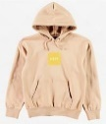
03-Oct-2023 | Powerful Magnets Be Amazing! – Magnetic Marvels | Toys and Childcare Products | Ingestion Hazard, Swallowing Risk | 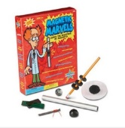
03-Oct-2023 | Cantaloupe | Food | Microbiological Hazard | /
04-Oct-2023 | Sleepers | Fabric / Textile / Garment / Home Textile | Choking Hazard, Ingestion Hazard | 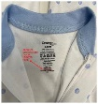
04-Oct-2023 | Buffalo Chicken Meatballs | Food | Risk of Allergy | /
05-Oct-2023 | Russound MCA-88 Multizone Controller Amplifier | Computer / Audio / Video / Other Electronics & Accessories | Fire Hazard | 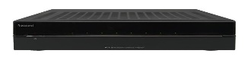
06-Oct-2023 | Losoya Top Down Bottom Up (TDBU) Cordless Light Filtering Cellular Pleated Shade | Household Items | Strangulation Hazard, Entanglement Hazard, Risk of Death | 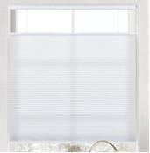
06-Oct-2023 | Various Mountain Equipment Company (MEC) Youth Jackets | Fabric / Textile / Garment / Home Textile | Entanglement Hazard | 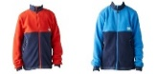  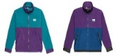
06-Oct-2023 | Honda Lawnmowers | Machinery | Injury Hazard | 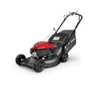  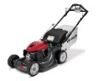
06-Oct-2023 | One Lot of Port North Lemon Z Rosin - Strain Specific Full Spectrum Solventless Soft Chews Edible Cannabis | Cannabis | Microbiological Hazard | 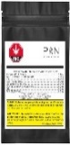  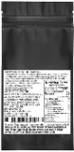
07-Oct-2023 | Young Turkey with Giblets | Food | Microbiological Hazard | /
11-Oct-2023 | Chateau Ivory Burlap Curtain Valance with Ties | Household Items | Strangulation Hazard, Entanglement Hazard, Risk of Death | 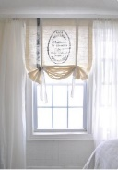
12-Oct-2023 | Little Sleepies Sleepyhead Lovey and Bandana Bibs | Fabric / Textile / Garment / Home Textile | Choking Hazard | 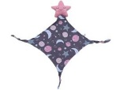  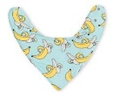
12-Oct-2023 | Convertible House Bed Frames and Montessori Floor Beds by Zipadee Kids | Furniture | Entrapment Hazard, Strangulation Hazard, Risk of Death | 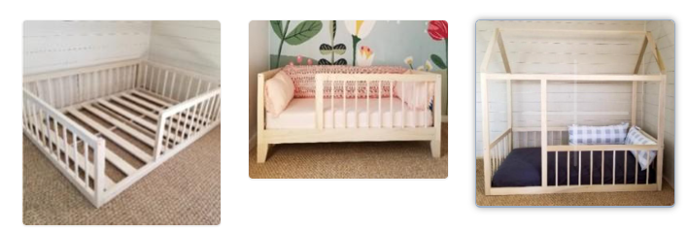
13-Oct-2023 | Tahina | Food | Microbiological Hazard, Strangulation Hazard, Risk of Death | 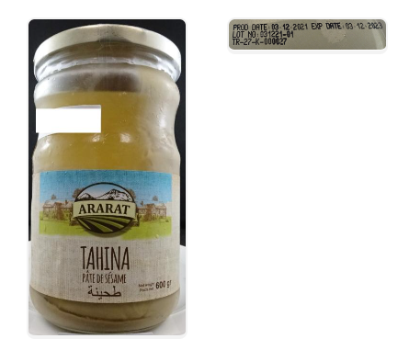
16-Oct-2023 | Fermented Vegan Proteins+ Peanut Butter Chocolate Bar | Food | Microbiological Hazard | /
18-Oct-2023 | Battery Pack Within Certain Eufy RoboVac X8 Hybrid Vacuums and Certain Eufy Replacement Battery Packs | Electrical Appliances | Fire Hazard | 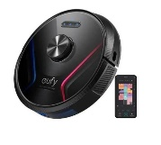
19-Oct-2023 | Wooden Railway Products | Toys and Childcare Products | Ingestion Hazard, Swallowing Risk | 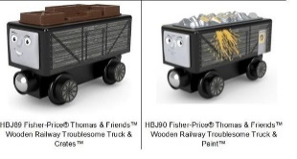
19-Oct-2023 | Buffalo Chicken Meatballs | Food | Risk of Allergy | /
20-Oct-2023 | Safes with Biometric Locks | Protective Equipment | Risk of Death, Safety Risk Hazard | 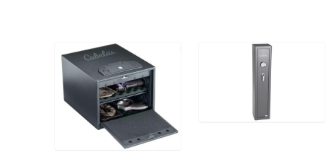
24-Oct-2023 | Breakfast Sausages | Food | Risk of Allergy | /
24-Oct-2023 | Wooden Nesting Rings and Wooden Sparkle Nesting Rings | Toys and Childcare Products | Entrapment Hazard | 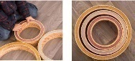  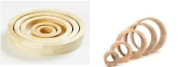
24-Oct-2023 | Lac St-Jean Tourtiere | Food | Risk of Allergy | /
25-Oct-2023 | Various Will & You Children’s Outerwear Tops | Fabric / Textile / Garment / Home Textile | Entanglement Hazard | 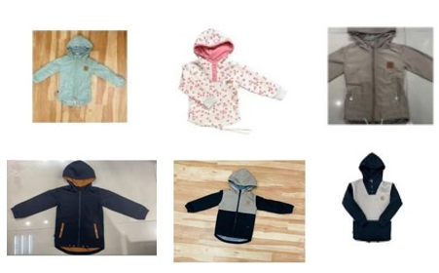
25-Oct-2023 | Enoki Mushroom | Food | Microbiological Hazard | 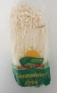
26-Oct-2023 | Multi-Function Pressure Cookers | Home Electrical Appliances | Burn Hazard | 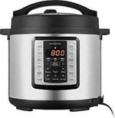  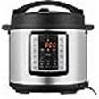  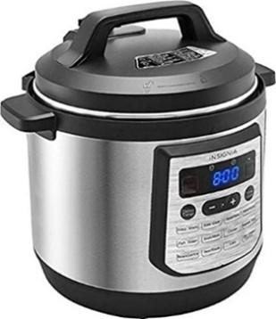
26-Oct-2023 | Bobcat ZS4000 and Kubota Stand-on Zero Turn Lawnmowers | Machinery | Crash Hazard, Laceration Hazard | 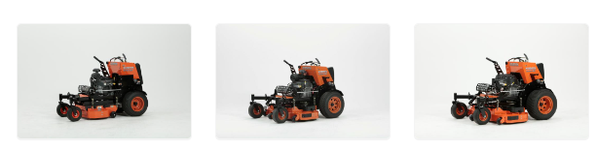  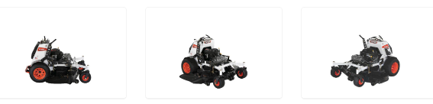  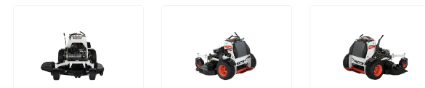
27-Oct-2023 | Various Brands of Caffeinated Energy Drinks | Food | Chemical Hazard | 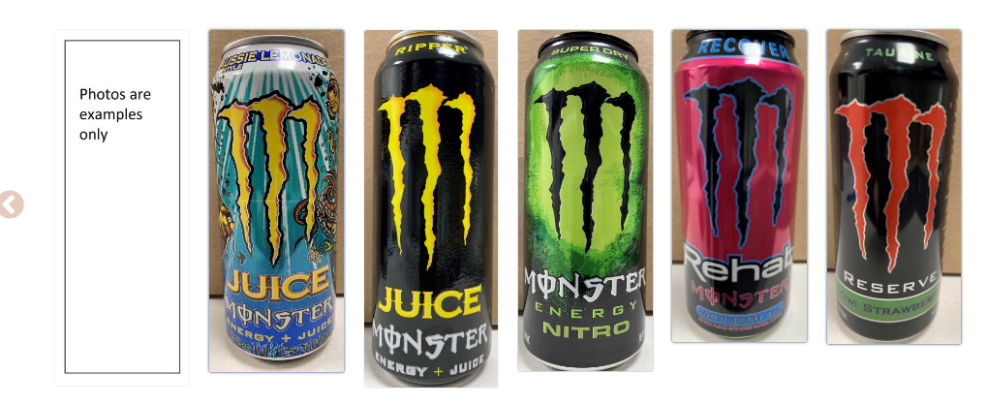
27-Oct-2023 | COWS Youth Terry Spots Hoody | Fabric / Textile / Garment / Home Textile | Strangulation Hazard | 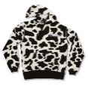
27-Oct-2023 | Slime Smoothies Borax Packet | Food | Chemical Hazard | 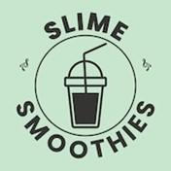
27-Oct-2023 | Topdeal Baby Feeding Nursing Pillows | Toys and Childcare Products | Choking Hazard, Aspiration Hazard
27-Oct-2023 | Creativity for Kids DIY Glowing Squishy Slime and Magical Mixing | Toys and Childcare Products | Chemical Hazard | 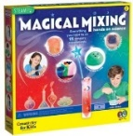  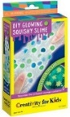
28-Oct-2023 | Taylor Shellfish Canada ULC / Oysters | Food | Microbiological Hazard | /
31-Oct-2023 | Linen Curtain Valance with Ties by Kingdom of Comfort | Fabric / Textile / Garment / Home Textile | Strangulation Hazard, Entanglement Hazard, Risk of Death | 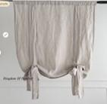
31-Oct-2023 | Various Custom Window Coverings with Ties by Prolinen | Fabric / Textile / Garment / Home Textile | Strangulation Hazard, Entanglement Hazard, Risk of Death | 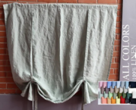
31-Oct-2023 | Various Custom Window Coverings with Ties by BalticLinenIdille | Fabric / Textile / Garment / Home Textile | Strangulation Hazard, Entanglement Hazard, Risk of Death | 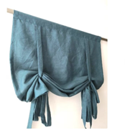
31-Oct-2023 | White Sliced Mushrooms | Food | Microbiological Hazard | 