Recall Cases Summary – China (Last Update Date: 31 October 2023)

Date | Province | Product | Categories | Hazard | Image
7-Oct-2023 | Guangdong | Lithium E-Bike Battery | Electrical Appliances | Fire Hazard, Safety Risk Hazard | /
7-Oct-2023 | Guangdong | Baby Shark Toy | Toys and Childcare Products | Injury Hazard, Safety Risk Hazard | /
7-Oct-2023 | Guangdong | Electric Bicycles | Sporting Goods / Equipment | Fire Hazard, Safety Risk Hazard, Injury Hazard, Crash Hazard | /
7-Oct-2023 | Guangdong | Electric Bicycles | Sporting Goods / Equipment | Explosion Hazard, Fire Hazard | /
7-Oct-2023 | Guangdong | Induction Cookers | Home Electrical Appliances | Fire Hazard, Safety Risk Hazard | /
7-Oct-2023 | Guangdong | Disposable Non-Medical Masks | Protective Equipment | Health Risk Hazard | /
7-Oct-2023 | Guangdong | Electric Bicycles | Sporting Goods / Equipment | Injury Hazard, Safety Risk Hazard | /
7-Oct-2023 | Guangdong | N95 Protective Masks and Disposable Protective Masks (Non-Medical) | Protective Equipment | Health Risk Hazard | /
9-Oct-2023 | Shanghai | Skipping Ropes | Sporting Goods / Equipment | Chemical Hazard, Health Risk Hazard | 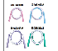
11-Oct-2023 | Jiangsu | Electric Bicycles | Sporting Goods / Equipment | Safety Risk Hazard, Electric Shock Hazard | 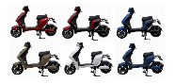
11-Oct-2023 | Jiangsu | Electric Bicycles | Sporting Goods / Equipment | Crash Hazard, Fire Hazard, Injury Hazard | 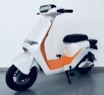
11-Oct-2023 | Jiangsu | Electric Bicycles | Sporting Goods / Equipment | Crash Hazard, Safety Risk Hazard, Injury Hazard | 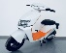
13-Oct-2023 | Chongqing | Men's Sneakers | Fabric / Textile / Garment / Home Textile | Skin Irritation Risk, Health Risk Hazard | /
13-Oct-2023 | Chongqing | Leather Shoes | Fabric / Textile / Garment / Home Textile | Fall Hazard, Health Risk Hazard | /
15-Oct-2023 | Guangdong | Induction Cookers | Home Electrical Appliances | Fire Hazard, Safety Risk Hazard | /
15-Oct-2023 | Guangdong | Insect Killer | Home Electrical Appliances | Electric Shock Hazard, Safety Risk Hazard | /
15-Oct-2023 | Guangdong | Floor Fans | Home Electrical Appliances | Cut Hazard, Safety Risk Hazard | /
15-Oct-2023 | Guangdong | Electric Kettles | Home Electrical Appliances | Electric Shock Hazard, Safety Risk Hazard | /
15-Oct-2023 | Guangdong | Electric Kettles | Home Electrical Appliances | Fire Hazard, Safety Risk Hazard | /
15-Oct-2023 | Guangdong | Electric Kettles | Home Electrical Appliances | Electric Shock Hazard, Fire Hazard, Safety Risk Hazard | /
16-Oct-2023 | Beijing | Synthetic Brake Fluid | Chemicals | Safety Risk Hazard | 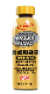
16-Oct-2023 | Beijing | Fuel-System Cleansers | Chemicals | Fire Hazard | 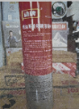
16-Oct-2023 | Beijing | Pencil Pouch | Stationery | Chemical Hazard, Health Risk Hazard | 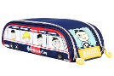
17-Oct-2023 | Henan | Baby Wearable Sleeping Bag | Fabric / Textile / Garment / Home Textile | Entanglement Hazard, Safety Risk Hazard | /
17-Oct-2023 | Henan | Children’s Underwear | Fabric / Textile / Garment / Home Textile | Choking Hazard, Suffocation Hazard, Safety Risk Hazard | /
17-Oct-2023 | Shandong | Electric Bicycles | Sporting Goods / Equipment | Safety Risk Hazard | /
17-Oct-2023 | Jilin | Student Uniforms (Summer) | Fabric / Textile / Garment / Home Textile | Entanglement Hazard, Safety Risk Hazard | /
17-Oct-2023 | Jiangsu | Electric Bicycles | Sporting Goods / Equipment | Injury Hazard, Crash Hazard, Fire Hazard | 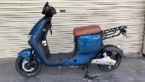
17-Oct-2023 | Jiangsu | Electric Bicycles | Sporting Goods / Equipment | Safety Risk Hazard, Fire Hazard, Electric Shock Hazard | 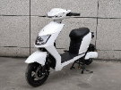
19-Oct-2023 | Jiangsu | Electric Bicycles | Sporting Goods / Equipment | Crash Hazard, Injury Hazard, Safety Risk Hazard, Fire Hazard | 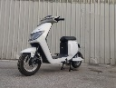
18-Oct-2023 | Jiangsu | Electric Bicycles | Sporting Goods / Equipment | Crash Hazard, Injury Hazard, Safety Risk Hazard, Fire Hazard | 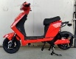  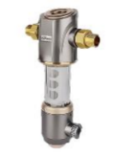
20-Oct-2023 | Beijing | Central Water Filtration System | Household Items | Health Risk Hazard | 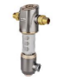
23-Oct-2023 | Hunan | Student Uniform Pants | Fabric / Textile / Garment / Home Textile | Skin Irritation Risk, Health Risk Hazard | 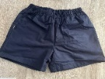
23-Oct-2023 | Henan | Infant Onesies | Fabric / Textile / Garment / Home Textile | Skin Irritation Risk, Health Risk Hazard | /
23-Oct-2023 | Sichuan | Bedsheet Set | Fabric / Textile / Garment / Home Textile | Burn Hazard, Microbiological Hazard | /
23-Oct-2023 | Sichuan | Bedsheet Set | Fabric / Textile / Garment / Home Textile | Health Risk Hazard, Risk of Allergy | /
23-Oct-2023 | Sichuan | Knitted Sports Pants and Children's Sports Pants | Fabric / Textile / Garment / Home Textile | Entanglement Hazard, Fall Hazard | /
23-Oct-2023 | Sichuan | Boys' Suits | Fabric / Textile / Garment / Home Textile | Entanglement Hazard, Suffocation Hazard, Fall Hazard | /
23-Oct-2023 | Sichuan | Children's Clothing | Fabric / Textile / Garment / Home Textile | Entanglement Hazard, Fall Hazard | /
23-Oct-2023 | Sichuan | Jeans | Fabric / Textile / Garment / Home Textile | Entanglement Hazard, Fall Hazard, Burn Hazard, Microbiological Hazard, Risk of Allergy, Health Risk Hazard | /
23-Oct-2023 | Sichuan | Jeans | Fabric / Textile / Garment / Home Textile | Entanglement Hazard, Fall Hazard | /
27-Oct-2023 | Hunan | Box Fans | Home Electrical Appliances | Electric Shock Hazard | 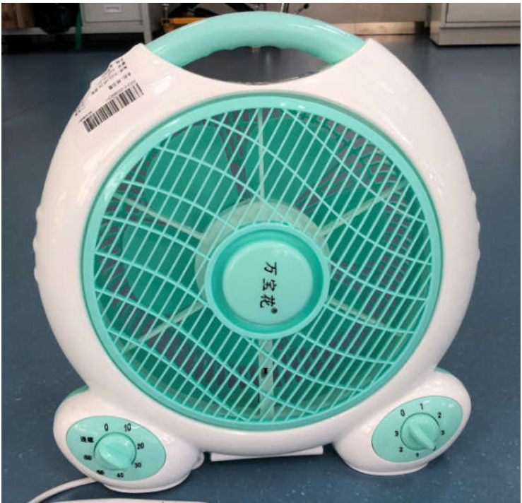
31-Oct-2023 | Hunan | Household Charging Station | Electrical Appliances | Electric Shock Hazard, Fire Hazard | 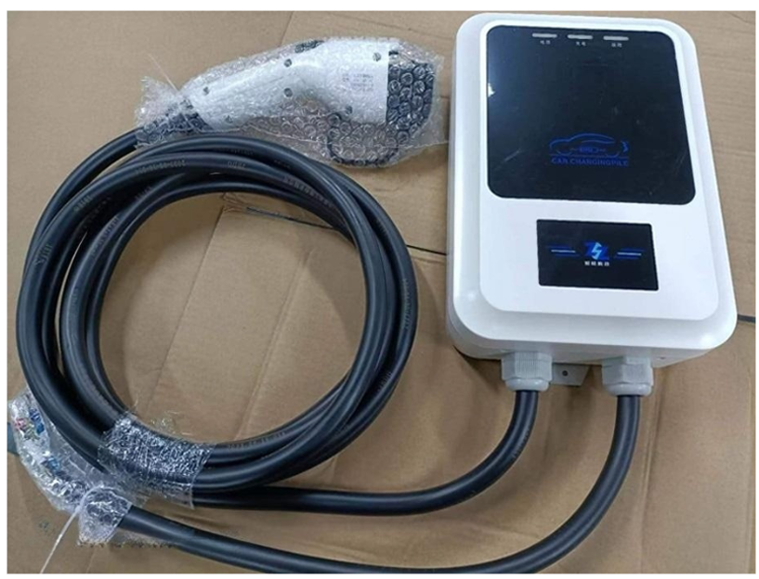
31-Oct-2023 | Hunan | Household Charging Station | Electrical Appliances | Electric Shock Hazard, Fire Hazard | 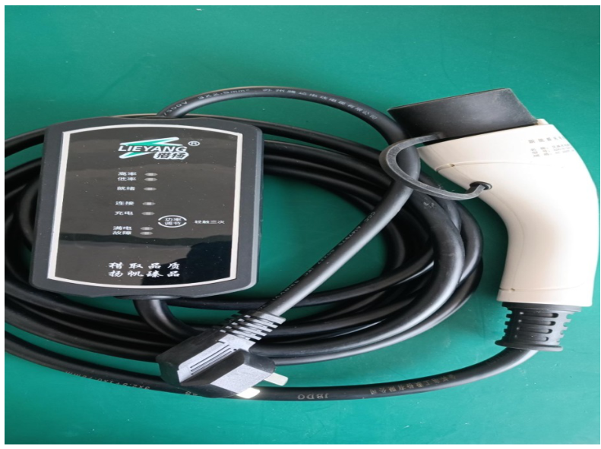
31-Oct-2023 | Hunan | Household Charging Station | Electrical Appliances | Electric Shock Hazard, Fire Hazard | 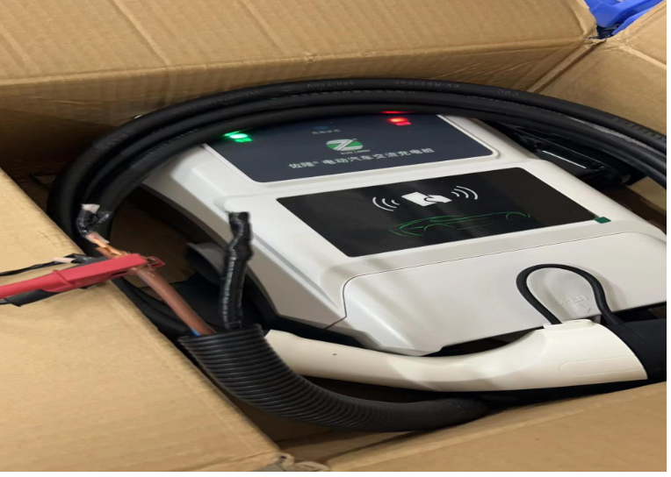
31-Oct-2023 | Hunan | Household Charging Station | Electrical Appliances | Electric Shock Hazard, Fire Hazard | 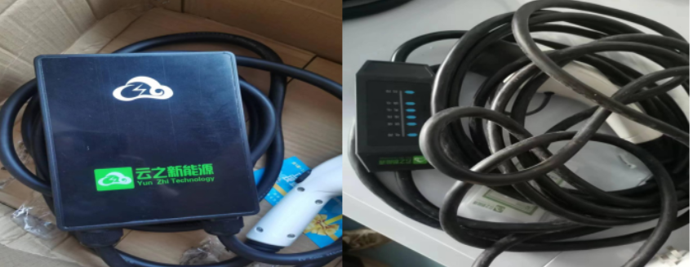
31-Oct-2023 | Hunan | Household Charging Station | Electrical Appliances | Electric Shock Hazard, Fire Hazard | 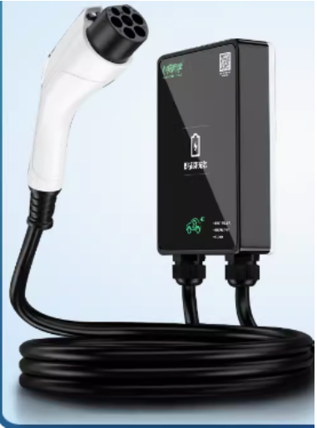
31-Oct-2023 | Hunan | Household Charging Station | Electrical Appliances | Electric Shock Hazard, Fire Hazard | 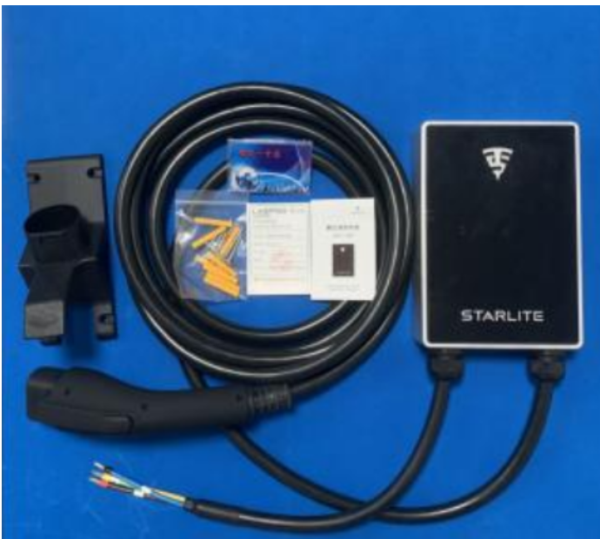
31-Oct-2023 | Hunan | Household Charging Station | Electrical Appliances | Electric Shock Hazard, Fire Hazard | 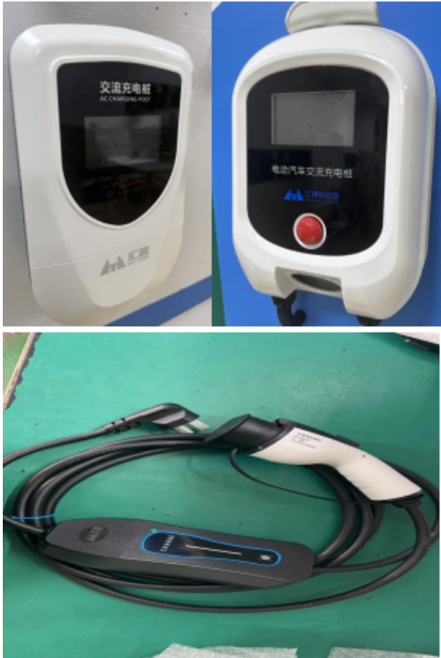
31-Oct-2023 | Hunan | Household Charging Station | Electrical Appliances | Electric Shock Hazard, Fire Hazard | 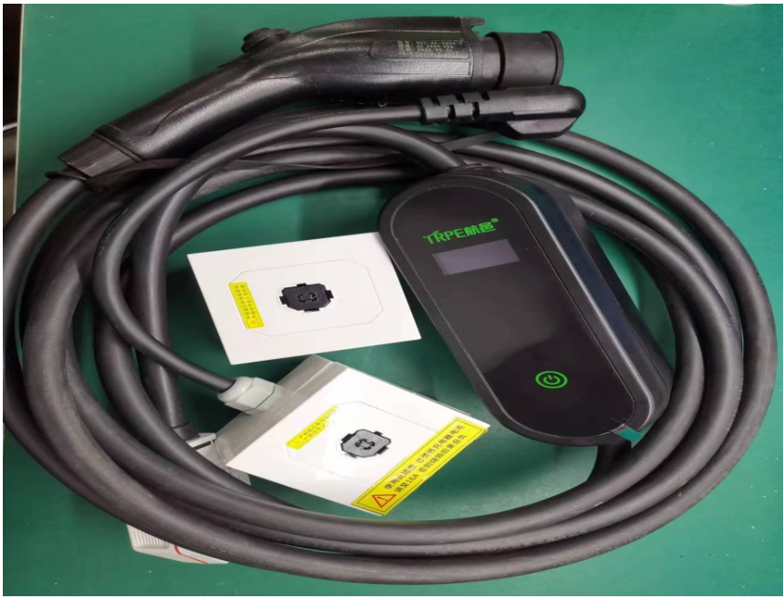
31-Oct-2023 | Hunan | Household Charging Station | Electrical Appliances | Electric Shock Hazard, Fire Hazard | 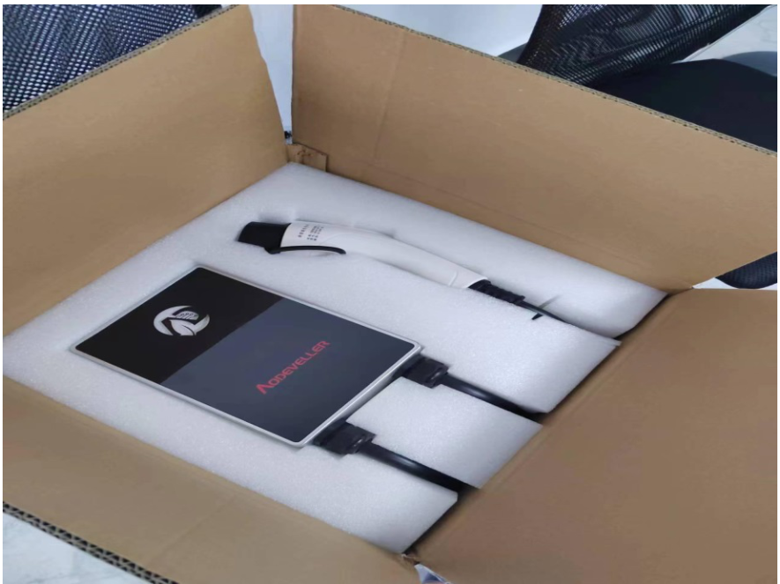
31-Oct-2023 | Hunan | Household Charging Station | Electrical Appliances | Electric Shock Hazard, Fire Hazard | 