Recall Cases Summary – Europe (Last Update Date: 31 October 2023)

Date | Notifying Country | Product | Categories | Hazard | Image
3-Oct-2023 | Italy | Fixing Spray | Bodycare / Cosmetics | Chemical Hazard | 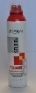
3-Oct-2023 | Italy | Eau De Parfum | Bodycare / Cosmetics | Chemical Hazard | 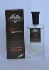
3-Oct-2023 | Italy | Roll-on Deodorant | Bodycare / Cosmetics | Chemical Hazard | 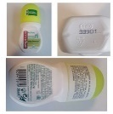
3-Oct-2023 | Italy | Hairspray | Bodycare / Cosmetics | Chemical Hazard | 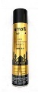
3-Oct-2023 | Italy | Hairspray | Bodycare / Cosmetics | Chemical Hazard | 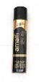
3-Oct-2023 | Italy | Shampoo | Bodycare / Cosmetics | Chemical Hazard | 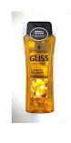
3-Oct-2023 | Italy | Shampoo | Bodycare / Cosmetics | Chemical Hazard
3-Oct-2023 | Italy | Shampoo | Bodycare / Cosmetics | Chemical Hazard | 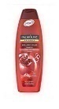
3-Oct-2023 | Italy | Hairspray | Bodycare / Cosmetics | Chemical Hazard | 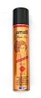
3-Oct-2023 | Italy | Hair Mousse | Bodycare / Cosmetics | Chemical Hazard | 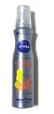
3-Oct-2023 | Italy | Liquid Soap | Bodycare / Cosmetics | Chemical Hazard | 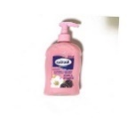
3-Oct-2023 | Italy | Hair Dye Set | Bodycare / Cosmetics | Chemical Hazard | 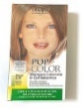  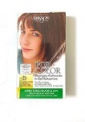  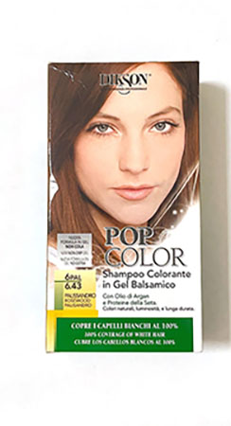  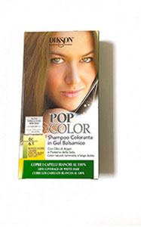
3-Oct-2023 | France | Soother Holder | Toys and Childcare Products | Strangulation Hazard | 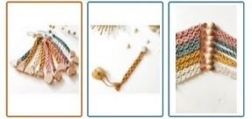
3-Oct-2023 | France | Balloons | Toys and Childcare Products | Chemical Hazard | 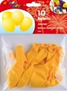  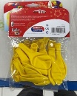
3-Oct-2023 | Italy | Roll-on Deodorant | Bodycare / Cosmetics | Chemical Hazard | 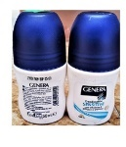
3-Oct-2023 | Italy | Conditioner | Bodycare / Cosmetics | Chemical Hazard | 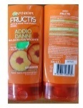
3-Oct-2023 | Italy | Shampoo | Bodycare / Cosmetics | Chemical Hazard | 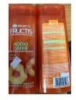
3-Oct-2023 | Italy | Shampoo | Bodycare / Cosmetics | Chemical Hazard | 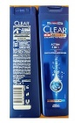
3-Oct-2023 | Italy | Shampoo | Bodycare / Cosmetics | Chemical Hazard | 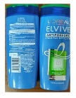
3-Oct-2023 | Italy | Hair Conditioner | Bodycare / Cosmetics | Chemical Hazard | 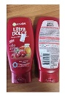
3-Oct-2023 | Italy | Shampoo | Bodycare / Cosmetics | Chemical Hazard | 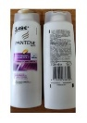
3-Oct-2023 | Italy | Hair Conditioner | Bodycare / Cosmetics | Chemical Hazard | 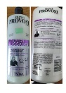
3-Oct-2023 | Italy | Bath Foam | Bodycare / Cosmetics | Chemical Hazard | 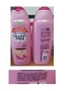
3-Oct-2023 | Italy | Bath Foam | Bodycare / Cosmetics | Chemical Hazard | 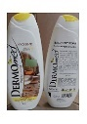
3-Oct-2023 | Italy | Shower Foam | Bodycare / Cosmetics | Chemical Hazard | 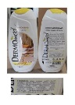
3-Oct-2023 | Italy | Shampoo | Bodycare / Cosmetics | Chemical Hazard | 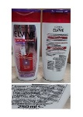
3-Oct-2023 | Finland | Hairpin | Accessories | Chemical Hazard | 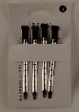
3-Oct-2023 | Hungary | Perfume | Bodycare / Cosmetics | Chemical Hazard | 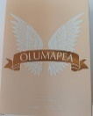
3-Oct-2023 | Hungary | Perfume | Bodycare / Cosmetics | Chemical Hazard | 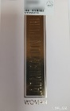
3-Oct-2023 | Sweden | Table Fan | Home Electrical Appliances | Environmental Hazard | 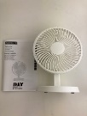
3-Oct-2023 | Hungary | Shower Gel | Bodycare / Cosmetics | Chemical Hazard | 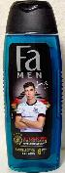
3-Oct-2023 | Czechia | Disposable Electronic Cigarette | Chemicals | Chemical Hazard | 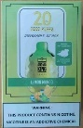
3-Oct-2023 | Hungary | Deodorant | Bodycare / Cosmetics | Chemical Hazard | 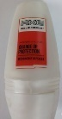
3-Oct-2023 | Hungary | Perfume | Bodycare / Cosmetics | Chemical Hazard | 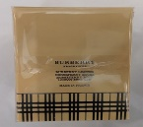
3-Oct-2023 | Sweden | Facial Hair Remover | Electrical Appliances | Environmental Hazard | 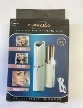
3-Oct-2023 | Sweden | Headphones | Computer / Audio / Video / Other Electronics & Accessories | Environmental Hazard | 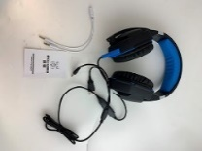
3-Oct-2023 | Sweden | Backpack | Fabric / Textile / Garment / Home Textile | Environmental Hazard | 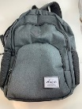
3-Oct-2023 | Sweden | Backpack | Fabric / Textile / Garment / Home Textile | Environmental Hazard | 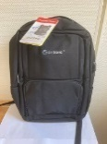
3-Oct-2023 | Bulgaria | Children's Sweatshirt | Fabric / Textile / Garment / Home Textile | Injury Hazard, Strangulation Hazard | 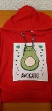
4-Oct-2023 | Italy | Hair Conditioner | Bodycare / Cosmetics | Chemical Hazard | 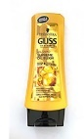
4-Oct-2023 | Italy | Shampoo | Bodycare / Cosmetics | Chemical Hazard | 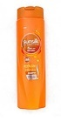
4-Oct-2023 | Italy | Hair Styling Foam | Bodycare / Cosmetics | Chemical Hazard | 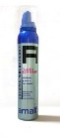
4-Oct-2023 | Italy | Hair Mousse | Bodycare / Cosmetics | Chemical Hazard | 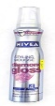
4-Oct-2023 | Italy | Skin Cleansing Gel | Bodycare / Cosmetics | Chemical Hazard | 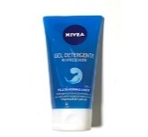
4-Oct-2023 | France | Modelling Clay | Toys and Childcare Products | Chemical Hazard | 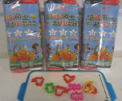
4-Oct-2023 | France | Welding Glue | Chemicals | Chemical Hazard | 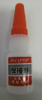
4-Oct-2023 | Italy | Shower Gel | Bodycare / Cosmetics | Chemical Hazard | 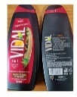
4-Oct-2023 | France | Set of Toy Vehicles | Toys and Childcare Products | Choking Hazard | 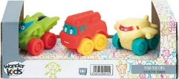
4-Oct-2023 | Sweden | HDMI Cable | Electrical Appliances | Chemical Hazard, Environmental Hazard | 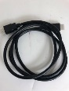
4-Oct-2023 | Slovenia | Rattle Toy | Toys and Childcare Products | Choking Hazard | 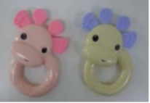
4-Oct-2023 | Hungary | Attachment for Brush Cutters | Machinery | Injury Hazard | 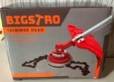  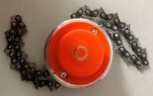
4-Oct-2023 | Bulgaria | Children’s Clothing Set | Fabric / Textile / Garment / Home Textile | Injury Hazard, Strangulation Hazard | 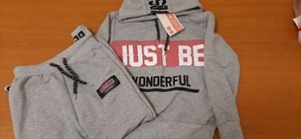
5-Oct-2023 | Italy | Wipes | Bodycare / Cosmetics | Chemical Hazard | 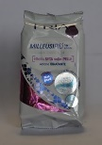
5-Oct-2023 | Italy | Beauty Set | Bodycare / Cosmetics | Chemical Hazard | 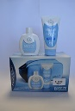
5-Oct-2023 | Ireland | Skateboard for Toy | Toys and Childcare Products | Choking Hazard
5-Oct-2023 | Latvia | Built-in Hob | Home Electrical Appliances | Asphyxiation Hazard | 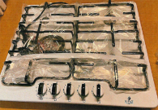
5-Oct-2023 | France | Fancy Dress | Fabric / Textile / Garment / Home Textile | Burn Hazard | 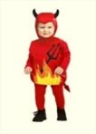
5-Oct-2023 | France | Finger Paint | Toys and Childcare Products | Chemical Hazard | 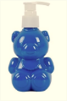
5-Oct-2023 | France | Toy Figurines | Toys and Childcare Products | Choking Hazard, Suffocation Hazard
5-Oct-2023 | Sweden | Flying Spinner | Toys and Childcare Products | Chemical Hazard, Environmental Hazard | 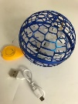
5-Oct-2023 | Slovenia | Plastic Toy Gun | Toys and Childcare Products | Choking Hazard | 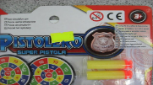  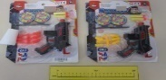
5-Oct-2023 | Hungary | Shower Gel | Bodycare / Cosmetics | Chemical Hazard | 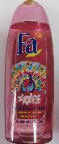
5-Oct-2023 | Malta | Baby Stroller | Toys and Childcare Products | Injury Hazard | 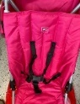  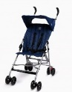
5-Oct-2023 | Lithuania | Soft Plastic Toy | Toys and Childcare Products | Chemical Hazard | 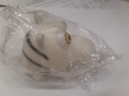
5-Oct-2023 | Italy | Bath Cream | Bodycare / Cosmetics | Chemical Hazard | 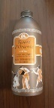
5-Oct-2023 | Italy | Bath Cream | Bodycare / Cosmetics | Chemical Hazard | 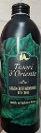
5-Oct-2023 | Italy | Eau De Toilette | Bodycare / Cosmetics | Chemical Hazard | 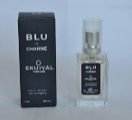
5-Oct-2023 | Italy | Deodorant Spray | Bodycare / Cosmetics | Chemical Hazard | 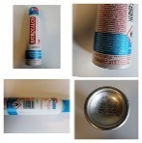
5-Oct-2023 | Italy | Roll-on Deodorant | Bodycare / Cosmetics | Chemical Hazard | 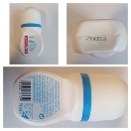
5-Oct-2023 | Italy | Deodorant Spray | Bodycare / Cosmetics | Chemical Hazard | 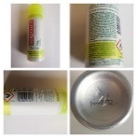
5-Oct-2023 | Italy | Shower Foam | Bodycare / Cosmetics | Chemical Hazard | 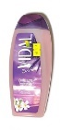
5-Oct-2023 | Malta | Play Dough | Toys and Childcare Products | Choking Hazard
5-Oct-2023 | Italy | Deodorant | Bodycare / Cosmetics | Chemical Hazard | 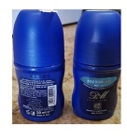
5-Oct-2023 | Italy | Roll-on Deodorant | Bodycare / Cosmetics | Chemical Hazard | 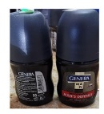
5-Oct-2023 | Czechia | Eau De Toilette | Bodycare / Cosmetics | Chemical Hazard | 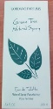  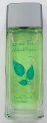
5-Oct-2023 | Italy | Hand Cream | Bodycare / Cosmetics | Chemical Hazard | 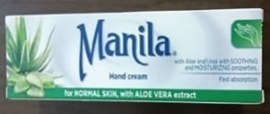
5-Oct-2023 | Italy | Anti-Wrinkle Cream | Bodycare / Cosmetics | Chemical Hazard | 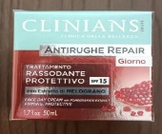
5-Oct-2023 | Italy | Hair Mask | Bodycare / Cosmetics | Chemical Hazard | 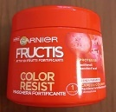
5-Oct-2023 | Italy | Aftershave | Bodycare / Cosmetics | Chemical Hazard | 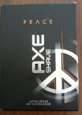
5-Oct-2023 | Hungary | Attachment for Brush Cutters | Machinery | Injury Hazard | 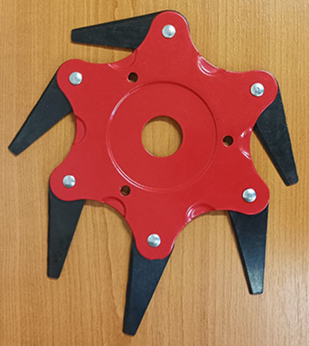
5-Oct-2023 | Hungary | Attachment for Brush Cutters | Machinery | Injury Hazard | 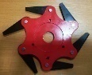
5-Oct-2023 | Hungary | Attachment for Brush Cutters | Machinery | Injury Hazard | 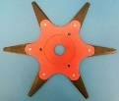
5-Oct-2023 | Sweden | Plastic Ball | Toys and Childcare Products | Environmental Hazard | 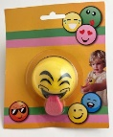
5-Oct-2023 | Lithuania | Lighting Chain | Electrical Appliances | Electric Shock Hazard | 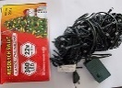
5-Oct-2023 | Slovenia | Soft Toy with Suction Cup | Toys and Childcare Products | Choking Hazard | 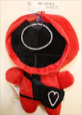
5-Oct-2023 | Italy | Shower Foam | Bodycare / Cosmetics | Chemical Hazard | 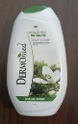
5-Oct-2023 | Italy | Deodorant Spray | Bodycare / Cosmetics | Chemical Hazard | 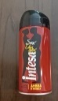
5-Oct-2023 | Poland | LED Power Supply | Electrical Appliances | Electric Shock Hazard | 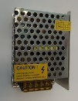
5-Oct-2023 | Ireland | Disposable Electronic Cigarette | Chemicals | Chemical Hazard | 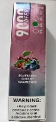  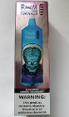
5-Oct-2023 | Ireland | Disposable Electronic Cigarette | Chemicals | Chemical Hazard | 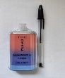  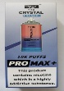
5-Oct-2023 | Ireland | Attachment for Brush Cutters | Machinery | Injury Hazard | 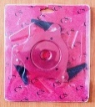
5-Oct-2023 | Ireland | Attachment for Brush Cutters | Machinery | Injury Hazard | 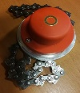
5-Oct-2023 | Hungary | Attachment for Brush Cutters | Machinery | Injury Hazard | 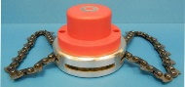
5-Oct-2023 | Hungary | Attachment for Brush Cutters | Machinery | Injury Hazard | 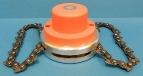
5-Oct-2023 | France | Skin Lightening Lotion | Bodycare / Cosmetics | Chemical Hazard | 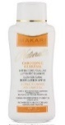
5-Oct-2023 | Finland | Rechargeable Flashlight | Electrical Appliances | Electric Shock Hazard | 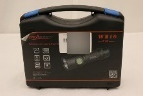
5-Oct-2023 | Finland | Charger for E-bike | Electrical Appliances | Electric Shock Hazard | 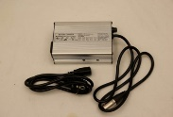
5-Oct-2023 | Sweden | Charms Set | Jewelry | Chemical Hazard
5-Oct-2023 | Hungary | Attachment for Brush Cutters | Machinery | Injury Hazard | 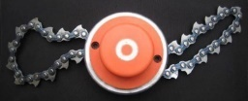
5-Oct-2023 | Hungary | Perfume | Bodycare / Cosmetics | Chemical Hazard
5-Oct-2023 | Hungary | Perfume | Bodycare / Cosmetics | Chemical Hazard | 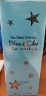
5-Oct-2023 | Sweden | Work Light | Electrical Appliances | Environmental Hazard | 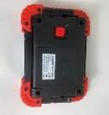  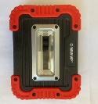
5-Oct-2023 | Sweden | Sensor Light | Electrical Appliances | Environmental Hazard
5-Oct-2023 | Hungary | Perfume | Bodycare / Cosmetics | Chemical Hazard | 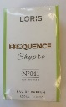
5-Oct-2023 | Hungary | Perfume | Bodycare / Cosmetics | Chemical Hazard | 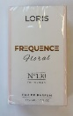
5-Oct-2023 | Sweden | Remote Controlled Car | Toys and Childcare Products | Environmental Hazard | 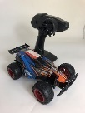
5-Oct-2023 | Hungary | Perfume | Bodycare / Cosmetics | Chemical Hazard | 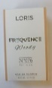
5-Oct-2023 | Sweden | Battery Charger | Electrical Appliances | Environmental Hazard | 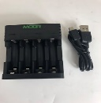
5-Oct-2023 | Hungary | Perfume | Bodycare / Cosmetics | Chemical Hazard | 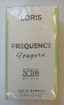
5-Oct-2023 | Hungary | Perfume | Bodycare / Cosmetics | Chemical Hazard | 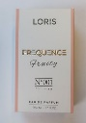
5-Oct-2023 | Hungary | Perfume | Bodycare / Cosmetics | Chemical Hazard | 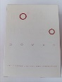
5-Oct-2023 | Hungary | Lamp Holder Adaptor | Tools and Hardware | Burn Hazard, Fire Hazard | 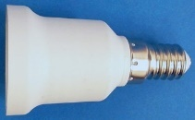
5-Oct-2023 | Hungary | Attachment for Brush Cutters | Machinery | Injury Hazard | 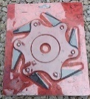
6-Oct-2023 | Hungary | Attachment for Brush Cutters | Machinery | Injury Hazard | 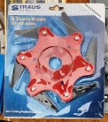
9-Oct-2023 | Germany | Car Windscreen Wash | Chemicals | Chemical Hazard | 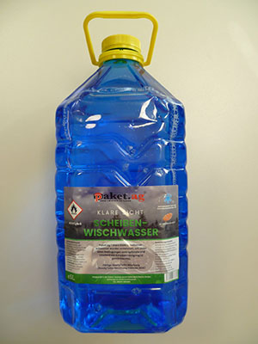
10-Oct-2023 | Germany | LED Light Bulb | Electrical Appliances | Electric Shock Hazard | 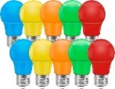
10-Oct-2023 | Austria | Bandages for Aromatherapy | Bodycare / Cosmetics | Chemical Hazard | 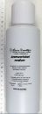
10-Oct-2023 | Lithuania | Hair Conditioner | Bodycare / Cosmetics | Chemical Hazard | 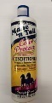
10-Oct-2023 | Lithuania | Shampoo | Bodycare / Cosmetics | Chemical Hazard | 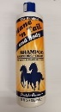
10-Oct-2023 | Lithuania | Hair Conditioner | Bodycare / Cosmetics | Chemical Hazard | 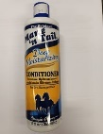
10-Oct-2023 | Lithuania | Hair Conditioner | Bodycare / Cosmetics | Chemical Hazard | 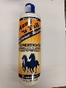
10-Oct-2023 | Hungary | Perfume | Bodycare / Cosmetics | Chemical Hazard | 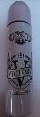
10-Oct-2023 | Hungary | Perfume | Bodycare / Cosmetics | Chemical Hazard | 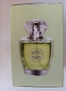  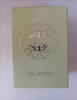
11-Oct-2023 | Ireland | Rattle Toy | Toys and Childcare Products | Choking Hazard | 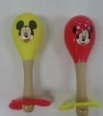
11-Oct-2023 | Denmark | Ceiling Lamp | Electrical Appliances | Electric Shock Hazard | 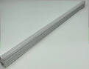
11-Oct-2023 | Denmark | Ceiling Lamp | Electrical Appliances | Electric Shock Hazard | 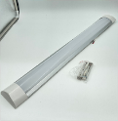
11-Oct-2023 | Czechia | Eau De Toilette | Bodycare / Cosmetics | Chemical Hazard | 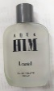
11-Oct-2023 | Sweden | Wireless Earphones | Computer / Audio / Video / Other Electronics & Accessories | Environmental Hazard | 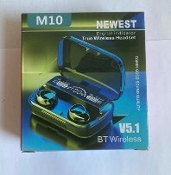
11-Oct-2023 | Sweden | Wireless Charging Bracket | Electrical Appliances | Environmental Hazard | 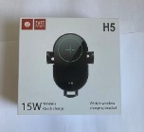
11-Oct-2023 | Sweden | Shoes | Footwear | Environmental Hazard | 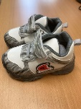
11-Oct-2023 | Sweden | Wristwatch | Accessories | Environmental Hazard | 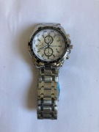
11-Oct-2023 | Hungary | Magnetic Toy | Toys and Childcare Products | Injury Hazard | 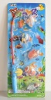
11-Oct-2023 | Finland | LED Lamp | Electrical Appliances | Electric Shock Hazard | 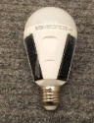
11-Oct-2023 | Poland | Plastic Doll | Toys and Childcare Products | Chemical Hazard | 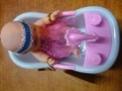
12-Oct-2023 | France | Plastic Rings Toy | Toys and Childcare Products | Cut Hazard, Injury Hazard | 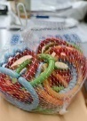
12-Oct-2023 | Hungary | Toy Musical Instrument | Toys and Childcare Products | Chemical Hazard | 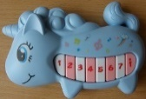
12-Oct-2023 | Germany | Disposable Electronic Cigarette | Chemicals | Chemical Hazard | 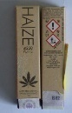  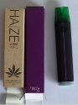  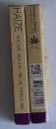
12-Oct-2023 | Ireland | Rattle Toy | Toys and Childcare Products | Choking Hazard | 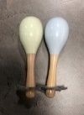
12-Oct-2023 | Italy | Cleansing Milk | Bodycare / Cosmetics | Chemical Hazard | 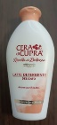
12-Oct-2023 | Poland | Soldering Iron | Tools and Hardware | Electric Shock Hazard, Fire Hazard | 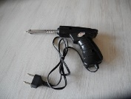
12-Oct-2023 | Hungary | Eau De Toilette | Bodycare / Cosmetics | Chemical Hazard | 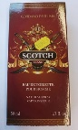
12-Oct-2023 | Cyprus | Children's Shoes | Footwear | Chemical Hazard | 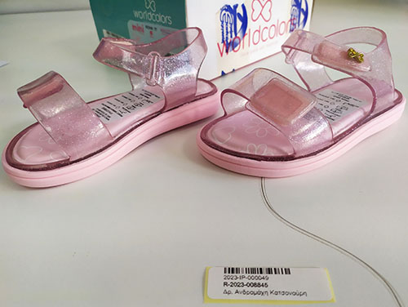
12-Oct-2023 | Lithuania | USB Charger | Electrical Appliances | Electric Shock Hazard | 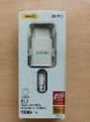
12-Oct-2023 | Sweden | Bicycle LED Lamp | Electrical Appliances | Environmental Hazard | 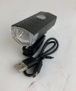
12-Oct-2023 | Sweden | Nail Scissors | Tools and Hardware | Environmental Hazard | 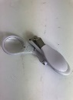
12-Oct-2023 | Finland | Lighting Chain | Electrical Appliances | Electric Shock Hazard | 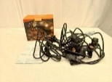
12-Oct-2023 | France | Glue | Chemicals | Chemical Hazard | 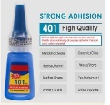
12-Oct-2023 | Hungary | Perfume | Bodycare / Cosmetics | Chemical Hazard | 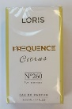
12-Oct-2023 | Hungary | Eau De Toilette | Bodycare / Cosmetics | Chemical Hazard | 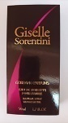
13-Oct-2023 | Hungary | Eau De Toilette | Bodycare / Cosmetics | Chemical Hazard | 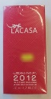
13-Oct-2023 | Hungary | Perfume | Bodycare / Cosmetics | Chemical Hazard | 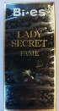
13-Oct-2023 | Hungary | Eau De Toilette | Bodycare / Cosmetics | Chemical Hazard | 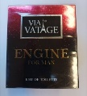
13-Oct-2023 | Lithuania | Plastic Doll | Toys and Childcare Products | Chemical Hazard | 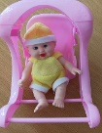
13-Oct-2023 | Hungary | Eau De Toilette | Bodycare / Cosmetics | Chemical Hazard | 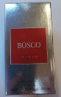
13-Oct-2023 | Hungary | Eau De Toilette | Bodycare / Cosmetics | Chemical Hazard | 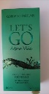
13-Oct-2023 | Hungary | Eau De Toilette | Bodycare / Cosmetics | Chemical Hazard | 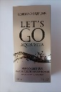
17-Oct-2023 | Estonia | Tattoo Ink | Chemicals | Chemical Hazard | 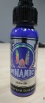
17-Oct-2023 | Estonia | Tattoo Ink | Chemicals | Chemical Hazard | 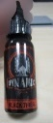
17-Oct-2023 | Sweden | Wireless MP3 Player For Car | Computer / Audio / Video / Other Electronics & Accessories | Environmental Hazard | 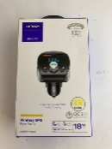
17-Oct-2023 | Sweden | Shaver | Electrical Appliances | Environmental Hazard | 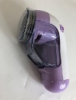
17-Oct-2023 | Sweden | Ring | Jewelry | Chemical Hazard | 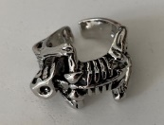
17-Oct-2023 | Sweden | Set of Rings | Jewelry | Chemical Hazard | 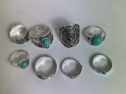
17-Oct-2023 | Sweden | Ring | Jewelry | Chemical Hazard | 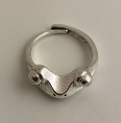
17-Oct-2023 | Czechia | Eau De Toilette | Bodycare / Cosmetics | Chemical Hazard | 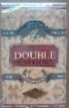
18-Oct-2023 | Estonia | Tattoo Ink | Chemicals | Chemical Hazard | 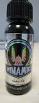
18-Oct-2023 | Hungary | Perfume | Chemicals | Chemical Hazard | 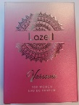
18-Oct-2023 | Hungary | Perfume | Chemicals | Chemical Hazard
19-Oct-2023 | Finland | Key Ring with Soft Toy | Toys and Childcare Products | Choking Hazard | 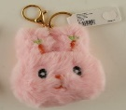  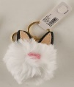
19-Oct-2023 | France | Button Batteries | Electrical Appliances | Chemical Hazard, Choking Hazard | 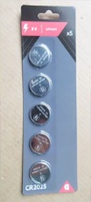
19-Oct-2023 | France | Portable Lamp | Electrical Appliances | Electric Shock Hazard | 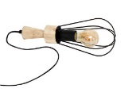
19-Oct-2023 | Germany | Safety Vest | Protective Equipment | Injury Hazard | 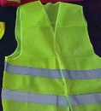
19-Oct-2023 | Germany | Safety Vest | Protective Equipment | Injury Hazard | 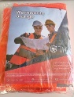
19-Oct-2023 | Bulgaria | Sweatshirt | Fabric / Textile / Garment / Home Textile | Injury Hazard, Strangulation Hazard
19-Oct-2023 | France | Glue | Chemicals | Chemical Hazard | 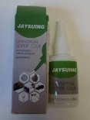
19-Oct-2023 | Hungary | Hair Dye | Bodycare / Cosmetics | Chemical Hazard | 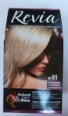
19-Oct-2023 | Lithuania | Plastic Doll | Toys and Childcare Products | Chemical Hazard | 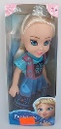
19-Oct-2023 | Lithuania | Plastic Doll | Toys and Childcare Products | Chemical Hazard | 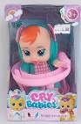
19-Oct-2023 | Slovenia | Soft Toy | Toys and Childcare Products | Chemical Hazard, Choking Hazard, Strangulation Hazard | 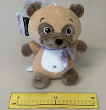
19-Oct-2023 | Lithuania | Toy Slime | Toys and Childcare Products | Chemical Hazard | 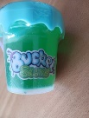
19-Oct-2023 | Lithuania | Plastic Doll | Toys and Childcare Products | Chemical Hazard | 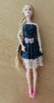
19-Oct-2023 | Lithuania | Wooden Car Toy | Toys and Childcare Products | Choking Hazard | 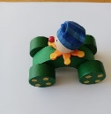
19-Oct-2023 | Finland | Soother Holder | Toys and Childcare Products | Choking Hazard | 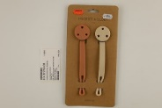
19-Oct-2023 | Germany | Concrete Screw | Construction Products | Injury Hazard | 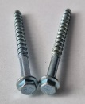
19-Oct-2023 | Germany | Concrete Screw | Construction Products | Injury Hazard | 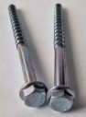
19-Oct-2023 | Romania | Eau De Toilette | Bodycare / Cosmetics | Chemical Hazard | 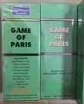
19-Oct-2023 | Romania | Yoyo Puffer Ball | Toys and Childcare Products | Strangulation Hazard | 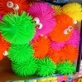
19-Oct-2023 | Germany | Hair Dye | Bodycare / Cosmetics | Chemical Hazard | 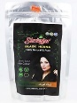
19-Oct-2023 | Sweden | Necklace | Jewelry | Chemical Hazard
19-Oct-2023 | Hungary | Cream | Bodycare / Cosmetics | Chemical Hazard | 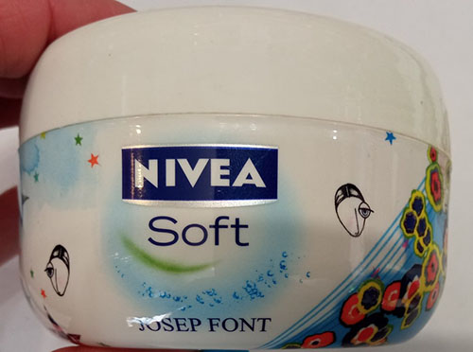
20-Oct-2023 | Lithuania | Rattle Toy | Toys and Childcare Products | Choking Hazard | 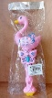
20-Oct-2023 | Germany | Tattoo Ink | Chemicals | Chemical Hazard | 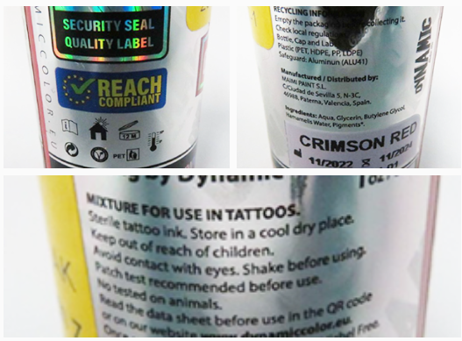
20-Oct-2023 | Germany | Concrete Screw | Construction Products | Injury Hazard | 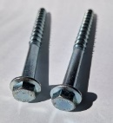
24-Oct-2023 | Romania | Eau De Toilette | Bodycare / Cosmetics | Chemical Hazard | 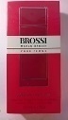
24-Oct-2023 | Romania | Eau De Toilette | Bodycare / Cosmetics | Chemical Hazard | 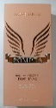
24-Oct-2023 | Romania | Perfume | Bodycare / Cosmetics | Chemical Hazard | 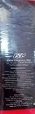
24-Oct-2023 | Romania | Perfume | Bodycare / Cosmetics | Chemical Hazard | 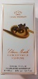
24-Oct-2023 | France | Finger Paint Kit | Toys and Childcare Products | Chemical Hazard | 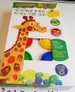
24-Oct-2023 | Romania | Yoyo Puffer Ball | Toys and Childcare Products | Strangulation Hazard
24-Oct-2023 | Italy | Liquid Soap | Bodycare / Cosmetics | Chemical Hazard | 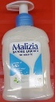
24-Oct-2023 | Italy | Bath and Shower Gel | Bodycare / Cosmetics | Chemical Hazard | 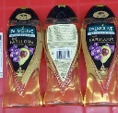
24-Oct-2023 | Hungary | Eau De Toilette | Bodycare / Cosmetics | Chemical Hazard | 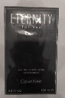
24-Oct-2023 | Romania | Eau De Toilette | Bodycare / Cosmetics | Chemical Hazard | 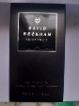
24-Oct-2023 | Hungary | Body Lotion | Bodycare / Cosmetics | Chemical Hazard | 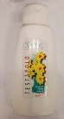
24-Oct-2023 | Hungary | Deodorant Spray | Bodycare / Cosmetics | Chemical Hazard | 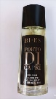
24-Oct-2023 | Sweden | Pendant | Jewelry | Chemical Hazard | 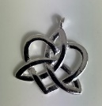
25-Oct-2023 | Ireland | Sleeping Bag | Fabric / Textile / Garment / Home Textile | Health Risk Hazard, Risk of Death | 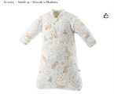
25-Oct-2023 | Ireland | Sleeping Bag | Fabric / Textile / Garment / Home Textile | Health Risk Hazard, Risk of Death | 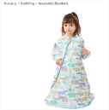
25-Oct-2023 | France | Fancy-Dress Costume | Fabric / Textile / Garment / Home Textile | Chemical Hazard
25-Oct-2023 | Italy | Deodorant Spray | Bodycare / Cosmetics | Chemical Hazard | 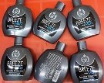
25-Oct-2023 | Italy | Deodorant Spray | Bodycare / Cosmetics | Chemical Hazard | 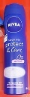
25-Oct-2023 | Cyprus | Flexible Water Pipe | Tools and Hardware | Chemical Hazard | 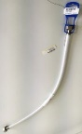
25-Oct-2023 | France | Teething Ring | Toys and Childcare Products | Choking Hazard | 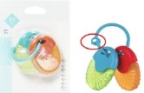
25-Oct-2023 | Germany | Concrete Screw | Construction Products | Injury Hazard | 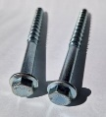
25-Oct-2023 | Finland | LED Power Supply | Electrical Appliances | Electric Shock Hazard | 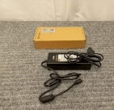
25-Oct-2023 | Sweden | Leave-in Hair Moisturizer | Bodycare / Cosmetics | Chemical Hazard | 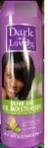
25-Oct-2023 | Finland | LED Light Bulb | Electrical Appliances | Electric Shock Hazard | 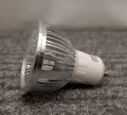
25-Oct-2023 | Finland | Insect Killer | Home Electrical Appliances | Electric Shock Hazard | 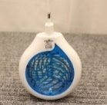
25-Oct-2023 | Finland | Travel Adaptor | Electrical Appliances | Electric Shock Hazard | 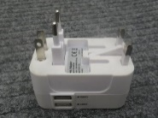
25-Oct-2023 | Finland | Battery Charger | Electrical Appliances | Electric Shock Hazard | 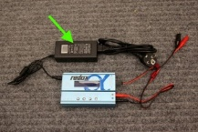
25-Oct-2023 | Poland | Power Supply | Electrical Appliances | Environmental Hazard | 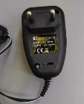
25-Oct-2023 | Hungary | Perfume | Bodycare / Cosmetics | Chemical Hazard | 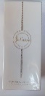
25-Oct-2023 | Hungary | Deodorant Spray | Bodycare / Cosmetics | Chemical Hazard | 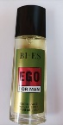
25-Oct-2023 | Sweden | LED Light Chain | Electrical Appliances | Environmental Hazard | 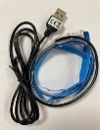
25-Oct-2023 | Sweden | Headset | Computer / Audio / Video / Other Electronics & Accessories | Environmental Hazard | 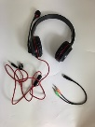
25-Oct-2023 | Sweden | LED Light Chain | Electrical Appliances | Environmental Hazard | 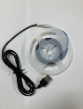
26-Oct-2023 | France | Toy Rattle | Toys and Childcare Products | Choking Hazard | 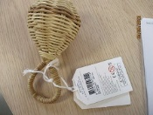
26-Oct-2023 | France | Soft Toy | Toys and Childcare Products | Choking Hazard | 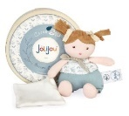
26-Oct-2023 | France | Soft Toy | Toys and Childcare Products | Choking Hazard | 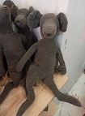
26-Oct-2023 | France | Toy Car | Toys and Childcare Products | Chemical Hazard, Choking Hazard | 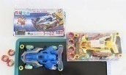  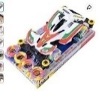
26-Oct-2023 | Ireland | Hair Dryer Brush | Electrical Appliances | Burn Hazard, Fire Hazard | 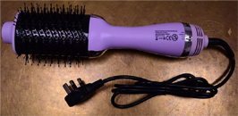
26-Oct-2023 | Ireland | Vanity Mirror | Home Electrical Appliances | Electric Shock Hazard | 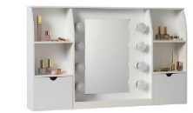
26-Oct-2023 | Germany | Motorcycle/  Spare Part | Car Components | Injury Hazard | 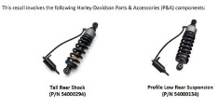
26-Oct-2023 | Estonia | Circular Saw Blade for Angle Grinders | Machinery | Cut Hazard, Injury Hazard | 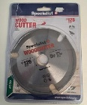
26-Oct-2023 | Slovakia | Attachment for Brush Cutters | Machinery | Injury Hazard | 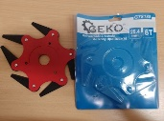
26-Oct-2023 | Germany | Concrete Screw | Construction Products | Injury Hazard | 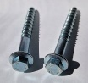
26-Oct-2023 | Sweden | Bag | Fabric / Textile / Garment / Home Textile | Chemical Hazard, Environmental Hazard | 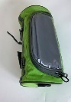
26-Oct-2023 | Sweden | Jumping Rope | Sporting Goods / Equipment | Chemical Hazard | 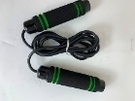
26-Oct-2023 | Czechia | Eau De Toilette | Bodycare / Cosmetics | Chemical Hazard | 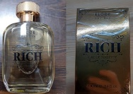
26-Oct-2023 | Sweden | Toiletry Bag | Fabric / Textile / Garment / Home Textile | Chemical Hazard | 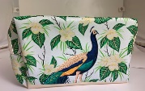
26-Oct-2023 | Finland | LED Light Bulb | Electrical Appliances | Electric Shock Hazard | 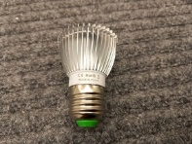
26-Oct-2023 | The Netherlands | Laser Pointer | Electrical Appliances | Damage to Sight
26-Oct-2023 | The Netherlands | Toy Birthday Cake | Toys and Childcare Products | Choking Hazard | 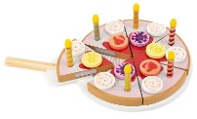
26-Oct-2023 | The Netherlands | Toy Camera | Toys and Childcare Products | Strangulation Hazard | 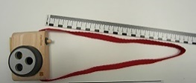
26-Oct-2023 | Poland | Toy Scooter | Toys and Childcare Products | Injury Hazard | 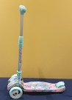
26-Oct-2023 | Sweden | Safety Barrier | Toys and Childcare Products | Choking Hazard | 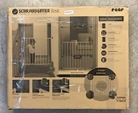
26-Oct-2023 | Sweden | Wristwatch | Accessories | Environmental Hazard | 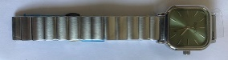
26-Oct-2023 | Sweden | USB Cable | Electrical Appliances | Environmental Hazard | 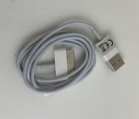
26-Oct-2023 | Sweden | Portable Diskette Drive | Electrical Appliances | Environmental Hazard | 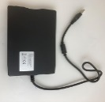
26-Oct-2023 | Sweden | Skin Care Device | Electrical Appliances | Environmental Hazard | 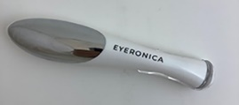
27-Oct-2023 | Denmark | Toy Gun | Toys and Childcare Products | Choking Hazard, Damage to Sight | 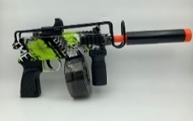
27-Oct-2023 | Hungary | Eau De Toilette | Bodycare / Cosmetics | Chemical Hazard | 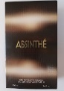
28-Oct-2023 | Sweden | Barcode Scanner | Electrical Appliances | Environmental Hazard | 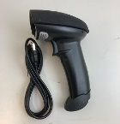
28-Oct-2023 | Sweden | Wristwatch | Accessories | Environmental Hazard | 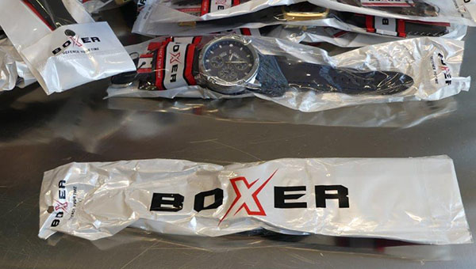  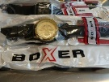
31-Oct-2023 | Sweden | Safety Barrier | Toys and Childcare Products | Injury Hazard, Strangulation Hazard | 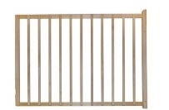
31-Oct-2023 | The Netherlands | Wooden Truck with Trailer | Toys and Childcare Products | Choking Hazard | 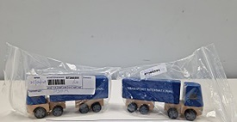
31-Oct-2023 | Luxembourg | Tyres | Car Components | Injury Hazard | 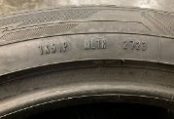
31-Oct-2023 | France | Glue | Chemicals | Chemical Hazard | 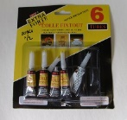
31-Oct-2023 | Romania | Toy Slime with Small Balls | Toys and Childcare Products | Choking Hazard | 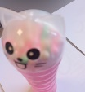
31-Oct-2023 | France | Finger Paints | Toys and Childcare Products | Chemical Hazard | 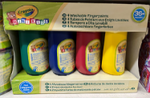
31-Oct-2023 | Hungary | Magnetic Fishing Toy | Toys and Childcare Products | Choking Hazard, Injury Hazard | 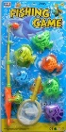
31-Oct-2023 | Sweden | Headband | Electrical Appliances | Chemical Hazard, Environmental Hazard | 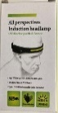
31-Oct-2023 | France | Anti-Algae Treatment for Swimming Pools | Chemicals | Chemical Hazard | 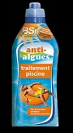
31-Oct-2023 | Sweden | Bath Mat | Household Items | Chemical Hazard, Environmental Hazard | 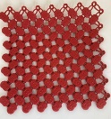
31-Oct-2023 | Sweden | Colour Screen Calendar | Electrical Appliances | Chemical Hazard, Environmental Hazard | 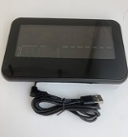
31-Oct-2023 | Sweden | Lamp | Electrical Appliances | Chemical Hazard, Environmental Hazard | 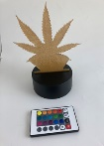
31-Oct-2023 | Sweden | Safety Barrier | Toys and Childcare Products | Injury Hazard, Strangulation Hazard | 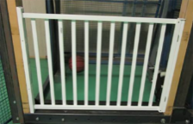
31-Oct-2023 | Sweden | Silvery Ring | Jewelry | Chemical Hazard | 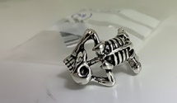
31-Oct-2023 | Sweden | Pendant Heart | Jewelry | Chemical Hazard | 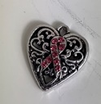
31-Oct-2023 | Sweden | Necklace | Jewelry | Chemical Hazard | 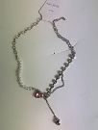
31-Oct-2023 | Slovakia | LED Lighting Chains | Electrical Appliances | Electric Shock Hazard | 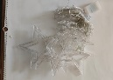  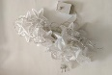  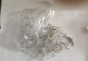
31-Oct-2023 | Slovakia | LED Lighting Chain | Electrical Appliances | Electric Shock Hazard | 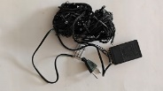
31-Oct-2023 | Slovakia | Christmas Tree | Electrical Appliances | Electric Shock Hazard | 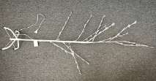
31-Oct-2023 | Sweden | Night Lamp with Insect Repellent | Electrical Appliances | Environmental Hazard | 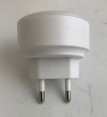
31-Oct-2023 | Hungary | Perfume | Bodycare / Cosmetics | Chemical Hazard | 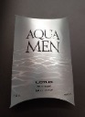
31-Oct-2023 | Hungary | Eau De Toilette | Bodycare / Cosmetics | Chemical Hazard | 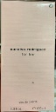
31-Oct-2023 | Hungary | Perfume | Bodycare / Cosmetics | Chemical Hazard | 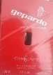
31-Oct-2023 | Hungary | Eau De Parfum | Bodycare / Cosmetics | Chemical Hazard | 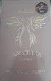
31-Oct-2023 | Sweden | Media Cable | Electrical Appliances | Environmental Hazard | 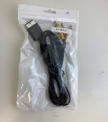
31-Oct-2023 | Sweden | USB Cable | Electrical Appliances | Environmental Hazard | 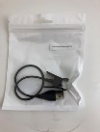
31-Oct-2023 | Denmark | Toy Tractor | Toys and Childcare Products | Choking Hazard | 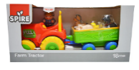  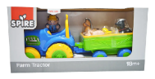
31-Oct-2023 | Croatia | Protective Gloves | Protective Equipment | Cut Hazard | 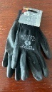
31-Oct-2023 | Poland | Toy Scooter | Toys and Childcare Products | Injury Hazard | 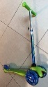
31-Oct-2023 | Poland | Wireless Earbuds | Computer / Audio / Video / Other Electronics & Accessories | Environmental Hazard | 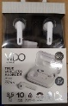
31-Oct-2023 | Hungary | Perfume | Bodycare / Cosmetics | Chemical Hazard | 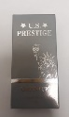
31-Oct-2023 | Hungary | Perfume | Bodycare / Cosmetics | Chemical Hazard | 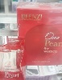
31-Oct-2023 | Poland | Perfume | Bodycare / Cosmetics | Chemical Hazard | 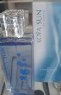
31-Oct-2023 | Poland | Electric Toy Motorcycle | Sporting Goods / Equipment | Injury Hazard | 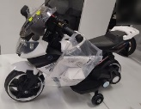
31-Oct-2023 | Lithuania | Toy Car | Toys and Childcare Products | Choking Hazard | 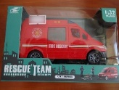
31-Oct-2023 | Slovakia | Lighting Chain | Electrical Appliances | Electric Shock Hazard | 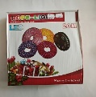
31-Oct-2023 | Lithuania | Screw-on Toy | Toys and Childcare Products | Choking Hazard | 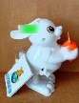  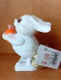
31-Oct-2023 | Lithuania | Toy Unicorn in a Plastic Egg | Toys and Childcare Products | Chemical Hazard | 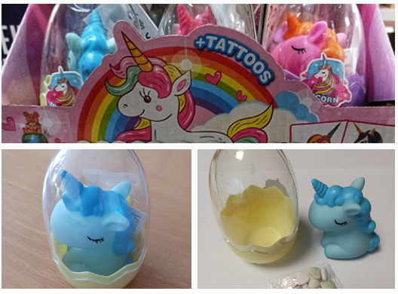
31-Oct-2023 | Lithuania | Toy Helicopter with Sweets | Toys and Childcare Products | Choking Hazard | 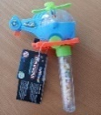
31-Oct-2023 | Poland | Fireworks | Outdoor Living Items | Burn Hazard, Injury Hazard | 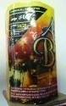
31-Oct-2023 | Slovakia | LED Lighting Chain | Electrical Appliances | Electric Shock Hazard | 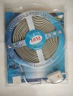
31-Oct-2023 | Poland | Soft Toy | Toys and Childcare Products | Choking Hazard
31-Oct-2023 | Sweden | Waist Chain | Jewelry | Chemical Hazard
31-Oct-2023 | Czechia | Toy with Sweets | Toys and Childcare Products | Chemical Hazard | 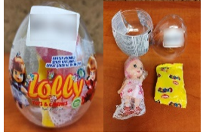
31-Oct-2023 | Lithuania | Machine Toy Set | Toys and Childcare Products | Choking Hazard | 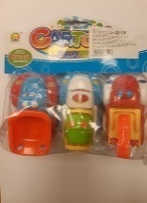
31-Oct-2023 | France | Pool Liner Repair Kit | Chemicals | Chemical Hazard, Damage to Sight, Health Risk Hazard | 