Recall Cases Summary – US (Last Update Date: 31 October 2023)

Date | Product | Categories | Hazard | Image
5-Oct-2023 | MCA-88 Multizone Controller Amplifiers | Computer / Audio / Video / Other Electronics & Accessories | Fire Hazard | 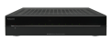
5-Oct-2023 | Slime Licker Sour Rolling Liquid Candies | Food | Choking Hazard | 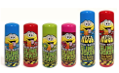
5-Oct-2023 | Cocco’s Candy Rolling Candy | Food | Choking Hazard, Risk of Death | 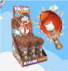  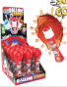  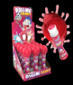
5-Oct-2023 | Children’s Blanket Sleepers and Robes | Fabric / Textile / Garment / Home Textile | Burn Hazard, Injury Hazard | 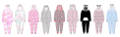
5-Oct-2023 | Capri Blue Pet Products | Chemicals | Microbiological Hazard | 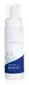
12-Oct-2023 | Children’s Play Tents | Toys and Childcare Products | Choking Hazard, Laceration Hazard | 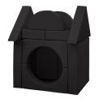
12-Oct-2023 | Sleepyhead Loveys and Bandana Bibs | Fabric / Textile / Garment / Home Textile | Choking Hazard | 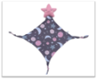  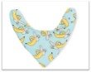
12-Oct-2023 | Countertop Nugget Ice Makers | Home Electrical Appliances | Laceration Hazard | 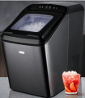  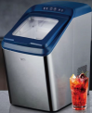  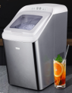
12-Oct-2023 | Children’s Weighted Blankets | Fabric / Textile / Garment / Home Textile | Asphyxiation Hazard, Risk of Death, Entrapment Hazard | 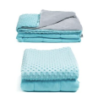
12-Oct-2023 | Crystal Clear Sodium Hydroxide | Chemicals | Burn Hazard, Skin Irritation Risk, Eye Irritation Risk | 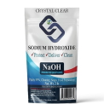
19-Oct-2023 | Biometric Gun Safes | Protective Equipment | Injury Hazard, Risk of Death | 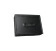  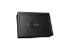  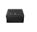  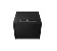  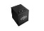  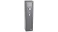  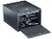
19-Oct-2023 | Thomas & Friends Wooden Railway Troublesome Truck & Crates and Troublesome Truck & Paint | Toys and Childcare Products | Choking Hazard, Ingestion Hazard | 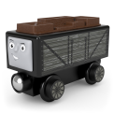  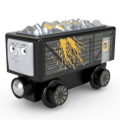
26-Oct-2023 | Pressure Cookers | Home Electrical Appliances | Burn Hazard | 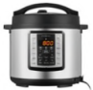  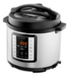  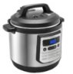
26-Oct-2023 | Engines Used in Lawn and Garden Equipment | Machinery | Fire Hazard, Burn Hazard | 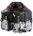  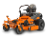  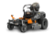  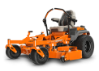  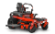  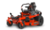  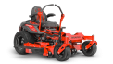  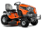  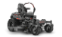  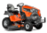  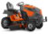  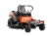  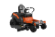  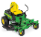  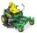  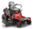
26-Oct-2023 | Cosco Jump, Spin & Play Activity Centers | Toys and Childcare Products | Fall Hazard, Injury Hazard | 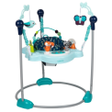  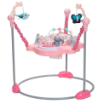
26-Oct-2023 | Bobcat and Kubota Stand-On Zero Turn Lawnmowers | Machinery | Crash Hazard, Laceration Hazard | 