Recall Cases Summary – Australia (Last Update Date: 30 November 2023)

Date | Product | Categories | Hazard | Image
1-Nov-2023 | ColorSpec Base Coat Colour - 300g Aerosol Can | Chemicals | Injury Hazard | 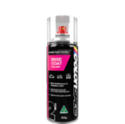
3-Nov-2023 | Wooden Railway Troublesome Truck & Crates and Wooden Railway Troublesome Truck & Paint | Toys and Childcare Products | Choking Hazard, Injury Hazard, Risk of Death, Swallowing Risk | 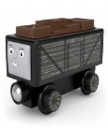  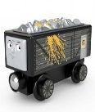
3-Nov-2023 | Grass Catcher for Victa Classic Cut Anniversary Edition Lawn Mower | Machinery | Injury Hazard, Laceration Hazard | 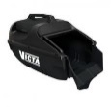  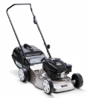
6-Nov-2023 | Powerforce 15m Heavy Duty Extension Lead- Yellow | Electrical Appliances | Injury Hazard, Risk of Death, Electric Shock Hazard, Fire Hazard | 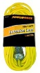
8-Nov-2023 | Battery World and Remote King Garage Remotes | Electrical Appliances | Choking Hazard, Injury Hazard, Risk of Death, Swallowing Risk, Burn Hazard | 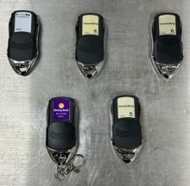
9-Nov-2023 | Pet Collar with LED Lights and Pet Safety Leash with LED Lights | Pet Items | Choking Hazard, Injury Hazard, Risk of Death, Swallowing Risk, Burn Hazard | 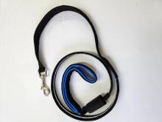  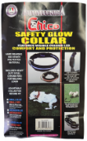
10-Nov-2023 | Dog 4in Megaton LED Ball - Blue/Orange and Dog 12in Megaton LED Vortex - Blue/Green | Toys and Childcare Products | Choking Hazard, Burn Hazard, Injury Hazard, Risk of Death, Swallowing Risk | 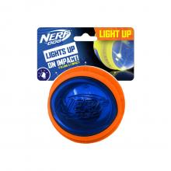
10-Nov-2023 | Little Drive Toy | Toys and Childcare Products | Choking Hazard, Suffocation Hazard, Risk of Death | 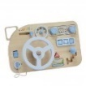
16-Nov-2023 | Riff the Fox Teether | Toys and Childcare Products | Choking Hazard, Suffocation Hazard, Risk of Death | 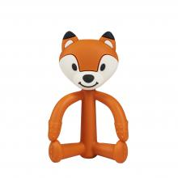
17-Nov-2023 | Solar Power Inverters | Electrical Appliances | Injury Hazard, Risk of Death, Electric Shock Hazard | 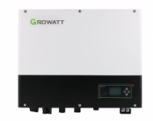
22-Nov-2023 | Casalux Solar LED Street Light | Electrical Appliances | Injury Hazard, Risk of Death, Fire Hazard | 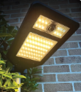
23-Nov-2023 | Aerpro White Key Chain Pocket Light | Electrical Appliances | Choking Hazard, Burn Hazard, Injury Hazard, Risk of Death, Swallowing Risk | 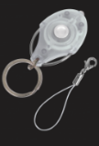
23-Nov-2023 | Music Box | Accessories | Choking Hazard, Burn Hazard, Injury Hazard, Risk of Death, Swallowing Risk | 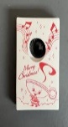  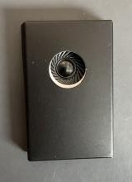  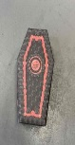  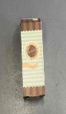
23-Nov-2023 | Remote Control Supplied with Aerpro AutoDAB+ Digital Radio | Computer / Audio / Video / Other Electronics & Accessories | Choking Hazard, Burn Hazard, Injury Hazard, Risk of Death, Swallowing Risk | 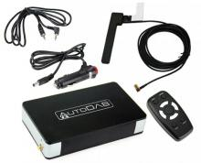
24-Nov-2023 | Fridge Vent Excess Sealant | Outdoor Living Items | Injury Hazard, Burn Hazard | 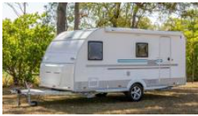
30-Nov-2023 | Mocka Wooden Play Gym | Toys and Childcare Products | Choking Hazard, Suffocation Hazard, Risk of Death | 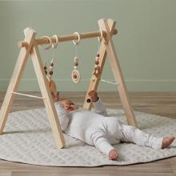
30-Nov-2023 | Maxell CR-1616 Micro Lithium Battery | Electrical Appliances | Choking Hazard, Burn Hazard, Injury Hazard, Risk of Death, Swallowing Risk | 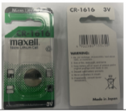
30-Nov-2023 | Flashing Clown Nose | Toys and Childcare Products | Choking Hazard, Injury Hazard, Swallowing Risk | 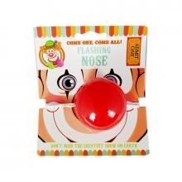
30-Nov-2023 | Comsol 4 Port HDMI Switch | Electrical Appliances | Choking Hazard, Burn Hazard, Injury Hazard, Risk of Death, Swallowing Risk | 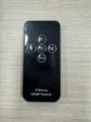
30-Nov-2023 | Gasmate Hose 1000mm High Pressure with Schrader Valve | Outdoor Living Items | Injury Hazard, Risk of Death, Fire Hazard, Explosion Hazard | 