Recall Cases Summary – Canada (Last Update Date: 30 November 2023)

Date | Product | Categories | Hazard | Image
1-Nov-2023 | Seafood Balls | Food | Risk of Allergy | 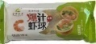  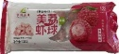  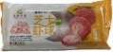  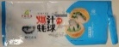
1-Nov-2023 | Honda Outboard Engines | Machinery | Crash Hazard, Injury Hazard | 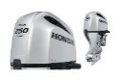  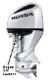  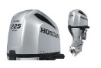
1-Nov-2023 | Battery Pack within Certain Anker EverFrost Powered Coolers | Electrical Appliances | Fire Hazard | 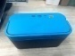  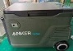  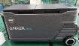  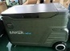  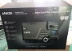
1-Nov-2023 | Cantaloupes | Food | Microbiological Hazard | 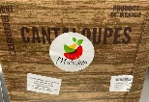
2-Nov-2023 | Residential Condensing Boilers, Combi Boilers and Packaged Systems | Home Electrical Appliances | Carbon Monoxide Poisoning Hazard | 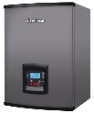
2-Nov-2023 | Ski Bindings | Sporting Goods / Equipment | Fall Hazard, Injury Hazard | 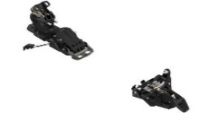
2-Nov-2023 | Apricot Halves in Light Syrup | Food | Chemical Hazard | /
3-Nov-2023 | Oak Leaf LLC Baby Feeding Nursing Pillows | Toys and Childcare Products | Choking Hazard | v
3-Nov-2023 | Chocolate Croissant | Food | Risk of Allergy | 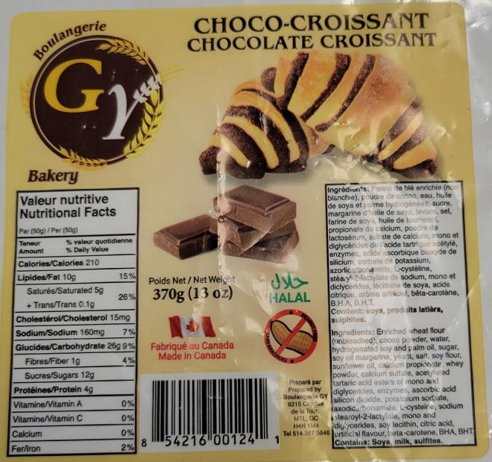
3-Nov-2023 | Mushroom Soup Mixes | Food | Risk of Allergy | /
6-Nov-2023 | STIHL MSA 300 Chain Saws | Machinery | Laceration Hazard | 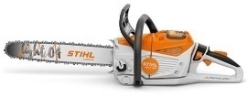
7-Nov-2023 | Drydock Strong Powerful Hull Cleaner | Chemicals | Injury Hazard, Risk of Death | 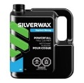
8-Nov-2023 | Shrimp Paste | Food | Risk of Allergy | 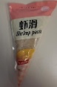
8-Nov-2023 | Champignon Énoki (Enoki Mushrooms) | Food | Microbiological Hazard | 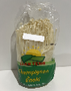
9-Nov-2023 | DR Pro Tow-Behind Field and Brush Mowers | Machinery | Fire Hazard, Burn Hazard | 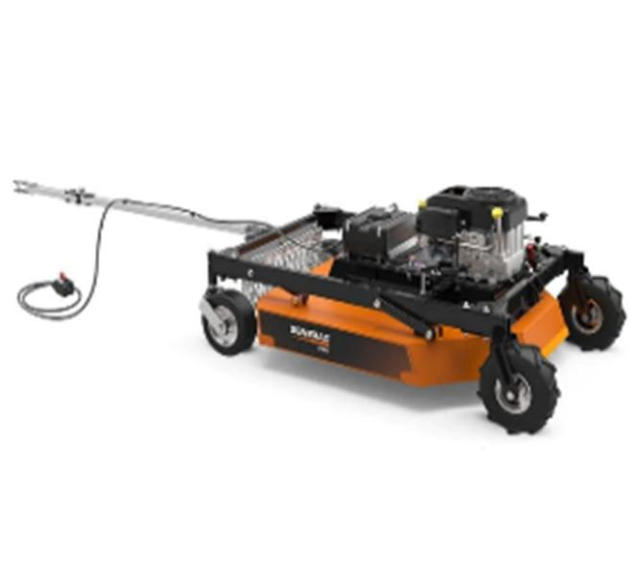  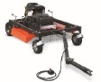
9-Nov-2023 | AKMI Kids Crop Top Plaid Long Sleeve Hoodie | Fabric / Textile / Garment / Home Textile | Strangulation Hazard | 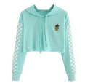
9-Nov-2023 | Naturally Brewed Soy Sauce | Food | Microbiological Hazard | /
10-Nov-2023 | Cantaloupe Products | Food | Microbiological Hazard | /
10-Nov-2023 | Gluten-Free Flours | Food | Risk of Allergy | /
14-Nov-2023 | Cantaloupes | Food | Microbiological Hazard | 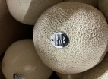
14-Nov-2023 | Cantaloupe | Food | Microbiological Hazard | /
15-Nov-2023 | Tikka Masala Cooking Sauce | Food | Risk of Allergy | 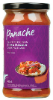
16-Nov-2023 | Milk Chocolate Covered Raisins | Food | Risk of Allergy | 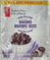
17-Nov-2023 | White Horizontal Fauxwood 2” Blind Safecord | Household Items | Strangulation Hazard, Entanglement Hazard, Risk of Death | 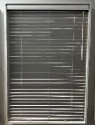
17-Nov-2023 | Pesto | Food | Microbiological Hazard | 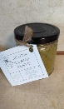
18-Nov-2023 | Various Brands of Fresh Cut Fruit | Food | Microbiological Hazard | /
20-Nov-2023 | Child Safety Seats | Toys and Childcare Products | Injury Hazard | 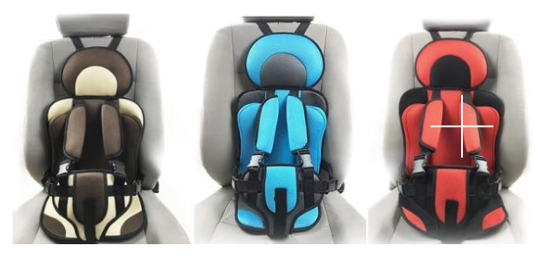
21-Nov-2023 | 100% Fresh Enoki Mushrooms | Food | Microbiological Hazard | 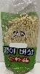
22-Nov-2023 | B’loonies | Toys and Childcare Products | Chemical Hazard | 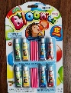
22-Nov-2023 | Lenovo USB-C Laptop Power Bank | Electrical Appliances | Fire Hazard | 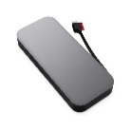
22-Nov-2023 | Cantaloupe | Food | Microbiological Hazard | /
22-Nov-2023 | Fruit Salad | Food | Microbiological Hazard | /
24-Nov-2023 | Cantaloupes | Food | Microbiological Hazard | 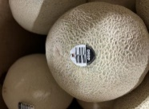
24-Nov-2023 | Home Decorators Collection Grand Duchess Balsam Fir 5000 LED Pre-Lit Artificial Christmas Tree | Electrical Appliances | Burn Hazard, Fire Hazard | 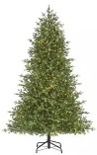
24-Nov-2023 | Nissui Brand Frozen Baked Wheat Cake with Octopus | Food | Risk of Allergy | /
27-Nov-2023 | Pro Point 7-Piece Propane Heating Torch Kit | Tools and Hardware | Fire Hazard, Burn Hazard | 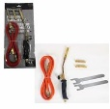
27-Nov-2023 | Cantaloupe | Food | Microbiological Hazard | /
30-Nov-2023 | CNC Alloy Pedals | Sporting Goods / Equipment | Fall Hazard | 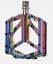
30-Nov-2023 | Cantaloupe | Food | Microbiological Hazard | /
30-Nov-2023 | Mixed Melon Chunks | Food | Microbiological Hazard | 