Recall Cases Summary – Europe (Last Update Date: 30 November 2023)

Date | Notifying Country | Product | Categories | Hazard | Image
1-Nov-2023 | Luxembourg | Bicycle Helmet | Protective Equipment | Health Risk Hazard, Injury Hazard | 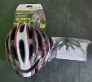
6-Nov-2023 | Ireland | Hand Cream | Bodycare / Cosmetics | Chemical Hazard | 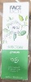
7-Nov-2023 | Norway | Electric Eyelash Curler | Electrical Appliances | Environmental Hazard | 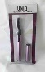
7-Nov-2023 | France | Perfume | Bodycare / Cosmetics | Chemical Hazard | 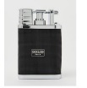  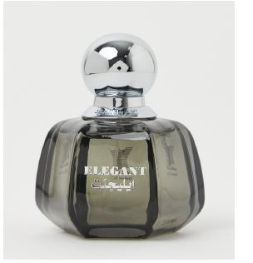
7-Nov-2023 | France | Perfume | Bodycare / Cosmetics | Chemical Hazard | 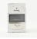  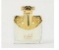  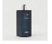  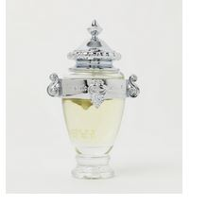  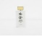  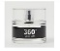
7-Nov-2023 | France | Perfume | Bodycare / Cosmetics | Chemical Hazard | 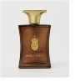
7-Nov-2023 | Germany | Disposable Electronic Cigarette | Chemicals | Chemical Hazard | 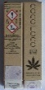
7-Nov-2023 | The Netherlands | Rain Boots | Footwear | Chemical Hazard | 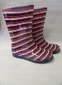
7-Nov-2023 | Czechia | Eau De Toilette | Bodycare / Cosmetics | Chemical Hazard | 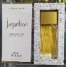
7-Nov-2023 | Sweden | Hat with Lighting Chain | Fabric / Textile / Garment / Home Textile | Environmental Hazard | 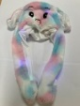
7-Nov-2023 | Sweden | LED Lighting Chain | Electrical Appliances | Environmental Hazard | 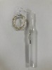
7-Nov-2023 | Sweden | Electrical Face Mask | Electrical Appliances | Environmental Hazard | 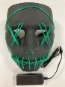
7-Nov-2023 | The Netherlands | Wooden Toy | Toys and Childcare Products | Strangulation Hazard | 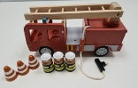
8-Nov-2023 | Hungary | Perfume | Bodycare / Cosmetics | Chemical Hazard
8-Nov-2023 | France | Dark Spots Corrector Cream | Bodycare / Cosmetics | Chemical Hazard | 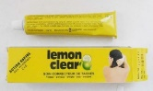
9-Nov-2023 | Italy | Tattoo Needles | Tools and Hardware | Microbiological Hazard | 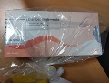
9-Nov-2023 | France | Expandable Toy | Toys and Childcare Products | Choking Hazard, Injury Hazard | 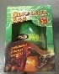
9-Nov-2023 | France | Electric Hedge Trimmer | Machinery | Electric Shock Hazard | 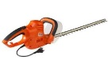
9-Nov-2023 | Sweden | Body Lotion | Bodycare / Cosmetics | Chemical Hazard | 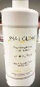
9-Nov-2023 | France | Fancy-Dress Costume | Fabric / Textile / Garment / Home Textile | Burn Hazard, Choking Hazard, Strangulation Hazard | 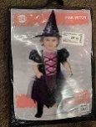
9-Nov-2023 | Norway | Nail Dryer | Electrical Appliances | Environmental Hazard | 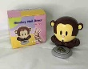
9-Nov-2023 | Lithuania | Lip Balm | Bodycare / Cosmetics | Microbiological Hazard | 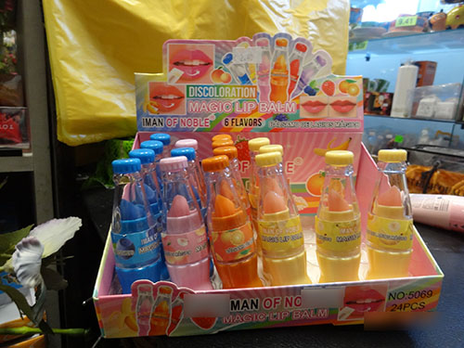
9-Nov-2023 | Estonia | Foaming Soap | Bodycare / Cosmetics | Burn Hazard | 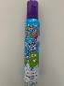  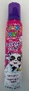
9-Nov-2023 | Romania | Tracksuit | Fabric / Textile / Garment / Home Textile | Injury Hazard, Strangulation Hazard | 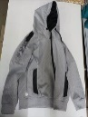
9-Nov-2023 | Ireland | Baby Self-Feeding Pillow | Toys and Childcare Products | Choking Hazard | 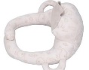
9-Nov-2023 | Ireland | Baby Self-feeding Pillow | Toys and Childcare Products | Choking Hazard | 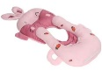
9-Nov-2023 | Ireland | Baby Self-Feeding Pillow | Toys and Childcare Products | Choking Hazard | 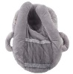
9-Nov-2023 | Ireland | Baby Self-Feeding Pillow | Toys and Childcare Products | Choking Hazard | 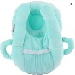
9-Nov-2023 | Ireland | Baby Self-Feeding Pillow | Toys and Childcare Products | Choking Hazard | 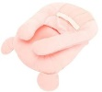
9-Nov-2023 | Lithuania | Toy Plane with Sweets | Toys and Childcare Products | Choking Hazard, Injury Hazard | 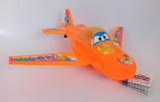
9-Nov-2023 | Hungary | Eau De Toilette | Bodycare / Cosmetics | Chemical Hazard | 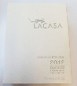
9-Nov-2023 | Sweden | Remote Control | Computer / Audio / Video / Other Electronics & Accessories | Environmental Hazard | 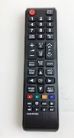
9-Nov-2023 | Sweden | Remote Control | Computer / Audio / Video / Other Electronics & Accessories | Environmental Hazard | 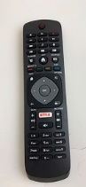
9-Nov-2023 | Sweden | Remote Control | Computer / Audio / Video / Other Electronics & Accessories | Environmental Hazard | 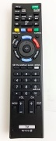
9-Nov-2023 | Sweden | Remote Control | Computer / Audio / Video / Other Electronics & Accessories | Environmental Hazard | 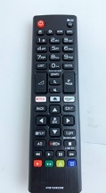
9-Nov-2023 | Sweden | Remote Control | Computer / Audio / Video / Other Electronics & Accessories | Environmental Hazard | 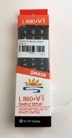
9-Nov-2023 | Sweden | Remote Control | Computer / Audio / Video / Other Electronics & Accessories | Environmental Hazard | 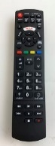
9-Nov-2023 | Sweden | Wireless Audio Receiver | Electrical Appliances | Environmental Hazard | 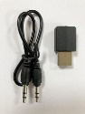
9-Nov-2023 | Sweden | USB Cable | Electrical Appliances | Environmental Hazard | 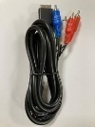
9-Nov-2023 | Sweden | Dual USB Adaptor | Electrical Appliances | Environmental Hazard | 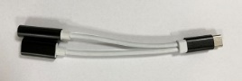
9-Nov-2023 | Sweden | Dual USB Adaptor | Electrical Appliances | Environmental Hazard | 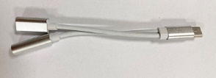
9-Nov-2023 | Sweden | Earphones | Computer / Audio / Video / Other Electronics & Accessories | Environmental Hazard | 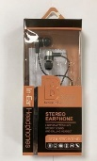
9-Nov-2023 | Sweden | Desktop Wireless Receiver | Computer / Audio / Video / Other Electronics & Accessories | Environmental Hazard | 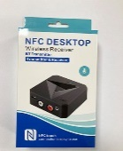
9-Nov-2023 | Sweden | Digital MP3 Player | Computer / Audio / Video / Other Electronics & Accessories | Environmental Hazard | 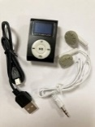
9-Nov-2023 | Sweden | Controller for Nintendo Wii | Computer / Audio / Video / Other Electronics & Accessories | Environmental Hazard | 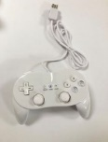
9-Nov-2023 | Sweden | Controller for Nintendo Wii | Computer / Audio / Video / Other Electronics & Accessories | Environmental Hazard
9-Nov-2023 | Sweden | Remote Control | Computer / Audio / Video / Other Electronics & Accessories | Environmental Hazard | 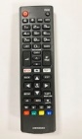
9-Nov-2023 | Sweden | USB Cable | Electrical Appliances | Environmental Hazard | 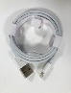
9-Nov-2023 | Germany | Ballpoint Pen | Stationery | Chemical Hazard | 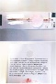
9-Nov-2023 | Germany | Children’s Flip-Flops | Footwear | Chemical Hazard | 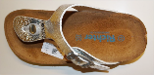
9-Nov-2023 | Sweden | USB Cable | Electrical Appliances | Environmental Hazard | 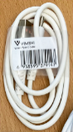
9-Nov-2023 | Sweden | Cooking Thermometer | Food Contact Material | Environmental Hazard | 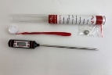
9-Nov-2023 | Sweden | Glow Stick | Electrical Appliances | Environmental Hazard | 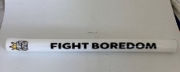
9-Nov-2023 | Czechia | Perfume | Bodycare / Cosmetics | Chemical Hazard | 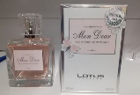
9-Nov-2023 | Hungary | Shampoo | Bodycare / Cosmetics | Chemical Hazard | 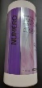
10-Nov-2023 | Hungary | Perfume | Bodycare / Cosmetics | Chemical Hazard | 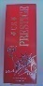
14-Nov-2023 | France | Magnetic Fishing Game | Toys and Childcare Products | Chemical Hazard, Choking Hazard | 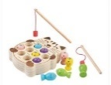
14-Nov-2023 | Hungary | Eye Contour Cream | Bodycare / Cosmetics | Chemical Hazard | 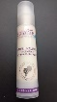
14-Nov-2023 | Czechia | Disposable Electronic Cigarette | Chemicals | Chemical Hazard | 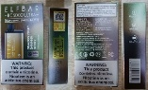  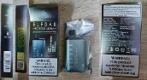
14-Nov-2023 | Hungary | Perfume | Bodycare / Cosmetics | Chemical Hazard | 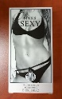
14-Nov-2023 | Hungary | Eau De Toilette | Bodycare / Cosmetics | Chemical Hazard | 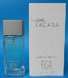
14-Nov-2023 | Sweden | Mobile Speaker | Computer / Audio / Video / Other Electronics & Accessories | Environmental Hazard | 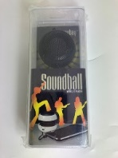
14-Nov-2023 | Sweden | Necklace | Jewelry | Chemical Hazard | 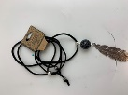
14-Nov-2023 | Hungary | Perfume | Bodycare / Cosmetics | Chemical Hazard
14-Nov-2023 | Bulgaria | Plastic Chair | Furniture | Injury Hazard | 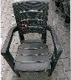
14-Nov-2023 | Bulgaria | Plastic Chair | Furniture | Injury Hazard | 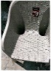
14-Nov-2023 | Hungary | Massage Cream | Bodycare / Cosmetics | Chemical Hazard | 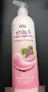
14-Nov-2023 | Hungary | Acne Control Cream | Bodycare / Cosmetics | Chemical Hazard | 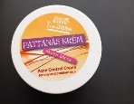
14-Nov-2023 | Poland | Plastic Doll | Toys and Childcare Products | Chemical Hazard | 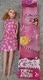
14-Nov-2023 | Lithuania | Hooded Sweatshirt | Fabric / Textile / Garment / Home Textile | Injury Hazard, Strangulation Hazard
15-Nov-2023 | Germany | Nesting Doll Set | Toys and Childcare Products | Choking Hazard | 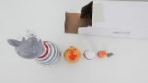
15-Nov-2023 | Germany | Toy Crossbow | Toys and Childcare Products | Choking Hazard | 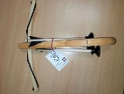
15-Nov-2023 | Sweden | Wall Clock | Electrical Appliances | Environmental Hazard | 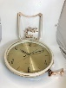
15-Nov-2023 | Hungary | Shampoo | Bodycare / Cosmetics | Chemical Hazard | 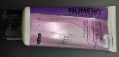
15-Nov-2023 | Poland | Magnetic Toy Set | Toys and Childcare Products | Injury Hazard | 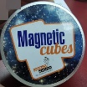
15-Nov-2023 | Lithuania | Hooded Sweatshirt | Fabric / Textile / Garment / Home Textile | Injury Hazard, Strangulation Hazard | 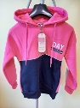
15-Nov-2023 | Lithuania | Hooded Sweatshirt | Fabric / Textile / Garment / Home Textile | Injury Hazard, Strangulation Hazard | 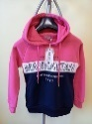
15-Nov-2023 | Lithuania | Hooded Sweatshirt | Fabric / Textile / Garment / Home Textile | Injury Hazard, Strangulation Hazard | 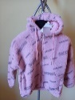
15-Nov-2023 | Lithuania | Hooded Sweatshirt | Fabric / Textile / Garment / Home Textile | Injury Hazard, Strangulation Hazard | 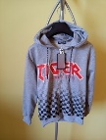
15-Nov-2023 | Lithuania | Tracksuit | Fabric / Textile / Garment / Home Textile | Injury Hazard, Strangulation Hazard | 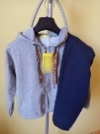
16-Nov-2023 | The Netherlands | Multi-Purpose Cleaner | Bodycare / Cosmetics | Chemical Hazard | 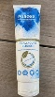
16-Nov-2023 | Cyprus | Toy Bow with Arrow | Toys and Childcare Products | Choking Hazard, Damage to Sight | 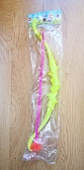
16-Nov-2023 | Germany | Skin Peel | Bodycare / Cosmetics | Chemical Hazard | 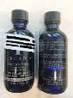
16-Nov-2023 | Germany | Toy Water Pistol | Toys and Childcare Products | Choking Hazard | 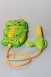
16-Nov-2023 | France | Ballpoint Pen | Stationery | Chemical Hazard, Choking Hazard | 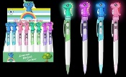
16-Nov-2023 | Germany | Toy Crossbow | Toys and Childcare Products | Choking Hazard | 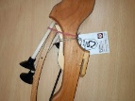
16-Nov-2023 | France | Key Ring | Toys and Childcare Products | Chemical Hazard, Choking Hazard | 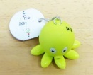
16-Nov-2023 | Sweden | Remote Control | Computer / Audio / Video / Other Electronics & Accessories | Environmental Hazard | 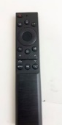
16-Nov-2023 | Sweden | Key Finder | Computer / Audio / Video / Other Electronics & Accessories | Environmental Hazard | 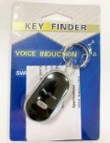
16-Nov-2023 | Sweden | Solar Garden LED Lamp | Electrical Appliances | Environmental Hazard | 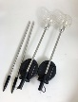
16-Nov-2023 | Sweden | USB Cable | Electrical Appliances | Environmental Hazard | 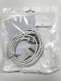
16-Nov-2023 | Sweden | Desktop Bluetooth Receiver | Computer / Audio / Video / Other Electronics & Accessories | Environmental Hazard | 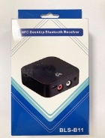
16-Nov-2023 | Sweden | Wallet | Fabric / Textile / Garment / Home Textile | Chemical Hazard | 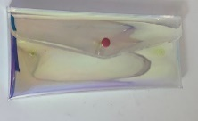
16-Nov-2023 | Iceland | Sensory Swing | Toys and Childcare Products | Strangulation Hazard, Suffocation Hazard | 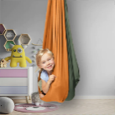
16-Nov-2023 | Sweden | Optical Mouse | Computer / Audio / Video / Other Electronics & Accessories | Chemical Hazard, Environmental Hazard | 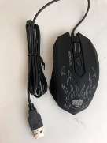
16-Nov-2023 | The Netherlands | Toy Train | Toys and Childcare Products | Choking Hazard | 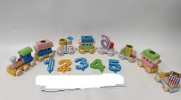
16-Nov-2023 | Germany | Electronic Cigarette Cartridge | Chemicals | Chemical Hazard | 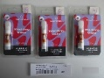  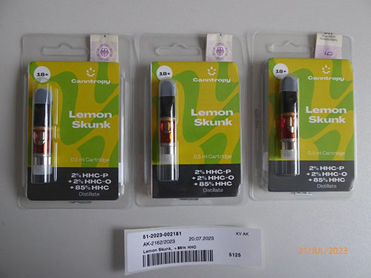  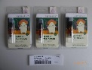
16-Nov-2023 | Ireland | Halloween Decoration | Fabric / Textile / Garment / Home Textile | Cut Hazard, Injury Hazard
16-Nov-2023 | Lithuania | Plastic Toy | Toys and Childcare Products | Chemical Hazard | 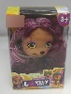
16-Nov-2023 | Czechia | Perfume | Bodycare / Cosmetics | Chemical Hazard | 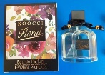
16-Nov-2023 | Germany | Baby Carrier | Toys and Childcare Products | Injury Hazard | 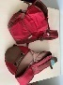
16-Nov-2023 | Sweden | Bluetooth Speaker | Computer / Audio / Video / Other Electronics & Accessories | Chemical Hazard, Environmental Hazard | 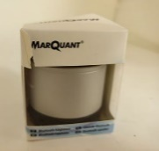
16-Nov-2023 | Lithuania | Rattle Toy | Toys and Childcare Products | Choking Hazard
16-Nov-2023 | Bulgaria | Plastic Chair | Furniture | Injury Hazard | 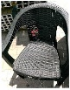
16-Nov-2023 | Bulgaria | Folding Table | Furniture | Injury Hazard | 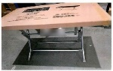
16-Nov-2023 | Denmark | Ceiling LED Lamp | Electrical Appliances | Electric Shock Hazard | 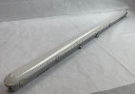
16-Nov-2023 | Lithuania | Tracksuit | Fabric / Textile / Garment / Home Textile | Injury Hazard, Strangulation Hazard | 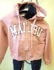
16-Nov-2023 | Italy | Shaving Soap | Bodycare / Cosmetics | Chemical Hazard | 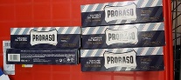
16-Nov-2023 | Italy | Aftershave | Bodycare / Cosmetics | Chemical Hazard | 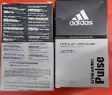
16-Nov-2023 | Italy | Deodorant Spray | Bodycare / Cosmetics | Chemical Hazard | 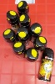  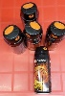
16-Nov-2023 | Italy | Roll-on Deodorant | Bodycare / Cosmetics | Chemical Hazard | 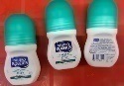
16-Nov-2023 | Italy | Hair Gel | Bodycare / Cosmetics | Chemical Hazard | 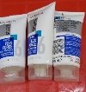
16-Nov-2023 | Slovakia | Attachment for Brush Cutters | Machinery | Injury Hazard | 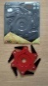
16-Nov-2023 | Italy | Face Cream | Bodycare / Cosmetics | Chemical Hazard | 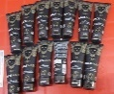
16-Nov-2023 | Italy | Eau De Toilette | Bodycare / Cosmetics | Chemical Hazard | 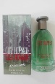
16-Nov-2023 | Sweden | Backpack with USB | Fabric / Textile / Garment / Home Textile | Environmental Hazard | 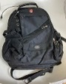
16-Nov-2023 | Austria | Battery-operated Soft Toy | Toys and Childcare Products | Choking Hazard | 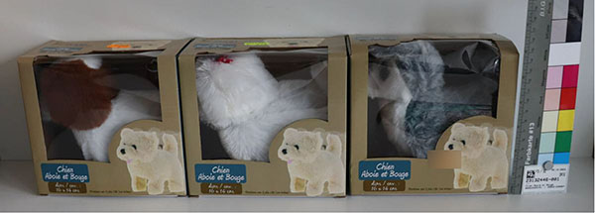
16-Nov-2023 | Italy | Eau De Toilette | Bodycare / Cosmetics | Chemical Hazard | 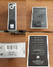
16-Nov-2023 | Italy | Eau De Toilette | Bodycare / Cosmetics | Chemical Hazard | 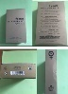
16-Nov-2023 | Italy | Perfume | Bodycare / Cosmetics | Chemical Hazard | 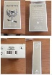
16-Nov-2023 | Italy | Perfume | Bodycare / Cosmetics | Chemical Hazard | 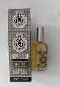
16-Nov-2023 | Italy | Perfume | Bodycare / Cosmetics | Chemical Hazard | 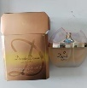
16-Nov-2023 | Italy | Perfume | Bodycare / Cosmetics | Chemical Hazard | 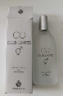
16-Nov-2023 | Italy | Eau De Toilette | Bodycare / Cosmetics | Chemical Hazard | 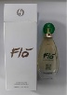
16-Nov-2023 | Italy | Soap Bar | Bodycare / Cosmetics | Chemical Hazard | 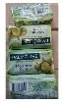
16-Nov-2023 | Germany | Children’s Flip Flops | Footwear | Chemical Hazard | 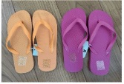
16-Nov-2023 | Italy | Shower Foam | Bodycare / Cosmetics | Chemical Hazard | 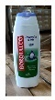
16-Nov-2023 | Italy | Slippers | Footwear | Chemical Hazard | 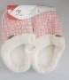  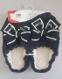  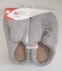  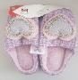
16-Nov-2023 | Italy | Slippers | Footwear | Chemical Hazard | 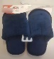  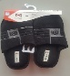  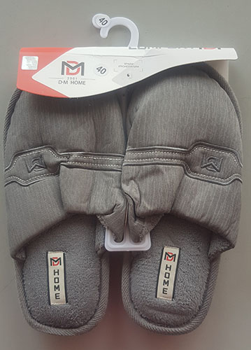
16-Nov-2023 | Italy | Shower Gel | Bodycare / Cosmetics | Chemical Hazard | 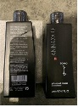
16-Nov-2023 | Italy | Perfume | Bodycare / Cosmetics | Chemical Hazard | 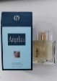
16-Nov-2023 | Italy | Shower Gel | Bodycare / Cosmetics | Chemical Hazard | 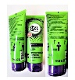
16-Nov-2023 | Italy | Perfume | Bodycare / Cosmetics | Chemical Hazard | 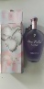
16-Nov-2023 | Italy | Sun Protection Spray | Bodycare / Cosmetics | Chemical Hazard | 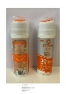
16-Nov-2023 | Italy | Night Cream | Bodycare / Cosmetics | Chemical Hazard | 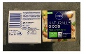
16-Nov-2023 | Italy | Hair Spray | Bodycare / Cosmetics | Chemical Hazard | 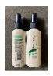
16-Nov-2023 | Bulgaria | Plastic Chair | Furniture | Injury Hazard | 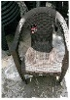
16-Nov-2023 | Hungary | Eye Cream | Bodycare / Cosmetics | Chemical Hazard | 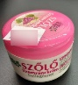
16-Nov-2023 | Hungary | Face Lotion | Bodycare / Cosmetics | Chemical Hazard | 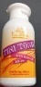
16-Nov-2023 | Hungary | Perfume | Bodycare / Cosmetics | Chemical Hazard | 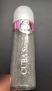
16-Nov-2023 | Hungary | Eau De Toilette | Bodycare / Cosmetics | Chemical Hazard | 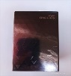
16-Nov-2023 | Italy | Shampoo and Conditioner | Bodycare / Cosmetics | Chemical Hazard | 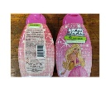
16-Nov-2023 | Hungary | Eau De Toilette | Bodycare / Cosmetics | Chemical Hazard | 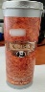
16-Nov-2023 | Italy | Shampoo | Bodycare / Cosmetics | Chemical Hazard | 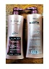
16-Nov-2023 | Italy | Shampoo | Bodycare / Cosmetics | Chemical Hazard | 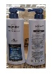
16-Nov-2023 | Italy | Eau De Toilette | Bodycare / Cosmetics | Chemical Hazard | 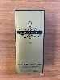
16-Nov-2023 | Italy | Perfume | Bodycare / Cosmetics | Chemical Hazard | 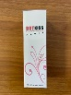
16-Nov-2023 | Sweden | Door Stop Alarm | Home Electrical Appliances | Environmental Hazard | 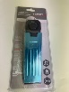
16-Nov-2023 | Italy | Hair Conditioner | Bodycare / Cosmetics | Chemical Hazard | 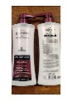
16-Nov-2023 | Italy | Hair Conditioner | Bodycare / Cosmetics | Chemical Hazard | 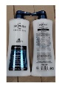
16-Nov-2023 | Sweden | Automatic Soap Dispenser | Electrical Appliances | Environmental Hazard | 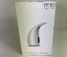  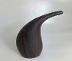
16-Nov-2023 | Italy | Hair Conditioner | Bodycare / Cosmetics | Chemical Hazard | 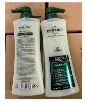
16-Nov-2023 | Italy | Shampoo | Bodycare / Cosmetics | Chemical Hazard | 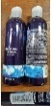
16-Nov-2023 | Italy | Perfume | Bodycare / Cosmetics | Chemical Hazard | 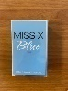
16-Nov-2023 | Italy | Eau De Toilette | Bodycare / Cosmetics | Chemical Hazard | 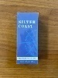
16-Nov-2023 | Italy | Perfume | Bodycare / Cosmetics | Chemical Hazard | 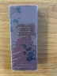
16-Nov-2023 | Hungary | Eau De Toilette | Bodycare / Cosmetics | Chemical Hazard | 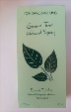
16-Nov-2023 | Hungary | Eau De Toilette | Bodycare / Cosmetics | Chemical Hazard | 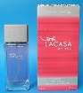
16-Nov-2023 | Sweden | LED String | Electrical Appliances | Environmental Hazard | 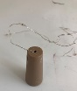
16-Nov-2023 | Hungary | Eau De Toilette | Bodycare / Cosmetics | Chemical Hazard | 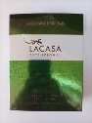
16-Nov-2023 | Hungary | Eau De Toilette | Bodycare / Cosmetics | Chemical Hazard | 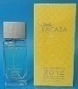
16-Nov-2023 | Czechia | Plastic Doll | Toys and Childcare Products | Chemical Hazard | 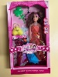
17-Nov-2023 | Poland | Plastic Dolls | Toys and Childcare Products | Chemical Hazard | 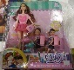
18-Nov-2023 | France | Insecticide | Chemicals | Chemical Hazard | 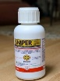
20-Nov-2023 | Germany | Safety Vest | Protective Equipment | Injury Hazard | 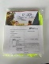
21-Nov-2023 | Romania | Slime | Toys and Childcare Products | Strangulation Hazard | 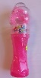
21-Nov-2023 | France | Leak Sealer | Chemicals | Chemical Hazard, Damage to Sight | 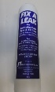  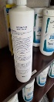
21-Nov-2023 | Italy | Eau De Toilette | Bodycare / Cosmetics | Chemical Hazard | 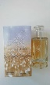
21-Nov-2023 | Italy | Perfume | Bodycare / Cosmetics | Chemical Hazard | 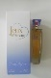
21-Nov-2023 | Italy | Deodorant Spray | Bodycare / Cosmetics | Chemical Hazard | 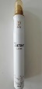
21-Nov-2023 | Italy | Eau De Toilette | Bodycare / Cosmetics | Chemical Hazard
21-Nov-2023 | Italy | Perfume | Bodycare / Cosmetics | Chemical Hazard | 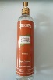
21-Nov-2023 | Italy | Perfume | Bodycare / Cosmetics | Chemical Hazard | 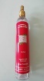
21-Nov-2023 | Italy | Deodorant Spray | Bodycare / Cosmetics | Chemical Hazard | 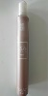
21-Nov-2023 | Italy | Perfume | Bodycare / Cosmetics | Chemical Hazard | 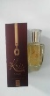
21-Nov-2023 | Latvia | Slime Toy | Toys and Childcare Products | Chemical Hazard | 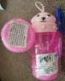
21-Nov-2023 | Italy | Eau De Toilette | Bodycare / Cosmetics | Chemical Hazard | 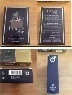
21-Nov-2023 | Italy | Eau De Toilette | Bodycare / Cosmetics | Chemical Hazard | 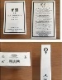
21-Nov-2023 | Italy | Cream for Feet | Bodycare / Cosmetics | Chemical Hazard | 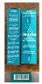
21-Nov-2023 | Italy | Perfume | Bodycare / Cosmetics | Chemical Hazard | 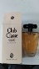
21-Nov-2023 | Italy | Perfume | Bodycare / Cosmetics | Chemical Hazard | 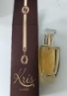
21-Nov-2023 | Sweden | Gaming Controller | Computer / Audio / Video / Other Electronics & Accessories | Environmental Hazard | 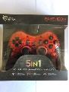
21-Nov-2023 | Hungary | Eau De Toilette | Bodycare / Cosmetics | Chemical Hazard | 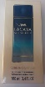
21-Nov-2023 | Sweden | Electrothermal Footwarmer | Electrical Appliances | Chemical Hazard, Environmental Hazard | 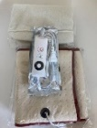
21-Nov-2023 | Sweden | Electric Callus Remover | Electrical Appliances | Environmental Hazard | 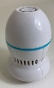
21-Nov-2023 | Sweden | Electric Toy | Toys and Childcare Products | Environmental Hazard | 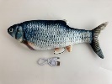
21-Nov-2023 | Sweden | Torch | Electrical Appliances | Environmental Hazard | 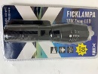
22-Nov-2023 | Italy | Liquid Soap | Bodycare / Cosmetics | Chemical Hazard | 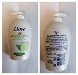
22-Nov-2023 | Italy | Eau De Toilette | Bodycare / Cosmetics | Chemical Hazard | 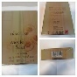
22-Nov-2023 | Italy | Shaving Cream | Bodycare / Cosmetics | Chemical Hazard | 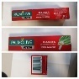
22-Nov-2023 | Italy | Moisturising Cream | Bodycare / Cosmetics | Chemical Hazard
22-Nov-2023 | Italy | Perfume | Bodycare / Cosmetics | Chemical Hazard | 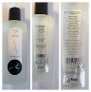
22-Nov-2023 | Italy | Soap | Bodycare / Cosmetics | Chemical Hazard | 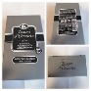
22-Nov-2023 | Italy | Moisturising Cleansing Milk | Bodycare / Cosmetics | Chemical Hazard | 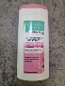
22-Nov-2023 | Italy | Deodorant | Bodycare / Cosmetics | Chemical Hazard | 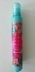
22-Nov-2023 | Italy | Perfume | Bodycare / Cosmetics | Chemical Hazard | 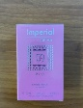
22-Nov-2023 | Italy | Shampoo | Bodycare / Cosmetics | Chemical Hazard | 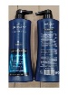
22-Nov-2023 | Sweden | Drone with a Discoball | Electrical Appliances | Chemical Hazard, Environmental Hazard | 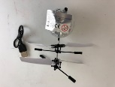
22-Nov-2023 | Sweden | Massage Device | Electrical Appliances | Environmental Hazard | 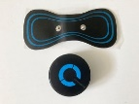
22-Nov-2023 | Sweden | Earrings | Jewelry | Chemical Hazard | 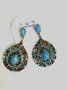
22-Nov-2023 | Sweden | Fridge | Home Electrical Appliances | Environmental Hazard | 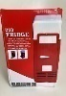  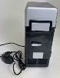
22-Nov-2023 | Lithuania | Necklace | Jewelry | Chemical Hazard | 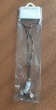
23-Nov-2023 | Italy | Breast-Firming Cream | Bodycare / Cosmetics | Chemical Hazard | 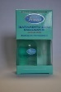
23-Nov-2023 | Italy | Breast Firming Cream | Bodycare / Cosmetics | Chemical Hazard | 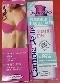
23-Nov-2023 | France | Button Batteries | Electrical Appliances | Chemical Hazard, Choking Hazard | 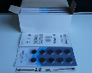
23-Nov-2023 | Italy | Soft Plastic Toy | Toys and Childcare Products | Chemical Hazard
23-Nov-2023 | France | Button Batteries | Electrical Appliances | Chemical Hazard, Choking Hazard | 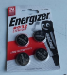
23-Nov-2023 | France | Button Batteries | Electrical Appliances | Chemical Hazard, Choking Hazard | 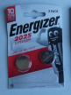
23-Nov-2023 | France | Button Batteries | Electrical Appliances | Chemical Hazard, Choking Hazard | 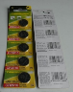
23-Nov-2023 | France | Button Batteries | Electrical Appliances | Chemical Hazard, Choking Hazard | 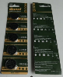
23-Nov-2023 | France | Button Batteries | Electrical Appliances | Chemical Hazard, Choking Hazard | 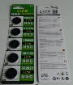
23-Nov-2023 | France | Button Batteries | Electrical Appliances | Chemical Hazard, Choking Hazard | 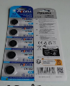
23-Nov-2023 | France | Button Batteries | Electrical Appliances | Chemical Hazard, Choking Hazard | 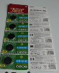
23-Nov-2023 | Ireland | Tealight Holder | Accessories | Burn Hazard, Cut Hazard | 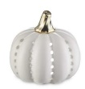
23-Nov-2023 | Slovakia | Attachment for Brush Cutters | Machinery | Injury Hazard | 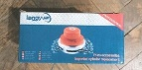
23-Nov-2023 | France | Interactive Doll | Toys and Childcare Products | Choking Hazard | 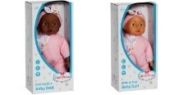
23-Nov-2023 | Germany | Skin Lightening Product | Bodycare / Cosmetics | Chemical Hazard | 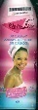
23-Nov-2023 | Hungary | Perfume | Bodycare / Cosmetics | Chemical Hazard | 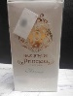
23-Nov-2023 | Italy | Gel for the Legs | Bodycare / Cosmetics | Chemical Hazard | 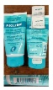
23-Nov-2023 | Italy | Face Tonic | Bodycare / Cosmetics | Chemical Hazard | 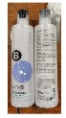
23-Nov-2023 | Hungary | Perfume | Bodycare / Cosmetics | Chemical Hazard | 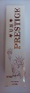
23-Nov-2023 | Poland | Plastic Toy | Toys and Childcare Products | Chemical Hazard | 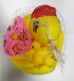
23-Nov-2023 | Sweden | Shower Mat | Household Items | Chemical Hazard | 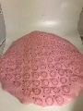
23-Nov-2023 | Poland | Toy Motorcycle | Toys and Childcare Products | Injury Hazard | 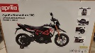
23-Nov-2023 | France | Toy Crossbow | Toys and Childcare Products | Injury Hazard | 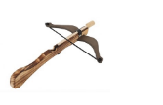
23-Nov-2023 | Sweden | Wireless Earbuds | Computer / Audio / Video / Other Electronics & Accessories | Chemical Hazard, Environmental Hazard | 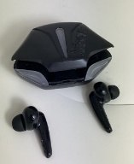
23-Nov-2023 | Hungary | Moisturising Cream | Bodycare / Cosmetics | Chemical Hazard | 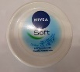
23-Nov-2023 | Hungary | Moisturising Cream | Bodycare / Cosmetics | Chemical Hazard | 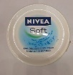
24-Nov-2023 | Italy | Aftershave | Bodycare / Cosmetics | Chemical Hazard | 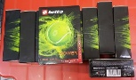
24-Nov-2023 | Italy | Liquid Soap | Bodycare / Cosmetics | Chemical Hazard | 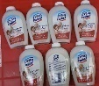
24-Nov-2023 | Italy | Bath Foam | Bodycare / Cosmetics | Chemical Hazard | 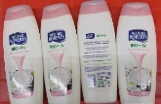
24-Nov-2023 | Italy | Deodorant Spray | Bodycare / Cosmetics | Chemical Hazard | 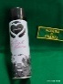
24-Nov-2023 | Italy | Body Lotion | Bodycare / Cosmetics | Chemical Hazard | 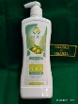
24-Nov-2023 | Italy | Shampoo and Conditioner | Bodycare / Cosmetics | Chemical Hazard | 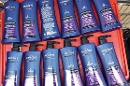
24-Nov-2023 | Italy | Shampoo | Bodycare / Cosmetics | Chemical Hazard | 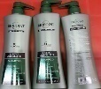
24-Nov-2023 | Italy | Shampoo | Bodycare / Cosmetics | Chemical Hazard | 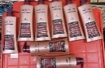
24-Nov-2023 | Italy | Soap | Bodycare / Cosmetics | Chemical Hazard | 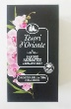
24-Nov-2023 | Italy | Deodorant Spray | Bodycare / Cosmetics | Chemical Hazard
24-Nov-2023 | Italy | Perfume | Bodycare / Cosmetics | Chemical Hazard | 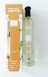
24-Nov-2023 | Italy | Perfume | Bodycare / Cosmetics | Chemical Hazard | 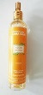
24-Nov-2023 | Italy | Perfume | Bodycare / Cosmetics | Chemical Hazard | 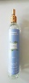
24-Nov-2023 | Italy | Perfume | Bodycare / Cosmetics | Chemical Hazard | 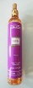
24-Nov-2023 | Italy | After Sun Cream | Bodycare / Cosmetics | Chemical Hazard | 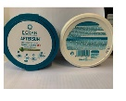
24-Nov-2023 | Italy | Perfume | Bodycare / Cosmetics | Chemical Hazard | 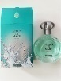
24-Nov-2023 | Italy | Perfume | Bodycare / Cosmetics | Chemical Hazard | 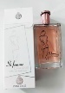
24-Nov-2023 | Hungary | Eau De Toilette | Bodycare / Cosmetics | Chemical Hazard | 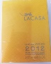
24-Nov-2023 | Sweden | Necklace | Jewelry | Chemical Hazard | 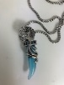
24-Nov-2023 | Sweden | Rings | Jewelry | Chemical Hazard | 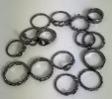
24-Nov-2023 | Sweden | Rings | Jewelry | Chemical Hazard | 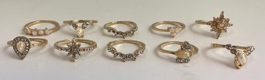
24-Nov-2023 | Hungary | Eau De Toilette | Bodycare / Cosmetics | Chemical Hazard | 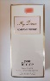
24-Nov-2023 | Hungary | Face Cream | Bodycare / Cosmetics | Chemical Hazard | 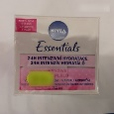
24-Nov-2023 | Hungary | Eau De Toilette | Bodycare / Cosmetics | Chemical Hazard | 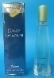
24-Nov-2023 | Estonia | Earrings | Jewelry | Chemical Hazard | 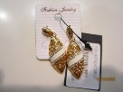
24-Nov-2023 | Hungary | Perfume | Bodycare / Cosmetics | Chemical Hazard | 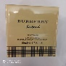
24-Nov-2023 | Hungary | Eau De Toilette | Bodycare / Cosmetics | Chemical Hazard | 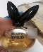  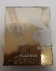
24-Nov-2023 | Hungary | Night Cream | Bodycare / Cosmetics | Chemical Hazard | 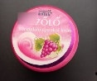
24-Nov-2023 | Hungary | Eau De Toilette | Bodycare / Cosmetics | Chemical Hazard | 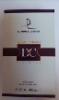
27-Nov-2023 | Italy | Deodorant | Bodycare / Cosmetics | Chemical Hazard | 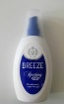
28-Nov-2023 | Italy | Firming Cream | Bodycare / Cosmetics | Chemical Hazard | 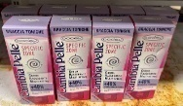
28-Nov-2023 | Italy | Shampoo | Bodycare / Cosmetics | Chemical Hazard | 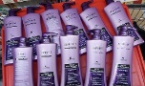
28-Nov-2023 | Italy | Bath Milk | Bodycare / Cosmetics | Chemical Hazard | 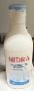
28-Nov-2023 | Italy | Deodorant | Bodycare / Cosmetics | Chemical Hazard | 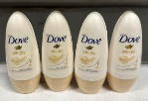
28-Nov-2023 | Italy | Soap | Bodycare / Cosmetics | Chemical Hazard | 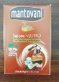
28-Nov-2023 | Italy | Body Cream | Bodycare / Cosmetics | Chemical Hazard | 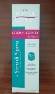
28-Nov-2023 | Italy | Liquid Soap | Bodycare / Cosmetics | Chemical Hazard | 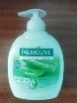
28-Nov-2023 | Italy | Perfume | Bodycare / Cosmetics | Chemical Hazard | 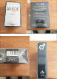
28-Nov-2023 | Italy | Perfume | Bodycare / Cosmetics | Chemical Hazard | 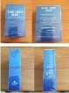
28-Nov-2023 | France | Rattle Toy | Toys and Childcare Products | Choking Hazard, Entrapment Hazard
28-Nov-2023 | Slovakia | Lighting Chain | Electrical Appliances | Electric Shock Hazard | 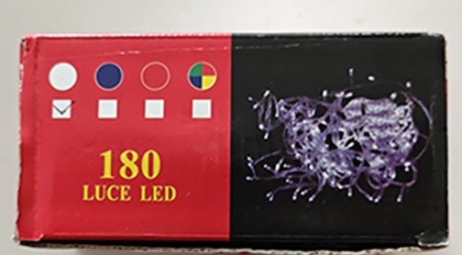
28-Nov-2023 | Slovakia | Attachment for Brush Cutters | Machinery | Injury Hazard | 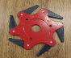  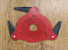
28-Nov-2023 | Lithuania | Novelty Lighter | Tools and Hardware | Fire Hazard
28-Nov-2023 | Hungary | Perfume | Bodycare / Cosmetics | Chemical Hazard | 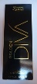
28-Nov-2023 | Hungary | Eau De Toilette | Bodycare / Cosmetics | Chemical Hazard | 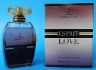
28-Nov-2023 | Sweden | Charger | Electrical Appliances | Environmental Hazard | 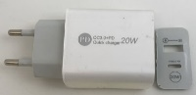
28-Nov-2023 | Hungary | Perfume | Bodycare / Cosmetics | Chemical Hazard
28-Nov-2023 | Sweden | Dog Necklace | Pet Items | Environmental Hazard | 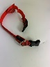
29-Nov-2023 | Hungary | Perfume | Bodycare / Cosmetics | Chemical Hazard | 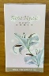
29-Nov-2023 | Italy | Perfume | Bodycare / Cosmetics | Chemical Hazard | 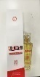
29-Nov-2023 | Hungary | Intimate Soap | Bodycare / Cosmetics | Chemical Hazard | 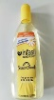
29-Nov-2023 | Italy | Perfume | Bodycare / Cosmetics | Chemical Hazard | 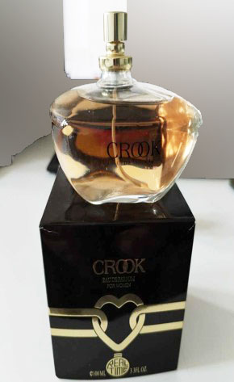
29-Nov-2023 | Lithuania | Glue | Chemicals | Chemical Hazard | 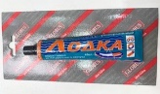
29-Nov-2023 | Lithuania | Doll | Toys and Childcare Products | Chemical Hazard | 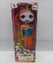
29-Nov-2023 | Sweden | Ring | Jewelry | Chemical Hazard | 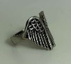
29-Nov-2023 | Hungary | Perfume | Bodycare / Cosmetics | Chemical Hazard
29-Nov-2023 | Hungary | Perfume | Bodycare / Cosmetics | Chemical Hazard | 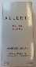
29-Nov-2023 | Finland | Charger for Electric Scooter | Electrical Appliances | Electric Shock Hazard | 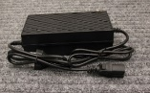
30-Nov-2023 | Italy | Soap Bubble Toy | Toys and Childcare Products | Microbiological Hazard | 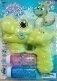
30-Nov-2023 | Italy | Body Cream | Bodycare / Cosmetics | Chemical Hazard | 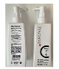
30-Nov-2023 | Germany | Disposable Electronic Cigarette | Chemicals | Chemical Hazard
30-Nov-2023 | Italy | Sun Lotion | Bodycare / Cosmetics | Chemical Hazard | 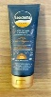
30-Nov-2023 | Slovakia | Candles | Household Items | Fire Hazard | 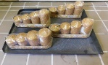
30-Nov-2023 | Sweden | Chargeable Flashlight | Electrical Appliances | Chemical Hazard, Environmental Hazard | 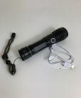
30-Nov-2023 | Lithuania | Extension Cord | Electrical Appliances | Electric Shock Hazard | 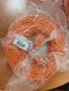
30-Nov-2023 | Lithuania | Toy Car | Toys and Childcare Products | Choking Hazard | 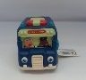  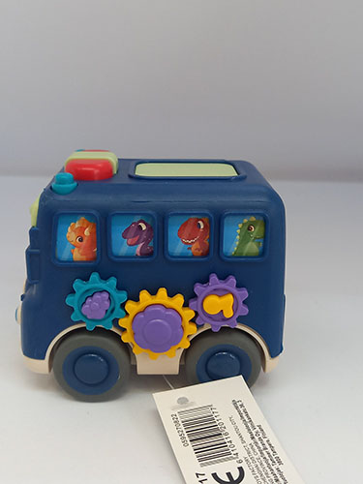
30-Nov-2023 | Sweden | Smart Watch | Computer / Audio / Video / Other Electronics & Accessories | Chemical Hazard, Environmental Hazard | 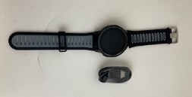
30-Nov-2023 | Slovakia | Lighting Chain | Electrical Appliances | Electric Shock Hazard | 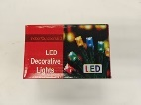
30-Nov-2023 | Sweden | Ring | Jewelry | Chemical Hazard | 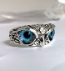
30-Nov-2023 | Sweden | Inflatable Ring | Toys and Childcare Products | Chemical Hazard | 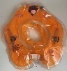
30-Nov-2023 | Slovakia | Lighting Chain | Electrical Appliances | Electric Shock Hazard | 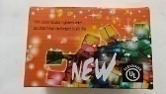
30-Nov-2023 | Hungary | Perfume | Bodycare / Cosmetics | Chemical Hazard | 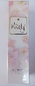
30-Nov-2023 | Hungary | Eau De Toilette | Bodycare / Cosmetics | Chemical Hazard | 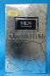
30-Nov-2023 | Slovakia | USB Charger | Electrical Appliances | Electric Shock Hazard | 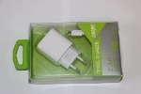
30-Nov-2023 | Hungary | Eau De Toilette | Bodycare / Cosmetics | Chemical Hazard | 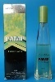
30-Nov-2023 | Hungary | Eau De Toilette | Bodycare / Cosmetics | Chemical Hazard | 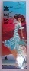
30-Nov-2023 | Sweden | Heated Gloves | Fabric / Textile / Garment / Home Textile | Chemical Hazard, Environmental Hazard | 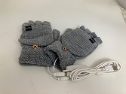
30-Nov-2023 | Sweden | Hip Training Device | Sporting Goods / Equipment | Environmental Hazard | 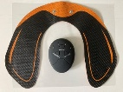
30-Nov-2023 | Hungary | Perfume | Bodycare / Cosmetics | Chemical Hazard | 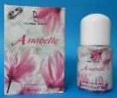
30-Nov-2023 | Sweden | Necklace | Jewelry | Chemical Hazard | 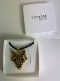
30-Nov-2023 | Hungary | Eau De Toilette | Bodycare / Cosmetics | Chemical Hazard | 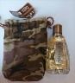
30-Nov-2023 | Estonia | Earrings | Jewelry | Chemical Hazard | 