Recall Cases Summary – US (Last Update Date: 30 November 2023)

Date | Product | Categories | Hazard | Image
2-Nov-2023 | Wood Lathes | Machinery | Injury Hazard, Laceration Hazard | 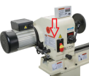  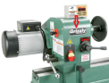
2-Nov-2023 | Yoocaa Baby Loungers | Toys and Childcare Products | Suffocation Hazard, Fall Hazard, Entrapment Hazard | 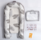  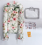  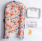  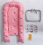  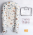  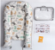  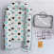  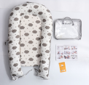  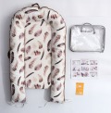  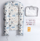
2-Nov-2023 | Infant Bath Seats | Toys and Childcare Products | Drowning Hazard | 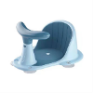
2-Nov-2023 | Condensing Boilers | Home Electrical Appliances | Carbon Monoxide Poisoning Hazard | 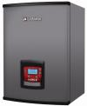  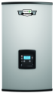  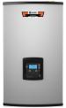
2-Nov-2023 | Electric Bicycles | Sporting Goods / Equipment | Fall Hazard, Injury Hazard | 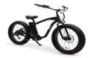
2-Nov-2023 | Creativity Street Children’s Assorted Craft Buttons | Accessories | Lead Poisoning Hazard, Health Risk Hazard | 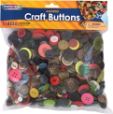
9-Nov-2023 | Ski Touring Binding | Sporting Goods / Equipment | Fall Hazard, Injury Hazard | 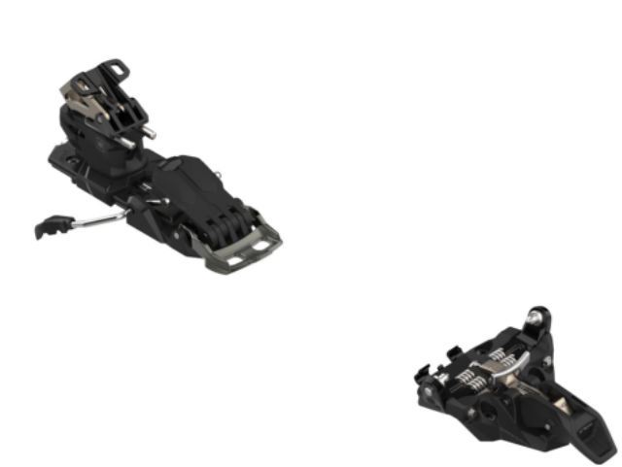
9-Nov-2023 | 3-Wick Glass Candles | Household Items | Fire Hazard, Laceration Hazard | 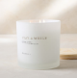  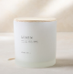  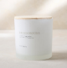
9-Nov-2023 | Tow-Behind Field & Brush Mowers | Machinery | Fire Hazard, Burn Hazard | 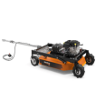  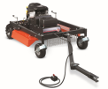
9-Nov-2023 | Children’s Nightgowns | Fabric / Textile / Garment / Home Textile | Burn Hazard, Injury Hazard | 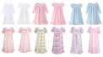  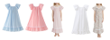  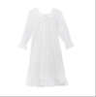  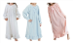
9-Nov-2023 | Infrared Quartz Electric Fireplaces | Home Electrical Appliances | Fire Hazard | 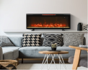
9-Nov-2023 | Mirrors | Household Items | Laceration Hazard
16-Nov-2023 | Stainless Steel Children’s Cups | Food Contact Material | Lead Poisoning Hazard, Health Risk Hazard, Choking Hazard, Laceration Hazard | 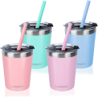
16-Nov-2023 | Hearth & Hand™ with Magnolia Toy Mushroom Peg Sorters | Toys and Childcare Products | Choking Hazard | 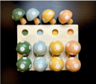
16-Nov-2023 | Red Shed Hammock Swing Chairs | Outdoor Living Items | Fall Hazard | 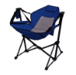
16-Nov-2023 | Women's High Heeled Sandals | Footwear | Fall Hazard | 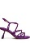  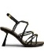  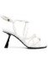  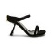  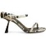  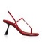  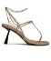  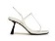  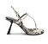  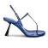
21-Nov-2023 | Gas Ranges | Home Electrical Appliances | Carbon Monoxide Poisoning Hazard, Risk of Death, Injury Hazard | 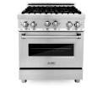  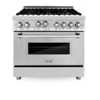  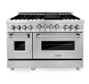
22-Nov-2023 | Balloon Time Mini Helium Tanks | Chemicals | Injury Hazard | 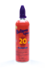
22-Nov-2023 | USB-C Laptop Power Banks | Electrical Appliances | Fire Hazard | 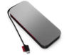
22-Nov-2023 | Stainless Steel Children’s Cups | Food Contact Material | Lead Poisoning Hazard, Choking Hazard, Laceration Hazard | 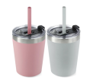
22-Nov-2023 | Vinyl Sliding Glass Doors | Household Items | Injury Hazard | 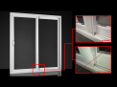
30-Nov-2023 | Loudspeaker | Computer / Audio / Video / Other Electronics & Accessories | Impact Hazard, Injury Hazard | 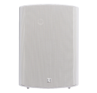  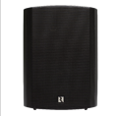
30-Nov-2023 | Electric Cooktops | Home Electrical Appliances | Burn Hazard
30-Nov-2023 | Heated Throws and Blankets | Home Electrical Appliances | Fire Hazard, Burn Hazard | 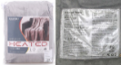  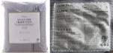  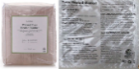  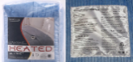
30-Nov-2023 | Vibe Bear Playyard Mattresses | Furniture | Suffocation Hazard | 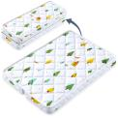
30-Nov-2023 | Pack and Play Mattresses | Furniture | Suffocation Hazard | 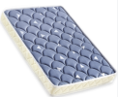
30-Nov-2023 | Tiblue Stainless Steel Children’s Cups | Food Contact Material | Lead Poisoning Hazard, Health Risk Hazard, Laceration Hazard, Choking Hazard | 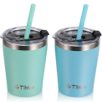  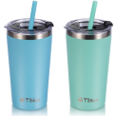
30-Nov-2023 | Stainless Steel Children’s Cup Sets | Food Contact Material | Lead Poisoning Hazard, Health Risk Hazard, Laceration Hazard, Choking Hazard | 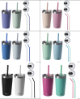  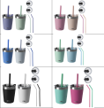
30-Nov-2023 | Supacaz Brand Orbitron Pedals | Sporting Goods / Equipment | Fall Hazard | 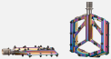
30-Nov-2023 | Inclined Sleeper Bassinets for YPSI and Z4 Strollers | Toys and Childcare Products | Risk of Death | 