Recall Cases Summary – Australia (Last Update Date: 31 December 2023)

Date | Product | Categories | Hazard | Image
5-Dec-2023 | Bell Shaker Toy | Toys and Childcare Products | Choking Hazard, Suffocation Hazard, Risk of Death | 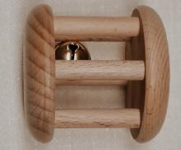
6-Dec-2023 | Camec Double Pole Power Point (GPO) with Dual USB Output | Electrical Appliances | Injury Hazard, Risk of Death, Fire Hazard | 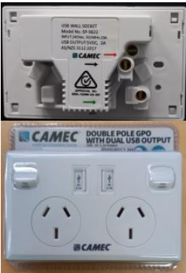
7-Dec-2023 | Christmas Light Up Gnome Tree Decoration | Accessories | Choking Hazard, Burn Hazard, Injury Hazard, Swallowing Risk | 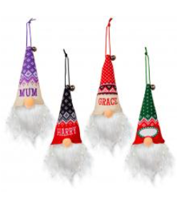
7-Dec-2023 | Automotive Shells | Electrical Appliances | Choking Hazard, Burn Hazard, Injury Hazard, Swallowing Risk, Risk of Death | 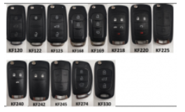
8-Dec-2023 | Slipper or Brake Pads for Radio Controlled Vehicles | Car Components | Health Risk Hazard | 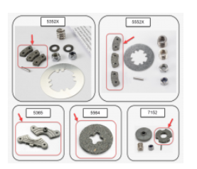
14-Dec-2023 | Solar Inverter | Machinery | Injury Hazard, Risk of Death, Electric Shock Hazard | 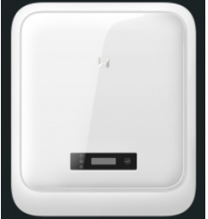
14-Dec-2023 | Electronic Kitchen Scale | Home Electrical Appliances | Choking Hazard, Burn Hazard, Injury Hazard, Swallowing Risk, Risk of Death | 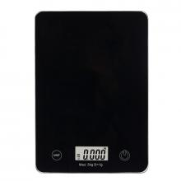
15-Dec-2023 | Outboard Engines | Machinery | Injury Hazard, Amputation Hazard, Laceration Hazard | 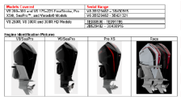
15-Dec-2023 | USB-C Laptop Power Bank | Electrical Appliances | Injury Hazard, Risk of Death, Fire Hazard | 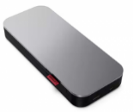
15-Dec-2023 | 5 Volt Switching Power Supply | Electrical Appliances | Injury Hazard, Risk of Death, Electric Shock Hazard | 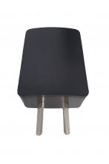
15-Dec-2023 | Bicycles | Sporting Goods / Equipment | Injury Hazard | 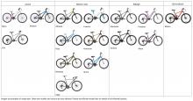  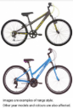
20-Dec-2023 | Squeeze Hand Yo-Yo Ball Toy | Toys and Childcare Products | Injury Hazard, Risk of Death, Strangulation Hazard | 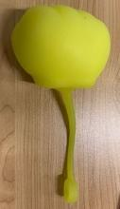
20-Dec-2023 | Comsol USB-C Universal Laptop Charger 96W | Electrical Appliances | Electric Shock Hazard, Injury Hazard, Risk of Death | 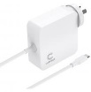
21-Dec-2023 | Sensory Glow Tube Toy | Toys and Childcare Products | Choking Hazard, Injury Hazard, Swallowing Risk | 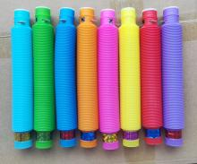
21-Dec-2023 | Dual Fuel Spit Rotisserie | Outdoor Living Items | Injury Hazard, Risk of Death, Electric Shock Hazard | 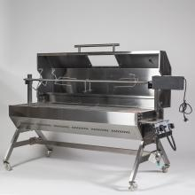
22-Dec-2023 | Tetris Tetrimino Waffle Maker | Toys and Childcare Products | Injury Hazard, Risk of Death, Electric Shock Hazard | 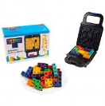
22-Dec-2023 | Magic Fairy Wand Toy | Toys and Childcare Products | Choking Hazard, Injury Hazard, Swallowing Risk | 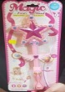
22-Dec-2023 | Caredent BioBrush | Household Items | Injury Hazard, Risk of Death, Choking Hazard | 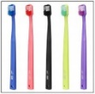
22-Dec-2023 | Airbag Man Inflation Coil and Wand with Digital Gauge | Tools and Hardware | Risk of Death, Choking Hazard, Burn Hazard, Swallowing Risk, Injury Hazard | 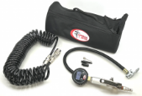
22-Dec-2023 | Promotional LED Glow Stick Torch | Electrical Appliances | Choking Hazard, Injury Hazard, Swallowing Risk | 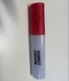  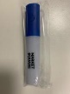  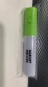
22-Dec-2023 | Flameless LED Tealight Candles | Electrical Appliances | Choking Hazard, Burn Hazard, Injury Hazard, Risk of Death, Swallowing Risk | 