Recall Cases Summary – Canada (Last Update Date: 31 December 2023)

Date | Product | Categories | Hazard | Image
1-Dec-2023 | Marcelle 40+ Anti-Wrinkle Cream | Bodycare / Cosmetics | Microbiological Hazard | 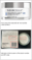
4-Dec-2023 | Zebra Blinds | Household Items | Entanglement Hazard, Strangulation Hazard, Risk of Death | 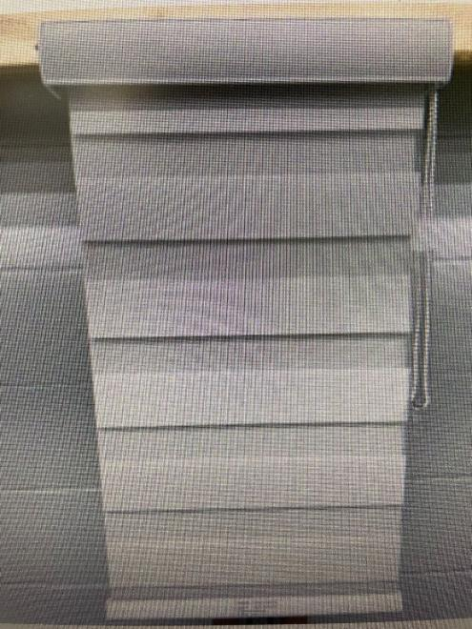
4-Dec-2023 | 30” Knob-Controlled Electric Radiant Cooktops | Home Electrical Appliances | Burn Hazard | 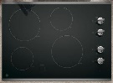  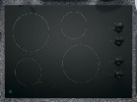
4-Dec-2023 | Caffeinated Energy Drinks | Food | Chemical Hazard | 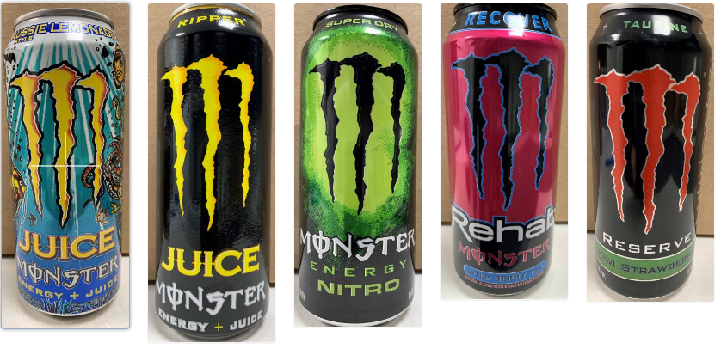
5-Dec-2023 | USB-C Laptop Power Bank | Electrical Appliances | Fire Hazard | 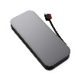
6-Dec-2023 | Rubber Cement | Chemicals | Injury Hazard, Risk of Death | 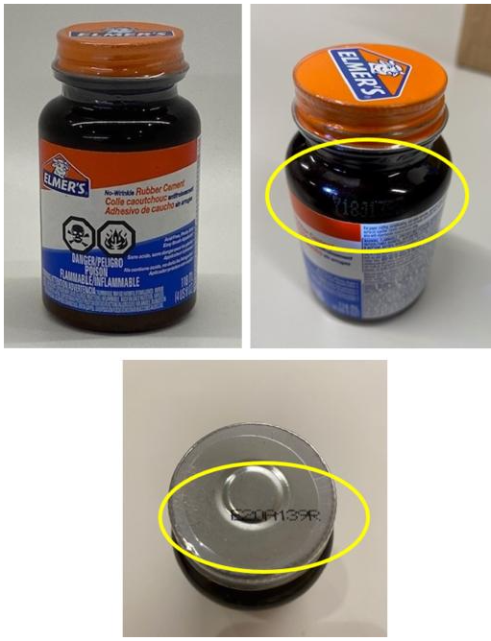
6-Dec-2023 | Enoki Mushroom | Food | Microbiological Hazard | 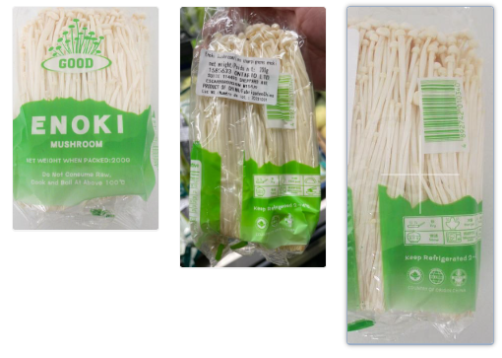
7-Dec-2023 | Mobile Murphy Beds | Furniture | Injury Hazard, Tip-Over Hazard, Entrapment Hazard | 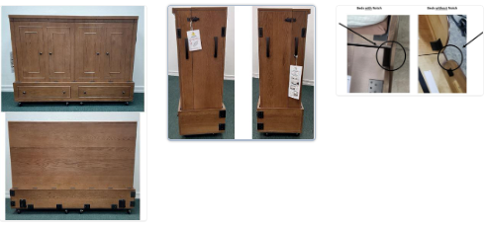
7-Dec-2023 | Bugaboo Dragonfly Stroller Seat | Toys and Childcare Products | Injury Hazard | 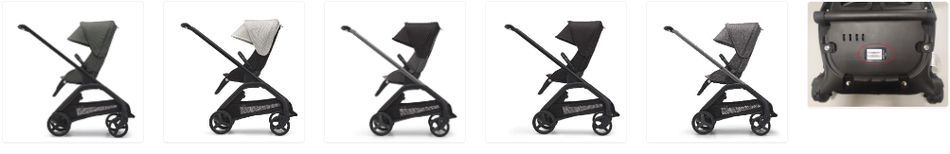
8-Dec-2023 | Baby Christmas Hat with Pom Pom | Fabric / Textile / Garment / Home Textile | Choking Hazard | 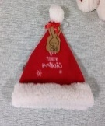
8-Dec-2023 | Sauces and Soup Bases | Food | Microbiological Hazard | 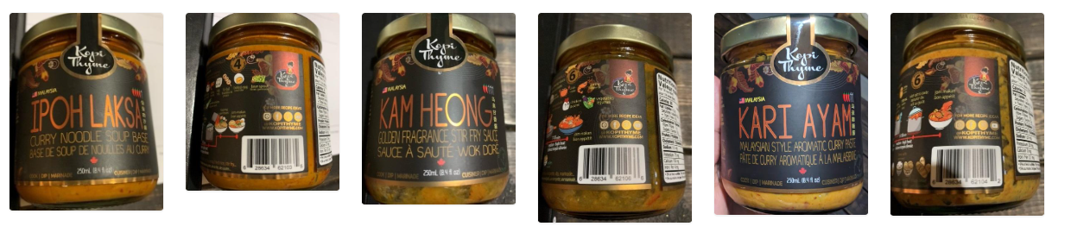  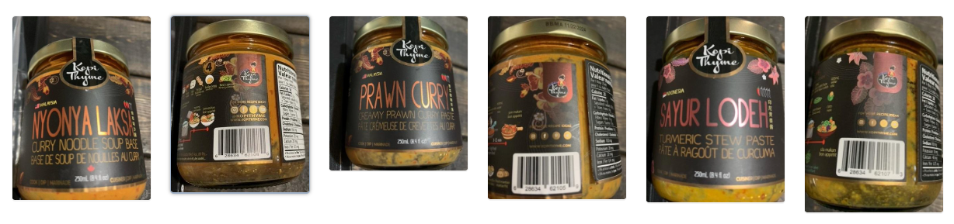
13-Dec-2023 | Taylor & Olive Halfway Insulating Cordless Roman Shades | Household Items | Choking Hazard | 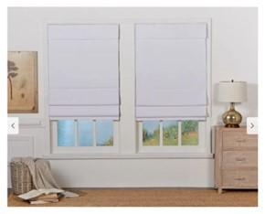
14-Dec-2023 | Lightweight Handheld Travel Steam Iron | Electrical Appliances | Fire Hazard, Burn Hazard, Electric Shock Hazard | 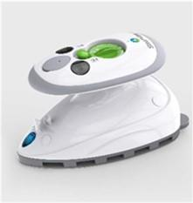
14-Dec-2023 | LOGiiX Piston Power 10,000 & 5000 Mini Power Banks | Electrical Appliances | Fire Hazard | 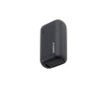
14-Dec-2023 | Copper Grove Yerevan Top Down Bottom Up Shades | Household Items | Strangulation Hazard
15-Dec-2023 | Various Corded Window Coverings | Household Items | Strangulation Hazard, Choking Hazard, Risk of Death | 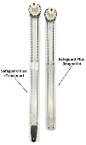  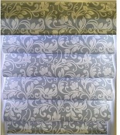
15-Dec-2023 | FG Square Santa Sleigh | Accessories | Fire Hazard | 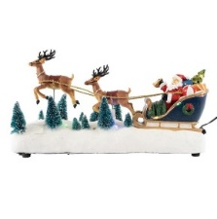
15-Dec-2023 | Enoki Mushroom | Food | Microbiological Hazard | 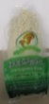
18-Dec-2023 | Dual Shade and Roller Shade Corded Window Coverings | Household Items | Strangulation Hazard, Risk of Death, Entanglement Hazard | 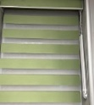  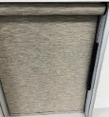
19-Dec-2023 | A-IPOWER Inverter Generator 7100/5700 WATT Model GXS7100IRDC | Electrical Appliances | Electric Shock Hazard | 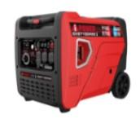
19-Dec-2023 | Shell Rotella ELC NF Pre-diluted 50/50 Heavy Duty Antifreeze + Coolant | Chemicals | Injury Hazard, Risk of Death | 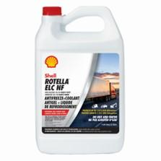
19-Dec-2023 | Based Vegan Steaks | Food | Risk of Allergy | 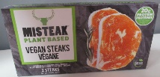
19-Dec-2023 | Scary Friends Mini-Bars | Food | Safety Risk Hazard | /
19-Dec-2023 | Unsweetened Coconut Plant-Based Yogurt | Food | Microbiological Hazard | /
20-Dec-2023 | T3 Champs Box Wallet | Fabric / Textile / Garment / Home Textile | Microbiological Hazard, Risk of Allergy | 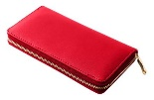
21-Dec-2023 | Pella Architect Series Casement Windows | Construction Products | Fall Hazard, Injury Hazard | 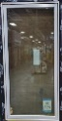
22-Dec-2023 | Caffeinated Energy Drinks | Food | Chemical Hazard | 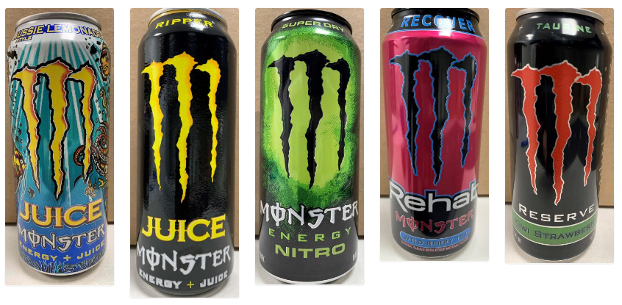
22-Dec-2023 | Fondue Set | Home Electrical Appliances | Burn Hazard | 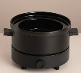
22-Dec-2023 | 2" Safe Cord TM Fauxwood | Household Items | Strangulation Hazard, Entanglement Hazard, Risk of Death | 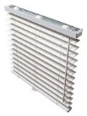
22-Dec-2023 | Playyard Mattresses | Fabric / Textile / Garment / Home Textile | Suffocation Hazard | 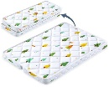
22-Dec-2023 | Parmesan Pesto Chicken with Steamed Spinach, Roasted Green Beans & Grape Tomatoes | Food | Microbiological Hazard | 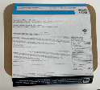
27-Dec-2023 | 2” SheathCord Fauxwood Blinds | Household Items | Strangulation Hazard, Entanglement Hazard, Risk of Death | 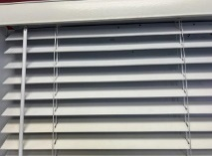
28-Dec-2023 | Home Bed Assist Handles | Household Items | Entrapment Hazard, Risk of Death | 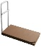  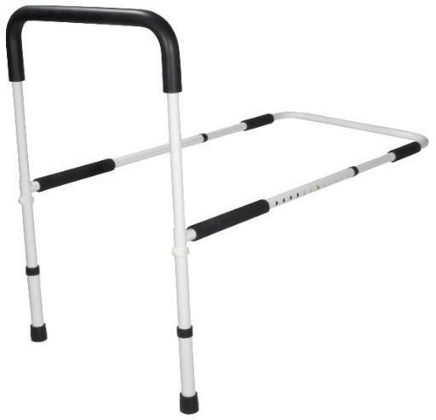  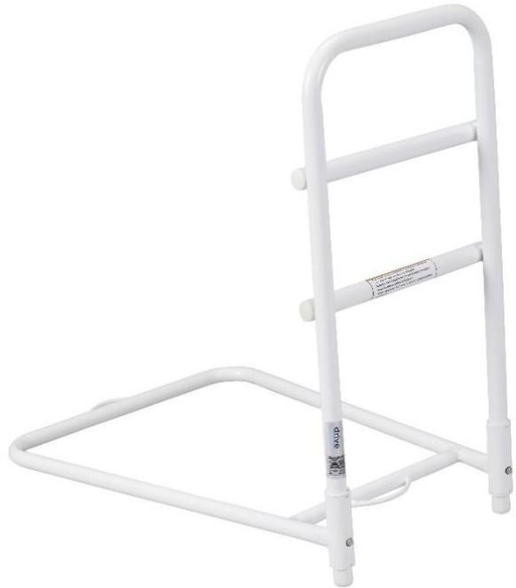  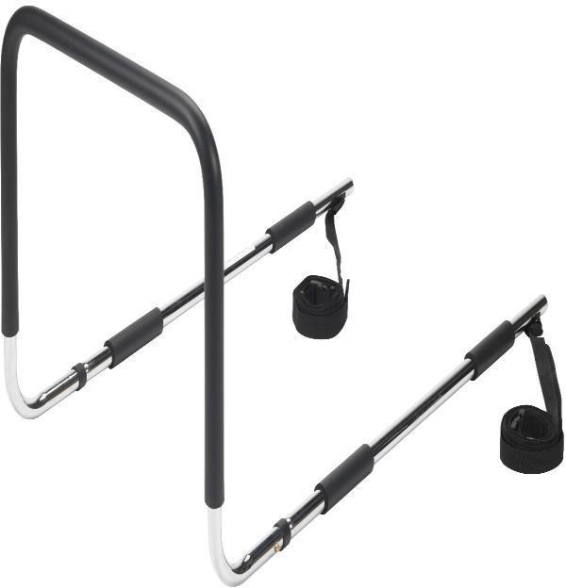
28-Dec-2023 | BlendJet 2 Portable Blenders | Electrical Appliances | Laceration Hazard | 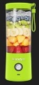
28-Dec-2023 | Various brands of Gorgonzola Truffle Cheese | Food | Microbiological Hazard | 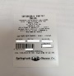  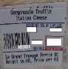
29-Dec-2023 | Portable Power Station and Blackfire Portable Power Station | Electrical Appliances | Fire Hazard, Burn Hazard | 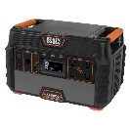  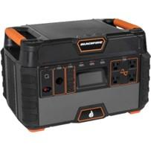
29-Dec-2023 | Smartlux Manual Open Roll (No-Guard Mechanism) Blinds | Household Items | Strangulation Hazard, Entanglement Hazard, Risk of Death | 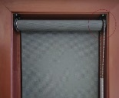
29-Dec-2023 | Magnetic Game | Toys and Childcare Products | Swallowing Risk, Ingestion Hazard | 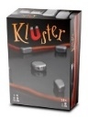
29-Dec-2023 | Fix A Leak | Chemicals | Chemical Hazard | 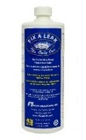
29-Dec-2023 | White Contour Baby Changing Pad | Toys and Childcare Products | Choking Hazard | 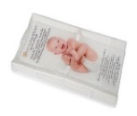
29-Dec-2023 | Various Home Decorators Collection and HDG Corded Window Coverings | Household Items | Choking Hazard | 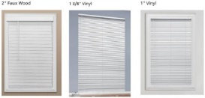
31-Dec-2023 | Nutramigen A+ LGG Hypoallergenic | Food | Microbiological Hazard | 