Recall Cases Summary – China (Last Update Date: 31 December 2023)

Date | Province | Product | Categories | Hazard | Image
4-Dec-2023 | Shanghai | Electric Bicycle | Sporting Goods / Equipment | Safety Risk Hazard, Crash Hazard | 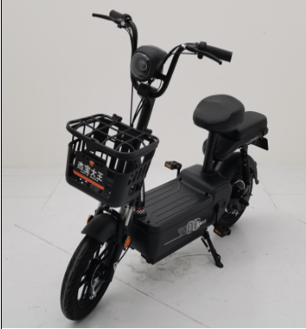
4-Dec-2023 | Fujian | Pencil Boxes | Stationery | Chemical Hazard | 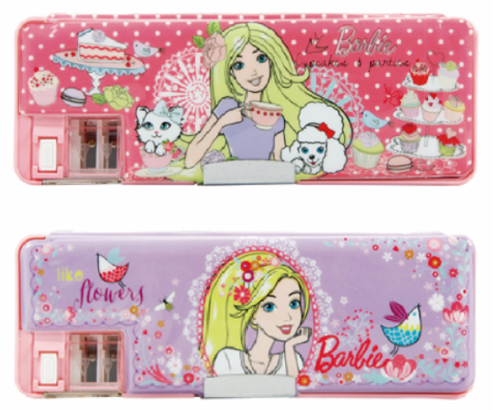
4-Dec-2023 | Fujian | Glue | Chemicals | Chemical Hazard | 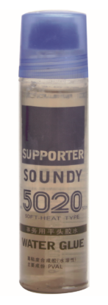
6-Dec-2023 | Zhejiang | Vacuum Cleaners | Home Electrical Appliances | Fire Hazard | 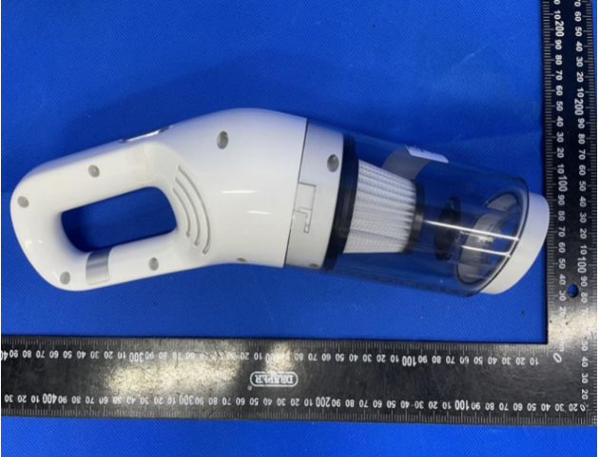
6-Dec-2023 | Inner Mongolia | Potent Windshield Washer Fluid | Chemicals | Crash Hazard, Injury Hazard, Risk of Death | /
6-Dec-2023 | Jiangsu | Professional Soft Eraser for Art | Stationery | Safety Risk Hazard, Chemical Hazard | 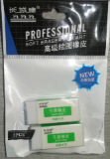
6-Dec-2023 | Zhejiang | Brushed Quilt Covers | Fabric / Textile / Garment / Home Textile | Health Risk Hazard | 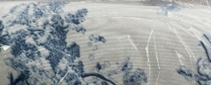
6-Dec-2023 | Zhejiang | Rainbow Road Cardboard Book Series | Toys and Childcare Products | Suffocation Hazard | 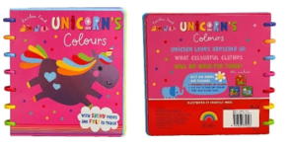
7-Dec-2023 | Inner Mongolia | Bamboo Chopsticks | Food Contact Material | Puncture Hazard, Safety Risk Hazard | /
7-Dec-2023 | Zhejiang | Wool Sweaters | Fabric / Textile / Garment / Home Textile | Eye Irritation Risk, Skin Irritation Risk, Chemical Hazard | 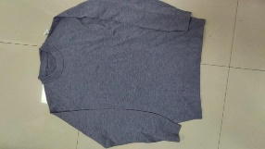
7-Dec-2023 | Zhejiang | Wool Sweaters | Fabric / Textile / Garment / Home Textile | Eye Irritation Risk, Skin Irritation Risk, Chemical Hazard | /
8-Dec-2023 | Anhui | Knife-Cut Paper | Stationery | Microbiological Hazard | /
8-Dec-2023 | Hubei | Paper Cups | Food Contact Material | Chemical Hazard | /
8-Dec-2023 | Anhui | Math Workbooks, Picture Books and Exercise Books | Stationery | Laceration Hazard, Damage to Sight | /
8-Dec-2023 | Anhui | Children's Suit Sets | Fabric / Textile / Garment / Home Textile | Health Risk Hazard | /
8-Dec-2023 | Anhui | Sports Shoes (Children's Shoes) | Footwear | Chemical Hazard | /
8-Dec-2023 | Anhui | Glasses | Accessories | Damage to Sight | /
8-Dec-2023 | Anhui | Sun Protection Clothes | Fabric / Textile / Garment / Home Textile | Health Risk Hazard | /
8-Dec-2023 | Anhui | Coreless Paper Rolls | Stationery | Chemical Hazard | /
8-Dec-2023 | Anhui | Engine Coolant | Chemicals | Safety Risk Hazard | /
11-Dec-2023 | Anhui | Adult Casual Hats | Fabric / Textile / Garment / Home Textile | Risk of Allergy, Chemical Hazard | /
11-Dec-2023 | Anhui | Electric Pressure Cookers | Home Electrical Appliances | Electric Shock Hazard, Injury Hazard | /
11-Dec-2023 | Anhui | Rice Cookers | Home Electrical Appliances | Burn Hazard, Electric Shock Hazard | /
11-Dec-2023 | Anhui | Outdoor Rattan Seats | Outdoor Living Items | Fall Hazard, Crushing Hazard | /
11-Dec-2023 | Anhui | Multi-Functional Massage Sticks | Home Electrical Appliances | Electric Shock Hazard | /
11-Dec-2023 | Anhui | School Uniforms | Fabric / Textile / Garment / Home Textile | Safety Risk Hazard | /
11-Dec-2023 | Inner Mongolia | Glass Cleaner for Automobile | Chemicals | Safety Risk Hazard | /
11-Dec-2023 | Anhui | Portable Dry Powder Fire Extinguishers | Protective Equipment | Safety Risk Hazard | /
11-Dec-2023 | Anhui | High-Energy Power Batteries | Car Components | Safety Risk Hazard | /
13-Dec-2023 | Xinjiang | Coursebooks (Workbooks) | Stationery | Laceration Hazard | /
13-Dec-2023 | Xinjiang | Desks | Furniture | Risk of Allergy | /
13-Dec-2023 | Ningxia | Festive Paper Cups | Food Contact Material | Chemical Hazard | /
13-Dec-2023 | Henan | Erasers | Stationery | Chemical Hazard | /
13-Dec-2023 | Jiangxi | Desks | Furniture | Crushing Hazard | /
13-Dec-2023 | Jiangxi | Copybooks | Stationery | Damage to Sight | /
13-Dec-2023 | Jiangxi | Exercise Books | Stationery | Damage to Sight | /
19-Dec-2023 | Liaoning | Duvet Covers | Fabric / Textile / Garment / Home Textile | Risk of Allergy | /
19-Dec-2023 | Jiangsu | Children’s Bat-Sleeve Jackets | Fabric / Textile / Garment / Home Textile | Strangulation Hazard, Suffocation Hazard | 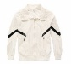
21-Dec-2023 | Anhui | Exercise Books | Stationery | Laceration Hazard | /
21-Dec-2023 | Anhui | Shoe Cabinets | Furniture | Chemical Hazard | /
21-Dec-2023 | Anhui | Cups | Food Contact Material | Burn Hazard | /
21-Dec-2023 | Anhui | Disposable Bamboo Chopsticks | Food Contact Material | Puncture Hazard, Safety Risk Hazard | /
21-Dec-2023 | Anhui | Shoe Cabinets | Furniture | Chemical Hazard | /
21-Dec-2023 | Anhui | Children's Suits | Fabric / Textile / Garment / Home Textile | Health Risk Hazard | /
21-Dec-2023 | Anhui | Disposable Bamboo Chopsticks | Food Contact Material | Puncture Hazard, Safety Risk Hazard | /
21-Dec-2023 | Anhui | Children's Clothing (Tops) | Fabric / Textile / Garment / Home Textile | Suffocation Hazard, Strangulation Hazard | /
21-Dec-2023 | Anhui | Children's Dresses | Fabric / Textile / Garment / Home Textile | Suffocation Hazard, Strangulation Hazard | /
21-Dec-2023 | Anhui | Aluminum Alloy Doors and Windows | Construction Products | Safety Risk Hazard | /
21-Dec-2023 | Anhui | Children's Hoodies | Fabric / Textile / Garment / Home Textile | Suffocation Hazard, Strangulation Hazard | /
21-Dec-2023 | Anhui | Mattresses | Fabric / Textile / Garment / Home Textile | Microbiological Hazard | /
21-Dec-2023 | Anhui | Air Fryer Paper (Natural Color) | Food Contact Material | Safety Risk Hazard | /
21-Dec-2023 | Anhui | Disposable Bamboo Chopsticks | Food Contact Material | Puncture Hazard | /
21-Dec-2023 | Anhui | Split Type Air Conditioners | Home Electrical Appliances | Electric Shock Hazard, Fire Hazard, Safety Risk Hazard | /
21-Dec-2023 | Anhui | Rolling Papers | Household Items | Risk of Allergy, Health Risk Hazard | /
21-Dec-2023 | Anhui | Melamine Tableware (Bowls) | Food Contact Material | Safety Risk Hazard | /
21-Dec-2023 | Anhui | Language Workbooks | Stationery | Laceration Hazard | /
21-Dec-2023 | Anhui | Exercise Books | Stationery | Laceration Hazard | /
21-Dec-2023 | Anhui | Toilet Paper | Household Items | Risk of Allergy, Health Risk Hazard | /
21-Dec-2023 | Anhui | Mathematics Exercise Books | Stationery | Laceration Hazard | /
21-Dec-2023 | Anhui | Diamond Cups | Food Contact Material | Health Risk Hazard | /
21-Dec-2023 | Anhui | Bedside Tables | Furniture | Chemical Hazard | /
21-Dec-2023 | Anhui | Bamboo Needles | Tools and Hardware | Laceration Hazard | /
21-Dec-2023 | Anhui | Disposable Bamboo Chopsticks | Food Contact Material | Puncture Hazard, Safety Risk Hazard | /
21-Dec-2023 | Anhui | Exercise Books | Stationery | Laceration Hazard | /
22-Dec-2023 | Liaoning | Shoe Cabinets | Furniture | Chemical Hazard
22-Dec-2023 | Anhui | Children's Strollers | Toys and Childcare Products | Fall Hazard | /
26-Dec-2023 | Hunan | Student Backpacks | Fabric / Textile / Garment / Home Textile | Chemical Hazard | 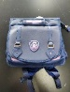
26-Dec-2023 | Hunan | Boys's Long-Sleeves T-Shirt Set for Students - Pants | Fabric / Textile / Garment / Home Textile | Fall Hazard, Injury Hazard | 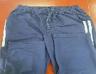
27-Dec-2023 | Henan | Cotton Pants | Fabric / Textile / Garment / Home Textile | Choking Hazard, Suffocation Hazard | /

