Recall Cases Summary – Europe (Last Update Date: 31 December 2023)

Date | Notifying Country | Product | Categories | Hazard | Image
1-Dec-2023 | France | Chainsaw | Machinery | Injury Hazard | 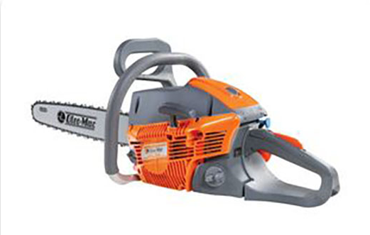
1-Dec-2023 | Poland | Magnetic Balls | Toys and Childcare Products | Choking Hazard, Injury Hazard | 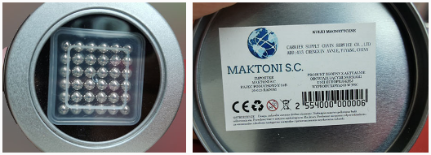
1-Dec-2023 | Lithuania | Soft Toy | Toys and Childcare Products | Choking Hazard | 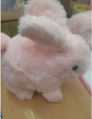
1-Dec-2023 | Hungary | Perfume | Bodycare / Cosmetics | Chemical Hazard | 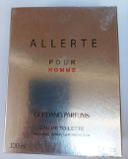
1-Dec-2023 | Germany | Motorcycle/  Spare Part | Car Components | Injury Hazard | 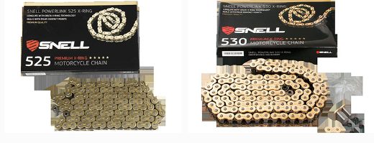
1-Dec-2023 | Germany | Working Gloves | Protective Equipment | Chemical Hazard | 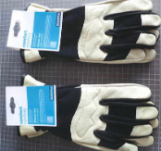
1-Dec-2023 | Germany | Relay Device and Descender | Sporting Goods / Equipment | Injury Hazard | 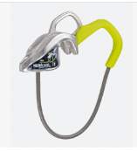
2-Dec-2023 | France | Glue | Chemicals | Chemical Hazard | 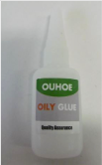
4-Dec-2023 | Malta | Soft Toy | Toys and Childcare Products | Choking Hazard | 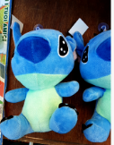
5-Dec-2023 | Sweden | Smartwatch | Computer / Audio / Video / Other Electronics & Accessories | Environmental Hazard | 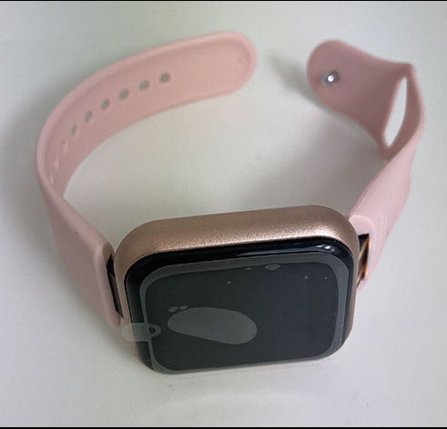
5-Dec-2023 | Poland | Magnetic Balls | Toys and Childcare Products | Injury Hazard | 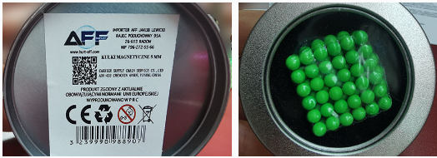
5-Dec-2023 | Hungary | Shower Gel | Bodycare / Cosmetics | Chemical Hazard | 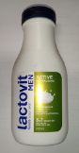
5-Dec-2023 | Finland | Hairpin | Accessories | Chemical Hazard | 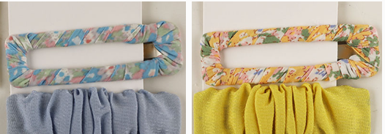
5-Dec-2023 | Sweden | Cosmetic Bag | Fabric / Textile / Garment / Home Textile | Chemical Hazard, Environmental Hazard | 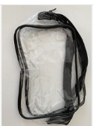
5-Dec-2023 | Finland | Plush Toy | Toys and Childcare Products | Choking Hazard | 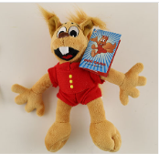
5-Dec-2023 | Hungary | Shower Gel | Bodycare / Cosmetics | Chemical Hazard | 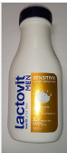
6-Dec-2023 | Czechia | Plastic Doll | Toys and Childcare Products | Chemical Hazard
6-Dec-2023 | Czechia | Plastic Doll | Toys and Childcare Products | Chemical Hazard | 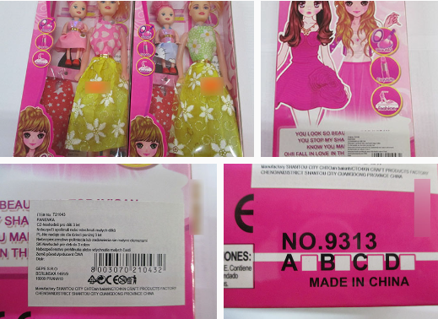
6-Dec-2023 | Lithuania | Extension Lead | Electrical Appliances | Electric Shock Hazard | 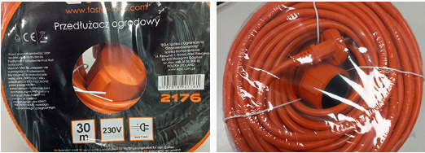
6-Dec-2023 | Poland | Magnetic Toy Set | Toys and Childcare Products | Injury Hazard | 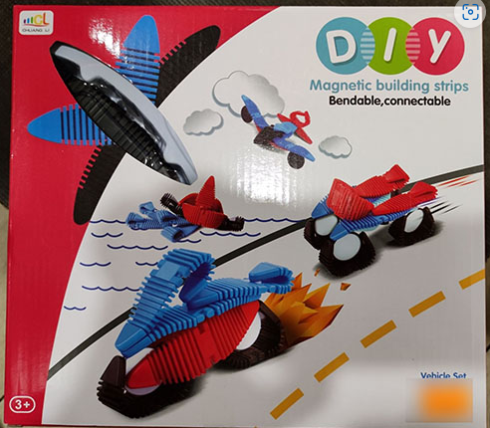
6-Dec-2023 | Estonia | Permanent Makeup Ink | Chemicals | Chemical Hazard | 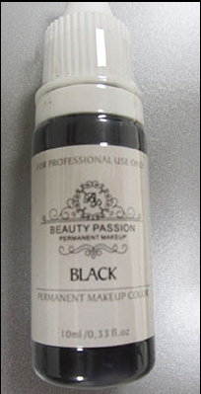
6-Dec-2023 | Finland | Hairpin | Accessories | Chemical Hazard | 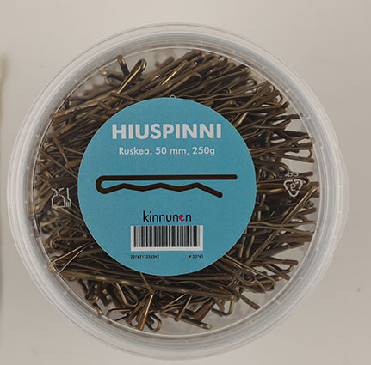
6-Dec-2023 | Hungary | Shower Gel | Bodycare / Cosmetics | Chemical Hazard | 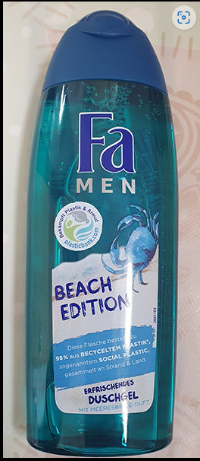
6-Dec-2023 | Germany | Children's Particle Filter Mask | Protective Equipment | Health Risk Hazard | 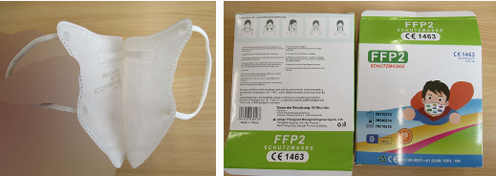
6-Dec-2023 | Bulgaria | Plastic Table | Furniture | Injury Hazard | 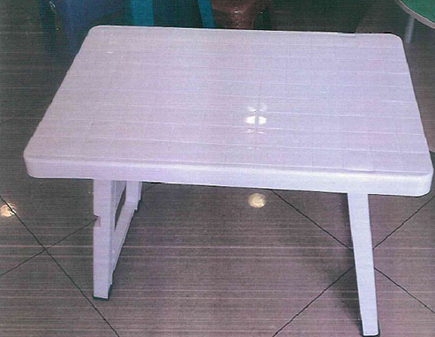
6-Dec-2023 | Estonia | Permanent Makeup Ink | Chemicals | Chemical Hazard | 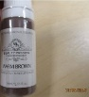
6-Dec-2023 | Hungary | Cream | Bodycare / Cosmetics | Chemical Hazard | 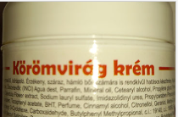
6-Dec-2023 | Hungary | Perfume Set | Bodycare / Cosmetics | Chemical Hazard | 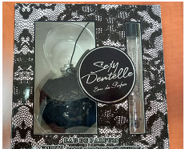
6-Dec-2023 | Hungary | Perfume | Bodycare / Cosmetics | Chemical Hazard | 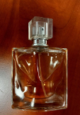
6-Dec-2023 | Estonia | Permanent Makeup Ink | Chemicals | Chemical Hazard | 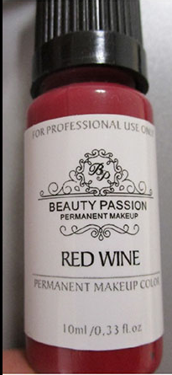
6-Dec-2023 | Bulgaria | Wooden Table | Furniture | Injury Hazard | 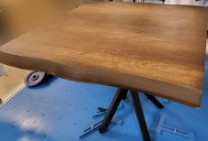
6-Dec-2023 | Lithuania | Toy Duck | Toys and Childcare Products | Choking Hazard | 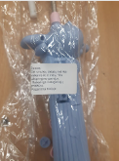  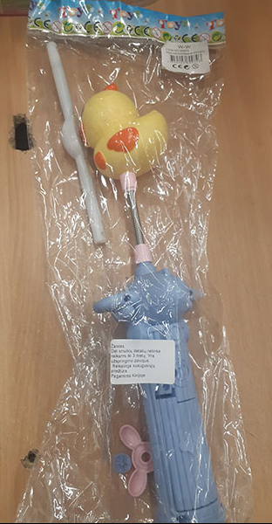
6-Dec-2023 | Bulgaria | Chair | Furniture | Injury Hazard | 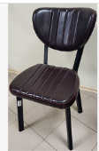
6-Dec-2023 | Lithuania | Toy Pistol | Toys and Childcare Products | Suffocation Hazard | 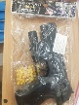
7-Dec-2023 | Lithuania | Rattle Toy | Toys and Childcare Products | Suffocation Hazard | 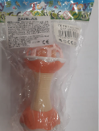
7-Dec-2023 | Poland | Slingshot Toy | Toys and Childcare Products | Damage to Sight | 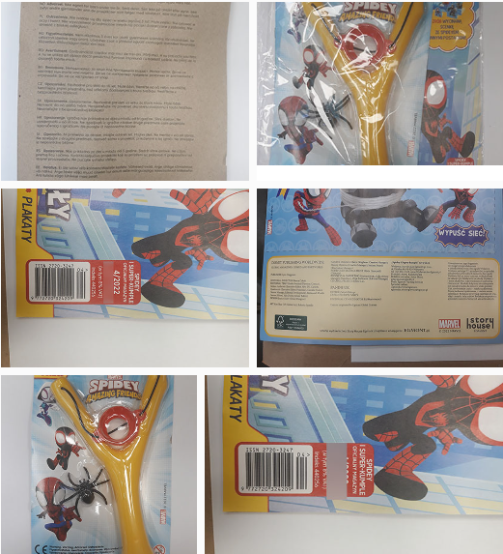
7-Dec-2023 | Belgium | Children´s High Chair | Toys and Childcare Products | Chemical Hazard | 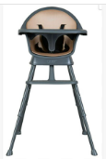
7-Dec-2023 | France | Airbag Backpack | Fabric / Textile / Garment / Home Textile | Injury Hazard | 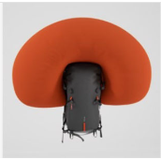
7-Dec-2023 | Lithuania | Doll | Toys and Childcare Products | Chemical Hazard | 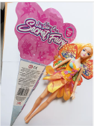
7-Dec-2023 | Germany | Particle Filter Mask | Protective Equipment | Choking Hazard | 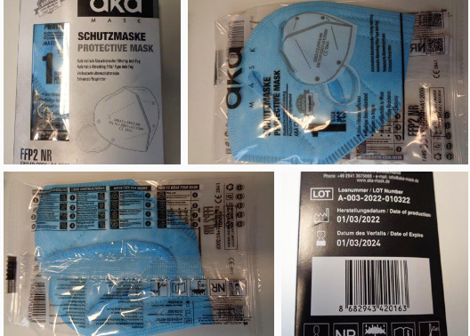
7-Dec-2023 | France | Teething Ring | Toys and Childcare Products | Choking Hazard | 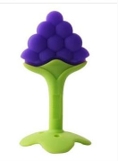
7-Dec-2023 | Malta | Toy Gun | Toys and Childcare Products | Choking Hazard, Damage to Sight, Injury Hazard | 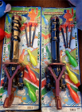
7-Dec-2023 | Finland | Musical Toy | Toys and Childcare Products | Strangulation Hazard, Suffocation Hazard | 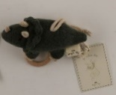
7-Dec-2023 | Ireland | Children's Fancy-Dress Mask | Toys and Childcare Products | Burn Hazard | 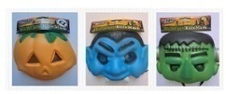
7-Dec-2023 | Denmark | Ceiling LED Light | Electrical Appliances | Electric Shock Hazard | 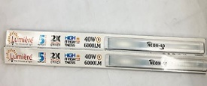
7-Dec-2023 | Poland | Plastic Toy | Toys and Childcare Products | Cut Hazard | 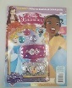
7-Dec-2023 | Lithuania | Bracelet | Jewelry | Chemical Hazard | 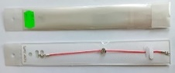
7-Dec-2023 | Lithuania | Ring | Jewelry | Chemical Hazard | 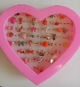
7-Dec-2023 | Hungary | Deodorant and Shower Gel Set | Bodycare / Cosmetics | Chemical Hazard | 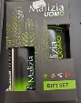
7-Dec-2023 | Hungary | Shaving Soap | Bodycare / Cosmetics | Chemical Hazard | 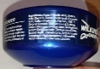
7-Dec-2023 | Hungary | Eau De Toilette | Bodycare / Cosmetics | Chemical Hazard | 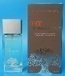
7-Dec-2023 | Hungary | Perfume | Bodycare / Cosmetics | Chemical Hazard | 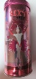
7-Dec-2023 | The Netherlands | Toy Train with Wagons | Toys and Childcare Products | Choking Hazard | 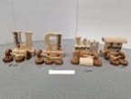
7-Dec-2023 | Hungary | Eau De Toilette | Bodycare / Cosmetics | Chemical Hazard | 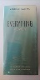
7-Dec-2023 | Czechia | Perfume | Bodycare / Cosmetics | Chemical Hazard | 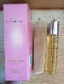
7-Dec-2023 | Czechia | Eau De Toilette | Bodycare / Cosmetics | Chemical Hazard | 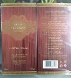
8-Dec-2023 | Germany | Particle Filter Mask | Protective Equipment | Health Risk Hazard | 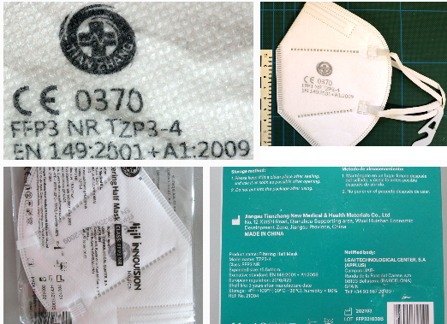
8-Dec-2023 | France | Dehumidifier | Home Electrical Appliances | Fire Hazard | 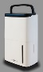
8-Dec-2023 | Germany | Insect Killer | Home Electrical Appliances | Electric Shock Hazard | 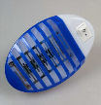
8-Dec-2023 | Denmark | Fireworks | Outdoor Living Items | Damage to Sight, Fire Hazard | 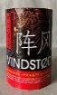
8-Dec-2023 | The Netherlands | Puzzle | Toys and Childcare Products | Choking Hazard | 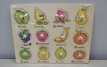
13-Dec-2023 | Czechia | Plastic Doll | Toys and Childcare Products | Chemical Hazard | 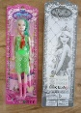
13-Dec-2023 | France | Button Batteries | Electrical Appliances | Chemical Hazard, Choking Hazard | 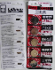
13-Dec-2023 | Norway | Raincoat | Fabric / Textile / Garment / Home Textile | Chemical Hazard | 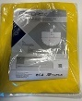
13-Dec-2023 | Norway | Floor PVC Tiles | Sporting Goods / Equipment | Chemical Hazard | 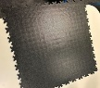
13-Dec-2023 | Italy | Shampoo and Conditioner | Bodycare / Cosmetics | Chemical Hazard | 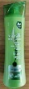
13-Dec-2023 | Italy | Hair Conditioner | Bodycare / Cosmetics | Chemical Hazard | 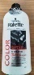
13-Dec-2023 | Italy | Liquid Soap | Bodycare / Cosmetics | Chemical Hazard | 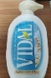
13-Dec-2023 | Italy | Liquid Hand Soap | Bodycare / Cosmetics | Chemical Hazard | 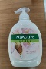
13-Dec-2023 | Italy | Liquid Soap | Bodycare / Cosmetics | Chemical Hazard | 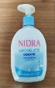
13-Dec-2023 | Italy | Shower Cream | Bodycare / Cosmetics | Chemical Hazard | 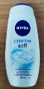
13-Dec-2023 | Sweden | Robotic Vacuum Cleaner | Home Electrical Appliances | Chemical Hazard, Environmental Hazard | 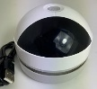
13-Dec-2023 | Italy | Shower Gel | Bodycare / Cosmetics | Chemical Hazard | 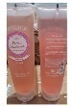
13-Dec-2023 | Lithuania | Expandable Toy | Toys and Childcare Products | Choking Hazard, Injury Hazard | 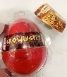
13-Dec-2023 | Italy | Body Cream | Bodycare / Cosmetics | Chemical Hazard | 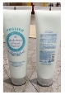
13-Dec-2023 | Italy | Body Cream | Bodycare / Cosmetics | Chemical Hazard | 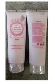
13-Dec-2023 | Slovenia | Particle Filter Mask | Protective Equipment | Health Risk Hazard | 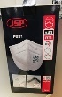
13-Dec-2023 | Italy | Body Lotion | Bodycare / Cosmetics | Chemical Hazard | 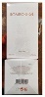
14-Dec-2023 | Italy | Deodorant Cream | Bodycare / Cosmetics | Health Risk Hazard, Injury Hazard | 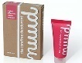
14-Dec-2023 | Italy | Shower Foam | Bodycare / Cosmetics | Chemical Hazard | 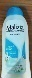
14-Dec-2023 | Italy | Bath Foam | Bodycare / Cosmetics | Chemical Hazard | 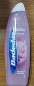
14-Dec-2023 | Italy | Perfume | Bodycare / Cosmetics | Chemical Hazard | 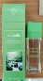
14-Dec-2023 | Italy | Perfume | Bodycare / Cosmetics | Chemical Hazard | 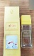
14-Dec-2023 | Sweden | Power Bank | Electrical Appliances | Chemical Hazard, Environmental Hazard | 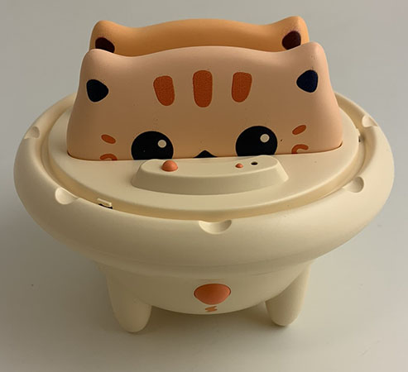
14-Dec-2023 | Austria | Cosmetic Set | Bodycare / Cosmetics | Chemical Hazard | 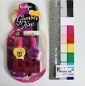
14-Dec-2023 | Italy | Scented Body Mist | Bodycare / Cosmetics | Chemical Hazard | 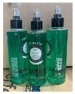
14-Dec-2023 | Italy | Varnish | Chemicals | Chemical Hazard | 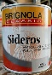
14-Dec-2023 | Italy | Varnish | Chemicals | Chemical Hazard | 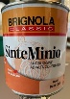
14-Dec-2023 | Italy | Varnish | Chemicals | Chemical Hazard | 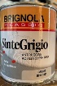
14-Dec-2023 | Italy | Varnish | Chemicals | Chemical Hazard | 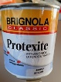
14-Dec-2023 | Italy | Hand Cream | Bodycare / Cosmetics | Chemical Hazard | 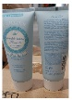
14-Dec-2023 | Italy | Hair and Body Wash | Bodycare / Cosmetics | Chemical Hazard | 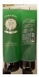
14-Dec-2023 | Italy | Varnish | Chemicals | Chemical Hazard | 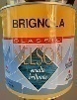
14-Dec-2023 | Italy | Bar of Soap | Bodycare / Cosmetics | Chemical Hazard | 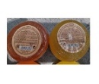
14-Dec-2023 | Italy | Eau De Toilette and Shower Gel Set | Bodycare / Cosmetics | Chemical Hazard | 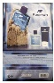
14-Dec-2023 | Sweden | Electrical Massage Balls | Electrical Appliances | Chemical Hazard, Environmental Hazard | 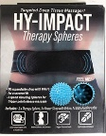
14-Dec-2023 | Hungary | Lighting Chain | Electrical Appliances | Burn Hazard, Electric Shock Hazard, Fire Hazard | 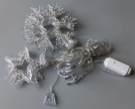
14-Dec-2023 | Sweden | Headphones | Computer / Audio / Video / Other Electronics & Accessories | Chemical Hazard, Environmental Hazard | 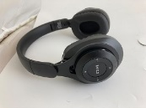
14-Dec-2023 | Denmark | Fireworks | Outdoor Living Items | Burn Hazard, Injury Hazard | 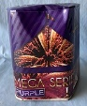
14-Dec-2023 | Poland | Power Bank | Electrical Appliances | Burn Hazard, Fire Hazard | 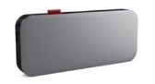
14-Dec-2023 | Denmark | Fireworks | Outdoor Living Items | Damage to Sight, Fire Hazard | 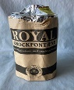
14-Dec-2023 | Hungary | Moisturizing Cream | Bodycare / Cosmetics | Chemical Hazard | 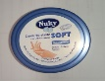
14-Dec-2023 | Hungary | Perfume | Bodycare / Cosmetics | Chemical Hazard | 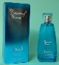
14-Dec-2023 | Hungary | Eau De Toilette | Bodycare / Cosmetics | Chemical Hazard | 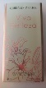
14-Dec-2023 | Lithuania | Plastic Doll | Toys and Childcare Products | Chemical Hazard | 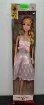
16-Dec-2023 | Sweden | LED Light | Electrical Appliances | Environmental Hazard | 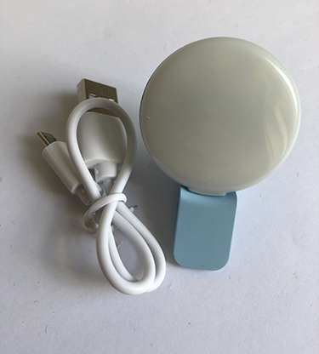  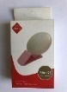
16-Dec-2023 | Sweden | Remote Control | Electrical Appliances | Environmental Hazard | 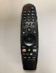
16-Dec-2023 | Sweden | USB Cable | Electrical Appliances | Environmental Hazard | 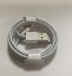
16-Dec-2023 | Sweden | USB Cable | Electrical Appliances | Environmental Hazard | 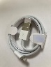
18-Dec-2023 | Slovakia | Attachment for Brush Cutters | Machinery | Injury Hazard | 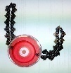
18-Dec-2023 | Lithuania | Plastic Doll | Toys and Childcare Products | Chemical Hazard | 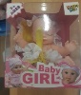
18-Dec-2023 | Hungary | Laser Pointer | Electrical Appliances | Damage to Sight | 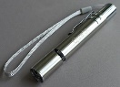
19-Dec-2023 | Italy | Bath Foam | Bodycare / Cosmetics | Chemical Hazard | 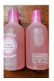
19-Dec-2023 | Ireland | Children's Snowsuit | Fabric / Textile / Garment / Home Textile | Choking Hazard | 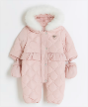
19-Dec-2023 | Italy | Protective Moisturising Lotion | Bodycare / Cosmetics | Chemical Hazard | 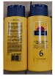
19-Dec-2023 | Italy | Eau De Toilette | Bodycare / Cosmetics | Chemical Hazard | 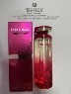
19-Dec-2023 | Italy | Eau De Toilette | Bodycare / Cosmetics | Chemical Hazard | 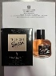
19-Dec-2023 | Italy | Eau De Toilette | Bodycare / Cosmetics | Chemical Hazard | 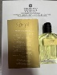
19-Dec-2023 | Italy | Eau De Toilette | Bodycare / Cosmetics | Chemical Hazard | 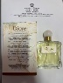
19-Dec-2023 | Italy | Perfume | Bodycare / Cosmetics | Chemical Hazard | 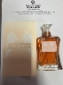
19-Dec-2023 | Italy | Eau De Toilette | Bodycare / Cosmetics | Chemical Hazard | 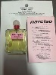
19-Dec-2023 | Hungary | Laser Pointer | Electrical Appliances | Damage to Sight | 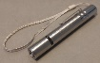
19-Dec-2023 | Hungary | Lighting Chain | Electrical Appliances | Electric Shock Hazard | 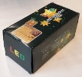
19-Dec-2023 | Hungary | Lighting Chain | Electrical Appliances | Burn Hazard, Electric Shock Hazard, Fire Hazard
19-Dec-2023 | Sweden | Bracelet | Jewelry | Chemical Hazard | 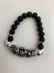
19-Dec-2023 | Sweden | Necklace | Jewelry | Chemical Hazard | 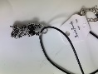
19-Dec-2023 | Sweden | Balloons | Toys and Childcare Products | Chemical Hazard | 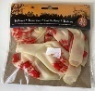
20-Dec-2023 | Bulgaria | Electric Water Heater | Home Electrical Appliances | Electric Shock Hazard | 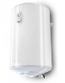
20-Dec-2023 | Bulgaria | Electric Water Heater | Home Electrical Appliances | Electric Shock Hazard | 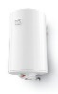
20-Dec-2023 | France | Fancy Dress Costume | Fabric / Textile / Garment / Home Textile | Chemical Hazard | 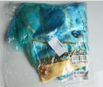
20-Dec-2023 | Sweden | Rings | Jewelry | Chemical Hazard | 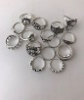
20-Dec-2023 | Finland | Soother Holder | Toys and Childcare Products | Choking Hazard, Strangulation Hazard | 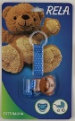
20-Dec-2023 | Italy | Hair Conditioner | Bodycare / Cosmetics | Chemical Hazard | 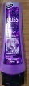
20-Dec-2023 | Italy | Bath Cream | Bodycare / Cosmetics | Chemical Hazard | 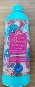
20-Dec-2023 | Italy | Bath Foam | Bodycare / Cosmetics | Chemical Hazard | 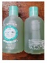
20-Dec-2023 | Italy | Body Scrub | Bodycare / Cosmetics | Chemical Hazard | 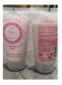
20-Dec-2023 | Luxembourg | Motorcycle Tyre | Car Components | Injury Hazard | 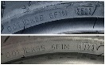
20-Dec-2023 | Italy | Travel Adaptor | Electrical Appliances | Electric Shock Hazard | 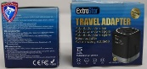
20-Dec-2023 | Germany | LED Strip | Electrical Appliances | Electric Shock Hazard | 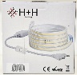
20-Dec-2023 | Sweden | Massage Pen | Electrical Appliances | Environmental Hazard | 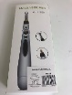
20-Dec-2023 | Sweden | Electric Nail Milling Machine | Electrical Appliances | Environmental Hazard | 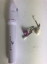
20-Dec-2023 | Hungary | Lighting Chain | Electrical Appliances | Burn Hazard, Electric Shock Hazard, Fire Hazard | 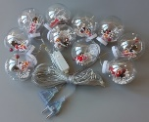
20-Dec-2023 | Hungary | Lighting Chain | Electrical Appliances | Burn Hazard, Electric Shock Hazard, Fire Hazard | 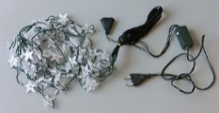
20-Dec-2023 | Sweden | LED Spotlight | Electrical Appliances | Environmental Hazard | 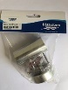
20-Dec-2023 | Sweden | Flashlight | Electrical Appliances | Environmental Hazard | 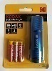
20-Dec-2023 | Lithuania | Plastic Doll | Toys and Childcare Products | Chemical Hazard | 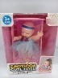
20-Dec-2023 | Italy | Eau De Toilette | Bodycare / Cosmetics | Chemical Hazard | 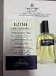
20-Dec-2023 | Slovenia | Bracelet | Jewelry | Chemical Hazard | 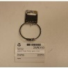
20-Dec-2023 | Italy | Eau De Toilette | Bodycare / Cosmetics | Chemical Hazard | 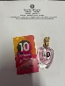
20-Dec-2023 | Poland | Soft Toy | Toys and Childcare Products | Choking Hazard | 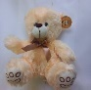
20-Dec-2023 | Poland | Toy Bow | Toys and Childcare Products | Choking Hazard, Injury Hazard | 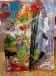
20-Dec-2023 | Sweden | Necklace | Jewelry | Chemical Hazard | 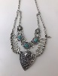
20-Dec-2023 | Lithuania | Rattle Toy Set | Toys and Childcare Products | Choking Hazard | 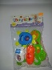
20-Dec-2023 | Denmark | Gel Blaster | Toys and Childcare Products | Choking Hazard, Damage to Sight | 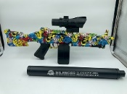
20-Dec-2023 | Sweden | Headphones | Computer / Audio / Video / Other Electronics & Accessories | Environmental Hazard | 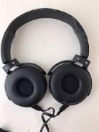
20-Dec-2023 | Italy | Varnish | Chemicals | Chemical Hazard | 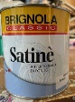
20-Dec-2023 | Italy | Varnish | Chemicals | Chemical Hazard | 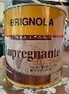
20-Dec-2023 | Italy | Varnish | Chemicals | Chemical Hazard | 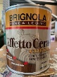
20-Dec-2023 | Sweden | Gloves | Fabric / Textile / Garment / Home Textile | Environmental Hazard | 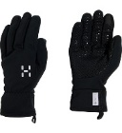
20-Dec-2023 | Sweden | Headband with Earphones | Computer / Audio / Video / Other Electronics & Accessories | Environmental Hazard | 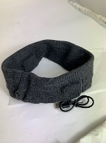
20-Dec-2023 | Sweden | USB Charger | Electrical Appliances | Environmental Hazard | 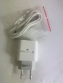
20-Dec-2023 | Sweden | Gloves with LED Lights | Fabric / Textile / Garment / Home Textile | Environmental Hazard | 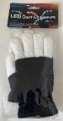
20-Dec-2023 | Sweden | Digital Watch | Computer / Audio / Video / Other Electronics & Accessories | Environmental Hazard | 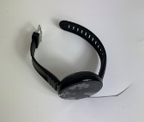
20-Dec-2023 | Portugal | Passenger Car | Car Components | Injury Hazard | 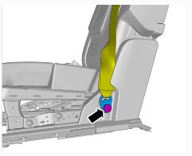
20-Dec-2023 | Ireland | Bodywash | Bodycare / Cosmetics | Microbiological Hazard | 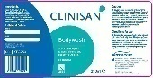  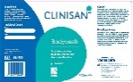
21-Dec-2023 | Ireland | Hair Dryer | Home Electrical Appliances | Electric Shock Hazard | 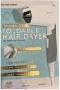
21-Dec-2023 | Austria | Skin Lightening Cream | Bodycare / Cosmetics | Chemical Hazard | 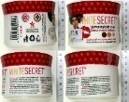
21-Dec-2023 | Norway | Jumping Rope | Sporting Goods / Equipment | Chemical Hazard | /
21-Dec-2023 | Ireland | Children's Snowsuit | Fabric / Textile / Garment / Home Textile | Choking Hazard | 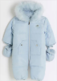
21-Dec-2023 | Sweden | Electric Key Finder | Electrical Appliances | Environmental Hazard | 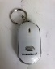
21-Dec-2023 | Czechia | Plastic Doll | Toys and Childcare Products | Chemical Hazard | 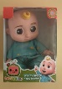
21-Dec-2023 | Sweden | LED Lamp | Home Electrical Appliances | Environmental Hazard | 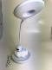
21-Dec-2023 | Lithuania | Toy Car | Toys and Childcare Products | Choking Hazard | 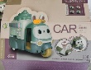
21-Dec-2023 | Lithuania | Musical Toy | Toys and Childcare Products | Choking Hazard | 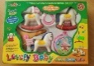
22-Dec-2023 | Ireland | Babies' Clothing Set | Fabric / Textile / Garment / Home Textile | Choking Hazard | 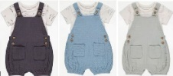
22-Dec-2023 | Ireland | Wall Charger | Electrical Appliances | Electric Shock Hazard, Fire Hazard | 