Recall Cases Summary – US (Last Update Date: 31 December 2023)

Date | Product | Categories | Hazard | Image
5-Dec-2023 | Foiresoft Zebra Roller Blinds | Household Items | Strangulation Hazard | 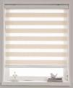
7-Dec-2023 | Oreck Discover Upright Vacuums | Home Electrical Appliances | Electric Shock Hazard | 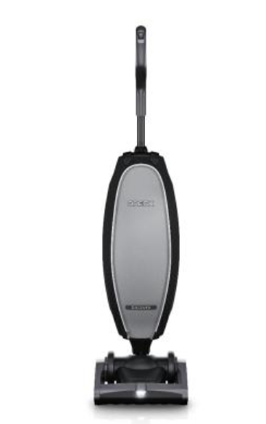
7-Dec-2023 | Nap Queen Maxima Hybrid Mattresses | Fabric / Textile / Garment / Home Textile | Fire Hazard | 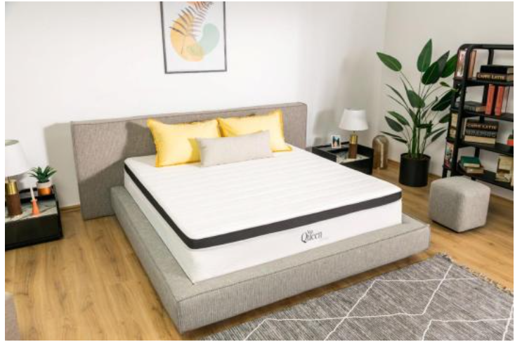
7-Dec-2023 | Bubba Bull Plush Toys | Toys and Childcare Products | Choking Hazard | 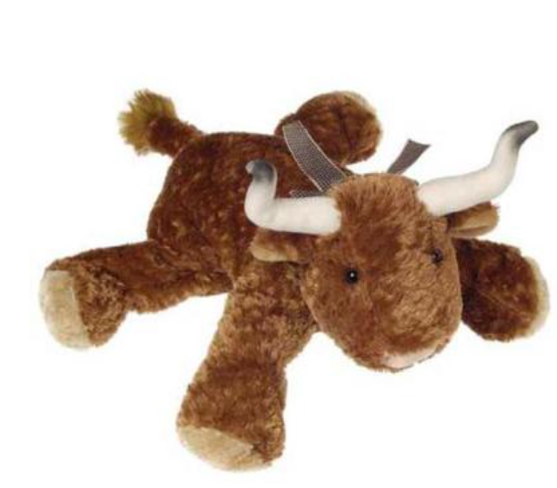
7-Dec-2023 | Outdoor Mold & Mildew Stain Remover with Hose End Nozzle | Chemicals | Eye Irritation Risk, Skin Irritation Risk, Injury Hazard | 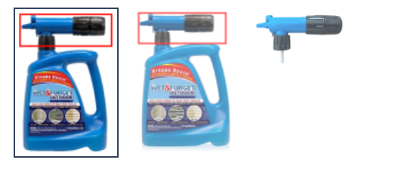
7-Dec-2023 | Windsor Queen Xtrabed™ | Furniture | Tip-Over Hazard, Entrapment Hazard, Injury Hazard | 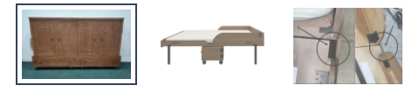
7-Dec-2023 | High-Powered Magnetic Balls | Toys and Childcare Products | Risk of Death, Swallowing Risk, Ingestion Hazard | 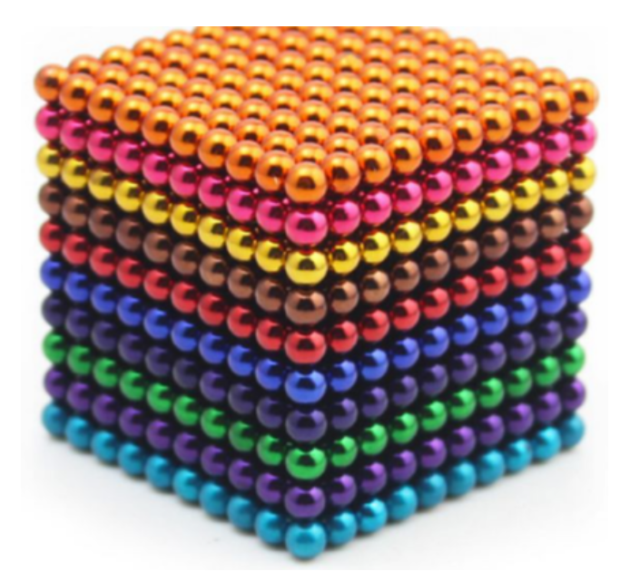
7-Dec-2023 | Baby Rattles | Toys and Childcare Products | Choking Hazard, Ingestion Hazard | 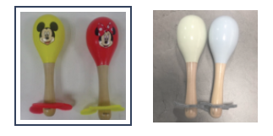
7-Dec-2023 | Squids Wire Tool Attachments with Screw Gate Tool Tails | Tools and Hardware | Injury Hazard | 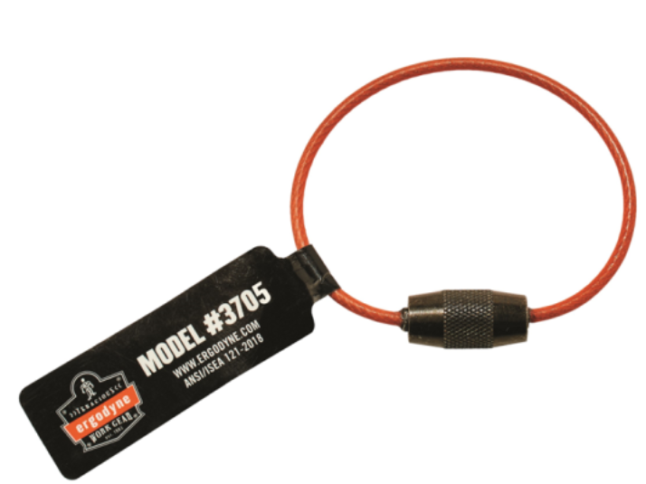
7-Dec-2023 | Vibe Bear Playyard Mattresses | Fabric / Textile / Garment / Home Textile | Suffocation Hazard | 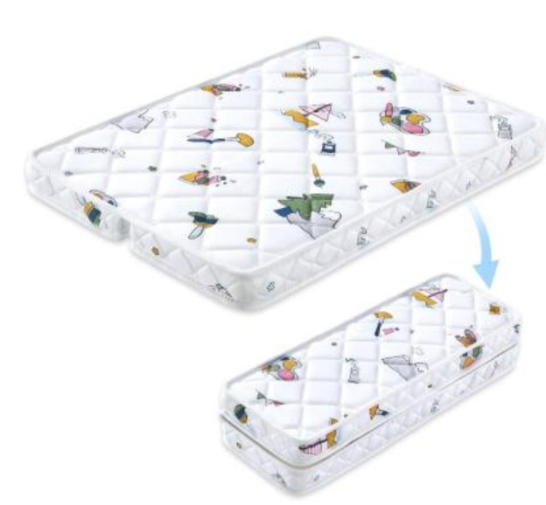
7-Dec-2023 | Dragonfly Seat Strollers | Toys and Childcare Products | Injury Hazard | 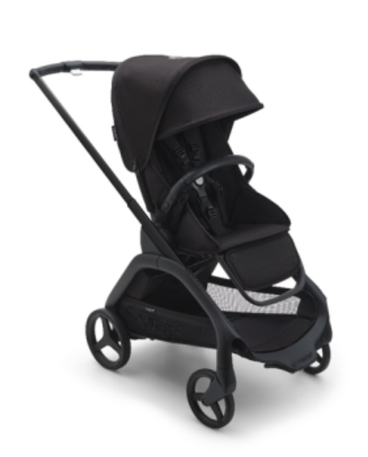
7-Dec-2023 | Moonsea Pack and Play Mattresses | Fabric / Textile / Garment / Home Textile | Suffocation Hazard | 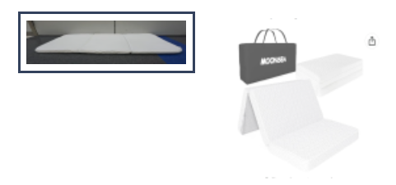
7-Dec-2023 | Mini String Lights | Electrical Appliances | Fire Hazard, Burn Hazard | 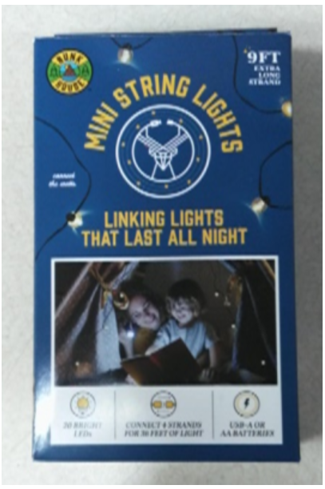
14-Dec-2023 | Steamfast Travel Steam Irons | Home Electrical Appliances | Fire Hazard, Burn Hazard, Electric Shock Hazard | 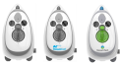  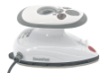
14-Dec-2023 | Power XL Dual Basket Air Fryers | Home Electrical Appliances | Burn Hazard | 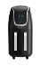  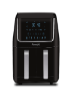
14-Dec-2023 | Quilted Cotton Mattress Pads | Fabric / Textile / Garment / Home Textile | Fire Hazard | 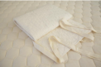
14-Dec-2023 | Griffin Duo Bunk Beds | Furniture | Fall Hazard, Injury Hazard | 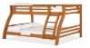  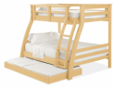
14-Dec-2023 | Flat Top Propane Grills | Outdoor Living Items | Fire Hazard | 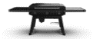
14-Dec-2023 | Collegiate Horse-Riding Saddles | Sporting Goods / Equipment | Fall Hazard, Injury Hazard | 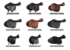
21-Dec-2023 | Litti City and Litti Pritti Dress-up Playsets and Prextex Slime Eggs | Toys and Childcare Products | Health Risk Hazard, Lead Poisoning Hazard | 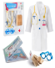  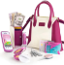  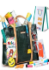  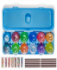
21-Dec-2023 | Casement Windows | Construction Products | Injury Hazard | 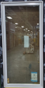
21-Dec-2023 | High Chairs | Toys and Childcare Products | Suffocation Hazard, Entrapment Hazard, Laceration Hazard | 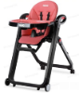  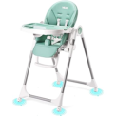
21-Dec-2023 | Hover-1 Helix Hoverboards | Sporting Goods / Equipment | Fire Hazard | 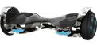  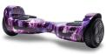
21-Dec-2023 | Rhino Tree Stands | Tools and Hardware | Fall Hazard | 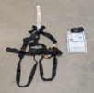
21-Dec-2023 | Blackfire and Klein Tools Power Stations | Tools and Hardware | Fire Hazard, Burn Hazard
21-Dec-2023 | Foldable Wood and Rope Bistro Set Chairs | Furniture | Fall Hazard | 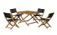  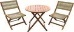  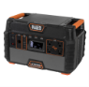
28-Dec-2023 | Simpson Pressure Washers | Machinery | Burn Hazard | 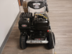
28-Dec-2023 | Portable Blenders | Electrical Appliances | Fire Hazard, Laceration Hazard
28-Dec-2023 | High-Powered Magnetic Balls | Toys and Childcare Products | Ingestion Hazard, Risk of Death, Swallowing Risk | 