Recall Cases Summary – Australia (Last Update Date: 31 January 2024)

Date | Product | Categories | Hazard | Image
10-Jan-2024 | A Little Lovely Company Novelty Shaped Night Lights | Electrical Appliances | Choking Hazard, Burn Hazard, Injury Hazard, Risk of Death, Swallowing Risk | 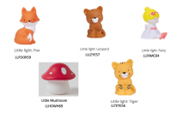
19-Jan-2024 | Grey Goose 40% Limited Edition 1L Night Vision - Northern Lights Edition | Electrical Appliances | Choking Hazard, Burn Hazard, Injury Hazard, Risk of Death, Swallowing Risk | 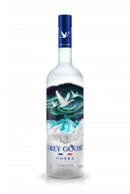
24-Jan-2024 | ÅSKSTORM 40W USB Charger | Electrical Appliances | Electric Shock Hazard, Fire Hazard, Burn Hazard, Risk of Death | 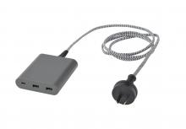
24-Jan-2024 | Gas Cooktop Connecting Elbow | Tools and Hardware | Injury Hazard, Risk of Death, Fire Hazard, Explosion Hazard, Risk of Exposure to Combustion Flue Gas | 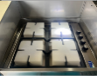  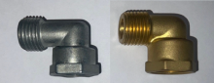
29-Jan-2024 | Workshop Bar Light | Electrical Appliances | Electric Shock Hazard, Injury Hazard, Risk of Death | 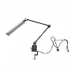
29-Jan-2024 | JT1500 Series Jet Skis | Sporting Goods / Equipment | Injury Hazard | 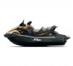  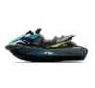
29-Jan-2024 | Engines in Cub Cadet Lawn Mowers | Machinery | Fire Hazard, Injury Hazard, Risk of Death | 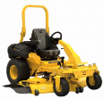
29-Jan-2024 | Engines in Hustler Lawn Mowers | Machinery | Fire Hazard, Injury Hazard, Risk of Death | 