Recall Cases Summary – Canada (Last Update Date: 31 January 2024)

Date | Product | Categories | Hazard | Image
2-Jan-2024 | Blinds | Household Items | Strangulation Hazard, Choking Hazard, Entanglement Hazard, Risk of Death | 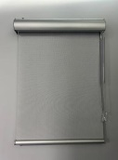
2-Jan-2024 | Zebra Blinds and Roller Shades with Chain and Chain Guard | Household Items | Strangulation Hazard, Entanglement Hazard, Risk of Death | 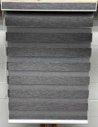
3-Jan-2024 | Olmitos Basic Zoo Walker | Toys and Childcare Products | Injury Hazard, Risk of Death, Fall Hazard | 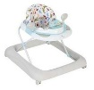
4-Jan-2024 | Therapist Select Percussion Personal Massagers | Electrical Appliances | Fire Hazard, Burn Hazard | 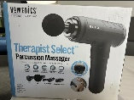
5-Jan-2024 | Zebra blinds with Chain and Chain Guard | Household Items | Strangulation Hazard, Choking Hazard, Entanglement Hazard, Risk of Death | 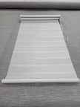
5-Jan-2024 | Tonkotsu Ramen Noodles | Food | Risk of Allergy | 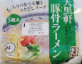
9-Jan-2024 | Caffeinated Energy Drinks | Food | Chemical Hazard | 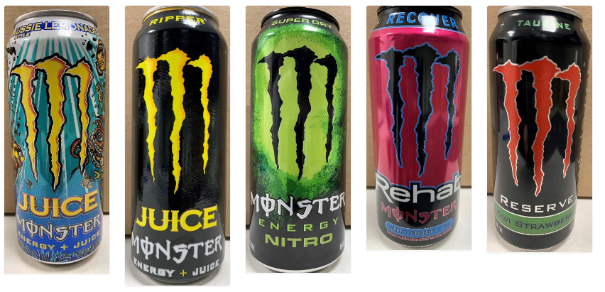
9-Jan-2024 | Vegan Gluten Free Margherita Pizza | Food | Risk of Allergy | 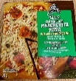
10-Jan-2024 | ÅSKSTORM 40W USB Charger Dark Grey NA | Electrical Appliances | Burn Hazard, Electric Shock Hazard | 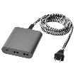
10-Jan-2024 | Blinds from Versailles Home Fashion | Household Items | Strangulation Hazard, Choking Hazard, Entanglement Hazard, Risk of Death | 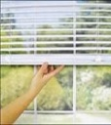
11-Jan-2024 | Granola Bars and Cereals and Treat Bars – Berry Bar | Food | Microbiological Hazard | /
11-Jan-2024 | Retrospec Scout Bicycle Helmet | Sporting Goods / Equipment | Fall Hazard, Crash Hazard, Injury Hazard | 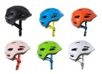  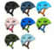
12-Jan-2024 | Sleepers | Fabric / Textile / Garment / Home Textile | Choking Hazard, Ingestion Hazard | 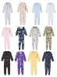  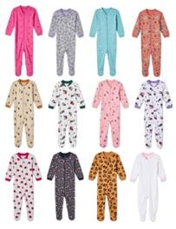
12-Jan-2024 | Parfait and Yogurt Bowls | Food | Microbiological Hazard | /
15-Jan-2024 | Corn (Frozen) | Food | Microbiological Hazard | 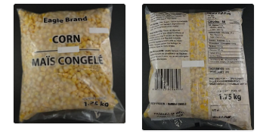
15-Jan-2024 | Collegiate English Horse-Riding Saddles | Sporting Goods / Equipment | Fall Hazard, Injury Hazard | 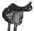  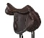  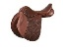  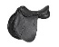  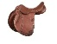  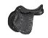  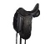  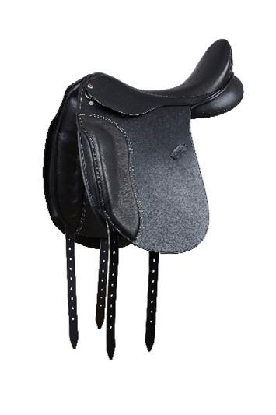  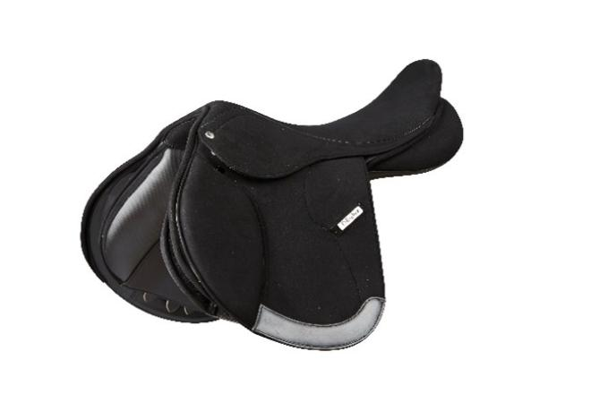
15-Jan-2024 | Chia Tropical Fruit Parfait and Yogurt Parfait | Food | Microbiological Hazard | 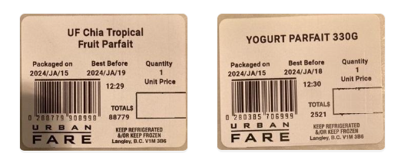
16-Jan-2024 | Cavendish Crunch Freeze Dried Treats | Food | Risk of Allergy | 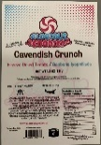  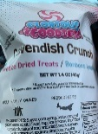
18-Jan-2024 | Home Design, Inc. Low Profile Beds | Furniture | Injury Hazard | 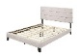  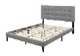  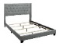  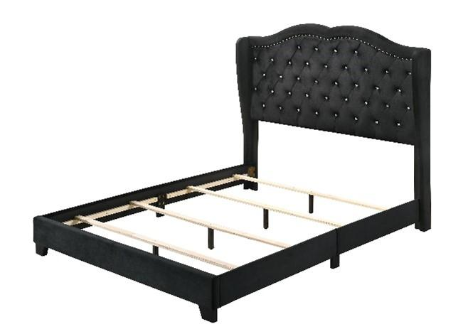  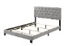
18-Jan-2024 | Steamist Tilt-Up Bath & Shower Seat | Furniture | Fall Hazard | 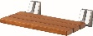  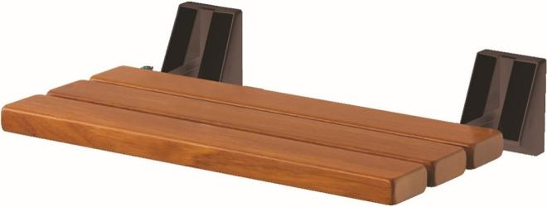  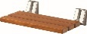  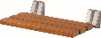
18-Jan-2024 | Vertical Blind Equipped with a Chain and Cord Shield from La Verticalerie | Household Items | Strangulation Hazard | 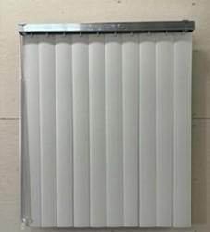
18-Jan-2024 | Hydration Drink | Food | Health Risk Hazard | /
19-Jan-2024 | Frikandellen | Food | Risk of Allergy | 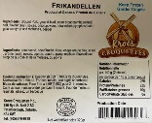
22-Jan-2024 | Various Window Coverings from Carsan EVP | Household Items | Strangulation Hazard | 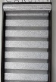  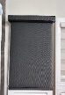
22-Jan-2024 | Various Dastex Brand Blinds and Shades | Household Items | Strangulation Hazard, Choking Hazard | 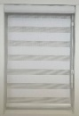
22-Jan-2024 | Zebra Blinds and Roller Blinds Equipped with a Chain and Cord Shield from Les Stores Ameuriq | Household Items | Strangulation Hazard
22-Jan-2024 | Sweet Pepper | Food | Risk of Allergy | /
23-Jan-2024 | Various Blinds by Persienne Design | Household Items | Strangulation Hazard | 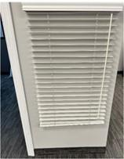  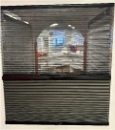
25-Jan-2024 | Maverick Coastal 60-Inch Outdoor Ceiling Fan | Electrical Appliances | Impact Hazard | 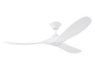  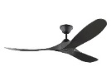
25-Jan-2024 | Various Custom-Made Corded Window Coverings | Household Items | Strangulation Hazard, Choking Hazard, Entanglement Hazard, Risk of Death | 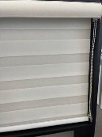
26-Jan-2024 | Various Window Coverings | Household Items | Strangulation Hazard, Choking Hazard, Entanglement Hazard, Risk of Death | 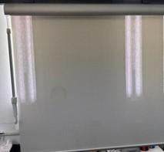
26-Jan-2024 | Keto Chocolate Chip Cookies and Keto Brownies | Food | Risk of Allergy | /
.

