Recall Cases Summary – China (Last Update Date: 31 January 2024)

Date |  |  | Province | Product | Categories | Hazard | Image
2-Jan-2024 |  |  | Anhui | Integrated Electrical Appliances | Electrical Appliances | Electric Shock Hazard, Injury Hazard | /
2-Jan-2024 |  |  | Anhui | Copybooks (Nine-Square Division) | Stationery | Laceration Hazard | /
2-Jan-2024 |  |  | Anhui | Children's Clothing (Tops) | Fabric / Textile / Garment / Home Textile | Suffocation Hazard, Entanglement Hazard | /
2-Jan-2024 |  |  | Anhui | Foreign Language Exercise Books | Stationery | Laceration Hazard | /
2-Jan-2024 |  |  | Anhui | Electric Bicycle Charger | Electrical Appliances | Electric Shock Hazard, Fire Hazard | /
2-Jan-2024 |  |  | Anhui | Electric Bicycle Charger | Electrical Appliances | Fire Hazard | /
2-Jan-2024 |  |  | Anhui | Electric Bicycle Charger | Electrical Appliances | Fire Hazard | /
2-Jan-2024 |  |  | Anhui | Electric Bicycle Charger | Electrical Appliances | Electric Shock Hazard, Fire Hazard | /
2-Jan-2024 |  |  | Anhui | Lead-Acid Batteries | Electrical Appliances | Electric Shock Hazard, Laceration Hazard | /
2-Jan-2024 |  |  | Anhui | Lithium Battery Charger | Electrical Appliances | Fire Hazard | /
2-Jan-2024 |  |  | Anhui | Electric Bicycle Chargers | Electrical Appliances | Fire Hazard | /
2-Jan-2024 |  |  | Anhui | Electric Bicycle Chargers | Electrical Appliances | Fire Hazard | /
2-Jan-2024 |  |  | Anhui | Electric Bicycle Chargers | Electrical Appliances | Fire Hazard | /
3-Jan-2024 |  |  | Zhejiang | Collodion Mops | Household Items | Laceration Hazard | 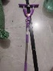
3-Jan-2024 |  |  | Zhejiang | Instant Hot Faucets | Home Electrical Appliances | Burn Hazard | 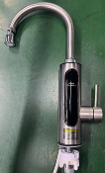
3-Jan-2024 |  |  | Zhejiang | Instant Hot Faucets | Home Electrical Appliances | Burn Hazard | 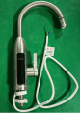
3-Jan-2024 |  |  | Shanghai | Household Gas Stoves | Household Items | Carbon Monoxide Poisoning Hazard | 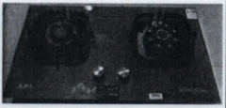
4-Jan-2024 |  |  | Hebei | Water Heating Electric Blankets | Home Electrical Appliances | Safety Risk Hazard | /
4-Jan-2024 |  |  | Hebei | Children's Bicycles | Toys and Childcare Products | Safety Risk Hazard | /
4-Jan-2024 |  |  | Jiangsu | Children's Dresses | Fabric / Textile / Garment / Home Textile | Entanglement Hazard | 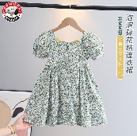
4-Jan-2024 |  |  | Hebei | Automatic Temperature Control Electric Blankets | Home Electrical Appliances | Safety Risk Hazard | /
4-Jan-2024 |  |  | Beijing | Treadmills | Sporting Goods / Equipment | Electric Shock Hazard | 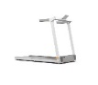
4-Jan-2024 |  |  | Beijing | Treadmills | Sporting Goods / Equipment | Electric Shock Hazard | 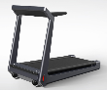
4-Jan-2024 |  |  | Shanghai | Ventilation Fans | Home Electrical Appliances | Electric Shock Hazard | 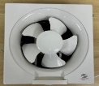
8-Jan-2024 |  |  | Shanxi | Bowls | Food Contact Material | Injury Hazard, Microbiological Hazard | 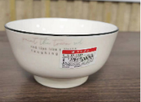
11-Jan-2024 |  |  | Beijing | Children's Balance Bikes | Toys and Childcare Products | Chemical Hazard
11-Jan-2024 |  |  | Henan | Shoulder Sleeves | Fabric / Textile / Garment / Home Textile | Ingestion Hazard, Choking Hazard, Suffocation Hazard | /
11-Jan-2024 |  |  | Zhejiang | Embedded LED Lamps | Electrical Appliances | Health Risk Hazard
11-Jan-2024 |  |  | Zhejiang | LED Panel Lights | Electrical Appliances | Health Risk Hazard
11-Jan-2024 |  |  | Shanghai | Five-in-One Puzzles | Toys and Childcare Products | Suffocation Hazard, Swallowing Risk | 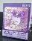  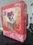  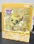  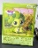  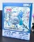
12-Jan-2024 |  |  | Shanghai | USB Chargers | Electrical Appliances | Burn Hazard, Electric Shock Hazard | 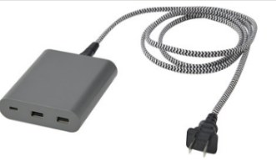
12-Jan-2024 |  |  | Shanghai | Electric Griddles | Home Electrical Appliances | Electric Shock Hazard | 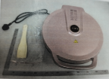
12-Jan-2024 |  |  | Jiangsu | Girls' Suits | Fabric / Textile / Garment / Home Textile | Laceration Hazard, Puncture Hazard, Entanglement Hazard | 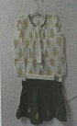
15-Jan-2024 |  |  | Shanghai | Treadmills | Sporting Goods / Equipment | Electric Shock Hazard | 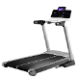  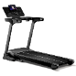
15-Jan-2024 |  |  | Shanghai | Children’s Electric Toothbrushes | Home Electrical Appliances | Swallowing Risk, Suffocation Hazard | 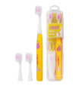
16-Jan-2024 |  |  | Shanghai | Jumpsuits | Fabric / Textile / Garment / Home Textile | Suffocation Hazard | 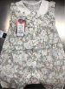
 | 16-Jan-2024 |  | Hebei | Children's Scooter Products | Sporting Goods / Equipment | Safety Risk Hazard | /
 | 16-Jan-2024 |  | Hebei | Children's Scooter Products | Sporting Goods / Equipment | Safety Risk Hazard | /
 | 16-Jan-2024 |  | Hebei | Children's Scooter Products | Sporting Goods / Equipment | Safety Risk Hazard | /
 | 16-Jan-2024 |  | Hebei | Children's Bicycles | Sporting Goods / Equipment | Safety Risk Hazard, Chemical Hazard | /
17-Jan-2024 |  |  | Shanghai | Hair Dryers | Home Electrical Appliances | Fire Hazard, Electric Shock Hazard | 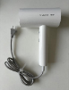
17-Jan-2024 |  |  | Shanghai | Air Purifiers | Home Electrical Appliances | Health Risk Hazard | 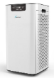
17-Jan-2024 |  |  | Shaanxi | Electric Blanket | Home Electrical Appliances | Electric Shock Hazard, Injury Hazard | /
17-Jan-2024 |  |  | Shaanxi | Electric Blanket | Home Electrical Appliances | Electric Shock Hazard, Injury Hazard | /
 | 17-Jan-2024 |  | Guangdong | Electric Bicycles | Sporting Goods / Equipment | Safety Risk Hazard | /
 |  | 17-Jan-2024 | Guangdong | Electric Bicycles | Sporting Goods / Equipment | Fire Hazard, Explosion Hazard | /
 |  | 17-Jan-2024 | Guangdong | Pencil Cases | Stationery | Chemical Hazard | /
 |  | 17-Jan-2024 | Guangdong | Student Scissors | Stationery | Laceration Hazard | /
 |  | 17-Jan-2024 | Guangdong | Disposable Protective Masks | Protective Equipment | Safety Risk Hazard | /
 |  | 17-Jan-2024 | Guangdong | Induction Cookers | Home Electrical Appliances | Fire Hazard | /
 |  | 17-Jan-2024 | Guangdong | Disposable Protective Masks | Protective Equipment | Safety Risk Hazard | /
 |  | 17-Jan-2024 | Guangdong | Electric Kettles | Home Electrical Appliances | Fire Hazard, Safety Risk Hazard | /
 |  | 17-Jan-2024 | Guangdong | Electric Ceramic Stoves | Home Electrical Appliances | Fire Hazard | /
 |  | 17-Jan-2024 | Guangdong | Range Hoods | Home Electrical Appliances | Electric Shock Hazard | /
 |  | 17-Jan-2024 | Guangdong | Ventilation Fans | Home Electrical Appliances | Electric Shock Hazard | /
 |  | 17-Jan-2024 | Guangdong | Ventilation Fans | Home Electrical Appliances | Fire Hazard, Electric Shock Hazard | /
 |  | 17-Jan-2024 | Guangdong | LED Ceiling Lamps | Electrical Appliances | Fire Hazard, Electric Shock Hazard | /
 |  | 17-Jan-2024 | Guangdong | Fixed LED Lamps | Electrical Appliances | Electric Shock Hazard | /
 |  | 17-Jan-2024 | Beijing | Sweeping Robots | Home Electrical Appliances | Electric Shock Hazard | 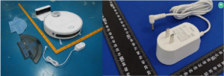
 |  | 17-Jan-2024 | Beijing | Corrugated Hoses Used to Connect Gas Appliances | Tools and Hardware | Risk of Exposure to Combustion Flue Gas | 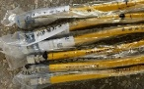
 |  | 18-Jan-2024 | Jiangsu | Narrow Shoe Racks | Furniture | Chemical Hazard | 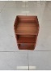
 |  | 18-Jan-2024 | Jiangsu | Tables | Furniture | Chemical Hazard | 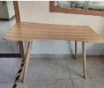
 |  | 19-Jan-2024 | Jiangsu | Plush Dog | Toys and Childcare Products | Suffocation Hazard | 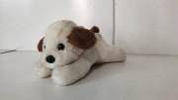
 |  | 22-Jan-2024 | Jiangsu | Embedded LED Lamps | Electrical Appliances | Fire Hazard, Electric Shock Hazard | 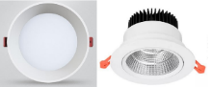
 |  | 22-Jan-202 | Shanghai | Children’s Electric Toothbrushes | Home Electrical Appliances | Safety Risk Hazard | 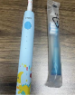  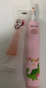
 |  | 23-Jan-2024 | Jiangsu | Fixed General-purpose Lamps (LED Surface-mounted) | Electrical Appliances | Electric Shock Hazard | 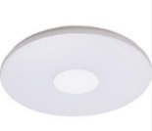
 |  | 23-Jan-2024 | Jiangsu | Fixed LED lamps | Electrical Appliances | Electric Shock Hazard | 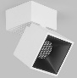
 |  | 23-Jan-2024 | Chongqing | Water Dispensers | Electrical Appliances | Electric Shock Hazard | /
 |  | 23-Jan-2024 | Chongqing | Micro-tillers | Electrical Appliances | Burn Hazard, Laceration Hazard | /
 |  | 24-Jan-2024 | Jiangxi | English Homework Books | Stationery | Damage to Sight | /
 |  | 24-Jan-2024 | Jiangxi | Exercise Book | Stationery | Damage to Sight | /
 |  | 24-Jan-2024 | Jiangxi | Disposable Plastic Cups | Food Contact Material | Burn Hazard | /
24-Jan-2024 |  |  | Beijing | Umbrellas | Outdoor Living Items | Puncture Hazard | 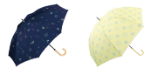
24-Jan-2024 |  |  | Beijing | Automatic Shutoff Valve for Pipeline Gas | Tools and Hardware | Risk of Exposure to Combustion Flue Gas | 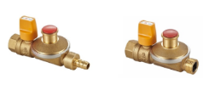
25-Jan-2024 |  |  | Beijing | Sunglasses | Accessories | Safety Risk Hazard | 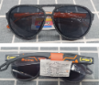
26-Jan-2024 |  |  | Beijing | Engine Coolant | Chemicals | Safety Risk Hazard | 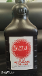
26-Jan-2024 |  |  | Beijing | Gasoline Engine Oil | Chemicals | Safety Risk Hazard | 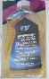
26-Jan-2024 |  |  | Hunan | Schoolbags | Fabric / Textile / Garment / Home Textile | Chemical Hazard | 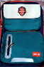
26-Jan-2024 |  |  | Hunan | Schoolbags | Fabric / Textile / Garment / Home Textile | Chemical Hazard | 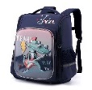
26-Jan-2024 |  |  | Hunan | Schoolbags | Fabric / Textile / Garment / Home Textile | Chemical Hazard | 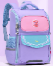
26-Jan-2024 |  |  | Hunan | Schoolbags | Fabric / Textile / Garment / Home Textile | Safety Risk Hazard | 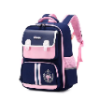
26-Jan-2024 |  |  | Hunan | Schoolbags | Fabric / Textile / Garment / Home Textile | Chemical Hazard | 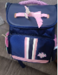
26-Jan-2024 |  |  | Hunan | Schoolbags | Fabric / Textile / Garment / Home Textile | Chemical Hazard | 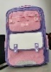
26-Jan-2024 |  |  | Hunan | Schoolbags | Fabric / Textile / Garment / Home Textile | Chemical Hazard | 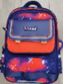
26-Jan-2024 |  |  | Hunan | Schoolbags | Fabric / Textile / Garment / Home Textile | Chemical Hazard | 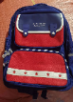
29-Jan-2024 |  |  | Zhejiang | Kids Electric Car | Toys and Childcare Products | Suffocation Hazard, Injury Hazard | 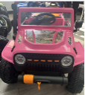
29-Jan-2024 |  |  | Zhejiang | Vacuum Cleaners | Home Electrical Appliances | Fire Hazard | 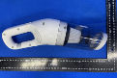
29-Jan-2024 |  |  | Zhejiang | Embedded LED Lamps | Electrical Appliances | Health Risk Hazard
29-Jan-2024 |  |  | Zhejiang | Kids Electric Car | Toys and Childcare Products | Suffocation Hazard, Crash Hazard | 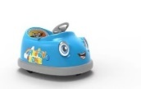
29-Jan-2024 |  |  | Hunan | Backpacks | Fabric / Textile / Garment / Home Textile | Safety Risk Hazard | 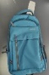
29-Jan-2024 |  |  | Hunan | Backpacks | Fabric / Textile / Garment / Home Textile | Safety Risk Hazard | 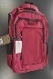
30-Jan-2024 |  |  | Shanxi | Infant Clothing | Fabric / Textile / Garment / Home Textile | Suffocation Hazard, Fall Hazard, Swallowing Risk | 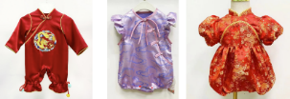
30-Jan-2024 |  |  | Shanxi | 7-inch Bucket Bowls and 8-inch Rice Plates | Food Contact Material | Microbiological Hazard, Safety Risk Hazard | 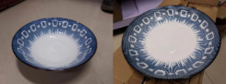
30-Jan-2024 |  |  | Shanxi | 5-inch Glazed Bowls and 8-inch Glazed Plates | Food Contact Material | Microbiological Hazard, Safety Risk Hazard | 