Recall Cases Summary – Europe (Last Update Date: 31 January 2024)

Date | Notifying Country | Product | Categories | Hazard | Image
3-Jan-2024 | Italy | USB Charger | Electrical Appliances | Electric Shock Hazard | 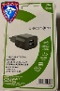
3-Jan-2024 | Italy | Travel Adapter | Electrical Appliances | Electric Shock Hazard | 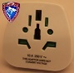
3-Jan-2024 | Sweden | Liquid Hand Soap | Bodycare / Cosmetics | Microbiological Hazard | 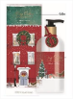
3-Jan-2024 | Sweden | Liquid Hand Soap | Bodycare / Cosmetics | Microbiological Hazard | 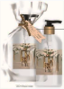
3-Jan-2024 | Sweden | Liquid Hand Soap | Bodycare / Cosmetics | Microbiological Hazard | 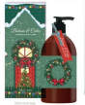
3-Jan-2024 | Sweden | Liquid Hand Soap | Bodycare / Cosmetics | Microbiological Hazard | 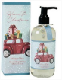
3-Jan-2024 | Norway | Artificial Christmas Tree | Accessories | Chemical Hazard, Environmental Hazard | 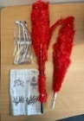  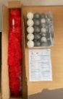
3-Jan-2024 | France | Armchair for Children | Toys and Childcare Products | Choking Hazard | 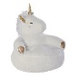
3-Jan-2024 | Denmark | Fireworks | Outdoor Living Items | Burn Hazard, Injury Hazard | 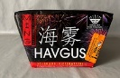
3-Jan-2024 | Lithuania | Toy Gun Set | Toys and Childcare Products | Choking Hazard | 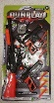
3-Jan-2024 | Lithuania | Toy Car | Toys and Childcare Products | Choking Hazard | 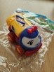
3-Jan-2024 | Lithuania | Toy Car | Toys and Childcare Products | Choking Hazard | 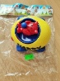
3-Jan-2024 | Malta | Disposable Electronic Cigarette | Chemicals | Chemical Hazard | 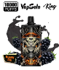
4-Jan-2024 | Germany | Face and Body Cream | Bodycare / Cosmetics | Microbiological Hazard | 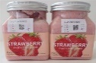
4-Jan-2024 | Sweden | Insect Killer | Home Electrical Appliances | Chemical Hazard, Environmental Hazard | 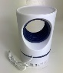
4-Jan-2024 | France | Watch | Jewelry | Chemical Hazard | 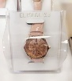
4-Jan-2024 | Norway | Jumping Rope | Sporting Goods / Equipment | Chemical Hazard | 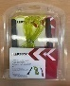
4-Jan-2024 | Sweden | Inflatable PVC Pillow | Outdoor Living Items | Chemical Hazard, Environmental Hazard | 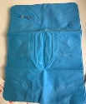
4-Jan-2024 | Slovenia | Particle Filter Mask | Protective Equipment | Health Risk Hazard | 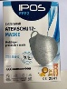
4-Jan-2024 | Slovenia | Plastic Doll | Toys and Childcare Products | Chemical Hazard | 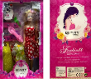
4-Jan-2024 | Finland | LED Light | Electrical Appliances | Electric Shock Hazard | 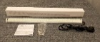
4-Jan-2024 | Slovenia | Plastic Doll | Toys and Childcare Products | Chemical Hazard | 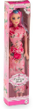
4-Jan-2024 | Finland | Tiara | Jewelry | Chemical Hazard | 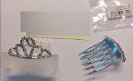
4-Jan-2024 | Lithuania | Disposable Electronic Cigarette | Chemicals | Chemical Hazard | 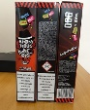
8-Jan-2024 | Denmark | Fireworks | Outdoor Living Items | Burn Hazard, Damage to Sight | 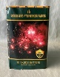
8-Jan-2024 | Norway | Power Wheel | Sporting Goods / Equipment | Chemical Hazard, Environmental Hazard | 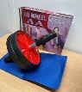
8-Jan-2024 | Denmark | Fireworks | Outdoor Living Items | Burn Hazard, Damage to Sight, Injury Hazard | 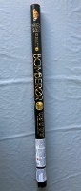
8-Jan-2024 | Denmark | Fireworks | Outdoor Living Items | Burn Hazard, Damage to Sight, Fire Hazard, Injury Hazard | 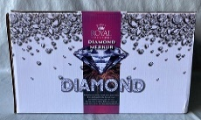
9-Jan-2024 | Austria | Double Grinder | Machinery | Electric Shock Hazard | 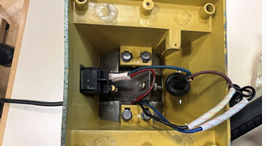
9-Jan-2024 | Spain | Perfume | Bodycare / Cosmetics | Chemical Hazard | 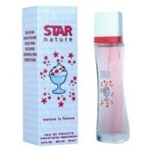
9-Jan-2024 | Germany | Front Suspension / Control Arm for Passenger Car | Car Components | Injury Hazard | 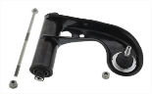
9-Jan-2024 | Germany | Nesting Toy Dolls | Toys and Childcare Products | Choking Hazard | 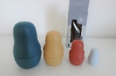
9-Jan-2024 | Sweden | Rings | Jewelry | Chemical Hazard | 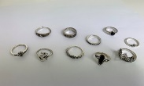
9-Jan-2024 | Sweden | Ear Cuff | Jewelry | Chemical Hazard | 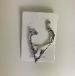
9-Jan-2024 | Sweden | Earrings | Jewelry | Chemical Hazard | 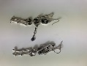
9-Jan-2024 | Sweden | Necklace | Jewelry | Chemical Hazard | 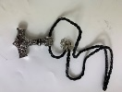
9-Jan-2024 | Sweden | Ring | Jewelry | Chemical Hazard | 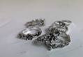
10-Jan-2024 | Sweden | LED Projector | Computer / Audio / Video / Other Electronics & Accessories | Environmental Hazard | 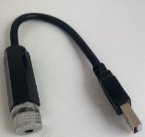
10-Jan-2024 | Germany | Rat Poison | Chemicals | Chemical Hazard | 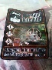
10-Jan-2024 | Denmark | Ceiling LED Light | Electrical Appliances | Electric Shock Hazard | 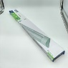
10-Jan-2024 | Finland | LED Strip | Electrical Appliances | Electric Shock Hazard | 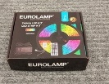
10-Jan-2024 | Sweden | Emergency Crank Radio | Computer / Audio / Video / Other Electronics & Accessories | Environmental Hazard | 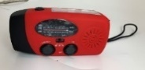
10-Jan-2024 | Finland | Dumbbell | Sporting Goods / Equipment | Chemical Hazard
10-Jan-2024 | Sweden | Plastic Duck | Toys and Childcare Products | Chemical Hazard | 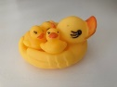
10-Jan-2024 | Lithuania | Toy Slime | Toys and Childcare Products | Chemical Hazard | 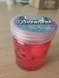
10-Jan-2024 | Lithuania | Toy Slime | Toys and Childcare Products | Chemical Hazard | 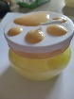
10-Jan-2024 | Czechia | Particle Filter Mask | Protective Equipment | Health Risk Hazard | 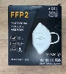
10-Jan-2024 | Sweden | Pencil Case | Stationery | Chemical Hazard, Environmental Hazard | 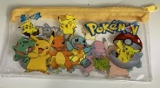
10-Jan-2024 | Finland | Cosmetic Bag | Fabric / Textile / Garment / Home Textile | Chemical Hazard | 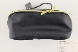
10-Jan-2024 | Lithuania | Disposable Electronic Cigarette | Chemicals | Chemical Hazard | 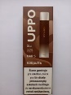
10-Jan-2024 | Sweden | Necklace | Jewelry | Chemical Hazard, Environmental Hazard
10-Jan-2024 | Poland | Power Supply | Electrical Appliances | Environmental Hazard | 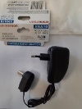
10-Jan-2024 | Norway | Flip Flops | Footwear | Chemical Hazard | 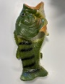  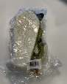
10-Jan-2024 | Norway | Massage Yoga Ball | Sporting Goods / Equipment | Chemical Hazard, Environmental Hazard | 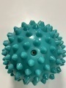
10-Jan-2024 | Norway | Sandals | Footwear | Chemical Hazard | 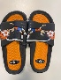
10-Jan-2024 | Czechia | Toy Car | Toys and Childcare Products | Environmental Hazard | 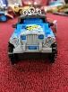
10-Jan-2024 | Czechia | Toy Gun | Toys and Childcare Products | Environmental Hazard | 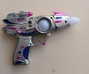
10-Jan-2024 | Czechia | Toy Keyboard | Toys and Childcare Products | Environmental Hazard | 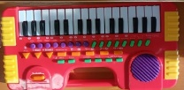
10-Jan-2024 | Czechia | Toy Hair Set | Toys and Childcare Products | Environmental Hazard | 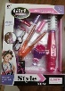
10-Jan-2024 | Lithuania | Disposable Electronic Cigarette | Chemicals | Chemical Hazard | 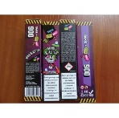
11-Jan-2024 | Sweden | Flashlight | Electrical Appliances | Chemical Hazard, Environmental Hazard | 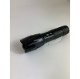
11-Jan-2024 | Sweden | LED Torch | Electrical Appliances | Chemical Hazard, Environmental Hazard | 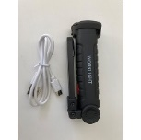
11-Jan-2024 | Lithuania | Extension Cord | Electrical Appliances | Burn Hazard, Electric Shock Hazard, Fire Hazard | 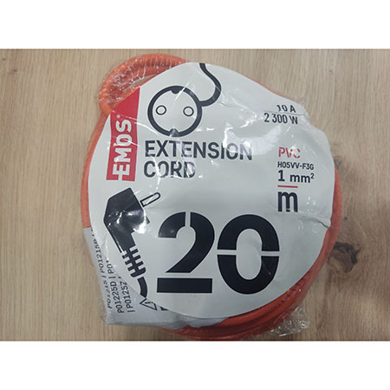
11-Jan-2024 | Finland | LED Rechargeable Flashlight | Electrical Appliances | Electric Shock Hazard | 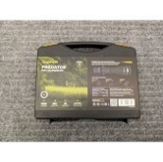
11-Jan-2024 | Sweden | Alarm | Electrical Appliances | Environmental Hazard | 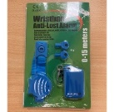
11-Jan-2024 | Sweden | Hair Curler | Home Electrical Appliances | Environmental Hazard | 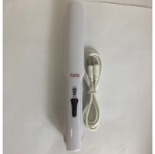
11-Jan-2024 | Sweden | Pet Nail Grinder | Electrical Appliances | Environmental Hazard | 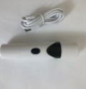
11-Jan-2024 | Sweden | Charging Cable | Electrical Appliances | Environmental Hazard | 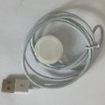
11-Jan-2024 | Sweden | Emergency Radio | Computer / Audio / Video / Other Electronics & Accessories | Environmental Hazard | 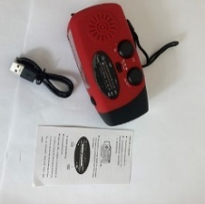
11-Jan-2024 | Sweden | Alarm | Home Electrical Appliances | Environmental Hazard | 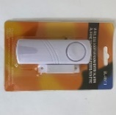
11-Jan-2024 | Sweden | Remote Control | Electrical Appliances | Environmental Hazard | 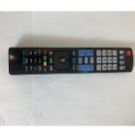
11-Jan-2024 | Sweden | Wireless Charger | Electrical Appliances | Environmental Hazard | 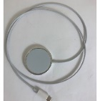
11-Jan-2024 | Sweden | Hair Removal Device | Home Electrical Appliances | Environmental Hazard | 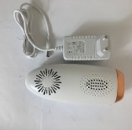
11-Jan-2024 | Sweden | Humidifier | Home Electrical Appliances | Environmental Hazard | 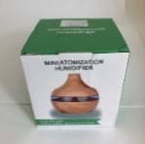
11-Jan-2024 | Sweden | Hair Clipper for Pets | Pet Items | Environmental Hazard | 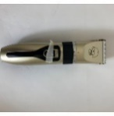
11-Jan-2024 | Czechia | Police Toy Car | Toys and Childcare Products | Environmental Hazard | 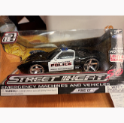
12-Jan-2024 | France | Perfumed Room Spray | Chemicals | Chemical Hazard | 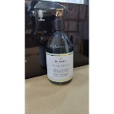
12-Jan-2024 | Ireland | Children's Fancy-Dress Mask | Toys and Childcare Products | Burn Hazard | 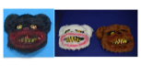
12-Jan-2024 | Sweden | Children's Watch | Accessories | Environmental Hazard | 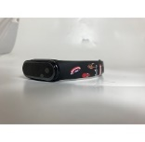
12-Jan-2024 | Sweden | Kitchen Timer | Home Electrical Appliances | Environmental Hazard | 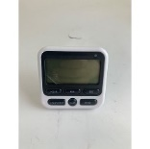
12-Jan-2024 | Sweden | Children's Watch | Accessories | Environmental Hazard | 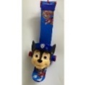
12-Jan-2024 | Cyprus | Children's Trousers | Fabric / Textile / Garment / Home Textile | Injury Hazard | 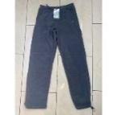
12-Jan-2024 | Cyprus | Children's Trousers | Fabric / Textile / Garment / Home Textile | Injury Hazard | 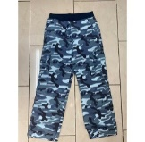
12-Jan-2024 | Cyprus | Children's Dress | Fabric / Textile / Garment / Home Textile | Injury Hazard, Strangulation Hazard | 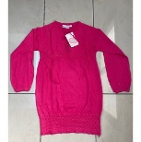
12-Jan-2024 | Sweden | USB Lighting Cable | Electrical Appliances | Environmental Hazard | 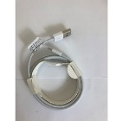
12-Jan-2024 | Sweden | Audio Cable | Electrical Appliances | Environmental Hazard | 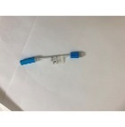
12-Jan-2024 | Sweden | Audio Cable | Electrical Appliances | Environmental Hazard | 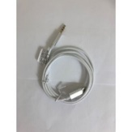
12-Jan-2024 | Sweden | Audio Cable | Electrical Appliances | Environmental Hazard | 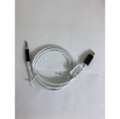
12-Jan-2024 | Sweden | USB Cable | Electrical Appliances | Environmental Hazard | 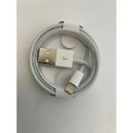
12-Jan-2024 | Cyprus | Sweatshirt | Fabric / Textile / Garment / Home Textile | Injury Hazard, Strangulation Hazard | 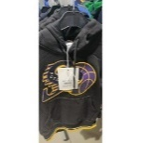
12-Jan-2024 | Sweden | USB Cable | Electrical Appliances | Environmental Hazard | 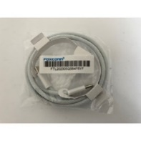
12-Jan-2024 | Sweden | USB Cable | Electrical Appliances | Environmental Hazard | 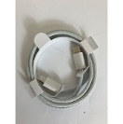
12-Jan-2024 | Sweden | Fire Alarm | Electrical Appliances | Environmental Hazard | 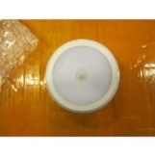
12-Jan-2024 | Sweden | Milk Frother | Home Electrical Appliances | Environmental Hazard | 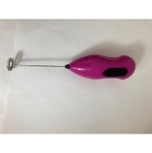
12-Jan-2024 | Czechia | Perfume | Bodycare / Cosmetics | Chemical Hazard | 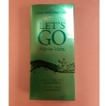
12-Jan-2024 | Finland | Hairpin | Accessories | Chemical Hazard | 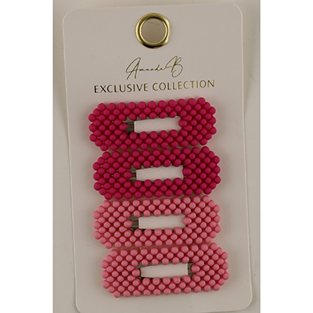  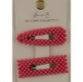
12-Jan-2024 | Bulgaria | Children’s Trousers | Fabric / Textile / Garment / Home Textile | Injury Hazard | 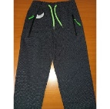
12-Jan-2024 | Poland | Portable Blender | Home Electrical Appliances | Fire Hazard, Injury Hazard | 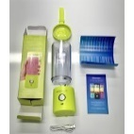
15-Jan-2024 | Malta | USB Charger | Electrical Appliances | Electric Shock Hazard, Fire Hazard | 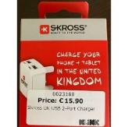
16-Jan-2024 | France | Toy Crossbow and Pistol | Toys and Childcare Products | Choking Hazard | 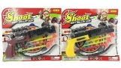
16-Jan-2024 | France | Soother | Toys and Childcare Products | Chemical Hazard | 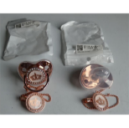
16-Jan-2024 | Poland | Electric Toy Motorcycle | Toys and Childcare Products | Injury Hazard | 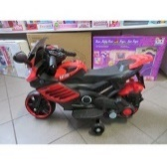
16-Jan-2024 | Denmark | Fireworks | Outdoor Living Items | Burn Hazard, Injury Hazard | 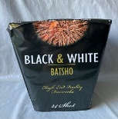
16-Jan-2024 | Denmark | Fireworks | Outdoor Living Items | Burn Hazard, Injury Hazard | 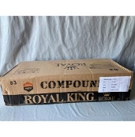
16-Jan-2024 | Germany | Particle Filter Mask | Protective Equipment | Health Risk Hazard | 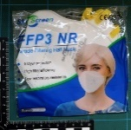
16-Jan-2024 | Denmark | Fireworks | Outdoor Living Items | Burn Hazard, Damage to Sight | 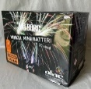
16-Jan-2024 | Hungary | Perfume | Bodycare / Cosmetics | Chemical Hazard
16-Jan-2024 | Hungary | Face Cream | Bodycare / Cosmetics | Chemical Hazard | 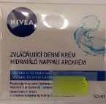
16-Jan-2024 | Ireland | Children's Jacket | Fabric / Textile / Garment / Home Textile | Choking Hazard | 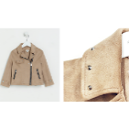
16-Jan-2024 | Hungary | Perfume | Bodycare / Cosmetics | Chemical Hazard | 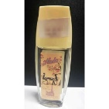
16-Jan-2024 | Hungary | Perfume | Bodycare / Cosmetics | Chemical Hazard | 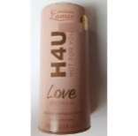
16-Jan-2024 | Hungary | Perfume | Bodycare / Cosmetics | Chemical Hazard | 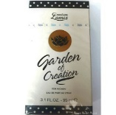
16-Jan-2024 | Hungary | Eau De Toilette | Bodycare / Cosmetics | Chemical Hazard | 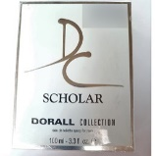
16-Jan-2024 | Hungary | Eau De Toilette | Bodycare / Cosmetics | Chemical Hazard | 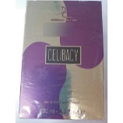
16-Jan-2024 | Hungary | Perfume | Bodycare / Cosmetics | Chemical Hazard | 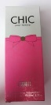
16-Jan-2024 | Hungary | Eau De Toilette | Bodycare / Cosmetics | Chemical Hazard | 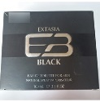
16-Jan-2024 | Sweden | Night Lamp | Electrical Appliances | Environmental Hazard | 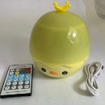
16-Jan-2024 | Sweden | Night Lamp | Electrical Appliances | Environmental Hazard | 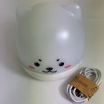
17-Jan-2024 | France | Toy Crossbow | Toys and Childcare Products | Damage to Sight, Injury Hazard | 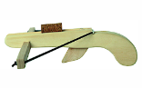
17-Jan-2024 | Denmark | Fireworks | Outdoor Living Items | Burn Hazard, Damage to Sight | 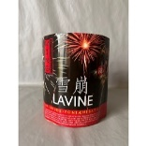
17-Jan-2024 | Sweden | Electric Toothbrush for Children | Home Electrical Appliances | Chemical Hazard, Environmental Hazard | 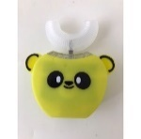
17-Jan-2024 | Ireland | Cordless Vacuum Cleaner | Home Electrical Appliances | Burn Hazard, Electric Shock Hazard | 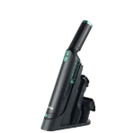
17-Jan-2024 | Sweden | Ring Light | Electrical Appliances | Environmental Hazard | 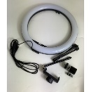
17-Jan-2024 | Norway | Fancy Dress | Fabric / Textile / Garment / Home Textile | Chemical Hazard, Environmental Hazard | 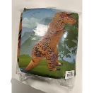
17-Jan-2024 | Poland | Toy Scooter | Toys and Childcare Products | Injury Hazard | 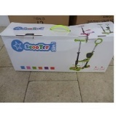
17-Jan-2024 | Czechia | Toy Gun | Toys and Childcare Products | Environmental Hazard | 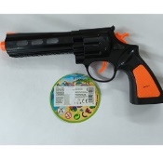
18-Jan-2024 | Ireland | Children’s Hoodie | Fabric / Textile / Garment / Home Textile | Injury Hazard, Strangulation Hazard | 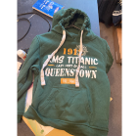
18-Jan-2024 | France | Plastic Figurines | Toys and Childcare Products | Chemical Hazard | 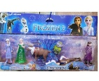
18-Jan-2024 | Ireland | Disco Bulb | Electrical Appliances | Electric Shock Hazard | 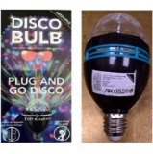
18-Jan-2024 | Denmark | Fireworks | Outdoor Living Items | Burn Hazard, Damage to Sight | 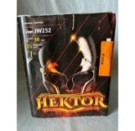
18-Jan-2024 | Sweden | Bluetooth Speaker | Computer / Audio / Video / Other Electronics & Accessories | Chemical Hazard, Environmental Hazard | 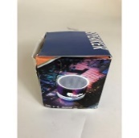
18-Jan-2024 | Sweden | LED Torch | Electrical Appliances | Chemical Hazard, Environmental Hazard | 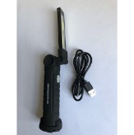
18-Jan-2024 | France | Electric Toy Train | Toys and Childcare Products | Chemical Hazard, Damage to Sight | 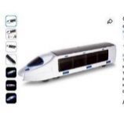
18-Jan-2024 | Norway | Pencil Case | Stationery | Chemical Hazard, Environmental Hazard | 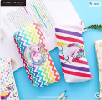
18-Jan-2024 | Norway | Necklace | Jewelry | Chemical Hazard | 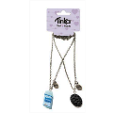
18-Jan-2024 | Sweden | Flashlight | Electrical Appliances | Chemical Hazard, Environmental Hazard | 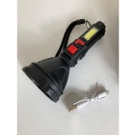
18-Jan-2024 | Lithuania | Electric Stove | Home Electrical Appliances | Burn Hazard | 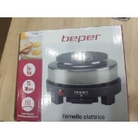
18-Jan-2024 | Lithuania | Disposable Electronic Cigarette | Chemicals | Chemical Hazard | 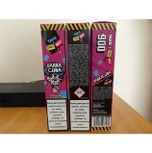
18-Jan-2024 | Sweden | USB Cable | Electrical Appliances | Environmental Hazard | 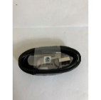
18-Jan-2024 | Poland | Plastic Toy | Toys and Childcare Products | Damage to Sight, Injury Hazard | 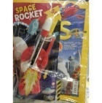
18-Jan-2024 | Poland | Plastic Ball with Plastic Rod | Toys and Childcare Products | Chemical Hazard | 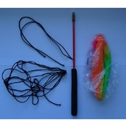
18-Jan-2024 | Cyprus | Children's Sweatshirt | Fabric / Textile / Garment / Home Textile | Injury Hazard, Strangulation Hazard | 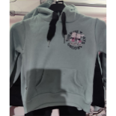
18-Jan-2024 | Germany | Particle Filter Mask | Protective Equipment | Health Risk Hazard | 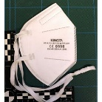
18-Jan-2024 | Denmark | Fireworks | Outdoor Living Items | Burn Hazard, Damage to Sight | 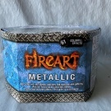
18-Jan-2024 | Sweden | Earpods | Computer / Audio / Video / Other Electronics & Accessories | Environmental Hazard | 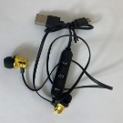
18-Jan-2024 | Sweden | Baby Monitor Alarm | Electrical Appliances | Environmental Hazard | 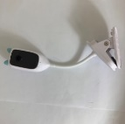
18-Jan-2024 | Sweden | Travel Adaptor | Electrical Appliances | Environmental Hazard | 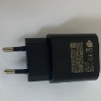
18-Jan-2024 | Belgium | Children's Trousers | Fabric / Textile / Garment / Home Textile | Injury Hazard | 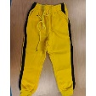
18-Jan-2024 | Lithuania | Electric Adaptor | Electrical Appliances | Electric Shock Hazard | 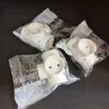
18-Jan-2024 | Cyprus | Water Shoes | Footwear | Chemical Hazard | 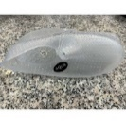
18-Jan-2024 | Hungary | Perfume | Bodycare / Cosmetics | Chemical Hazard | 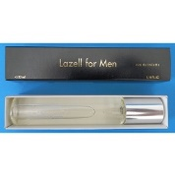
18-Jan-2024 | Hungary | Perfume | Bodycare / Cosmetics | Chemical Hazard | 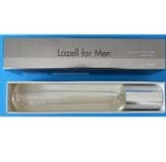
18-Jan-2024 | Czechia | Jumping Ball | Sporting Goods / Equipment | Chemical Hazard | 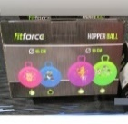
19-Jan-2024 | Sweden | Ring | Jewelry | Chemical Hazard | 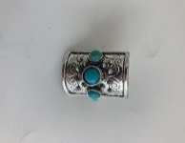
19-Jan-2024 | Estonia | USB Headset | Computer / Audio / Video / Other Electronics & Accessories | Chemical Hazard | 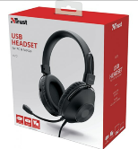
22-Jan-2024 | France | Babies' Soother | Toys and Childcare Products | Chemical Hazard | 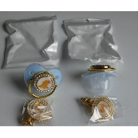
22-Jan-2024 | Malta | Electric Cable | Electrical Appliances | Fire Hazard | 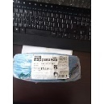
22-Jan-2024 | Germany | Soother Holder | Toys and Childcare Products | Choking Hazard | 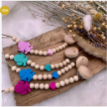
22-Jan-2024 | Hungary | Laser Pointer | Electrical Appliances | Damage to Sight, Electric Shock Hazard | 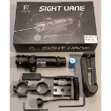
22-Jan-2024 | The Netherlands | Baby Puzzle Ball | Toys and Childcare Products | Choking Hazard | 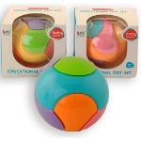
23-Jan-2024 | Cyprus | Children's Sweatshirt | Fabric / Textile / Garment / Home Textile | Injury Hazard | 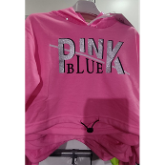
23-Jan-2024 | France | Folding Stand for Changing Table | Toys and Childcare Products | Injury Hazard | 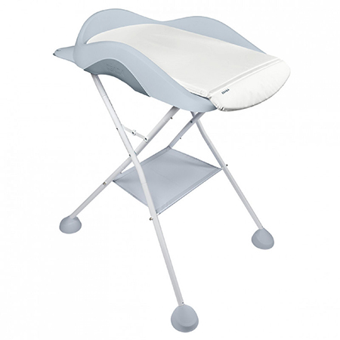
23-Jan-2024 | Sweden | Finger Paint | Toys and Childcare Products | Chemical Hazard | 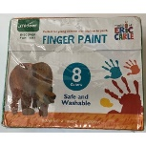
23-Jan-2024 | Finland | Battery Charger | Electrical Appliances | Electric Shock Hazard | 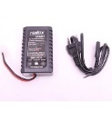  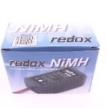
23-Jan-2024 | Finland | Battery Charger | Electrical Appliances | Electric Shock Hazard | 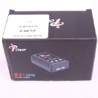  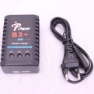
24-Jan-2024 | Italy | Travel Adaptor | Electrical Appliances | Electric Shock Hazard | 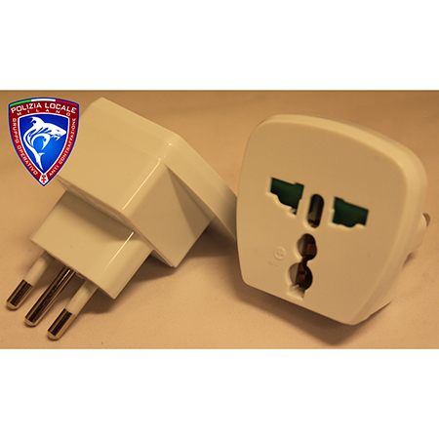  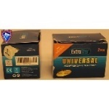
24-Jan-2024 | Italy | Travel Adaptor | Electrical Appliances | Electric Shock Hazard | 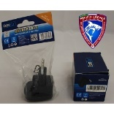
24-Jan-2024 | Malta | Plastic Doll | Toys and Childcare Products | Chemical Hazard | 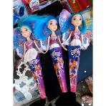
24-Jan-2024 | Malta | Slime Toy | Toys and Childcare Products | Chemical Hazard | 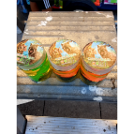
24-Jan-2024 | Malta | Plastic Doll | Toys and Childcare Products | Chemical Hazard | 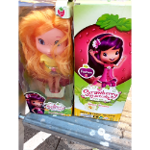
24-Jan-2024 | France | Babies' Soother | Toys and Childcare Products | Chemical Hazard | 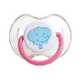  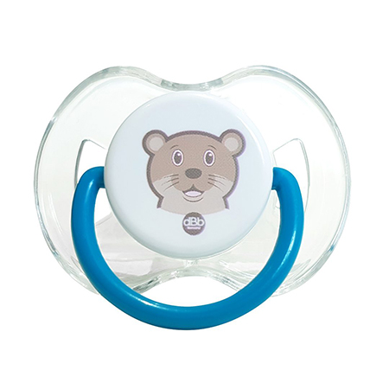  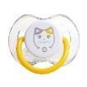
24-Jan-2024 | Cyprus | Stamp Pen Set | Toys and Childcare Products | Chemical Hazard | 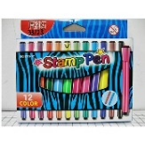
24-Jan-2024 | Cyprus | Pencil Set | Toys and Childcare Products | Chemical Hazard | 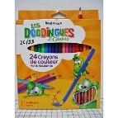
24-Jan-2024 | Cyprus | Acrylic Paint Set | Toys and Childcare Products | Chemical Hazard | 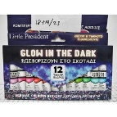
24-Jan-2024 | Cyprus | Crayon Set | Toys and Childcare Products | Chemical Hazard | 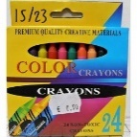
24-Jan-2024 | France | Electric Scooter | Sporting Goods / Equipment | Electric Shock Hazard, Injury Hazard | 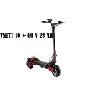
24-Jan-2024 | France | Babies' Soother | Toys and Childcare Products | Chemical Hazard | 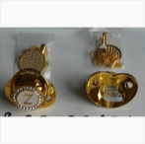
24-Jan-2024 | Slovakia | Toy Train | Toys and Childcare Products | Choking Hazard | 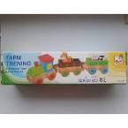
24-Jan-2024 | Ireland | Children's Slippers | Footwear | Injury Hazard | 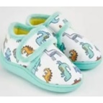
24-Jan-2024 | The Netherlands | Toy Train | Toys and Childcare Products | Choking Hazard | 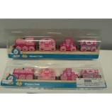
24-Jan-2024 | France | Earrings | Jewelry | Chemical Hazard | 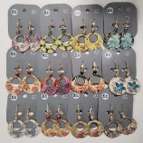
24-Jan-2024 | Sweden | Toy Slime | Toys and Childcare Products | Chemical Hazard | 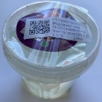
24-Jan-2024 | Sweden | Balloons | Toys and Childcare Products | Chemical Hazard | 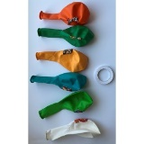
24-Jan-2024 | Sweden | Toy Slime | Toys and Childcare Products | Chemical Hazard | 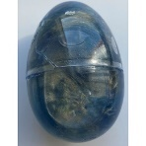
24-Jan-2024 | Greece | Brooch | Jewelry | Chemical Hazard | 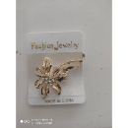
24-Jan-2024 | France | Rail Kit for Sliding Doors | Tools and Hardware | Injury Hazard | 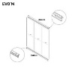
25-Jan-2024 | Lithuania | Glue | Chemicals | Chemical Hazard | 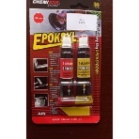
25-Jan-2024 | Hungary | Laser Pointer | Electrical Appliances | Damage to Sight, Electric Shock Hazard | 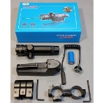
25-Jan-2024 | Sweden | Toy Ball | Toys and Childcare Products | Environmental Hazard | 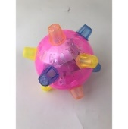
25-Jan-2024 | Cyprus | Wall Hanger | Household Items | Chemical Hazard | 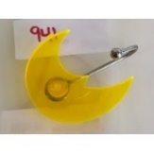
25-Jan-2024 | Hungary | Eau De Toilette | Bodycare / Cosmetics | Chemical Hazard | 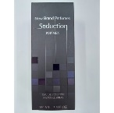
25-Jan-2024 | Hungary | Eau De Toilette | Bodycare / Cosmetics | Chemical Hazard | 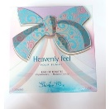
25-Jan-2024 | Romania | Children's Hat | Fabric / Textile / Garment / Home Textile | Injury Hazard, Strangulation Hazard | 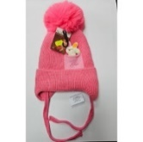
25-Jan-2024 | Czechia | Disposable Electronic Cigarette | Chemicals | Chemical Hazard | 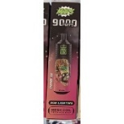
25-Jan-2024 | Sweden | Tealight LED Candle | Electrical Appliances | Environmental Hazard | 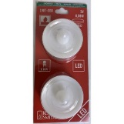
25-Jan-2024 | Sweden | Flashlight Gloves | Fabric / Textile / Garment / Home Textile | Environmental Hazard | 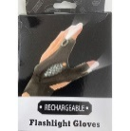
25-Jan-2024 | Sweden | Hair Clipper Kit | Home Electrical Appliances | Environmental Hazard | 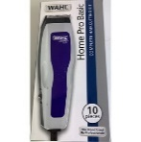
25-Jan-2024 | Sweden | LED Candle | Electrical Appliances | Environmental Hazard | 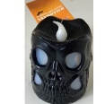
25-Jan-2024 | Sweden | Children's Smart Watch | Computer / Audio / Video / Other Electronics & Accessories | Environmental Hazard | 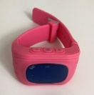
25-Jan-2024 | Sweden | Solar-Powered Outdoor LED Light | Electrical Appliances | Environmental Hazard | 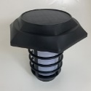
25-Jan-2024 | Sweden | Lamp | Electrical Appliances | Environmental Hazard | 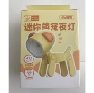
25-Jan-2024 | Sweden | Gaming Headset | Computer / Audio / Video / Other Electronics & Accessories | Environmental Hazard | 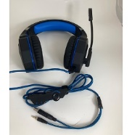
25-Jan-2024 | Sweden | Alarm | Home Electrical Appliances | Environmental Hazard | 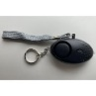
25-Jan-2024 | Sweden | LED Mask | Toys and Childcare Products | Environmental Hazard | 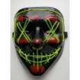
25-Jan-2024 | Sweden | LED Lighting Chain | Electrical Appliances | Environmental Hazard | 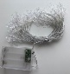
25-Jan-2024 | Sweden | Mini Phone Fan | Electrical Appliances | Environmental Hazard | 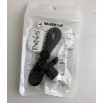
25-Jan-2024 | Sweden | Gaming Mouse | Computer / Audio / Video / Other Electronics & Accessories | Environmental Hazard | 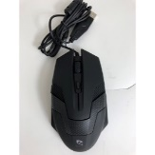
25-Jan-2024 | Sweden | Infrared Thermometer | Medical Devices | Environmental Hazard | 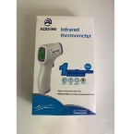
26-Jan-2024 | Czechia | Disposable Electronic Cigarette | Chemicals | Chemical Hazard | 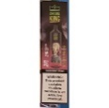
26-Jan-2024 | The Netherlands | Perfume | Bodycare / Cosmetics | Chemical Hazard | 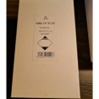
29-Jan-2024 | Cyprus | Squeaky Toy | Toys and Childcare Products | Chemical Hazard | 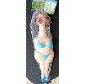
30-Jan-2024 | Denmark | Fireworks | Outdoor Living Items | Burn Hazard, Injury Hazard | 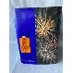
30-Jan-2024 | Lithuania | Lighting Chain | Electrical Appliances | Electric Shock Hazard | 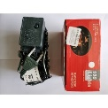
30-Jan-2024 | Lithuania | Varnish | Chemicals | Chemical Hazard | 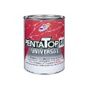
30-Jan-2024 | Lithuania | Sunscreen Milk | Bodycare / Cosmetics | Chemical Hazard, Microbiological Hazard | 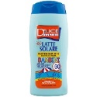
31-Jan-2024 | Germany | Nesting Toy Dolls | Toys and Childcare Products | Choking Hazard | 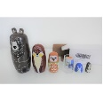
31-Jan-2024 | Germany | Particle Filter Mask | Protective Equipment | Health Risk Hazard | 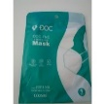
31-Jan-2024 | Norway | Teeth Whitening Pen | Bodycare / Cosmetics | Chemical Hazard | 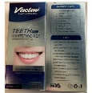
31-Jan-2024 | Sweden | Gaming Headset | Computer / Audio / Video / Other Electronics & Accessories | Chemical Hazard | 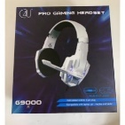
31-Jan-2024 | Sweden | Toy Slime | Toys and Childcare Products | Chemical Hazard | 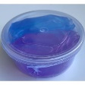
31-Jan-2024 | Norway | Teeth Whitening Gel | Bodycare / Cosmetics | Chemical Hazard
31-Jan-2024 | Sweden | Foot File | Electrical Appliances | Chemical Hazard, Environmental Hazard | 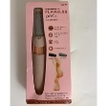
31-Jan-2024 | Czechia | Disposable Electronic Cigarette | Chemicals | Chemical Hazard | 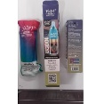
31-Jan-2024 | Czechia | Disposable Electronic Cigarette | Chemicals | Chemical Hazard | 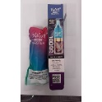
31-Jan-2024 | Sweden | Electric Lighter | Electrical Appliances | Chemical Hazard, Environmental Hazard | 