Recall Cases Summary – US (Last Update Date: 31 January 2024)

Date | Product | Categories | Hazard | Image
4-Jan-2024 | Redeemer Work Boots | Footwear | Injury Hazard | 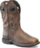
4-Jan-2024 | Massagers | Electrical Appliances | Fire Hazard, Burn Hazard | 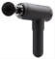
4-Jan-2024 | Folding E-Bicycles | Sporting Goods / Equipment | Crash Hazard, Injury Hazard | 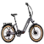  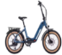  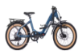
4-Jan-2024 | UBBCARE Play Yard Mattresses | Fabric / Textile / Garment / Home Textile | Suffocation Hazard | 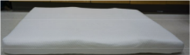
4-Jan-2024 | Adult Bicycle Helmets | Sporting Goods / Equipment | Crash Hazard, Injury Hazard | 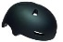  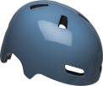
11-Jan-2024 | Millions of Plastic New Age Furniture Tip-over Restraint Kits | Tools and Hardware | Tip-Over Hazard, Entanglement Hazard, Risk of Death, Injury Hazard | 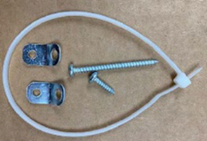
18-Jan-2024 | Upholstered Low Profile Standard and Platform Beds | Furniture | Fall Hazard, Injury Hazard | 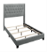  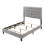  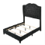  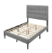  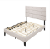
18-Jan-2024 | Wall-Mounted Tilt-Up Bath & Shower Seats | Furniture | Fall Hazard, Laceration Hazard | 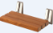  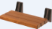  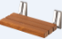  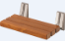
18-Jan-2024 | Mattress Pads | Fabric / Textile / Garment / Home Textile | Fire Hazard
25-Jan-2024 | BRS Fuel Bottles | Food Contact Material | Burn Hazard, Poisoning Hazard | 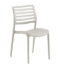  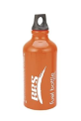
25-Jan-2024 | Plastic Side Chairs | Furniture | Fall Hazard
25-Jan-2024 | E-Bikes | Sporting Goods / Equipment | Fire Hazard | 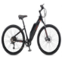  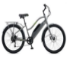  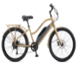
25-Jan-2024 | Yaomiao Children’s Rhinestone Silver Tiaras | Jewelry | Lead Poisoning Hazard | 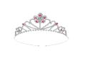
25-Jan-2024 | Maverick Coastal Outdoor Ceiling Fans | Electrical Appliances | Impact Hazard, Injury Hazard | 