Recall Cases Summary – Australia (Last Update Date: 29 February 2024)

Date | Product | Categories | Hazard | Image
1-Feb-2024 | Brilliant Basics 1L Sipper Drink Bottle | Food Contact Material | Choking Hazard, Suffocation Hazard, Risk of Death | 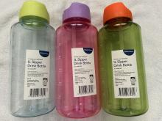
1-Feb-2024 | Tender Leaf Toys Stacking Forest | Toys and Childcare Products | Choking Hazard, Suffocation Hazard, Risk of Death | 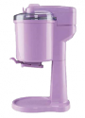  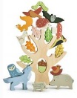
1-Feb-2024 | Ambiano Soft Serve Ice Cream Maker | Home Electrical Appliances | Health Risk Hazard
1-Feb-2024 | Pinwheel Giveaway Toy | Toys and Childcare Products | Choking Hazard, Suffocation Hazard, Risk of Death | 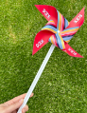
13-Feb-2024 | Silicone Nesting Bears Toy | Toys and Childcare Products | Choking Hazard, Suffocation Hazard, Risk of Death
14-Feb-2024 | Casio Electronic Calculator | Computer / Audio / Video / Other Electronics & Accessories | Choking Hazard, Injury Hazard, Swallowing Risk | 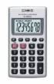
15-Feb-2024 | World’s Smallest Alarm Clock | Home Electrical Appliances | Choking Hazard, Injury Hazard, Swallowing Risk | 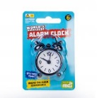  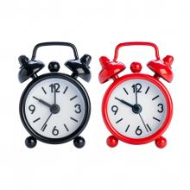
16-Feb-2024 | Aerpro Lights for Vehicles | Car Accessories | Choking Hazard, Injury Hazard, Swallowing Risk | 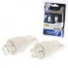  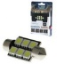  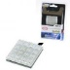  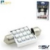
21-Feb-2024 | Squishy Octopus | Toys and Childcare Products | Injury Hazard, Strangulation Hazard, Risk of Death | 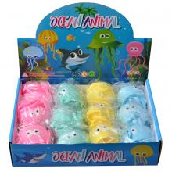  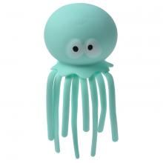
23-Feb-2024 | Vehicle Recovery and Snatch Straps | Car Accessories | Injury Hazard, Risk of Death | 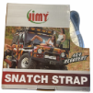  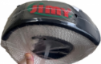
28-Feb-2024 | Smart Tag | Computer / Audio / Video / Other Electronics & Accessories | Choking Hazard, Burn Hazard, Injury Hazard, Risk of Death, Swallowing Risk | 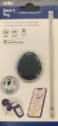
29-Feb-2024 | T3 Timer | Computer / Audio / Video / Other Electronics & Accessories | Choking Hazard, Burn Hazard, Injury Hazard, Risk of Death, Swallowing Risk | 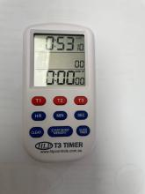
29-Feb-2024 | Bath Toy Set | Toys and Childcare Products | Suffocation Hazard, Choking Hazard, Risk of Death, Swallowing Risk | 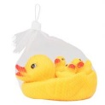
29-Feb-2024 | Snow Globe Gin Liqueur Orange & Gingerbread | Accessories | Choking Hazard, Burn Hazard, Injury Hazard, Risk of Death, Swallowing Risk | 