Recall Cases Summary – Canada (Last Update Date: 29 February 2024)

Date | Product | Categories | Hazard | Image
1-Feb-2024 | iSelect Voice-Controlled Adjustable Dumbbells | Sporting Goods / Equipment | Impact Hazard | 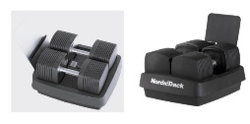
1-Feb-2024 | Hand and Floor Vacuum Cleaner | Home Electrical Appliances | Fire Hazard | 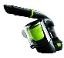  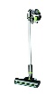
1-Feb-2024 | 12-Speed Shift Brake Levers | Sporting Goods / Equipment | Fall Hazard | 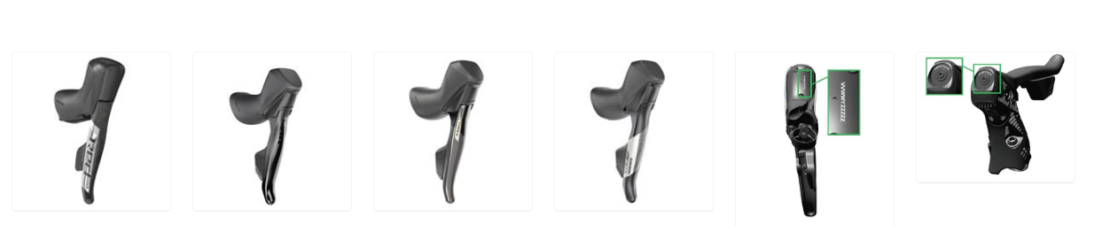
1-Feb-2024 | Slide & Seek Ball Run with Wooden Knobs | Toys and Childcare Products | Choking Hazard | 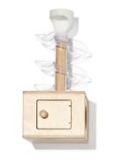
2-Feb-2024 | Cordless Blinds from Browns Linens | Household Items | Strangulation Hazard, Choking Hazard, Entanglement Hazard, Risk of Death | 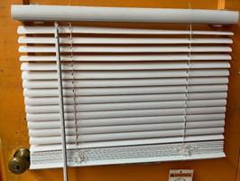
8-Feb-2024 | Husqvarna Petrol Grass Trimmer | Machinery | Fire Hazard | 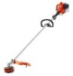  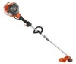  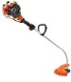
8-Feb-2024 | Side-By-Side Refrigerators | Home Electrical Appliances | Choking Hazard, Laceration Hazard | 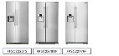  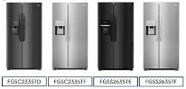
8-Feb-2024 | Handheld Garment Steamers | Home Electrical Appliances | Burn Hazard | 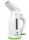  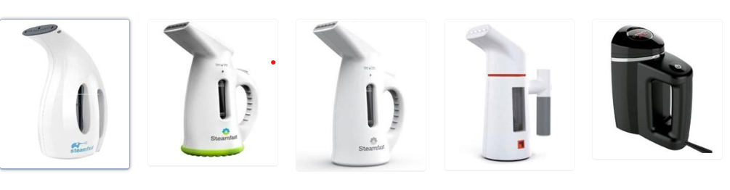  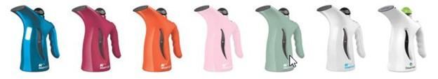
8-Feb-2024 | Children’s Hooded Flannel Bathrobes | Fabric / Textile / Garment / Home Textile | Burn Hazard | 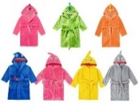
9-Feb-2024 | Baby Walkers | Toys and Childcare Products | Injury Hazard, Risk of Death, Fall Hazard | 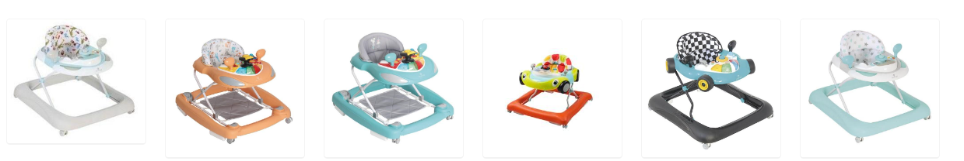
9-Feb-2024 | Baby Walkers | Toys and Childcare Products | Injury Hazard, Risk of Death, Fall Hazard | 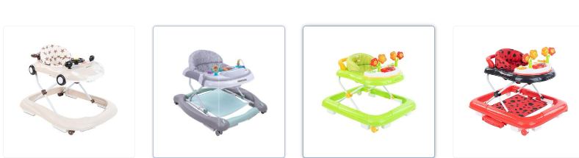  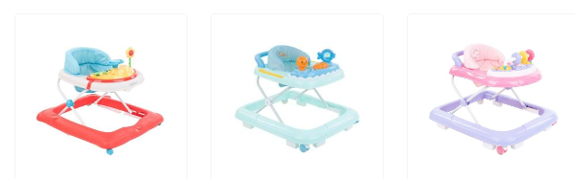
9-Feb-2024 | Baby Walkers | Toys and Childcare Products | Injury Hazard, Risk of Death, Fall Hazard | 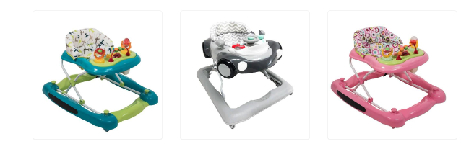
14-Feb-2024 | USB Charger Adapter | Electrical Appliances | Electric Shock Hazard | 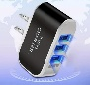
15-Feb-2024 | Rear-Control Range | Home Electrical Appliances | Electric Shock Hazard | 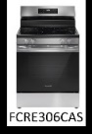
15-Feb-2024 | Bell Soquel Youth Helmets | Protective Equipment | Injury Hazard | 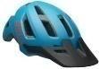  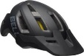
15-Feb-2024 | Char-Broil Digital Electric Smokers | Home Electrical Appliances | Electric Shock Hazard | 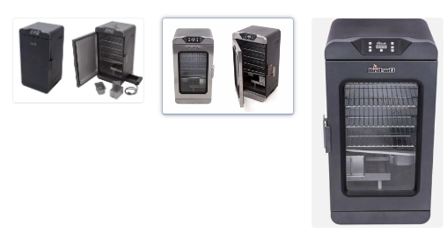  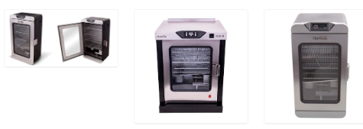
16-Feb-2024 | Trend Logic 2.1A iPhone Home Charging Kit | Electrical Appliances | Electric Shock Hazard | 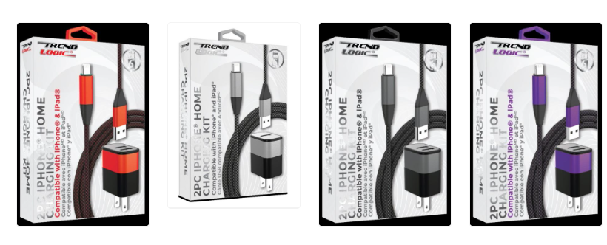
16-Feb-2024 | Peg Perego Canada YPSI and Z4 Bassinets | Toys and Childcare Products | Entrapment Hazard, Suffocation Hazard | 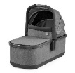  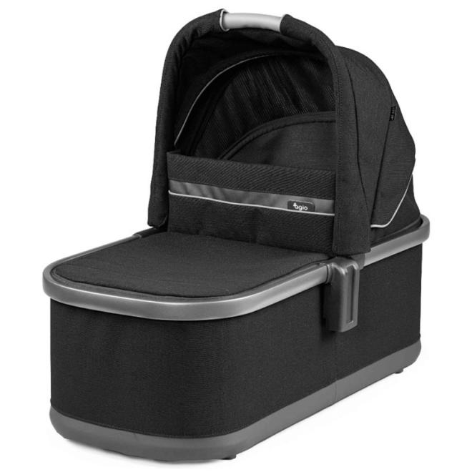
21-Feb-2024 | FirstPower 4000mAh V6 Battery Replacement for Dyson V6 Series Vacuums | Electrical Appliances | Fire Hazard, Burn Hazard | 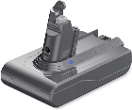
21-Feb-2024 | AC Adapters | Electrical Appliances | Fire Hazard, Burn Hazard | 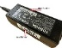  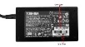  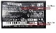
21-Feb-2024 | Heavy Duty Wall Charger Real 2.1 A | Electrical Appliances | Electric Shock Hazard | 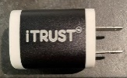
21-Feb-2024 | Bico Estonia Custom Window Coverings with Tie | Household Items | Strangulation Hazard, Entanglement Hazard, Risk of Death | 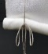  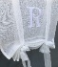
22-Feb-2024 | Camping Cooking Pots | Food Contact Material | Burn Hazard | 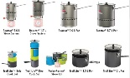
28-Feb-2024 | Double USB AC Adapter | Electrical Appliances | Electric Shock Hazard, Fire Hazard | 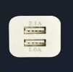  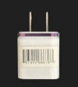
29-Feb-2024 | Bicycles | Sporting Goods / Equipment | Fall Hazard | 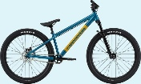
29-Feb-2024 | Ason Tech USB Wall Charger | Electrical Appliances | Electric Shock Hazard | 