Recall Cases Summary – China (Last Update Date: 29 February 2024)

Date | Province | Product | Categories | Hazard | Image
1-Feb-2024 | Shanghai | Automatic Fragrance Machines | Home Electrical Appliances | Electric Shock Hazard
1-Feb-2024 | Shanghai | Children’s Swimming Pool Slippers | Footwear | Chemical Hazard | 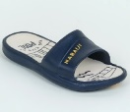
1-Feb-2024 | Shanghai | Baby Strollers | Toys and Childcare Products | Safety Risk Hazard | 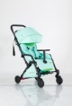
1-Feb-2024 | Fujian | Mesh Shoes | Footwear | Chemical Hazard | 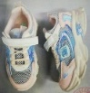
1-Feb-2024 | Fujian | Toddler Sandals | Footwear | Swallowing Risk | 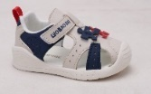
5-Feb-2024 | Henan | Disposable Paper Cups | Food Contact Material | Burn Hazard | /
5-Feb-2024 | Henan | Portable Fire Extinguisher | Chemicals | Safety Risk Hazard | /
8-Feb-2024 | Tianjin | Electric Bicycles | Sporting Goods / Equipment | Electric Shock Hazard, Fire Hazard | /
21-Feb-2024 | Zhejiang | Power Adapters | Electrical Appliances | Electric Shock Hazard | 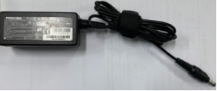
26-Feb-2024 | Guangdong | Household Gas Stoves | Household Items | Carbon Monoxide Poisoning Hazard | /
26-Feb-2024 | Guangdong | Heating Rods | Electrical Appliances | Electric Shock Hazard | /
26-Feb-2024 | Guangdong | Household Gas Stoves | Household Items | Carbon Monoxide Poisoning Hazard | /
26-Feb-2024 | Guangdong | Household Gas Stoves | Household Items | Risk of Exposure to Combustion Flue Gas | /
26-Feb-2024 | Guangdong | Household Gas Stoves | Household Items | Risk of Exposure to Combustion Flue Gas | /
26-Feb-2024 | Guangdong | Household Gas Stoves | Household Items | Carbon Monoxide Poisoning Hazard | /
26-Feb-2024 | Guangdong | Household Gas Stoves | Household Items | Carbon Monoxide Poisoning Hazard | /
26-Feb-2024 | Guangdong | Household Refrigerators | Home Electrical Appliances | Electric Shock Hazard | /
26-Feb-2024 | Guangdong | Household Gas Water Heaters | Home Electrical Appliances | Electric Shock Hazard | /
26-Feb-2024 | Guangdong | Electric Kettles | Home Electrical Appliances | Fire Hazard | /
26-Feb-2024 | Guangdong | Watercolor Brushes | Stationery | Swallowing Risk | /
26-Feb-2024 | Guangdong | Lithium-Ion Batteries for Electric Bike | Electrical Appliances | Fire Hazard | /
26-Feb-2024 | Guangdong | Disposable Protective Masks (3D) | Protective Equipment | Health Risk Hazard | /
26-Feb-2024 | Guangdong | Desks and Chairs | Furniture | Skin Irritation Risk, Risk of Allergy | /
27-Feb-2024 | Hunan | Backpacks | Fabric / Textile / Garment / Home Textile | Safety Risk Hazard | 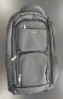
27-Feb-2024 | Hunan | Student Schoolbags | Fabric / Textile / Garment / Home Textile | Chemical Hazard | 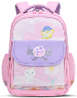
29-Feb-2024 | Shanghai | Scooters | Sporting Goods / Equipment | Fall Hazard, Injury Hazard | 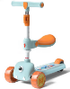
29-Feb-2024 | Shanghai | Jumpsuits | Fabric / Textile / Garment / Home Textile | Strangulation Hazard | 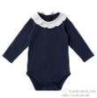  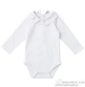
29-Feb-2024 | Shanghai | Round Neck Wool Underwear Sets | Fabric / Textile / Garment / Home Textile | Health Risk Hazard | 