Recall Cases Summary – Europe (Last Update Date: 29 February 2024)

Date | Notifying Country | Product | Categories | Hazard | Image
1-Feb-2024 | Greece | Necklace | Jewelry | Chemical Hazard | 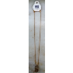
1-Feb-2024 | Greece | Earrings | Jewelry | Chemical Hazard | 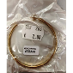
1-Feb-2024 | Cyprus | Set of Acrylic Paints | Toys and Childcare Products | Chemical Hazard | 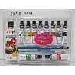
1-Feb-2024 | The Netherlands | Telescopic Ladder | Tools and Hardware | Injury Hazard | 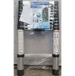
1-Feb-2024 | Germany | Nesting Toy Dolls | Toys and Childcare Products | Choking Hazard | 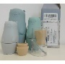
1-Feb-2024 | Sweden | Aroma Diffuser | Electrical Appliances | Chemical Hazard, Environmental Hazard | 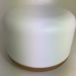
1-Feb-2024 | Sweden | LED Light with USB | Electrical Appliances | Chemical Hazard, Environmental Hazard | 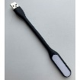
1-Feb-2024 | Estonia | Skin Cream | Bodycare / Cosmetics | Chemical Hazard
1-Feb-2024 | The Netherlands | Eau De Parfum | Bodycare / Cosmetics | Chemical Hazard | 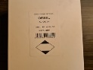
1-Feb-2024 | Sweden | Hat with Headset | Computer / Audio / Video / Other Electronics & Accessories | Chemical Hazard | 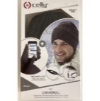  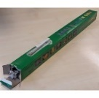
1-Feb-2024 | Hungary | Lighting Chain | Electrical Appliances | Electric Shock Hazard | 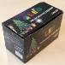
1-Feb-2024 | Hungary | Lighting Chain | Electrical Appliances | Burn Hazard, Electric Shock Hazard, Fire Hazard | 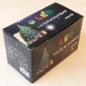
1-Feb-2024 | Hungary | Lighting Chain | Electrical Appliances | Burn Hazard, Electric Shock Hazard, Fire Hazard | 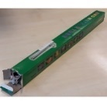
1-Feb-2024 | Sweden | Drone | Electrical Appliances | Chemical Hazard, Environmental Hazard | 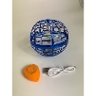
1-Feb-2024 | France | Tattoo Ink - Permanent Makeup | Chemicals | Microbiological Hazard | 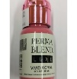
1-Feb-2024 | Sweden | Electric Nail File | Electrical Appliances | Chemical Hazard, Environmental Hazard | 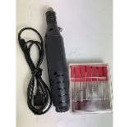
1-Feb-2024 | Sweden | Headset with Microphone | Computer / Audio / Video / Other Electronics & Accessories | Environmental Hazard | 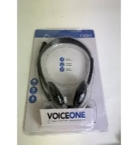
1-Feb-2024 | Sweden | LED Light | Electrical Appliances | Environmental Hazard | 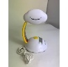
1-Feb-2024 | Lithuania | Lighting Chain | Electrical Appliances | Electric Shock Hazard | 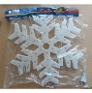
1-Feb-2024 | Lithuania | Lighting Chain | Electrical Appliances | Electric Shock Hazard | 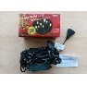
1-Feb-2024 | Sweden | LED Strip | Electrical Appliances | Environmental Hazard | 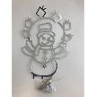
1-Feb-2024 | Poland | Plastic Swing | Toys and Childcare Products | Entrapment Hazard, Injury Hazard, Strangulation Hazard | 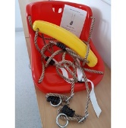
1-Feb-2024 | Poland | Toy Scooter | Toys and Childcare Products | Injury Hazard | 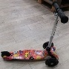
1-Feb-2024 | Poland | Wooden Swing | Toys and Childcare Products | Injury Hazard, Strangulation Hazard | 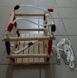
1-Feb-2024 | Sweden | Keyboard Cleaner | Electrical Appliances | Chemical Hazard, Environmental Hazard | 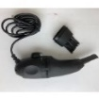
1-Feb-2024 | Hungary | Babies' Clothing Set | Fabric / Textile / Garment / Home Textile | Choking Hazard | 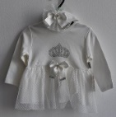
3-Feb-2024 | Germany | Safety Vest | Protective Equipment | Injury Hazard | 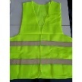
3-Feb-2024 | Germany | Safety Vest | Protective Equipment | Injury Hazard | 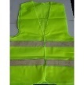
6-Feb-2024 | France | Toy Car | Toys and Childcare Products | Choking Hazard | 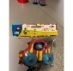
6-Feb-2024 | Lithuania | Lighting Chain | Electrical Appliances | Electric Shock Hazard | 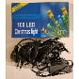
6-Feb-2024 | Finland | Wallet | Fabric / Textile / Garment / Home Textile | Chemical Hazard | 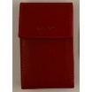
6-Feb-2024 | Lithuania | Toy Fishing Set | Toys and Childcare Products | Choking Hazard | 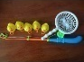
6-Feb-2024 | Hungary | Children’s Dress | Fabric / Textile / Garment / Home Textile | Choking Hazard, Injury Hazard | 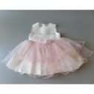
6-Feb-2024 | Romania | Lighting Chain | Electrical Appliances | Electric Shock Hazard | 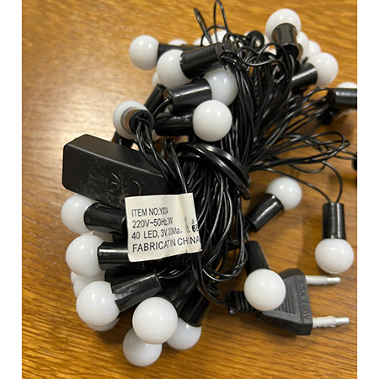
6-Feb-2024 | Romania | Soap | Bodycare / Cosmetics | Chemical Hazard | 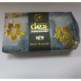
7-Feb-2024 | Malta | Soft Toy | Toys and Childcare Products | Choking Hazard | 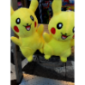
7-Feb-2024 | Cyprus | Squeaky Toy | Toys and Childcare Products | Chemical Hazard
7-Feb-2024 | Lithuania | Toy Airplanes | Toys and Childcare Products | Choking Hazard | 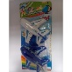
7-Feb-2024 | Czechia | Disposable Electronic Cigarette | Chemicals | Chemical Hazard | 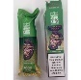
7-Feb-2024 | Czechia | Disposable Electronic Cigarette | Chemicals | Chemical Hazard | 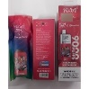
7-Feb-2024 | The Netherlands | Night Light | Electrical Appliances | Electric Shock Hazard | 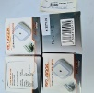
8-Feb-2024 | France | Finger-Paint Inkpad | Toys and Childcare Products | Chemical Hazard, Choking Hazard | 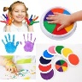
8-Feb-2024 | France | Finger Paint Kit | Toys and Childcare Products | Chemical Hazard, Choking Hazard | 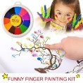
8-Feb-2024 | Latvia | Cleaning Product | Chemicals | Chemical Hazard | 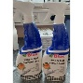
8-Feb-2024 | Norway | Wallet | Fabric / Textile / Garment / Home Textile | Chemical Hazard | 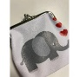
8-Feb-2024 | Norway | Children's Tracksuit | Fabric / Textile / Garment / Home Textile | Chemical Hazard | 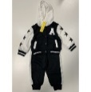
8-Feb-2024 | Denmark | Flail-Type Cutting Attachment | Machinery | Cut Hazard, Injury Hazard | 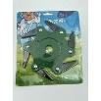
8-Feb-2024 | Ireland | Socks and Tights | Fabric / Textile / Garment / Home Textile | Health Risk Hazard | 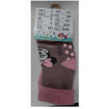
8-Feb-2024 | Sweden | Insect Killer | Electrical Appliances | Chemical Hazard, Environmental Hazard | 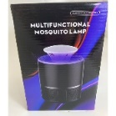
8-Feb-2024 | Sweden | Hair Remover | Electrical Appliances | Chemical Hazard, Environmental Hazard | 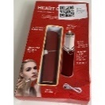
8-Feb-2024 | Czechia | Disposable Electronic Cigarette | Chemicals | Chemical Hazard | 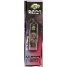
8-Feb-2024 | Czechia | Disposable Electronic Cigarette | Chemicals | Chemical Hazard | 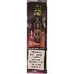
8-Feb-2024 | Czechia | Disposable Electronic Cigarette | Chemicals | Chemical Hazard | 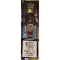
8-Feb-2024 | Czechia | Disposable Electronic Cigarette | Chemicals | Chemical Hazard | 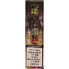
8-Feb-2024 | Czechia | Disposable Electronic Cigarette | Chemicals | Chemical Hazard | 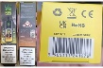
8-Feb-2024 | Czechia | Disposable Electronic Cigarette | Chemicals | Chemical Hazard | 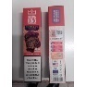
8-Feb-2024 | Czechia | Disposable Electronic Cigarette | Chemicals | Chemical Hazard | 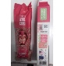
8-Feb-2024 | Czechia | Disposable Electronic Cigarette | Chemicals | Chemical Hazard | 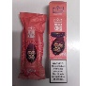
8-Feb-2024 | Czechia | Disposable Electronic Cigarette | Chemicals | Chemical Hazard | 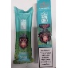
8-Feb-2024 | Poland | Magnetic Toy | Toys and Childcare Products | Choking Hazard, Injury Hazard | 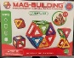
8-Feb-2024 | France | Finger Paint | Toys and Childcare Products | Chemical Hazard | 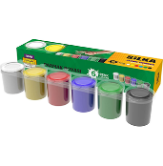
8-Feb-2024 | Hungary | Studio Flash Light | Electrical Appliances | Electric Shock Hazard | 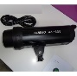
8-Feb-2024 | Hungary | Studio Flash Light | Electrical Appliances | Electric Shock Hazard | 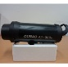
8-Feb-2024 | Hungary | Baby Travel Cot | Toys and Childcare Products | Injury Hazard | 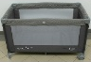
8-Feb-2024 | Czechia | Toy Drill | Toys and Childcare Products | Environmental Hazard | 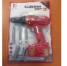
8-Feb-2024 | Czechia | Toy Drill | Toys and Childcare Products | Environmental Hazard | 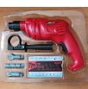
8-Feb-2024 | Czechia | Toy Car | Toys and Childcare Products | Environmental Hazard | 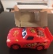
8-Feb-2024 | Austria | Skin Lightening Lotion | Bodycare / Cosmetics | Chemical Hazard | 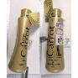
8-Feb-2024 | Germany | Learning Tower | Toys and Childcare Products | Choking Hazard, Injury Hazard | 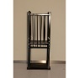
8-Feb-2024 | Germany | Nesting Dolls | Toys and Childcare Products | Choking Hazard | 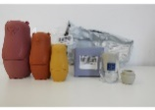
8-Feb-2024 | Finland | Puffer Toy | Toys and Childcare Products | Choking Hazard | 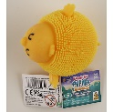
8-Feb-2024 | Germany | Laser Pointer | Electrical Appliances | Damage to Sight | 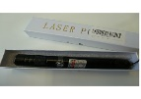
8-Feb-2024 | France | Headlight Repair Fluid | Chemicals | Chemical Hazard | 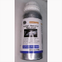
8-Feb-2024 | Hungary | High Chair | Toys and Childcare Products | Injury Hazard | 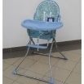
8-Feb-2024 | Czechia | Electronic Toy | Toys and Childcare Products | Environmental Hazard
8-Feb-2024 | Sweden | Electronic Calendar | Computer / Audio / Video / Other Electronics & Accessories | Chemical Hazard, Environmental Hazard | 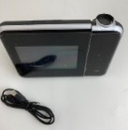
9-Feb-2024 | Germany | Safety Vest | Protective Equipment | Injury Hazard | 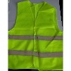
9-Feb-2024 | Germany | Safety Vest | Protective Equipment | Injury Hazard | 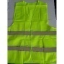
10-Feb-2024 | The Netherlands | Wooden Baby Toy | Toys and Childcare Products | Choking Hazard | 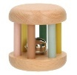
13-Feb-2024 | France | Soft Toy | Toys and Childcare Products | Choking Hazard | 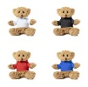
13-Feb-2024 | Germany | Soother Holder | Toys and Childcare Products | Choking Hazard | 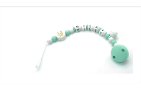
13-Feb-2024 | Cyprus | Squeaky Toy | Toys and Childcare Products | Chemical Hazard | 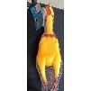
13-Feb-2024 | France | Toy Rattle | Toys and Childcare Products | Choking Hazard | 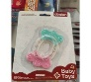  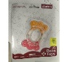
13-Feb-2024 | France | Push Along Toy | Toys and Childcare Products | Choking Hazard | 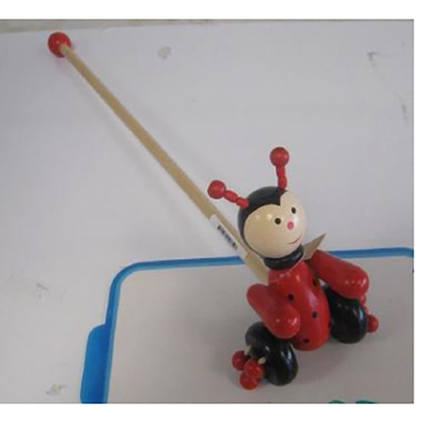
13-Feb-2024 | Denmark | LED Lamp | Electrical Appliances | Electric Shock Hazard | 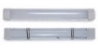
13-Feb-2024 | France | Soother | Toys and Childcare Products | Chemical Hazard | 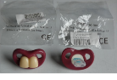
13-Feb-2024 | Ireland | Hair Curler | Home Electrical Appliances | Electric Shock Hazard | 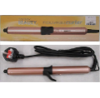
13-Feb-2024 | France | Soother | Toys and Childcare Products | Chemical Hazard | 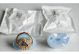
13-Feb-2024 | Austria | Ski Boot | Sporting Goods / Equipment | Injury Hazard | 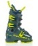  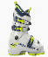  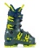  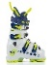
13-Feb-2024 | Austria | Toy Recorder | Toys and Childcare Products | Damage to Hearing | 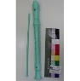
13-Feb-2024 | Austria | Puffer Toy | Toys and Childcare Products | Choking Hazard | 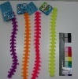
13-Feb-2024 | Romania | Soap | Bodycare / Cosmetics | Chemical Hazard | 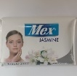
13-Feb-2024 | Romania | Soap | Bodycare / Cosmetics | Chemical Hazard | 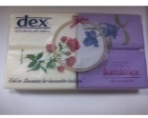
13-Feb-2024 | Finland | Equestrian Helmet | Protective Equipment | Injury Hazard | 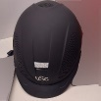
13-Feb-2024 | Finland | Equestrian Helmet | Protective Equipment | Injury Hazard | 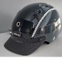
13-Feb-2024 | Sweden | Headphones | Computer / Audio / Video / Other Electronics & Accessories | Chemical Hazard, Environmental Hazard | 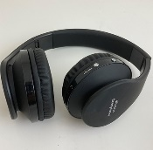
13-Feb-2024 | Sweden | Air Purifier | Electrical Appliances | Chemical Hazard, Environmental Hazard | 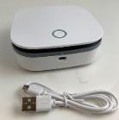
13-Feb-2024 | Hungary | Children's Dress | Fabric / Textile / Garment / Home Textile | Choking Hazard | 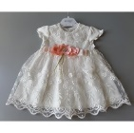
13-Feb-2024 | Czechia | Eau De Toilette | Bodycare / Cosmetics | Chemical Hazard | 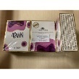
13-Feb-2024 | Bulgaria | Sweatshirt | Fabric / Textile / Garment / Home Textile | Injury Hazard, Strangulation Hazard | 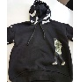  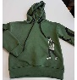  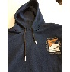  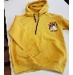
14-Feb-2024 | France | Headlight Repair Fluid | Chemicals | Chemical Hazard | 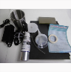
14-Feb-2024 | Sweden | Halloween Decoration | Toys and Childcare Products | Environmental Hazard | 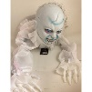
14-Feb-2024 | Sweden | Halloween Decoration | Toys and Childcare Products | Environmental Hazard | 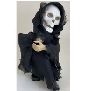
14-Feb-2024 | Sweden | LED Necklace | Toys and Childcare Products | Environmental Hazard | 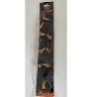
15-Feb-2024 | Cyprus | Goggles | Sporting Goods / Equipment | Chemical Hazard | 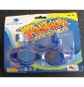
15-Feb-2024 | Cyprus | Children's Jacket | Fabric / Textile / Garment / Home Textile | Injury Hazard, Strangulation Hazard | 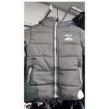
15-Feb-2024 | France | Soft Toy | Toys and Childcare Products | Choking Hazard, Suffocation Hazard | 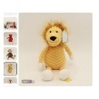
15-Feb-2024 | Estonia | Downlight | Electrical Appliances | Safety Risk Hazard | 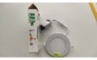
15-Feb-2024 | Czechia | Disposable Electronic Cigarette | Chemicals | Chemical Hazard | 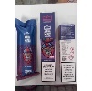
15-Feb-2024 | Czechia | Disposable Electronic Cigarette | Chemicals | Chemical Hazard | 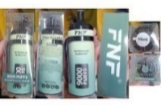
15-Feb-2024 | Czechia | Disposable Electronic Cigarette | Chemicals | Chemical Hazard | 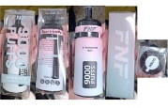
15-Feb-2024 | Czechia | Disposable Electronic Cigarette | Chemicals | Chemical Hazard | 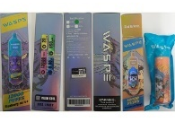
15-Feb-2024 | Czechia | Disposable Electronic Cigarette | Chemicals | Chemical Hazard | 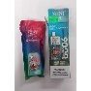
15-Feb-2024 | Czechia | Disposable Electronic Cigarette | Chemicals | Chemical Hazard | 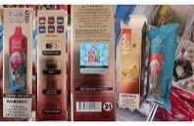
15-Feb-2024 | Czechia | Disposable Electronic Cigarette | Chemicals | Chemical Hazard | 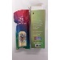
15-Feb-2024 | Czechia | Disposable Electronic Cigarette | Chemicals | Chemical Hazard | 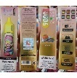
15-Feb-2024 | Czechia | Disposable Electronic Cigarette | Chemicals | Chemical Hazard | 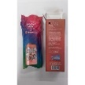
15-Feb-2024 | Czechia | Disposable Electronic Cigarette | Chemicals | Chemical Hazard | 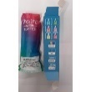
15-Feb-2024 | Czechia | Disposable Electronic Cigarette | Chemicals | Chemical Hazard | 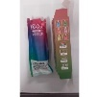
15-Feb-2024 | France | Shower Column | Household Items | Cut Hazard, Injury Hazard | 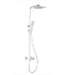  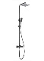
15-Feb-2024 | France | Toy Cell Phone | Toys and Childcare Products | Chemical Hazard, Choking Hazard | 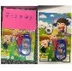
15-Feb-2024 | France | Soother | Toys and Childcare Products | Chemical Hazard | 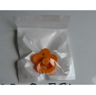
15-Feb-2024 | Finland | Surprise Toy | Toys and Childcare Products | Injury Hazard | 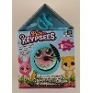  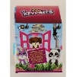
15-Feb-2024 | Germany | Soother Holder | Toys and Childcare Products | Choking Hazard | 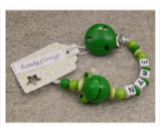
15-Feb-2024 | Germany | Tattoo Ink | Chemicals | Chemical Hazard | 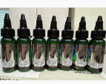
15-Feb-2024 | Lithuania | Car Windscreen Washing Fluid | Chemicals | Burn Hazard, Fire Hazard | 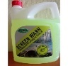
15-Feb-2024 | Lithuania | Car Windscreen Washing Fluid | Chemicals | Burn Hazard, Fire Hazard | 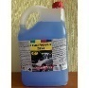
15-Feb-2024 | Hungary | Baby Walker | Toys and Childcare Products | Injury Hazard | 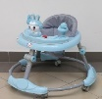
15-Feb-2024 | France | Baby Sleeping Bag | Fabric / Textile / Garment / Home Textile | Choking Hazard | 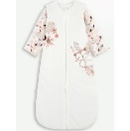
15-Feb-2024 | Hungary | Children's Dress | Fabric / Textile / Garment / Home Textile | Injury Hazard | 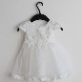
15-Feb-2024 | Hungary | Children's Dress | Fabric / Textile / Garment / Home Textile | Choking Hazard | 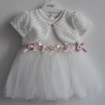
15-Feb-2024 | Estonia | Downlight | Electrical Appliances | Safety Risk Hazard | 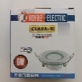
15-Feb-2024 | Estonia | LED Panel | Electrical Appliances | Safety Risk Hazard | 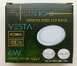
15-Feb-2024 | Belgium | Particle Filter Mask | Protective Equipment | Health Risk Hazard | 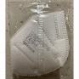
15-Feb-2024 | Cyprus | Toy Glasses and Nose | Toys and Childcare Products | Chemical Hazard | 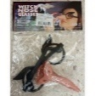
15-Feb-2024 | Ireland | Beverage Warmer | Electrical Appliances | Electric Shock Hazard, Fire Hazard | 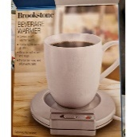
15-Feb-2024 | Malta | Gas Space Heater | Household Items | Fire Hazard | 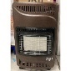
15-Feb-2024 | France | Expansive Foam | Chemicals | Chemical Hazard | 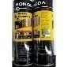
15-Feb-2024 | Sweden | Liquid Hourglass | Accessories | Chemical Hazard | 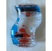
15-Feb-2024 | Germany | Electric Lunchbox | Electrical Appliances | Electric Shock Hazard | 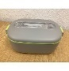
15-Feb-2024 | Germany | Electric Lunchbox | Electrical Appliances | Electric Shock Hazard | 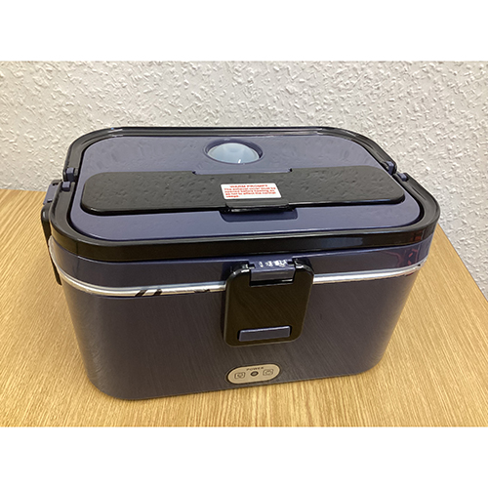
15-Feb-2024 | Germany | Electric Lunchbox | Electrical Appliances | Electric Shock Hazard | 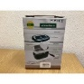
15-Feb-2024 | Germany | Earrings | Jewelry | Chemical Hazard | 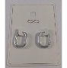
15-Feb-2024 | Poland | Toy Gun Set | Toys and Childcare Products | Choking Hazard | 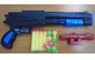
15-Feb-2024 | Sweden | Electric Doorbell | Electrical Appliances | Chemical Hazard, Environmental Hazard | 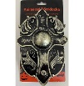
15-Feb-2024 | Sweden | Halloween Decoration | Accessories | Chemical Hazard | 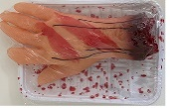
15-Feb-2024 | Sweden | Window Sticker | Accessories | Chemical Hazard | 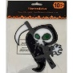
15-Feb-2024 | Sweden | Halloween Decoration | Accessories | Chemical Hazard | 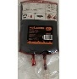
16-Feb-2024 | Germany | Nesting Toy Dolls | Toys and Childcare Products | Choking Hazard | 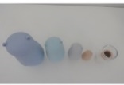
16-Feb-2024 | Hungary | Children's Dress | Fabric / Textile / Garment / Home Textile | Choking Hazard | 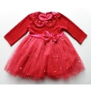
16-Feb-2024 | Hungary | Children's Shoes | Footwear | Choking Hazard | 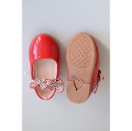
16-Feb-2024 | Hungary | Children's Shoes | Footwear | Choking Hazard | 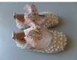
16-Feb-2024 | Hungary | Children's Shoes | Footwear | Choking Hazard | 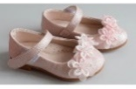
16-Feb-2024 | Czechia | Disposable Electronic Cigarette | Chemicals | Chemical Hazard | 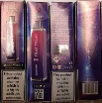
16-Feb-2024 | Czechia | Disposable Electronic Cigarette | Chemicals | Chemical Hazard | 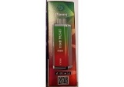
16-Feb-2024 | Czechia | Disposable Electronic Cigarette | Chemicals | Chemical Hazard | 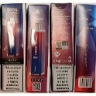
16-Feb-2024 | Czechia | Disposable Electronic Cigarette | Chemicals | Chemical Hazard | 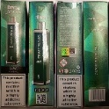
16-Feb-2024 | Malta | Soft Toy | Toys and Childcare Products | Choking Hazard | 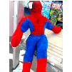
16-Feb-2024 | Czechia | Disposable Electronic Cigarette | Chemicals | Chemical Hazard | 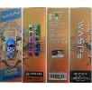
17-Feb-2024 | Czechia | Disposable Electronic Cigarette | Chemicals | Chemical Hazard | 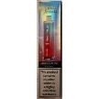
17-Feb-2024 | Czechia | Disposable Electronic Cigarette | Chemicals | Chemical Hazard | 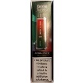
17-Feb-2024 | Czechia | Disposable Electronic Cigarette | Chemicals | Chemical Hazard | 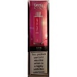
17-Feb-2024 | Czechia | Disposable Electronic Cigarette | Chemicals | Chemical Hazard | 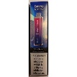
19-Feb-2024 | Germany | Soap | Bodycare / Cosmetics | Chemical Hazard | 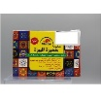
20-Feb-2024 | Denmark | Attachment for Brush Cutter | Machinery | Injury Hazard | 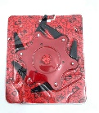
20-Feb-2024 | Denmark | Attachment for Brush Cutter | Machinery | Injury Hazard | 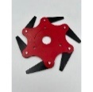
20-Feb-2024 | Denmark | Attachment for Brush Cutter | Machinery | Injury Hazard
20-Feb-2024 | Ireland | Hand Cleaner | Bodycare / Cosmetics | Microbiological Hazard | 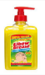
20-Feb-2024 | Sweden | Liquid Hourglass | Accessories | Chemical Hazard | 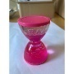
20-Feb-2024 | Germany | Learning Tower | Furniture | Injury Hazard | 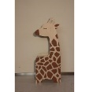
20-Feb-2024 | France | Children's Puffer Jacket | Fabric / Textile / Garment / Home Textile | Choking Hazard | 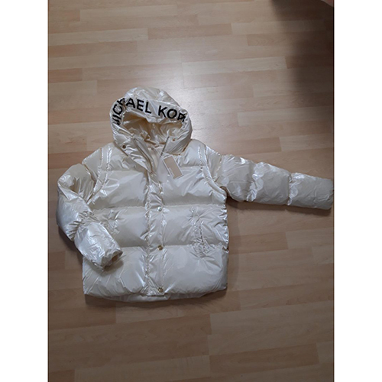  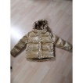
20-Feb-2024 | Romania | Lighting Chain | Electrical Appliances | Electric Shock Hazard | 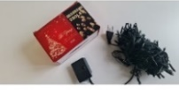
20-Feb-2024 | Malta | Head Support Strap | Toys and Childcare Products | Injury Hazard, Suffocation Hazard | 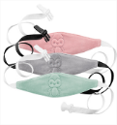
20-Feb-2024 | Poland | Earrings | Jewelry | Chemical Hazard | 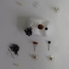
20-Feb-2024 | Poland | Earrings | Jewelry | Chemical Hazard | 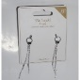
20-Feb-2024 | Poland | Earrings | Jewelry | Chemical Hazard | 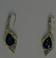
20-Feb-2024 | Romania | Soap | Bodycare / Cosmetics | Chemical Hazard | 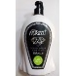
20-Feb-2024 | Romania | Perfume | Bodycare / Cosmetics | Chemical Hazard | 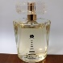
20-Feb-2024 | Sweden | Magnifying Glass with LED | Electrical Appliances | Environmental Hazard | 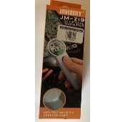
20-Feb-2024 | Sweden | Tracker | Electrical Appliances | Environmental Hazard | 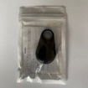
20-Feb-2024 | Sweden | Car Charger | Electrical Appliances | Environmental Hazard | 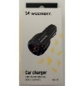
20-Feb-2024 | Sweden | LED Light | Electrical Appliances | Environmental Hazard | 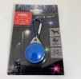
20-Feb-2024 | Sweden | LED Flashlight | Electrical Appliances | Chemical Hazard, Environmental Hazard | 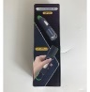
20-Feb-2024 | Sweden | Balloons | Toys and Childcare Products | Chemical Hazard | 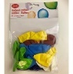
20-Feb-2024 | Sweden | Slime Kit | Toys and Childcare Products | Chemical Hazard | 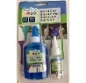
20-Feb-2024 | Sweden | Face Epilator | Electrical Appliances | Chemical Hazard, Environmental Hazard | 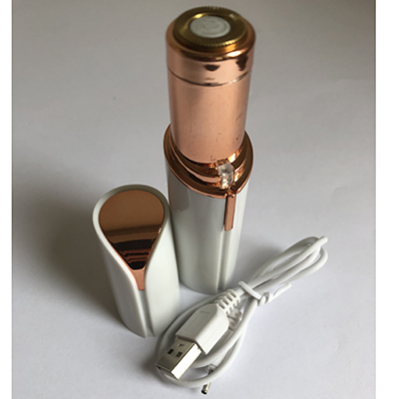
20-Feb-2024 | Sweden | Skin Cleaning Device | Electrical Appliances | Chemical Hazard, Environmental Hazard | 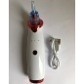
20-Feb-2024 | Czechia | Plastic Doll | Toys and Childcare Products | Chemical Hazard | 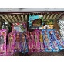
20-Feb-2024 | Sweden | Nasal Absorber | Electrical Appliances | Chemical Hazard, Environmental Hazard | 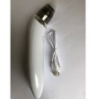
20-Feb-2024 | Sweden | Light Chain | Electrical Appliances | Chemical Hazard, Environmental Hazard | 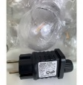  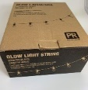
20-Feb-2024 | Sweden | USB Fan | Electrical Appliances | Chemical Hazard, Environmental Hazard | 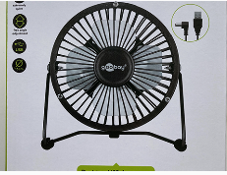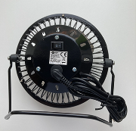
21-Feb-2024 | Germany | Electric Motorcycle | Sporting Goods / Equipment | Fire Hazard | 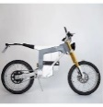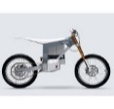
21-Feb-2024 | Germany | Electronic Cigarette | Chemicals | Chemical Hazard | 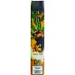
21-Feb-2024 | Germany | Electronic Cigarette | Chemicals | Chemical Hazard | 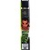
21-Feb-2024 | Bulgaria | Office Chair | Furniture | Injury Hazard | 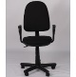
21-Feb-2024 | Lithuania | Eyelash and Eyebrow Dyes | Bodycare / Cosmetics | Chemical Hazard | 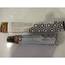
21-Feb-2024 | Sweden | Fabric Shaver | Electrical Appliances | Environmental Hazard | 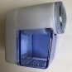
21-Feb-2024 | Sweden | Glasses with LED Light | Electrical Appliances | Chemical Hazard, Environmental Hazard | 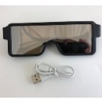
21-Feb-2024 | Sweden | Thermometer-Hygrometer | Electrical Appliances | Environmental Hazard | 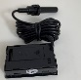
22-Feb-2024 | Belgium | Particle Filter Mask | Protective Equipment | Health Risk Hazard | 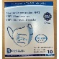
22-Feb-2024 | France | Balloons | Toys and Childcare Products | Chemical Hazard | 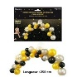
22-Feb-2024 | Slovakia | Safety Vest | Protective Equipment | Injury Hazard | 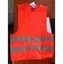
22-Feb-2024 | Malta | Gas Heater | Household Items | Fire Hazard | 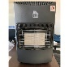
22-Feb-2024 | Malta | Gas Heater | Household Items | Asphyxiation Hazard | 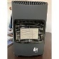
22-Feb-2024 | Lithuania | Thinner | Chemicals | Chemical Hazard | 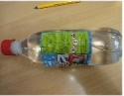
22-Feb-2024 | France | Face Cream | Bodycare / Cosmetics | Microbiological Hazard | 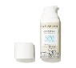
22-Feb-2024 | France | Hand Disinfectant | Chemicals | Burn Hazard, Fire Hazard | 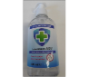
22-Feb-2024 | Sweden | Liquid Hourglass | Accessories | Chemical Hazard | 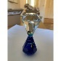
22-Feb-2024 | Sweden | Liquid Hourglass | Accessories | Chemical Hazard | 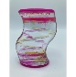
22-Feb-2024 | Czechia | Disposable Electronic Cigarette | Chemicals | Chemical Hazard | 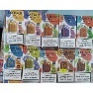
22-Feb-2024 | Germany | Rubber Mallet | Tools and Hardware | Chemical Hazard | 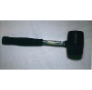
22-Feb-2024 | Czechia | Disposable Electronic Cigarette | Chemicals | Chemical Hazard | 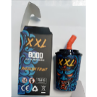
22-Feb-2024 | Hungary | Children's Dress | Fabric / Textile / Garment / Home Textile | Choking Hazard | 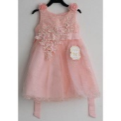
22-Feb-2024 | Czechia | Disposable Electronic Cigarette | Chemicals | Chemical Hazard | 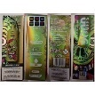
22-Feb-2024 | Czechia | Disposable Electronic Cigarette | Chemicals | Chemical Hazard | 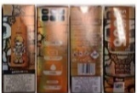
22-Feb-2024 | Hungary | Children's Dress | Fabric / Textile / Garment / Home Textile | Choking Hazard, Injury Hazard | 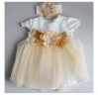
22-Feb-2024 | Czechia | Disposable Electronic Cigarette | Chemicals | Chemical Hazard | 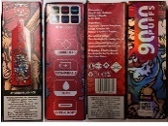
22-Feb-2024 | Czechia | Disposable Electronic Cigarette | Chemicals | Chemical Hazard | 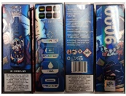
22-Feb-2024 | Czechia | Disposable Electronic Cigarette | Chemicals | Chemical Hazard | 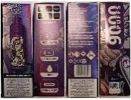
22-Feb-2024 | Czechia | Disposable Electronic Cigarette | Chemicals | Chemical Hazard | 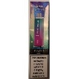
22-Feb-2024 | Czechia | Disposable Electronic Cigarette | Chemicals | Chemical Hazard | 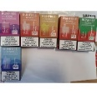
22-Feb-2024 | Czechia | Disposable Electronic Cigarette | Chemicals | Chemical Hazard | 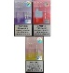  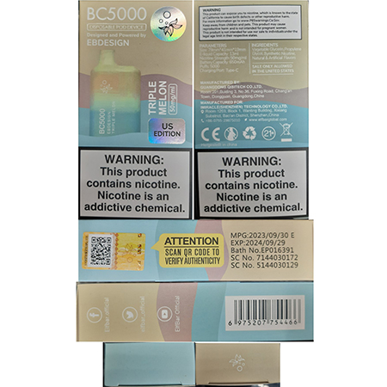
22-Feb-2024 | Hungary | Children's Dress | Fabric / Textile / Garment / Home Textile | Choking Hazard | 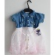
22-Feb-2024 | Czechia | Disposable Electronic Cigarette | Chemicals | Chemical Hazard | 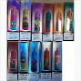
22-Feb-2024 | Sweden | Electric Dice Roller | Electrical Appliances | Environmental Hazard | 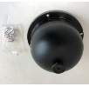
22-Feb-2024 | Denmark | Attachment for Brush Cutter | Machinery | Injury Hazard
22-Feb-2024 | Denmark | Attachment for Brush Cutter | Machinery | Injury Hazard | 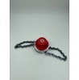
22-Feb-2024 | Denmark | Attachment for Brush Cutter | Machinery | Injury Hazard | 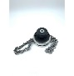
22-Feb-2024 | Denmark | Attachment for Brush Cutter | Machinery | Injury Hazard | 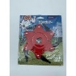
22-Feb-2024 | Denmark | Attachment for Brush Cutter | Machinery | Injury Hazard | 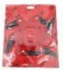
22-Feb-2024 | Denmark | Attachment for Brush Cutter | Machinery | Injury Hazard | 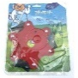
22-Feb-2024 | Denmark | Attachment for Brush Cutter | Machinery | Injury Hazard | 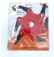
22-Feb-2024 | Denmark | Attachment for Brush Cutter | Machinery | Injury Hazard | 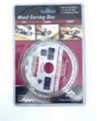
22-Feb-2024 | Denmark | Attachment for Brush Cutter | Machinery | Injury Hazard | 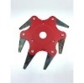
22-Feb-2024 | Denmark | Attachment for Brush Cutter | Machinery | Injury Hazard | 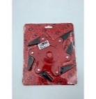
22-Feb-2024 | Denmark | Attachment for Brush Cutter | Machinery | Injury Hazard | 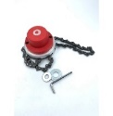
22-Feb-2024 | Denmark | Attachment for Brush Cutter | Machinery | Injury Hazard
22-Feb-2024 | Lithuania | Plastic Toy | Toys and Childcare Products | Suffocation Hazard | 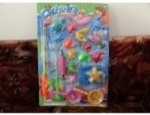
22-Feb-2024 | Italy | Shampoo | Bodycare / Cosmetics | Chemical Hazard | 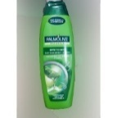
22-Feb-2024 | Italy | Soap | Bodycare / Cosmetics | Chemical Hazard | 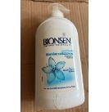
22-Feb-2024 | Romania | Eau De Toilette | Bodycare / Cosmetics | Chemical Hazard | 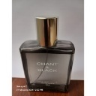
22-Feb-2024 | Sweden | Neck Massager | Electrical Appliances | Chemical Hazard, Environmental Hazard | 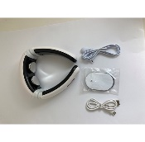
22-Feb-2024 | Sweden | WiFi Repeater | Electrical Appliances | Chemical Hazard, Environmental Hazard | 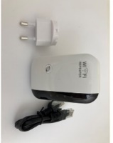
22-Feb-2024 | Poland | USB Charger | Electrical Appliances | Burn Hazard, Electric Shock Hazard | 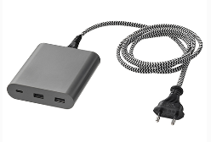
22-Feb-2024 | Sweden | LED Light | Electrical Appliances | Environmental Hazard | 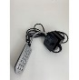
22-Feb-2024 | Italy | Perfume | Bodycare / Cosmetics | Chemical Hazard | 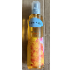  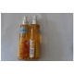
22-Feb-2024 | Italy | Hand Cream | Bodycare / Cosmetics | Chemical Hazard | 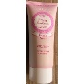
22-Feb-2024 | Italy | Perfume | Bodycare / Cosmetics | Chemical Hazard | 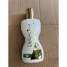
22-Feb-2024 | Italy | Hand and Nail Cream | Bodycare / Cosmetics | Chemical Hazard | 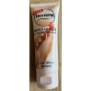
22-Feb-2024 | Italy | Hair and Body Wash | Bodycare / Cosmetics | Chemical Hazard | 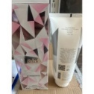
22-Feb-2024 | Sweden | USB Cable | Electrical Appliances | Chemical Hazard, Environmental Hazard | 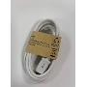
22-Feb-2024 | Lithuania | Lighting Chain | Electrical Appliances | Electric Shock Hazard | 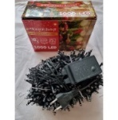
22-Feb-2024 | Sweden | Children's Camera | Computer / Audio / Video / Other Electronics & Accessories | Chemical Hazard, Environmental Hazard | 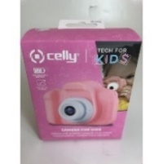
23-Feb-2024 | Denmark | Attachment for Brush Cutter | Machinery | Injury Hazard | 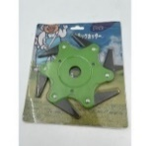
23-Feb-2024 | Denmark | Attachment for Brush Cutter | Machinery | Injury Hazard | 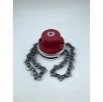
23-Feb-2024 | Denmark | Attachment for Brush Cutter | Machinery | Injury Hazard | 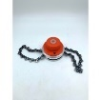
23-Feb-2024 | Denmark | Attachment for Brush Cutter | Machinery | Injury Hazard | 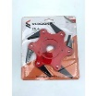
23-Feb-2024 | Denmark | Attachment for Brush Cutter | Machinery | Injury Hazard | 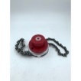
23-Feb-2024 | Denmark | Attachment for Brush Cutter | Machinery | Injury Hazard | 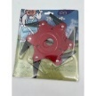
23-Feb-2024 | France | Soother | Toys and Childcare Products | Chemical Hazard | 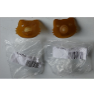
23-Feb-2024 | Italy | Body Oil | Bodycare / Cosmetics | Chemical Hazard | 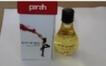
23-Feb-2024 | Romania | Perfume | Bodycare / Cosmetics | Chemical Hazard | 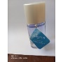
23-Feb-2024 | Italy | Perfumed Body Cream | Bodycare / Cosmetics | Chemical Hazard | 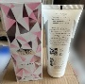
26-Feb-2024 | Germany | Ballpoint Pen | Stationery | Chemical Hazard | 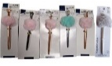
26-Feb-2024 | Cyprus | Residual-Current Device | Electrical Appliances | Electric Shock Hazard | 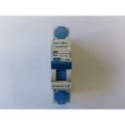
27-Feb-2024 | Ireland | Wireless Microphone | Computer / Audio / Video / Other Electronics & Accessories | Burn Hazard, Fire Hazard | 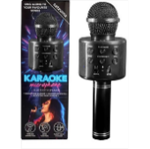
27-Feb-2024 | France | Plastic Doll | Toys and Childcare Products | Chemical Hazard, Choking Hazard | 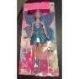
27-Feb-2024 | Poland | Toy Remote Control | Toys and Childcare Products | Environmental Hazard | 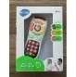
27-Feb-2024 | Poland | Duck Toy | Toys and Childcare Products | Environmental Hazard | 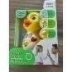
27-Feb-2024 | Germany | Kitchen Stool | Furniture | Injury Hazard | 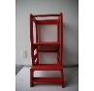
27-Feb-2024 | Poland | Toy Make-up Set | Bodycare / Cosmetics | Chemical Hazard | 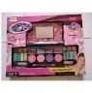
28-Feb-2024 | Italy | Body Lotion | Bodycare / Cosmetics | Chemical Hazard | 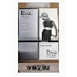
28-Feb-2024 | Italy | Hand Cream | Bodycare / Cosmetics | Chemical Hazard | 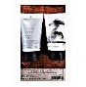
28-Feb-2024 | Italy | Perfume | Bodycare / Cosmetics | Chemical Hazard
28-Feb-2024 | Italy | Perfume | Bodycare / Cosmetics | Chemical Hazard | 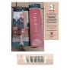
28-Feb-2024 | Italy | Cleansing Milk | Bodycare / Cosmetics | Chemical Hazard | 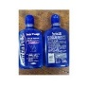
28-Feb-2024 | Italy | Eau De Toilette | Bodycare / Cosmetics | Chemical Hazard | 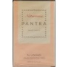
28-Feb-2024 | Italy | Shower Gel and Body Lotion Set | Bodycare / Cosmetics | Chemical Hazard | 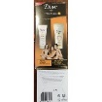
28-Feb-2024 | Italy | Firming Cream | Bodycare / Cosmetics | Chemical Hazard
28-Feb-2024 | Italy | Body Lotion | Bodycare / Cosmetics | Chemical Hazard
28-Feb-2024 | Italy | Body Lotion | Bodycare / Cosmetics | Chemical Hazard | 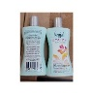
28-Feb-2024 | Italy | Hair Cream | Bodycare / Cosmetics | Chemical Hazard | 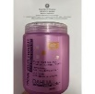
28-Feb-2024 | France | Finger-Paint Inkpad | Toys and Childcare Products | Chemical Hazard, Choking Hazard | 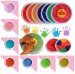
28-Feb-2024 | France | Soft Toy | Toys and Childcare Products | Choking Hazard | 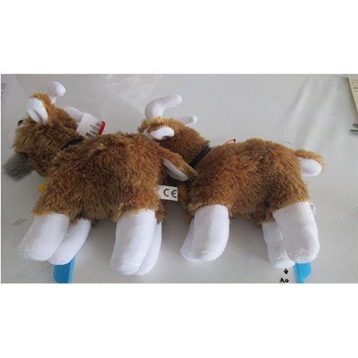  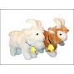
28-Feb-2024 | Italy | Eau De Toilette | Bodycare / Cosmetics | Chemical Hazard | 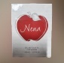
28-Feb-2024 | Italy | Soap | Bodycare / Cosmetics | Chemical Hazard | 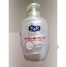
28-Feb-2024 | Italy | Shampoo | Bodycare / Cosmetics | Chemical Hazard | 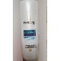
28-Feb-2024 | France | Balloons | Toys and Childcare Products | Chemical Hazard | 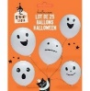
28-Feb-2024 | Italy | Deodorant Spray | Bodycare / Cosmetics | Chemical Hazard | 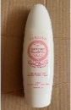
28-Feb-2024 | Italy | Body Cream | Bodycare / Cosmetics | Chemical Hazard | 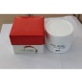
28-Feb-2024 | France | Car Wheels Cleaner | Chemicals | Chemical Hazard | 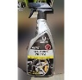
28-Feb-2024 | France | Car Wax | Chemicals | Chemical Hazard | 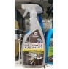
28-Feb-2024 | France | Balloons | Toys and Childcare Products | Chemical Hazard | 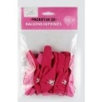
28-Feb-2024 | The Netherlands | Plastic Playpen | Toys and Childcare Products | Injury Hazard, Strangulation Hazard | 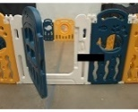
28-Feb-2024 | Hungary | Plastic Doll | Toys and Childcare Products | Chemical Hazard
28-Feb-2024 | Hungary | Plastic Doll | Toys and Childcare Products | Chemical Hazard | 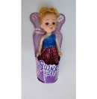
28-Feb-2024 | Sweden | Charging Cable | Electrical Appliances | Environmental Hazard | 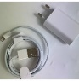
28-Feb-2024 | Czechia | Toy Tank | Toys and Childcare Products | Environmental Hazard | 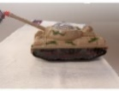
28-Feb-2024 | Italy | Body Lotion | Bodycare / Cosmetics | Chemical Hazard | 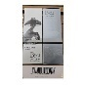
28-Feb-2024 | Italy | Body Lotion | Bodycare / Cosmetics | Chemical Hazard | 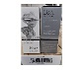
28-Feb-2024 | Italy | Body Lotion | Bodycare / Cosmetics | Chemical Hazard | 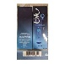
28-Feb-2024 | Italy | Perfume | Bodycare / Cosmetics | Chemical Hazard | 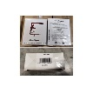
28-Feb-2024 | Italy | Body Lotion | Bodycare / Cosmetics | Chemical Hazard | 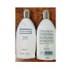
28-Feb-2024 | Italy | Face Cream | Bodycare / Cosmetics | Chemical Hazard | 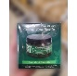
28-Feb-2024 | Italy | Hair and Body Wash | Bodycare / Cosmetics | Chemical Hazard | 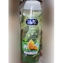
28-Feb-2024 | Italy | Deodorant Spray | Bodycare / Cosmetics | Chemical Hazard | 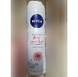
28-Feb-2024 | Italy | Moisturising Cream | Bodycare / Cosmetics | Chemical Hazard | 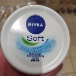
28-Feb-2024 | Italy | Candle | Bodycare / Cosmetics | Chemical Hazard | 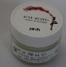
28-Feb-2024 | Italy | Bath Cream | Bodycare / Cosmetics | Chemical Hazard | 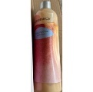
28-Feb-2024 | Estonia | Toy Train | Toys and Childcare Products | Choking Hazard | 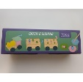
29-Feb-2024 | Italy | Eau De Toilette | Bodycare / Cosmetics | Chemical Hazard | 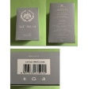
29-Feb-2024 | Italy | Eau De Toilette | Bodycare / Cosmetics | Chemical Hazard | 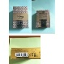
29-Feb-2024 | Italy | Eau De Toilette | Bodycare / Cosmetics | Chemical Hazard | 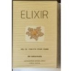
29-Feb-2024 | Italy | Eau De Toilette | Bodycare / Cosmetics | Chemical Hazard | 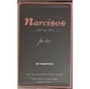
29-Feb-2024 | Italy | Eau De Toilette | Bodycare / Cosmetics | Chemical Hazard | 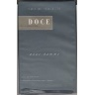
29-Feb-2024 | Italy | Eau De Toilette | Bodycare / Cosmetics | Chemical Hazard | 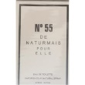
29-Feb-2024 | Italy | Travel Adaptor | Electrical Appliances | Electric Shock Hazard | 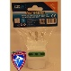
29-Feb-2024 | Italy | Cream | Bodycare / Cosmetics | Chemical Hazard
29-Feb-2024 | Italy | Body Cream | Bodycare / Cosmetics | Chemical Hazard | 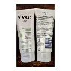
29-Feb-2024 | Italy | Shampoo | Bodycare / Cosmetics | Chemical Hazard | 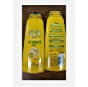
29-Feb-2024 | Italy | Hair Dye | Bodycare / Cosmetics | Chemical Hazard | 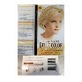
29-Feb-2024 | Italy | Slime Toy | Toys and Childcare Products | Chemical Hazard
29-Feb-2024 | Italy | Hair Dye | Bodycare / Cosmetics | Chemical Hazard | 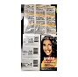
29-Feb-2024 | Italy | Make-Up Remover Wipes | Bodycare / Cosmetics | Chemical Hazard | 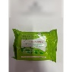
29-Feb-2024 | Italy | Make-Up Remover Wipes | Bodycare / Cosmetics | Chemical Hazard | 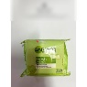
29-Feb-2024 | Italy | Hair Dye | Bodycare / Cosmetics | Chemical Hazard | 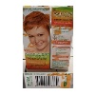
29-Feb-2024 | Italy | Hair Dye | Bodycare / Cosmetics | Chemical Hazard | 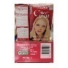
29-Feb-2024 | Italy | Face Tonic | Bodycare / Cosmetics | Chemical Hazard | 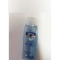
29-Feb-2024 | Italy | Body Cream | Bodycare / Cosmetics | Chemical Hazard | 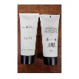
29-Feb-2024 | Italy | Face Tonic | Bodycare / Cosmetics | Chemical Hazard | 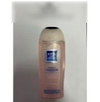
29-Feb-2024 | Italy | Hairspray | Bodycare / Cosmetics | Chemical Hazard | 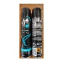
29-Feb-2024 | Italy | Shampoo | Bodycare / Cosmetics | Chemical Hazard
29-Feb-2024 | Italy | Shampoo | Bodycare / Cosmetics | Chemical Hazard
29-Feb-2024 | Italy | Hair Conditioner | Bodycare / Cosmetics | Chemical Hazard | 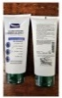
29-Feb-2024 | Italy | Shampoo | Bodycare / Cosmetics | Chemical Hazard | 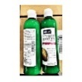
29-Feb-2024 | Italy | Hair Dye | Bodycare / Cosmetics | Chemical Hazard | 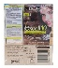
29-Feb-2024 | Italy | Night Cream | Bodycare / Cosmetics | Chemical Hazard | 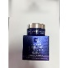
29-Feb-2024 | Italy | Hair Dye | Bodycare / Cosmetics | Chemical Hazard | 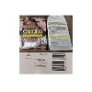
29-Feb-2024 | Italy | Perfume | Bodycare / Cosmetics | Chemical Hazard | 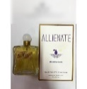
29-Feb-2024 | Italy | Shampoo | Bodycare / Cosmetics | Chemical Hazard | 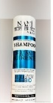
29-Feb-2024 | Italy | Shampoo | Bodycare / Cosmetics | Chemical Hazard | 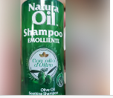
29-Feb-2024 | Ireland | Hairdryer | Home Electrical Appliances | Burn Hazard, Fire Hazard | 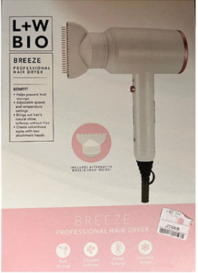
29-Feb-2024 | Estonia | Christmas Decoration | Accessories | Chemical Hazard | 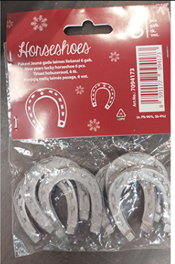
29-Feb-2024 | Finland | Bath Toy | Toys and Childcare Products | Cut Hazard, Injury Hazard
29-Feb-2024 | Finland | Bath Toy | Toys and Childcare Products | Cut Hazard, Injury Hazard | 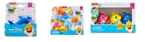
29-Feb-2024 | Denmark | Attachment for Brush Cutter | Machinery | Injury Hazard | 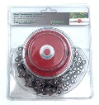
29-Feb-2024 | Cyprus | Plastic Doll | Toys and Childcare Products | Chemical Hazard | 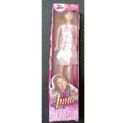
29-Feb-2024 | Italy | Face Cream | Bodycare / Cosmetics | Chemical Hazard | 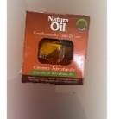
29-Feb-2024 | Italy | Bath and Shower Gel | Bodycare / Cosmetics | Chemical Hazard | 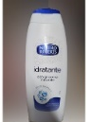
29-Feb-2024 | Cyprus | Residual-Current Device | Electrical Appliances | Electric Shock Hazard | 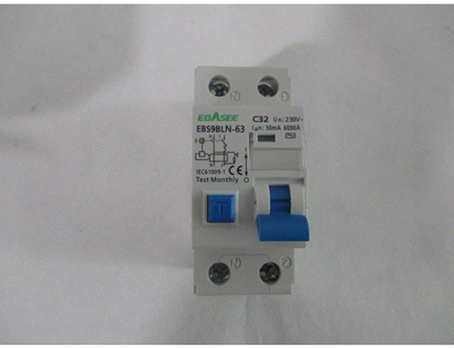
29-Feb-2024 | Poland | Necklace | Jewelry | Chemical Hazard | 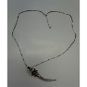
29-Feb-2024 | France | Car Wheel Cleaner | Chemicals | Chemical Hazard | 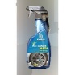
29-Feb-2024 | Sweden | Children's Flip-Flops | Footwear | Chemical Hazard | 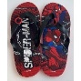
29-Feb-2024 | Poland | Bicycle Helmet | Protective Equipment | Injury Hazard | 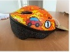
29-Feb-2024 | Poland | Toy Fishing Game | Toys and Childcare Products | Choking Hazard, Injury Hazard | 