Recall Cases Summary – US (Last Update Date: 29 February 2024)

Date | Product | Categories | Hazard | Image
1-Feb-2024 | Children’s Nightgowns | Fabric / Textile / Garment / Home Textile | Fire Hazard, Burn Hazard, Injury Hazard | 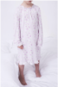
1-Feb-2024 | NordicTrack 50 LB iSelect Voice-Controlled Adjustable Dumbbells | Sporting Goods / Equipment | Impact Hazard | 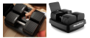
1-Feb-2024 | Lithium-Ion Battery Sold for Pixy Flying Cameras | Computer / Audio / Video / Other Electronics & Accessories | Fire Hazard | 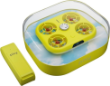
1-Feb-2024 | Fishing Games | Toys and Childcare Products | Ingestion Hazard, Risk of Death, Swallowing Risk | 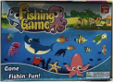
1-Feb-2024 | Shift Brake Levers | Sporting Goods / Equipment | Crash Hazard | 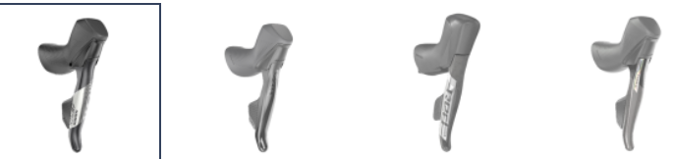  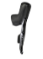
1-Feb-2024 | High-Powered Magnetic Balls | Toys and Childcare Products | Ingestion Hazard, Risk of Death, Swallowing Risk | 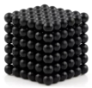
1-Feb-2024 | Slide & Seek Ball Runs with Wooden Knobs | Toys and Childcare Products | Choking Hazard | 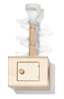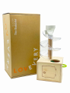
1-Feb-2024 | Replacement Light Bulbs | Electrical Appliances | Laceration Hazard | 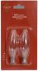  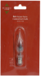  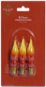  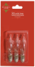
1-Feb-2024 | Children’s Nightgowns | Fabric / Textile / Garment / Home Textile | Burn Hazard, Injury Hazard | 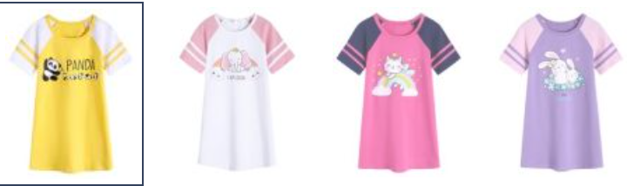  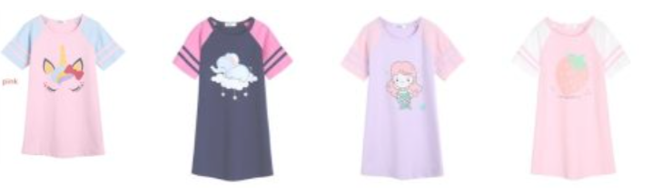  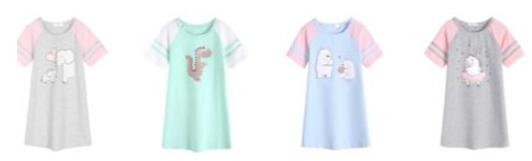  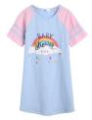
1-Feb-2024 | Children’s Bicycles | Sporting Goods / Equipment | Crash Hazard, Injury Hazard, Entrapment Hazard | 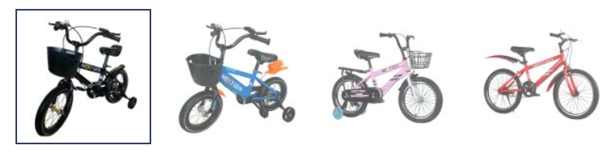
1-Feb-2024 | BMX Race Bicycle Stems | Sporting Goods / Equipment | Injury Hazard, Crash Hazard | 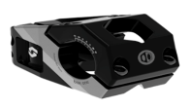
1-Feb-2024 | Glass Little Wanderer Snow Globes | Accessories | Laceration Hazard | 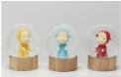  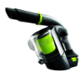
1-Feb-2024 | Multi Reach Hand and Floor Vacuum Cleaners | Home Electrical Appliances | Fire Hazard
8-Feb-2024 | Gas-Powered Grass Trimmers | Machinery | Fire Hazard | 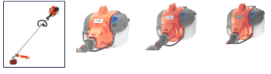
8-Feb-2024 | Children’s Bathrobes | Fabric / Textile / Garment / Home Textile | Burn Hazard | 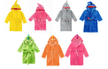
8-Feb-2024 | Handheld Garment Steamer | Home Electrical Appliances | Burn Hazard | 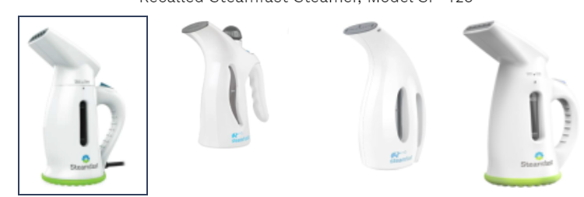  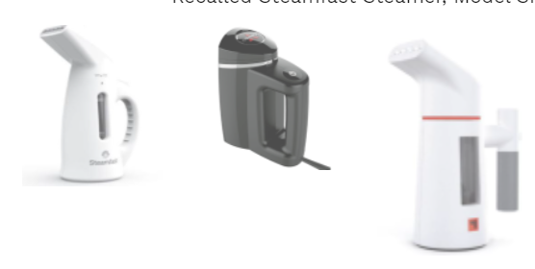
8-Feb-2024 | Side by Side Refrigerators with Slim Ice Buckets | Home Electrical Appliances | Choking Hazard, Laceration Hazard | 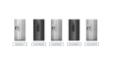  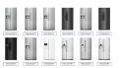
8-Feb-2024 | Lighters | Tools and Hardware | Burn Hazard, Fire Hazard | 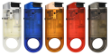  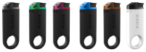
8-Feb-2024 | GPU Angled Adapters | Electrical Appliances | Burn Hazard, Fire Hazard | 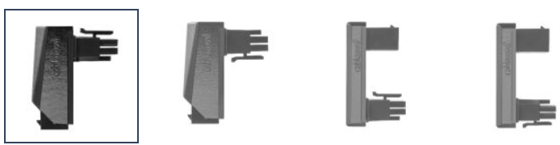  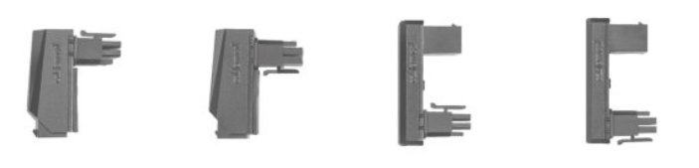
15-Feb-2024 | Rhino Climbing Sticks | Sporting Goods / Equipment | Fall Hazard, Laceration Hazard
15-Feb-2024 | Growing Table-Mini Greenhouse and Raised Garden Bed | Outdoor Living Items | Fire Hazard, Injury Hazard | 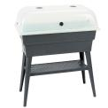
15-Feb-2024 | Digital Electric Smokers | Home Electrical Appliances | Electric Shock Hazard | 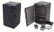  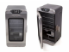  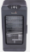  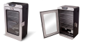  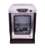  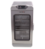
15-Feb-2024 | Frigidaire Rear-Controlled Ranges | Home Electrical Appliances | Electric Shock Hazard | 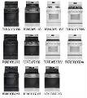
15-Feb-2024 | Bell Soquel Youth Bicycle Helmets | Protective Equipment | Injury Hazard | 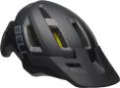
15-Feb-2024 | BRS and BULin Liquid Fuel Bottles | Food Contact Material | Burn Hazard, Poisoning Hazard, Fire Hazard | 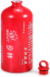
21-Feb-2024 | Laptop AC Adapters | Electrical Appliances | Burn Hazard, Fire Hazard | 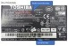  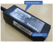  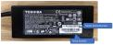  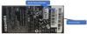
22-Feb-2024 | JURLEA Rugs | Fabric / Textile / Garment / Home Textile | Fire Hazard | 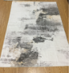  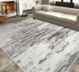
22-Feb-2024 | EVAS 20 lb. Propane Exchange Tanks | Chemicals | Fire Hazard, Risk of Exposure to Combustion Flue Gas | 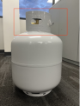
22-Feb-2024 | USB Chargers | Electrical Appliances | Burn Hazard, Electric Shock Hazard | 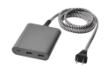
22-Feb-2024 | Camping Cooking Pots | Food Contact Material | Burn Hazard | 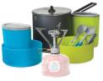  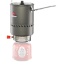  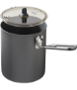  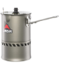
22-Feb-2024 | Biometric Gun Safes | Protective Equipment | Injury Hazard, Risk of Death | 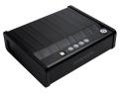
22-Feb-2024 | Biometric Gun Safes | Protective Equipment | Injury Hazard, Risk of Death | 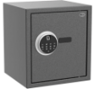
22-Feb-2024 | Biometric Personal Safes | Protective Equipment | Injury Hazard, Risk of Death | 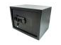  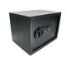
22-Feb-2024 | Biometric Gun Safes | Protective Equipment | Injury Hazard, Risk of Death | 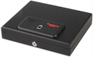  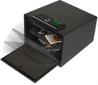
22-Feb-2024 | Magik & Kover Pack and Play Mattresses | Fabric / Textile / Garment / Home Textile | Suffocation Hazard | 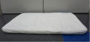
22-Feb-2024 | Spring Spirit and Biloban Pack and Play Mattresses | Fabric / Textile / Garment / Home Textile | Suffocation Hazard | 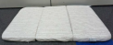  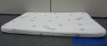
29-Feb-2024 | Family Croquet Sets | Sporting Goods / Equipment | Lead Poisoning Hazard, Health Risk Hazard | 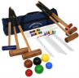  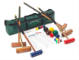
29-Feb-2024 | Charge Stations | Electrical Appliances | Burn Hazard | 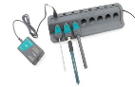
29-Feb-2024 | Vanilla Underground Minecraft TNT Children’s Pajamas | Fabric / Textile / Garment / Home Textile | Burn Hazard, Injury Hazard | 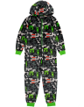
29-Feb-2024 | Mobile Stands for Large Interactive Flat Panel Displays | Household Items | Tip-Over Hazard, Entrapment Hazard | 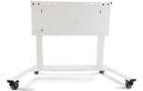
29-Feb-2024 | Children’s Pajama Sets | Fabric / Textile / Garment / Home Textile | Burn Hazard, Injury Hazard | 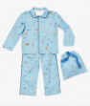
29-Feb-2024 | Hydrogen Peroxide Mouthwash | Bodycare / Cosmetics | Poisoning Hazard, Swallowing Risk | 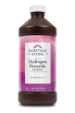  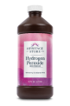
29-Feb-2024 | Bicycles | Sporting Goods / Equipment | Fall Hazard, Injury Hazard | 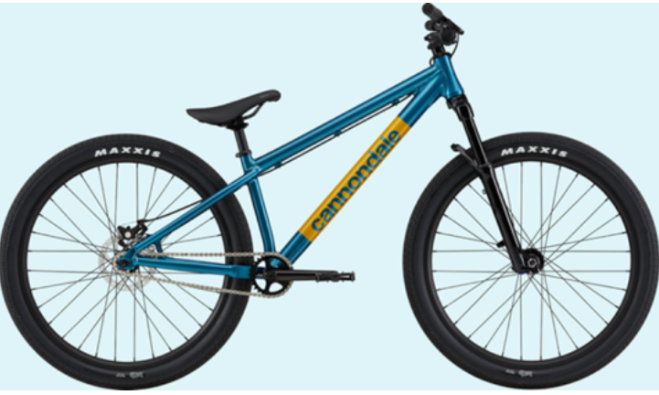
29-Feb-2024 | Children’s Pajamas | Fabric / Textile / Garment / Home Textile | Fall Hazard, Injury Hazard | 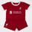  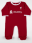  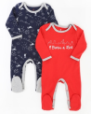  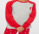  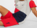  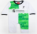  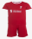  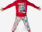
29-Feb-2024 | Portable Tankless Water Heaters | Home Electrical Appliances | Fire Hazard, Risk of Exposure to Combustion Flue Gas | 