Recall Cases Summary – Australia (Last Update Date: 31 March 2024)

Date | Product | Categories | Hazard | Image
1-Mar-2024 | Keji USB Dual Port Wall Charger 2.4A | Electrical Appliances | Injury Hazard, Risk of Death, Electric Shock Hazard | 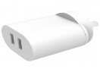  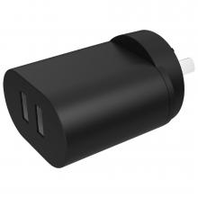
1-Mar-2024 | Comsol 20W USB -C Wall Charger | Electrical Appliances | Injury Hazard, Risk of Death, Electric Shock Hazard | 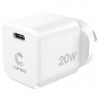
1-Mar-2024 | Comsol Dual Port USB Wall Charger 3.4A/17W | Electrical Appliances | Injury Hazard, Risk of Death, Electric Shock Hazard | 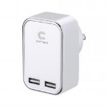
1-Mar-2024 | Cannondale Dave Bicycles & Frames | Sporting Goods / Equipment | Injury Hazard | 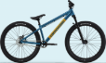
6-Mar-2024 | Comsol 20W Dual Port USB Wall Charger | Electrical Appliances | Injury Hazard, Risk of Death, Electric Shock Hazard | 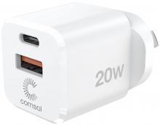
6-Mar-2024 | Comsol 65W 3 Port USB-A/USB-C Laptop GaN Wall Charger | Electrical Appliances | Injury Hazard, Risk of Death, Electric Shock Hazard | 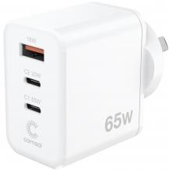
6-Mar-2024 | Comsol 4 Port USB Wall Charger 4.5A | Electrical Appliances | Injury Hazard, Risk of Death, Electric Shock Hazard | 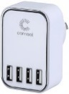
6-Mar-2024 | Comsol 4 Port USB Wall Charger with USB-C 24W White | Electrical Appliances | Injury Hazard, Risk of Death, Electric Shock Hazard | 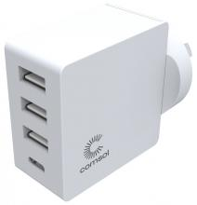
6-Mar-2024 | Laptop AC Adapter | Electrical Appliances | Burn Hazard, Injury Hazard, Risk of Death, Fire Hazard | 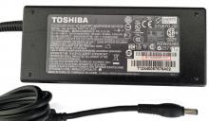
7-Mar-2024 | Hard Hat Attached Electrically Insulated Earmuffs | Protective Equipment | Damage to Hearing | 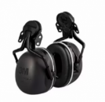  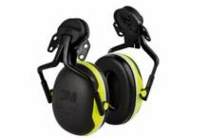
7-Mar-2024 | Earmuffs | Protective Equipment | Damage to Hearing | 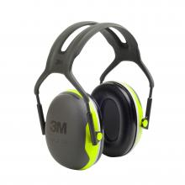
8-Mar-2024 | GT LaBomba Bicycles and Frames | Sporting Goods / Equipment | Injury Hazard | 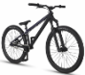  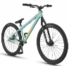  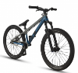
8-Mar-2024 | LED Lanterns with Inbuilt Lithium Battery & 4 Pack U-Lite Varieties | Electrical Appliances | Burn Hazard, Fire Hazard | 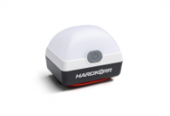  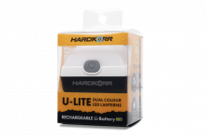
15-Mar-2024 | DIY Nail Art Studio | Bodycare / Cosmetics | Risk of Allergy | 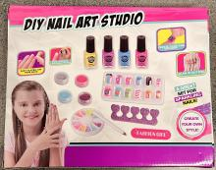
20-Mar-2024 | EGO Power+ Cordless Brushless Hedge Trimmer | Machinery | Laceration Hazard | 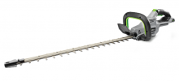
20-Mar-2024 | AC Adaptor PA-10 for Mixer | Electrical Appliances | Electric Shock Hazard, Injury Hazard, Risk of Death | 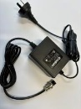
21-Mar-2024 | Revell Reading Glasses with LED Light | Medical Devices | Choking Hazard, Burn Hazard, Risk of Death, Swallowing Risk | 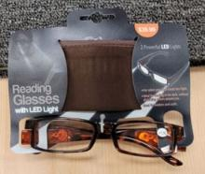
21-Mar-2024 | Novelty Items | Toys and Childcare Products | Choking Hazard, Injury Hazard, Swallowing Risk | 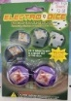  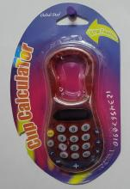  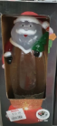
21-Mar-2024 | Complete Balance Conditioner | Bodycare / Cosmetics | Risk of Allergy | 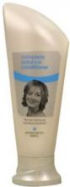
21-Mar-2024 | Sparkle Wings Swimming Circle | Sporting Goods / Equipment | Drowning Hazard | 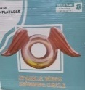
21-Mar-2024 | Sunglasses | Protective Equipment | Damage to Sight | 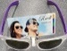  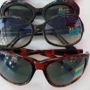  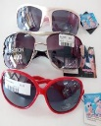  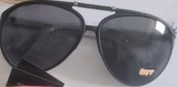  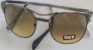  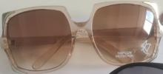  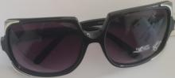  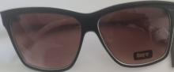  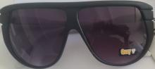  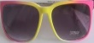  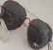
21-Mar-2024 | Adhesive Nail Sets | Bodycare / Cosmetics | Risk of Allergy | 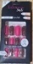  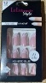  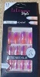  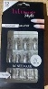  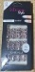  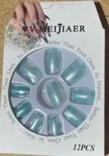  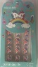  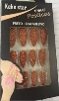
21-Mar-2024 | Cuckoo Air Circulator Pedestal Fan | Home Electrical Appliances | Choking Hazard, Burn Hazard, Risk of Death, Swallowing Risk | 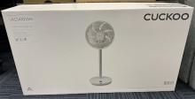
21-Mar-2024 | Little Boys Sleep Twosie | Fabric / Textile / Garment / Home Textile | Burn Hazard | 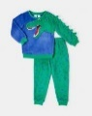
22-Mar-2024 | Novelty Items | Toys and Childcare Products | Choking Hazard, Burn Hazard, Risk of Death, Swallowing Risk | 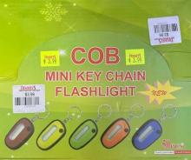  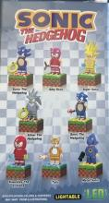
26-Mar-2024 | MagMove 5K Power Bank | Electrical Appliances | Burn Hazard, Fire Hazard | 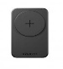  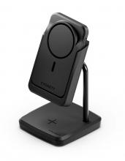  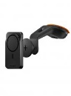
26-Mar-2024 | Novelty Products | Toys and Childcare Products | Choking Hazard, Burn Hazard, Risk of Death, Swallowing Risk | 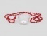  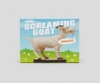  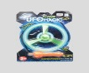  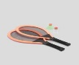  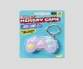  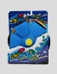  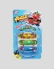  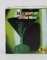  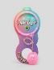  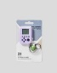  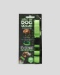  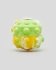  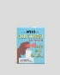  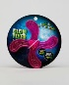  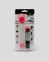  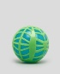  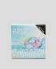  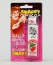  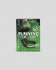  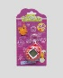  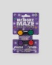  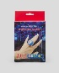
26-Mar-2024 | Novelty Keyrings | Accessories | Choking Hazard, Burn Hazard, Risk of Death, Swallowing Risk | 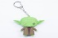  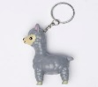  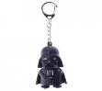  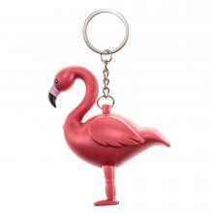  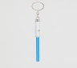  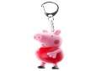  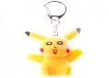  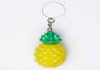  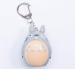  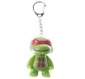  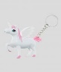  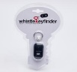  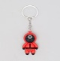  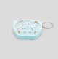  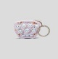  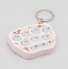  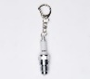
26-Mar-2024 | Novelty Lighting Products | Electrical Appliances | Choking Hazard, Burn Hazard, Risk of Death, Swallowing Risk | 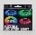  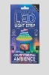  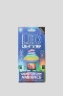  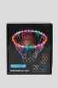  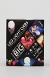  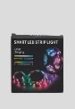  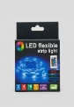  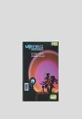  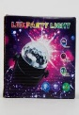  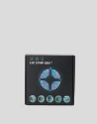  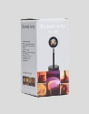  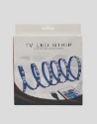
26-Mar-2024 | Coles Assorted Easter Plush Toys | Toys and Childcare Products | Choking Hazard, Suffocation Hazard, Risk of Death | 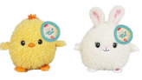  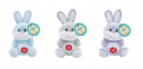
26-Mar-2024 | Digital Notepad and Infinity Colour Pad | Computer / Audio / Video / Other Electronics & Accessories | Choking Hazard, Burn Hazard, Risk of Death, Swallowing Risk | 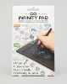  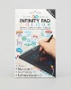
26-Mar-2024 | Crocs Jibbitz Products | Accessories | Choking Hazard, Burn Hazard, Risk of Death, Swallowing Risk | 