Recall Cases Summary – Canada (Last Update Date: 31 March 2024)

Date | Product | Categories | Hazard | Image
6-Mar-2024 | Graphics Processing Unit (GPU) Angled Adapters | Electrical Appliances | Fire Hazard, Burn Hazard | 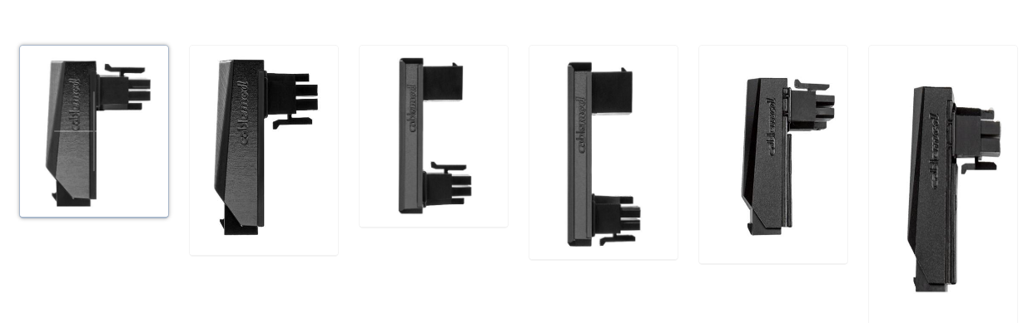  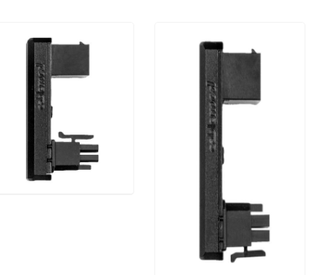
6-Mar-2024 | Travel PD Charger PD+QC3.0 and USB-C 20W Power Adapter | Electrical Appliances | Electric Shock Hazard | 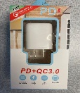  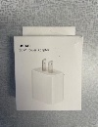
6-Mar-2024 | Baby Einstein Sky Explorers Walkers | Toys and Childcare Products | Injury Hazard, Risk of Death | 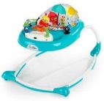
6-Mar-2024 | GT LaBomba Bicycles and Framesets | Sporting Goods / Equipment | Fall Hazard | 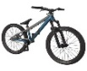  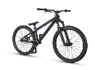  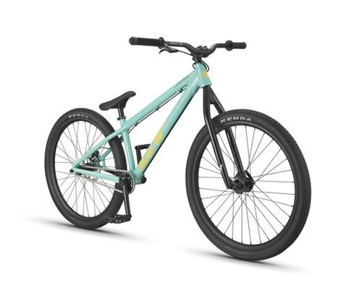
7-Mar-2024 | 2-Piece Tommy Bahama Set (Smiley Crew Neck Long Sleeve with Twill Pant) | Fabric / Textile / Garment / Home Textile | Choking Hazard | 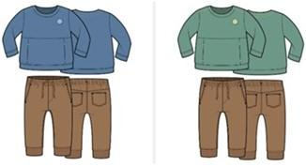
7-Mar-2024 | Tranyoo T-A11 Fast Charger Adapter | Electrical Appliances | Electric Shock Hazard | 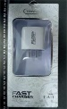  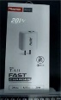
12-Mar-2024 | Shades by Elite Window Fashions | Household Items | Strangulation Hazard, Risk of Death, Choking Hazard | 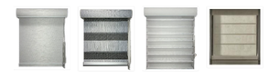
13-Mar-2024 | Starmaker USB Wall Chargers | Electrical Appliances | Electric Shock Hazard, Fire Hazard | 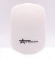  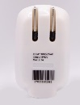  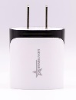  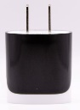
14-Mar-2024 | Insignia™ Digital Air Fryers, Insignia™ Analog Air Fryers and Insignia™ Digital Air Fryer Ovens | Home Electrical Appliances | Fire Hazard, Burn Hazard, Laceration Hazard | 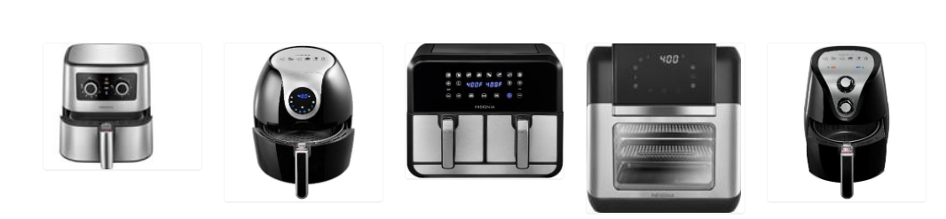
18-Mar-2024 | USB-C 30W Power Charger Adapter | Electrical Appliances | Electric Shock Hazard | 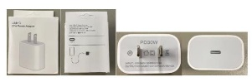
20-Mar-2024 | USB Wall Chargers | Electrical Appliances | Electric Shock Hazard, Fire Hazard | 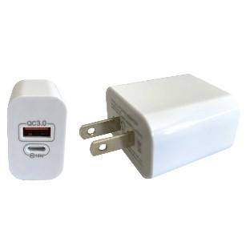
22-Mar-2024 | Elink 2.1A USB Charger | Electrical Appliances | Fire Hazard | 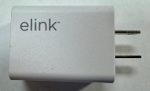
22-Mar-2024 | Shakeel Bhai Mehndi Waley Henna Cones | Bodycare / Cosmetics | Chemical Hazard | 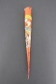  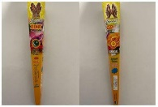  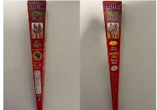
28-Mar-2024 | Vevor Snow Melting Mats | Electrical Appliances | Fire Hazard | 