Recall Cases Summary – China (Last Update Date: 31 March 2024)

 |  | Date | Province | Product | Categories | Hazard | Image
 |  | 6-Mar-2024 | Hebei | Electric Blanket | Home Electrical Appliances | Electric Shock Hazard | /
 |  | 6-Mar-2024 | Hebei | Children's Bicycles | Sporting Goods / Equipment | Safety Risk Hazard | /
 |  | 6-Mar-2024 | Hebei | Children's Bicycles | Sporting Goods / Equipment | Chemical Hazard, Safety Risk Hazard | /
6-Mar-2024 |  |  | Hebei | Children's Scooter | Sporting Goods / Equipment | Safety Risk Hazard | /
6-Mar-2024 |  |  | Hebei | Children's Scooter | Sporting Goods / Equipment | Safety Risk Hazard | /
6-Mar-2024 |  |  | Hebei | Children's Scooter | Sporting Goods / Equipment | Safety Risk Hazard | /
7-Mar-2024 |  |  | Hebei | Children's Bicycles | Sporting Goods / Equipment | Safety Risk Hazard | /
7-Mar-2024 |  |  | Hebei | Children's Bicycles | Sporting Goods / Equipment | Safety Risk Hazard | /
7-Mar-2024 |  |  | Hebei | Children's Bicycles | Sporting Goods / Equipment | Safety Risk Hazard | /
7-Mar-2024 |  |  | Shanghai | Baby Strollers | Toys and Childcare Products | Safety Risk Hazard | 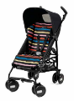
8-Mar-2024 |  |  | Hebei | Children's Bicycles | Sporting Goods / Equipment | Chemical Hazard | /
8-Mar-2024 |  |  | Hebei | Children's Scooters | Sporting Goods / Equipment | Injury Hazard | /
8-Mar-2024 |  |  | Hebei | Children's Scooters | Sporting Goods / Equipment | Safety Risk Hazard | /
8-Mar-2024 |  |  | Hebei | Temperature-Adjustable Electric Blankets | Home Electrical Appliances | Electric Shock Hazard | /
8-Mar-2024 |  |  | Hebei | Children's Bicycles | Sporting Goods / Equipment | Chemical Hazard, Safety Risk Hazard | /
8-Mar-2024 |  |  | Hebei | Children's Bicycles | Sporting Goods / Equipment | Chemical Hazard, Health Risk Hazard | /
8-Mar-2024 |  |  | Hebei | Children's Scooters | Sporting Goods / Equipment | Chemical Hazard, Safety Risk Hazard | /
8-Mar-2024 |  |  | Henan | Electric Blankets | Home Electrical Appliances | Safety Risk Hazard, Fire Hazard | /
12-Mar-2024 |  |  | Jiangsu | Dolls | Toys and Childcare Products | Suffocation Hazard, Ingestion Hazard | 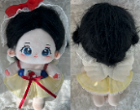
12-Mar-2024 |  |  | Inner Mongolia | Exercise Book | Stationery | Damage to Sight | /
14-Mar-2024 |  |  | Zhejiang | Household Bottled Liquefied Petroleum Gas Pressure Regulators | Tools and Hardware | Risk of Exposure to Combustion Flue Gas | 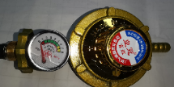
14-Mar-2024 |  |  | Zhejiang | Household Bottled Liquefied Petroleum Gas Pressure Regulators | Tools and Hardware | Risk of Exposure to Combustion Flue Gas | 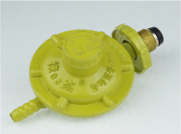
 | 14-Mar-2024 |  | Zhejiang | Household Bottled Liquefied Petroleum Gas Pressure Regulators | Tools and Hardware | Risk of Exposure to Combustion Flue Gas | 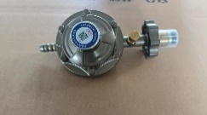
 | 14-Mar-2024 |  | Zhejiang | Stainless Steel Wire Leakage Net | Food Contact Material | Chemical Hazard | 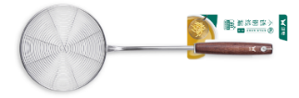
 | 14-Mar-2024 |  | Zhejiang | Household Embedded Gas Stoves | Household Items | Carbon Monoxide Poisoning Hazard | 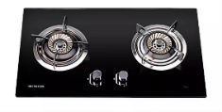
 | 14-Mar-2024 |  | Zhejiang | 304 Stainless Steel Corrugated Hoses for Connecting Gas Appliances | Tools and Hardware | Risk of Exposure to Combustion Flue Gas | 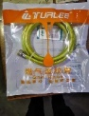
 | 14-Mar-2024 |  | Zhejiang | Peelers | Food Contact Material | Safety Risk Hazard | 
 | 19-Mar-2024 |  | Beijing | Smart Thermostats | Home Electrical Appliances | Electric Shock Hazard | 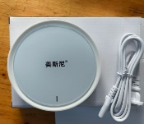
 | 19-Mar-2024 |  | Beijing | Gasoline Additives | Chemicals | Safety Risk Hazard | /
 | 20-Mar-2024 |  | Shanghai | Baby Sleeping Bag with Legs | Fabric / Textile / Garment / Home Textile | Entanglement Hazard | 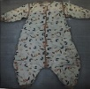  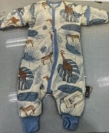
 | 20-Mar-2024 |  | Shanghai | Playmats for Babies | Toys and Childcare Products | Chemical Hazard | 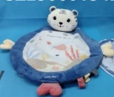
 | 21-Mar-2024 |  | Shanghai | Space Scooters | Sporting Goods / Equipment | Suffocation Hazard, Injury Hazard, Fall Hazard | 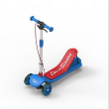
 | 21-Mar-2024 |  | Anhui | Toilet Paper Roll | Household Items | Risk of Allergy | /
 | 21-Mar-2024 |  | Anhui | Air Purifiers | Home Electrical Appliances | Safety Risk Hazard | /
 | 21-Mar-2024 |  | Shandong | Multi-Function Electric Pots | Home Electrical Appliances | Fire Hazard | /
 | 21-Mar-2024 |  | Anhui | Refrigerators | Home Electrical Appliances | Electric Shock Hazard | /
 | 21-Mar-2024 |  | Anhui | Power Adapters | Electrical Appliances | Electric Shock Hazard, Safety Risk Hazard | /
 | 21-Mar-2024 |  | Anhui | Safety Helmets | Protective Equipment | Safety Risk Hazard | /
 | 21-Mar-2024 |  | Anhui | Single-Phase Electric Submersible Pumps | Electrical Appliances | Electric Shock Hazard | /
 | 21-Mar-2024 |  | Anhui | Plastic Storage Boxes | Household Items | Injury Hazard | /
 | 21-Mar-2024 |  | Anhui | Student Uniforms | Fabric / Textile / Garment / Home Textile | Entanglement Hazard, Fall Hazard | /
 | 21-Mar-2024 |  | Anhui | Paper Bowls | Food Contact Material | Burn Hazard | /
 | 21-Mar-2024 |  | Anhui | Chairs | Furniture | Chemical Hazard | /
 | 21-Mar-2024 |  | Shandong | Multi-Function Electric Pot | Home Electrical Appliances | Electric Shock Hazard, Fire Hazard | /
 | 21-Mar-2024 |  | Shandong | Portable Dry Powder Fire Extinguishers | Chemicals | Safety Risk Hazard | /
 | 22-Mar-2024 |  | Anhui | Energy-Efficient Electric Fire Bucket | Home Electrical Appliances | Health Risk Hazard | /
 | 22-Mar-2024 |  | Beijing | Coconut Palm Mattresses | Fabric / Textile / Garment / Home Textile | Laceration Hazard, Suffocation Hazard, Injury Hazard | 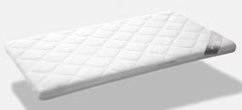
 | 26-Mar-2024 |  | Fujian | Summer School Uniform Trousers | Fabric / Textile / Garment / Home Textile | Strangulation Hazard | 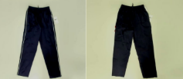
 | 26-Mar-2024 |  | Fujian | Facial Tissues | Household Items | Microbiological Hazard | 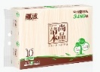
 | 28-Mar-2024 |  | Shanghai | Plush Pendants | Toys and Childcare Products | Choking Hazard, Swallowing Risk | 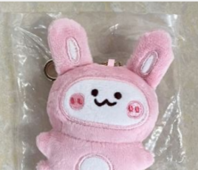
 | 28-Mar-2024 |  | Hunan | Paper Bowls | Food Contact Material | Burn Hazard | 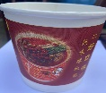
 | 28-Mar-2024 |  | Hunan | Paper Bowls | Food Contact Material | Burn Hazard | 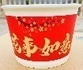
28-Mar-2024 |  |  | Shanghai | Silicone Baby Bottles | Toys and Childcare Products | Swallowing Risk | 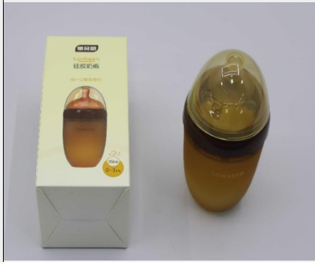
28-Mar-2024 |  |  | Shandong | Multi-Function Electric Pots | Home Electrical Appliances | Electric Shock Hazard, Fire Hazard, Burn Hazard | /
28-Mar-2024 |  |  | Shandong | Multi-Function Electric Pots | Home Electrical Appliances | Fire Hazard, Burn Hazard | /
28-Mar-2024 |  |  | Shandong | Multi-Function Electric Pots | Home Electrical Appliances | Electric Shock Hazard, Fire Hazard, Burn Hazard | /
28-Mar-2024 |  |  | Shandong | Multi-Function Electric Pots | Home Electrical Appliances | Electric Shock Hazard, Fire Hazard, Burn Hazard | /
28-Mar-2024 |  |  | Shandong | Multi-Function Electric Pots | Home Electrical Appliances | Electric Shock Hazard, Safety Risk Hazard | /
28-Mar-2024 |  |  | Shandong | Multi-Function Electric Pots | Home Electrical Appliances | Electric Shock Hazard, Fire Hazard, Burn Hazard | /

