Recall Cases Summary – Canada (Last Update Date: 30 April 2024)

Date | Product | Categories | Hazard | Image
2-Apr-2024 | JURLEA Area Rugs | Fabric / Textile / Garment / Home Textile | Fire Hazard | 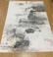  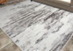
3-Apr-2024 | MX USB & PD Wall Charger | Electrical Appliances | Electric Shock Hazard | 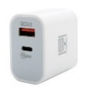
4-Apr-2024 | C2 Detachable Crank Cocking Aid by Excalibur Crossbow Inc. | Tools and Hardware | Impact Hazard | 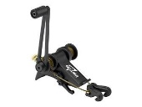
4-Apr-2024 | RideAlong Child Bike Seat | Sporting Goods / Equipment | Chemical Hazard | 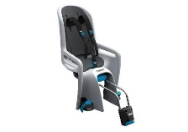
8-Apr-2024 | Berkley Jensen Citronella 72-in. Outdoor Torches | Outdoor Living Items | Burn Hazard, Injury Hazard | 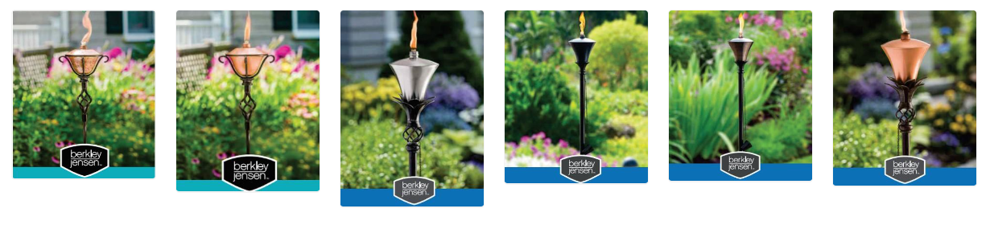
10-Apr-2024 | 2-in-1 Bedside Sleeper & Portable Cradle | Toys and Childcare Products | Entrapment Hazard, Suffocation Hazard | 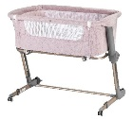  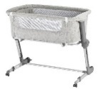
11-Apr-2024 | Yoto Mini Speaker | Computer / Audio / Video / Other Electronics & Accessories | Burn Hazard, Fire Hazard | 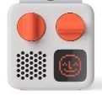
11-Apr-2024 | Delta Cycle Stem Raisers | Tools and Hardware | Fall Hazard, Crash Hazard | 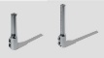  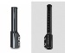
11-Apr-2024 | Kinderfeets Hanging Gym Products | Sporting Goods / Equipment | Fall Hazard | 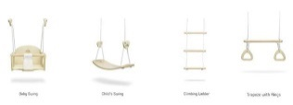
12-Apr-2024 | Turkish Cotton Hooded Terry Kids Bathrobes | Fabric / Textile / Garment / Home Textile | Burn Hazard | 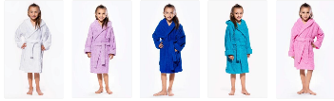
15-Apr-2024 | AGV Tourmodular DOT (E2206) Multi MPLK and Solid MPLK Motorcycle Helmets | Protective Equipment | Injury Hazard, Risk of Death | 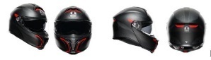  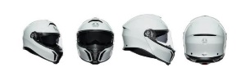
17-Apr-2024 | Vertical Blinds with Split-Draw | Household Items | Strangulation Hazard, Risk of Death | 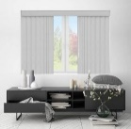
18-Apr-2024 | Yamaha PA-10B AC Power Adapter | Electrical Appliances | Electric Shock Hazard | 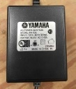
18-Apr-2024 | Gossamer Pro AGX+ Cranksets | Sporting Goods / Equipment | Fall Hazard | 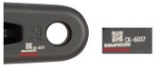  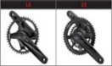
23-Apr-2024 | USB Wall Charger | Electrical Appliances | Electric Shock Hazard | 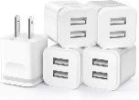
23-Apr-2024 | Vanity LED Wall Lights | Electrical Appliances | Fire Hazard | 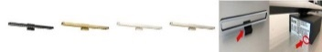
24-Apr-2024 | Shakeel Bhai Mehndi Waley Henna Cones | Bodycare / Cosmetics | Risk of Allergy, Chemical Hazard | 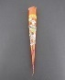  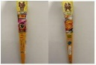  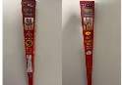
25-Apr-2024 | Log Splitters and Cylinder Kits | Machinery | Injury Hazard | 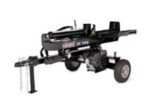
25-Apr-2024 | X4 Series Earmuffs | Protective Equipment | Damage to Hearing | 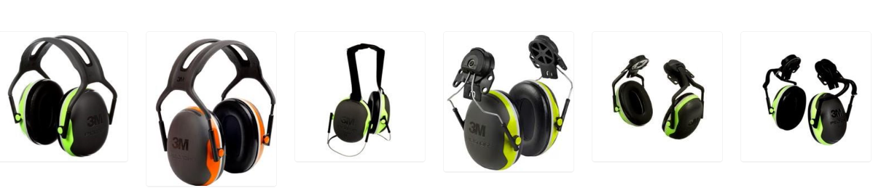
25-Apr-2024 | Crate & Barrel Hampshire Cribs | Toys and Childcare Products | Fall Hazard, Entanglement Hazard | 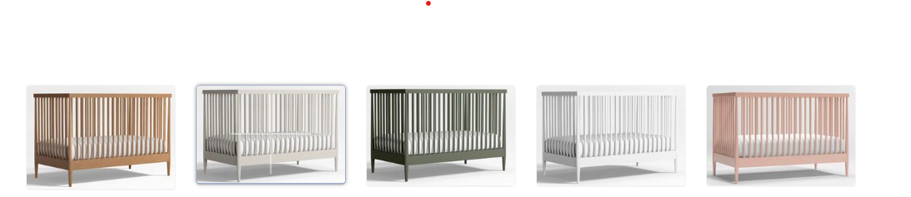
25-Apr-2024 | Big Space Electric Baby Crib Cradle Infant Rocker Auto Swing Bed Baby Cradle | Toys and Childcare Products | Entanglement Hazard, Strangulation Hazard | 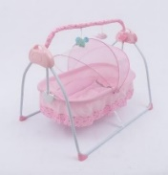
25-Apr-2024 | Children’s Hooded Bathrobe | Fabric / Textile / Garment / Home Textile | Burn Hazard | 