Recall Cases Summary – China (Last Update Date: 30 April 2024)
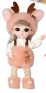
Date | Province | Product | Categories | Hazard | Image
2-Apr-2024 | Shandong | Multi-Function Electric Hot Pots | Home Electrical Appliances | Fire Hazard | /
2-Apr-2024 | Shandong | Multi-Function Electric Hot Pots | Home Electrical Appliances | Fire Hazard | /
2-Apr-2024 | Hebei | Children's Scooters | Toys and Childcare Products | Safety Risk Hazard | /
2-Apr-2024 | Hebei | Children's Bicycles | Toys and Childcare Products | Chemical Hazard | /
2-Apr-2024 | Hebei | Children's Bicycles | Toys and Childcare Products | Chemical Hazard | /
2-Apr-2024 | Hebei | Children's Bicycles | Toys and Childcare Products | Chemical Hazard | /
2-Apr-2024 | Shanghai | AC Power Adapters | Electrical Appliances | Electric Shock Hazard | 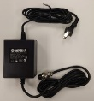
3-Apr-2024 | Hebei | Children's Bicycles | Toys and Childcare Products | Chemical Hazard | /
3-Apr-2024 | Beijing | Interactive Ornament Dolls | Toys and Childcare Products | Suffocation Hazard | 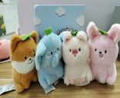
8-Apr-2024 | Shandong | Multi-Function Electric Hot Pots | Home Electrical Appliances | Fire Hazard | /
8-Apr-2024 | Shandong | Heavy Oil Cleaning Agent | Chemicals | Chemical Hazard | /
10-Apr-2024 | Shanghai | Pencil Box Sets for Drawing | Stationery | Laceration Hazard | /
10-Apr-2024 | Guangdong | Gloria Dress-up Toys | Toys and Childcare Products | Suffocation Hazard
10-Apr-2024 | Guangdong | Shoulder-Covered Hip Hoodies | Fabric / Textile / Garment / Home Textile | Swallowing Risk, Suffocation Hazard | 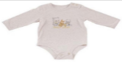
10-Apr-2024 | Guangdong | Puzzle Toys | Toys and Childcare Products | Swallowing Risk, Choking Hazard | 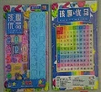
10-Apr-2024 | Guangdong | Electric Toys / Assembled Toys | Toys and Childcare Products | Burn Hazard, Damage to Skin | 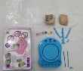
10-Apr-2024 | Guangdong | Remote Control Cars | Toys and Childcare Products | Choking Hazard | /
10-Apr-2024 | Guangdong | Sports Toys | Toys and Childcare Products | Injury Hazard | 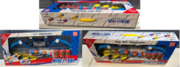
10-Apr-2024 | Guangdong | Puzzle Toys | Toys and Childcare Products | Injury Hazard | 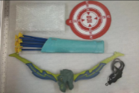
10-Apr-2024 | Guangdong | Magnetic Building Block Toys | Toys and Childcare Products | Suffocation Hazard | 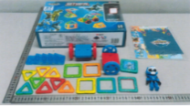
10-Apr-2024 | Guangdong | Educational Toy Cars | Toys and Childcare Products | Injury Hazard | 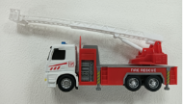
10-Apr-2024 | Guangdong | Toys | Toys and Childcare Products | Safety Risk Hazard | 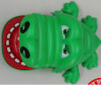
11-Apr-2024 | Shanghai | Frog Swimming Chairs | Sporting Goods / Equipment | Chemical Hazard, Suffocation Hazard | 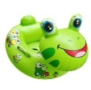
11-Apr-2024 | Henan | Clay Sets | Toys and Childcare Products | Cut Hazard | /
11-Apr-2024 | Shanghai | Cute Pig Swimming Rings | Sporting Goods / Equipment | Chemical Hazard | 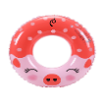  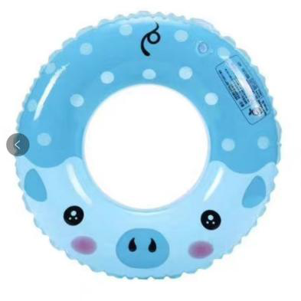
11-Apr-2024 | Henan | Portable Dry Powder Fire Extinguishers | Chemicals | Safety Risk Hazard | /
11-Apr-2024 | Henan | Children's Scooter | Toys and Childcare Products | Chemical Hazard | /
11-Apr-2024 | Hunan | Women’s Shoes | Footwear | Fall Hazard | 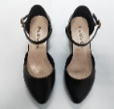
11-Apr-2024 | Hebei | Children's Bicycles | Toys and Childcare Products | Safety Risk Hazard, Chemical Hazard | /
11-Apr-2024 | Hebei | Scooters | Sporting Goods / Equipment | Safety Risk Hazard | /
11-Apr-2024 | Hebei | Children’s Scooters | Toys and Childcare Products | Safety Risk Hazard | /
11-Apr-2024 | Hebei | Toy Scooters | Sporting Goods / Equipment | Safety Risk Hazard | /
11-Apr-2024 | Fujian | Women’s Fashionable Casual Shoes | Footwear | Chemical Hazard | 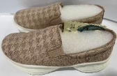
12-Apr-2024 | Shandong | Multi-Function Electric Hot Pot | Home Electrical Appliances | Fire Hazard | /
12-Apr-2024 | Shandong | Multi-Function Electric Hot Pot | Home Electrical Appliances | Electric Shock Hazard, Fire Hazard, Burn Hazard | /
15-Apr-2024 | Shandong | Multi-Function Electric Hot Pot | Home Electrical Appliances | Electric Shock Hazard, Fire Hazard, Burn Hazard | /
15-Apr-2024 | Shandong | Multi-Function Electric Hot Pot | Home Electrical Appliances | Fire Hazard | /
16-Apr-2024 | Hunan | Plastic Cups | Food Contact Material | Burn Hazard | 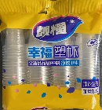
16-Apr-2024 | Inner Mongolia | Story Telling Machine | Toys and Childcare Products | Fire Hazard, Explosion Hazard | /
18-Apr-2024 | Shanghai | Swimming Rings for Children | Sporting Goods / Equipment | Chemical Hazard | 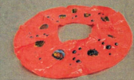
19-Apr-2024 | Hebei | Temperature-Adjustable Electric Blankets | Home Electrical Appliances | Safety Risk Hazard | /
19-Apr-2024 | Hebei | Children's Scooter | Toys and Childcare Products | Fall Hazard | /
19-Apr-2024 | Hebei | Electronic Control Electric Heating Pans | Electrical Appliances | Electric Shock Hazard | /
19-Apr-2024 | Hebei | Temperature-Adjustable Electric Blankets | Home Electrical Appliances | Electric Shock Hazard | /
19-Apr-2024 | Hebei | Children's Bicycle | Toys and Childcare Products | Safety Risk Hazard | /
22-Apr-2024 | Guangdong | Laundry Beads | Chemicals | Ingestion Hazard | /
22-Apr-2024 | Henan | Wavy Soft Ruler Set | Stationery | Chemical Hazard
22-Apr-2024 | Henan | Erasers | Stationery | Chemical Hazard
22-Apr-2024 | Zhejiang | Electric Fans (Circulation Fans) | Home Electrical Appliances | Electric Shock Hazard | 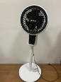
22-Apr-2024 | Zhejiang | Circulation Fans | Home Electrical Appliances | Electric Shock Hazard | 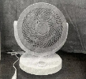
22-Apr-2024 | Zhejiang | Circulation Fans | Home Electrical Appliances | Safety Risk Hazard | 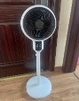
22-Apr-2024 | Zhejiang | LPG Gas Regulator for Household | Tools and Hardware | Safety Risk Hazard | 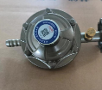
23-Apr-2024 | Guangdong | Shiba Inu Doll with Elk Dressing | Toys and Childcare Products | Suffocation Hazard | 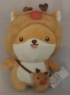
23-Apr-2024 | Guangdong | Multi-Function Food Processors | Home Electrical Appliances | Laceration Hazard | 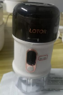
23-Apr-2024 | Guangdong | Mobile Sockets | Electrical Appliances | Electric Shock Hazard, Fire Hazard | 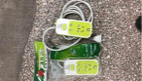
23-Apr-2024 | Guangdong | Food Processors (Babycook) | Home Electrical Appliances | Laceration Hazard | 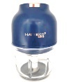
23-Apr-2024 | Guangdong | Toy Cars | Toys and Childcare Products | Puncture Hazard | 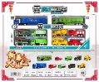
23-Apr-2024 | Guangdong | Projectile Toys Gun | Toys and Childcare Products | Swallowing Risk, Choking Hazard | 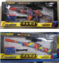
23-Apr-2024 | Guangdong | Projectile Toys Gun | Toys and Childcare Products | Swallowing Risk, Choking Hazard | 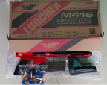
23-Apr-2024 | Guangdong | Ball Pens | Stationery | Chemical Hazard | 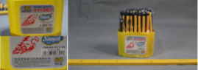
23-Apr-2024 | Zhejiang | Bottled Liquefied Petroleum Gas Pressure Regulators | Tools and Hardware | Risk of Exposure to Combustion Flue Gas | 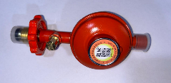
23-Apr-2024 | Anhui | Infant Mattresses | Fabric / Textile / Garment / Home Textile | Entanglement Hazard, Injury Hazard, Swallowing Risk | /
23-Apr-2024 | Anhui | Single Use Bamboo Chopsticks | Food Contact Material | Swallowing Risk, Puncture Hazard | /
23-Apr-2024 | Anhui | Portable Dry Powder Fire Extinguishers | Chemicals | Explosion Hazard, Safety Risk Hazard | /
23-Apr-2024 | Anhui | Student Book Bags | Fabric / Textile / Garment / Home Textile | Chemical Hazard, Health Risk Hazard | /
23-Apr-2024 | Anhui | Heating Pad | Electrical Appliances | Fire Hazard | /
23-Apr-2024 | Anhui | Walking Harness | Toys and Childcare Products | Fall Hazard | /
23-Apr-2024 | Anhui | Household Gas Stoves | Household Items | Risk of Exposure to Combustion Flue Gas | /
23-Apr-2024 | Anhui | English Books | Stationery | Laceration Hazard | /
23-Apr-2024 | Anhui | Men’s Windbreaker | Fabric / Textile / Garment / Home Textile | Health Risk Hazard | /
23-Apr-2024 | Guangdong | Tabletop Game | Toys and Childcare Products | Suffocation Hazard | 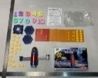
23-Apr-2024 | Guangdong | Crawl and Learn Monkey Toy | Toys and Childcare Products | Suffocation Hazard | 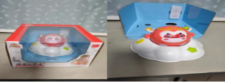
23-Apr-2024 | Guangdong | Remote Control Toys | Toys and Childcare Products | Suffocation Hazard, Swallowing Risk | 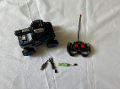
23-Apr-2024 | Guangdong | Interesting Puzzle Toys | Toys and Childcare Products | Suffocation Hazard, Chemical Hazard | 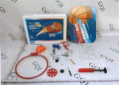
25-Apr-2024 | Hebei | Children's Bicycles | Toys and Childcare Products | Chemical Hazard | /
25-Apr-2024 | Hebei | Children's Scooters | Toys and Childcare Products | Safety Risk Hazard | /
25-Apr-2024 | Hebei | Children's Scooters | Toys and Childcare Products | Safety Risk Hazard | /
25-Apr-2024 | Hebei | Scooters | Sporting Goods / Equipment | Safety Risk Hazard | /
25-Apr-2024 | Hebei | Children's Scooters | Toys and Childcare Products | Safety Risk Hazard | /
26-Apr-2024 | Fujian | Electric Bicycles | Sporting Goods / Equipment | Safety Risk Hazard, Fire Hazard | 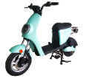
26-Apr-2024 | Inner Mongolia | Vests | Fabric / Textile / Garment / Home Textile | Swallowing Risk, Skin Irritation Risk, Microbiological Hazard | 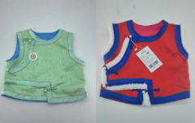
28-Apr-2024 | Shanghai | Coffee Tables | Furniture | Tip-Over Hazard | 
28-Apr-2024 | Shanghai | Electric Bicycles | Sporting Goods / Equipment | Crash Hazard, Electric Shock Hazard, Fire Hazard | 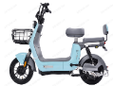  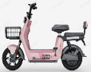
29-Apr-2024 | Henan | Infant Fabric Sandals | Footwear | Chemical Hazard | /
29-Apr-2024 | Henan | Dralon Clothing with Shoulder Button | Fabric / Textile / Garment / Home Textile | Choking Hazard, Suffocation Hazard | /
29-Apr-2024 | Shanxi | Antibacterial Steel Spoons | Food Contact Material | Microbiological Hazard | 