Recall Cases Summary – Europe (Last Update Date: 30 April 2024)

Date | Notifying Country | Product | Categories | Hazard | Image
2-Apr-2024 | France | Toy Make-up Set | Toys and Childcare Products | Chemical Hazard | 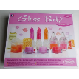
2-Apr-2024 | Germany | USB Charger | Electrical Appliances | Electric Shock Hazard | 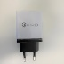  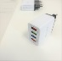
2-Apr-2024 | Germany | Wireless Charger | Electrical Appliances | Burn Hazard | 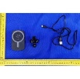
2-Apr-2024 | Poland | Toy Car | Toys and Childcare Products | Environmental Hazard | 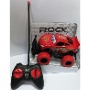
2-Apr-2024 | Lithuania | Children's Puffer Vest | Fabric / Textile / Garment / Home Textile | Injury Hazard, Strangulation Hazard | 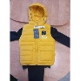
2-Apr-2024 | Lithuania | Toy Telephone | Toys and Childcare Products | Choking Hazard | 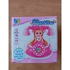
2-Apr-2024 | Poland | Toy Iron | Toys and Childcare Products | Environmental Hazard | 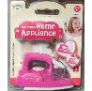
2-Apr-2024 | Slovakia | Attachment for Brush Cutters | Machinery | Injury Hazard | 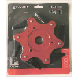
3-Apr-2024 | Germany | Skin-Lightening Lotion | Bodycare / Cosmetics | Chemical Hazard | 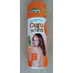
3-Apr-2024 | Lithuania | Disposable Electronic Cigarette | Chemicals | Chemical Hazard | 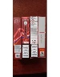
3-Apr-2024 | Finland | Equestrian Helmet | Protective Equipment | Injury Hazard | 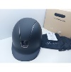
3-Apr-2024 | Poland | Fireworks | Outdoor Living Items | Burn Hazard, Injury Hazard | 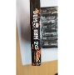
3-Apr-2024 | Poland | Helmet | Protective Equipment | Injury Hazard | 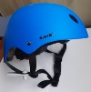
4-Apr-2024 | Germany | Wireless Charger | Electrical Appliances | Burn Hazard | 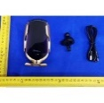
4-Apr-2024 | Poland | Plastic Ball | Toys and Childcare Products | Chemical Hazard | 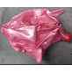
4-Apr-2024 | Finland | Equestrian Helmet | Protective Equipment | Injury Hazard | 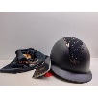
4-Apr-2024 | Lithuania | Plastic Toy | Toys and Childcare Products | Strangulation Hazard | 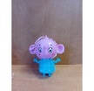
4-Apr-2024 | Ireland | Soother Holder | Toys and Childcare Products | Choking Hazard | 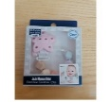
4-Apr-2024 | Spain | Lighting Chain | Electrical Appliances | Burn Hazard, Fire Hazard, Injury Hazard | 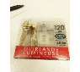
4-Apr-2024 | Czechia | Disposable Electronic Cigarette | Chemicals | Chemical Hazard | 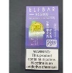
4-Apr-2024 | Belgium | Particle Filter Mask | Protective Equipment | Health Risk Hazard | 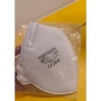
4-Apr-2024 | Finland | Power Adaptor | Electrical Appliances | Electric Shock Hazard | 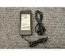
5-Apr-2024 | France | Toy Car | Toys and Childcare Products | Chemical Hazard | 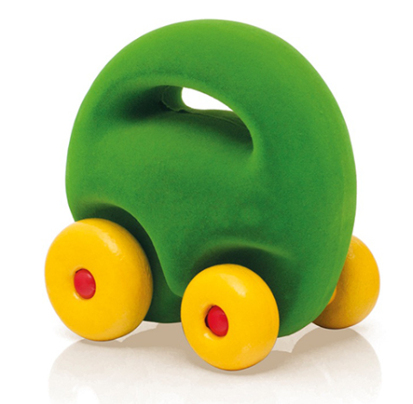
9-Apr-2024 | Czechia | Disposable Electronic Cigarette | Chemicals | Chemical Hazard | 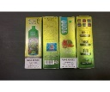
9-Apr-2024 | France | Toy Sword with Battery | Toys and Childcare Products | Chemical Hazard, Choking Hazard | 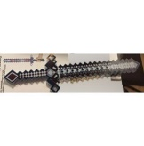
9-Apr-2024 | France | Soft Toy | Toys and Childcare Products | Choking Hazard | 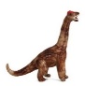
9-Apr-2024 | Ireland | Soft Toys | Toys and Childcare Products | Choking Hazard | 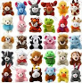
9-Apr-2024 | The Netherlands | Backpack | Fabric / Textile / Garment / Home Textile | Chemical Hazard | 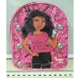
9-Apr-2024 | Italy | Deodorant | Bodycare / Cosmetics | Chemical Hazard | 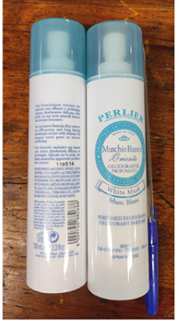
9-Apr-2024 | The Netherlands | Backpack | Fabric / Textile / Garment / Home Textile | Chemical Hazard | 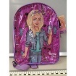
9-Apr-2024 | The Netherlands | Backpack | Fabric / Textile / Garment / Home Textile | Chemical Hazard | 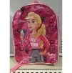
9-Apr-2024 | France | Children's Bath Thermometer | Toys and Childcare Products | Choking Hazard | 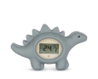
9-Apr-2024 | France | Toy Set | Toys and Childcare Products | Damage to Sight | 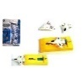
9-Apr-2024 | Sweden | Hand Crank Radio | Computer / Audio / Video / Other Electronics & Accessories | Environmental Hazard | 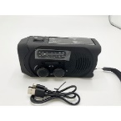
9-Apr-2024 | Sweden | Earrings | Jewelry | Chemical Hazard | 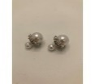
9-Apr-2024 | Sweden | Earrings | Jewelry | Chemical Hazard | 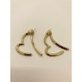
9-Apr-2024 | Germany | Necklace | Jewelry | Chemical Hazard | 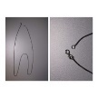
9-Apr-2024 | Sweden | Earrings | Jewelry | Chemical Hazard | 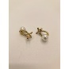
9-Apr-2024 | Sweden | USB Cable | Electrical Appliances | Environmental Hazard | 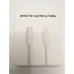
9-Apr-2024 | Sweden | USB Cable | Electrical Appliances | Environmental Hazard | 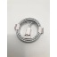
9-Apr-2024 | Lithuania | Legs Spray | Bodycare / Cosmetics | Chemical Hazard | 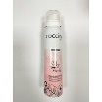
9-Apr-2024 | Lithuania | Perfume | Bodycare / Cosmetics | Chemical Hazard | 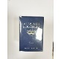
9-Apr-2024 | Lithuania | Perfume | Bodycare / Cosmetics | Chemical Hazard | 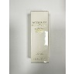
9-Apr-2024 | Lithuania | Face Cream | Bodycare / Cosmetics | Chemical Hazard | 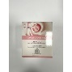
9-Apr-2024 | Poland | Travel Adaptor | Electrical Appliances | Electric Shock Hazard | 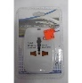
9-Apr-2024 | Czechia | Moisturising Cream | Bodycare / Cosmetics | Chemical Hazard | 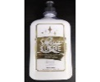
9-Apr-2024 | Italy | Hand Cream | Bodycare / Cosmetics | Chemical Hazard | 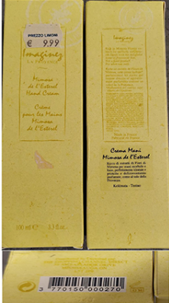
9-Apr-2024 | France | Dinosaur Building Kit | Toys and Childcare Products | Chemical Hazard, Choking Hazard | 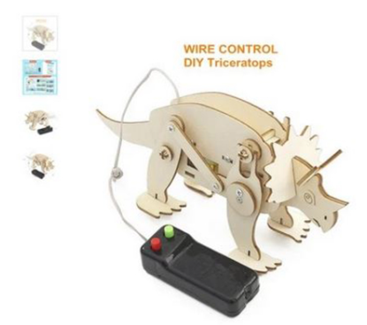
9-Apr-2024 | Denmark | Toy Sword with Battery | Toys and Childcare Products | Choking Hazard | 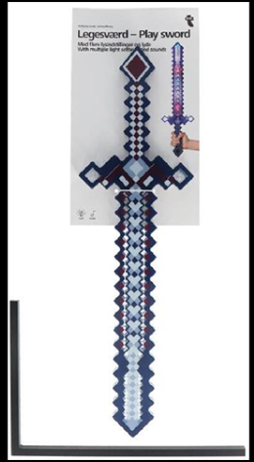
9-Apr-2024 | Croatia | Toy Slime | Toys and Childcare Products | Chemical Hazard | 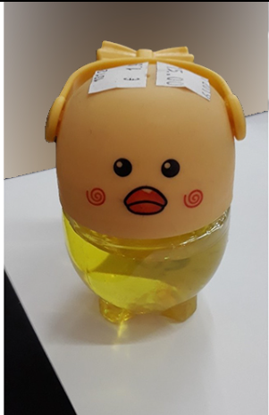
10-Apr-2024 | Ireland | Camping Cooking Pot | Food Contact Material | Burn Hazard | 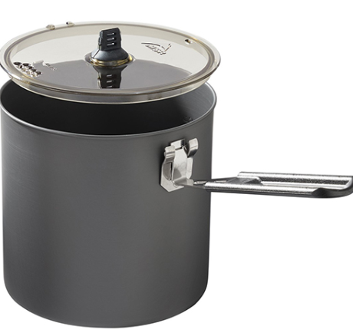  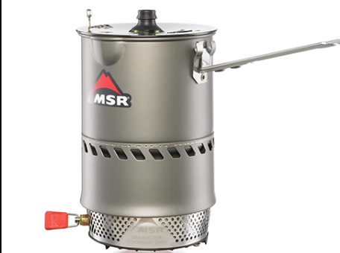
10-Apr-2024 | France | Magnetic Toy | Toys and Childcare Products | Choking Hazard | 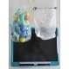
10-Apr-2024 | Sweden | Cleaning Wipes for Stainless Steel | Chemicals | Chemical Hazard | 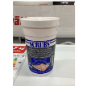
10-Apr-2024 | Sweden | Earrings | Jewelry | Chemical Hazard | 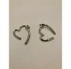
10-Apr-2024 | Sweden | Earrings | Jewelry | Chemical Hazard | 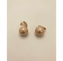
10-Apr-2024 | Sweden | Climbing Arch | Toys and Childcare Products | Injury Hazard | 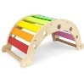
10-Apr-2024 | Poland | Toy Telephone | Toys and Childcare Products | Damage to Hearing | 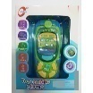
11-Apr-2024 | Spain | Smart Plug | Electrical Appliances | Electric Shock Hazard | 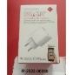
11-Apr-2024 | France | Magnetic Toy | Toys and Childcare Products | Choking Hazard | 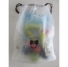
11-Apr-2024 | The Netherlands | Children's Backpack | Fabric / Textile / Garment / Home Textile | Chemical Hazard | 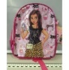
11-Apr-2024 | The Netherlands | Children's Backpack | Fabric / Textile / Garment / Home Textile | Chemical Hazard | 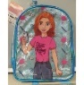
11-Apr-2024 | France | Insecticide | Chemicals | Chemical Hazard | 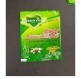
11-Apr-2024 | Ireland | Hair Curler | Electrical Appliances | Electric Shock Hazard | 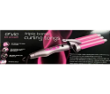
11-Apr-2024 | Ireland | UV Nail Lamp | Electrical Appliances | Electric Shock Hazard | 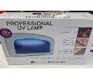
11-Apr-2024 | Sweden | USB Charger | Electrical Appliances | Environmental Hazard | 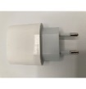
11-Apr-2024 | Sweden | Essential Oil Blend | Chemicals | Chemical Hazard | 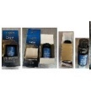
11-Apr-2024 | Sweden | Essential Oil Blend | Chemicals | Chemical Hazard | 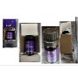
11-Apr-2024 | Sweden | Wireless Speaker | Computer / Audio / Video / Other Electronics & Accessories | Chemical Hazard, Environmental Hazard | 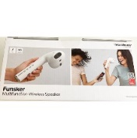
11-Apr-2024 | Sweden | Electric Lighter | Electrical Appliances | Chemical Hazard, Environmental Hazard | 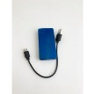
11-Apr-2024 | France | Crimp Beads | Jewelry | Chemical Hazard | 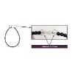  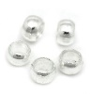
11-Apr-2024 | Croatia | Soft Toy | Toys and Childcare Products | Choking Hazard | 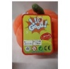
11-Apr-2024 | Czechia | Shower Cream | Bodycare / Cosmetics | Chemical Hazard | 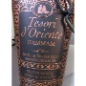
11-Apr-2024 | Czechia | Plastic Doll | Toys and Childcare Products | Chemical Hazard | 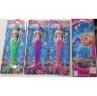
11-Apr-2024 | Czechia | Shampoo | Bodycare / Cosmetics | Chemical Hazard | 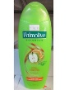
11-Apr-2024 | Czechia | Shampoo | Bodycare / Cosmetics | Chemical Hazard | 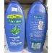
11-Apr-2024 | Czechia | Shampoo | Bodycare / Cosmetics | Chemical Hazard | 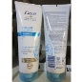
11-Apr-2024 | Poland | Set of Toy Musical Instruments | Toys and Childcare Products | Choking Hazard, Strangulation Hazard | 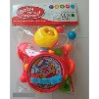
11-Apr-2024 | Hungary | Multiplug Socket | Electrical Appliances | Electric Shock Hazard | 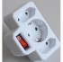
11-Apr-2024 | Hungary | Plastic Doll | Toys and Childcare Products | Chemical Hazard | 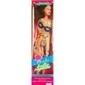
11-Apr-2024 | Hungary | Plastic Doll | Toys and Childcare Products | Chemical Hazard | 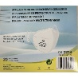  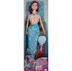
12-Apr-2024 | Belgium | Particle Filter Mask | Protective Equipment | Health Risk Hazard
12-Apr-2024 | Finland | Water Balloons | Toys and Childcare Products | Choking Hazard, Injury Hazard | 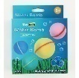
16-Apr-2024 | Romania | Eau De Toilette | Bodycare / Cosmetics | Chemical Hazard | 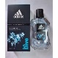
16-Apr-2024 | Romania | Shower Cream | Bodycare / Cosmetics | Chemical Hazard | 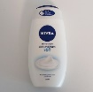
16-Apr-2024 | Romania | Soap | Bodycare / Cosmetics | Chemical Hazard | 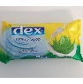
16-Apr-2024 | Romania | Liquid Soap | Bodycare / Cosmetics | Chemical Hazard | 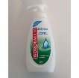
16-Apr-2024 | France | Toy Tambourine | Toys and Childcare Products | Choking Hazard, Injury Hazard | 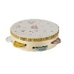
16-Apr-2024 | France | Apron | Fabric / Textile / Garment / Home Textile | Chemical Hazard | 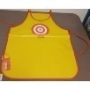
16-Apr-2024 | Poland | Fireworks | Outdoor Living Items | Burn Hazard, Injury Hazard | 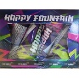
16-Apr-2024 | Lithuania | USB Charger | Electrical Appliances | Electric Shock Hazard | 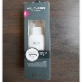
16-Apr-2024 | Czechia | Deodorant | Bodycare / Cosmetics | Chemical Hazard | 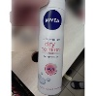
16-Apr-2024 | Hungary | Children's Shoes | Footwear | Choking Hazard | 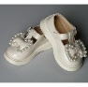
17-Apr-2024 | Germany | Children's Wireless Headphone | Toys and Childcare Products | Chemical Hazard | 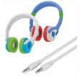
17-Apr-2024 | Sweden | Essential Oil | Chemicals | Chemical Hazard | 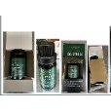
17-Apr-2024 | Poland | Toy Boat | Toys and Childcare Products | Environmental Hazard | 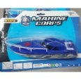
17-Apr-2024 | Hungary | Toy Scooter | Toys and Childcare Products | Injury Hazard | 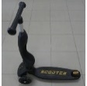
17-Apr-2024 | Sweden | Charging Station | Electrical Appliances | Environmental Hazard | 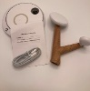
17-Apr-2024 | Hungary | Soft Toy Set | Toys and Childcare Products | Chemical Hazard | 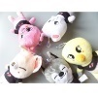
17-Apr-2024 | Sweden | Cat Toy | Pet Items | Environmental Hazard | 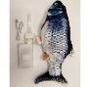
17-Apr-2024 | Sweden | Toy Boat | Toys and Childcare Products | Environmental Hazard | 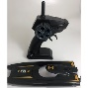
18-Apr-2024 | Sweden | Magnifier Glass | Electrical Appliances | Chemical Hazard, Environmental Hazard | 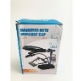
18-Apr-2024 | Sweden | Headlight | Sporting Goods / Equipment | Chemical Hazard, Environmental Hazard | 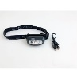
18-Apr-2024 | Germany | Squeezable Toy | Toys and Childcare Products | Microbiological Hazard | 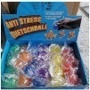
18-Apr-2024 | Czechia | Hair Gel | Bodycare / Cosmetics | Chemical Hazard | 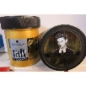
18-Apr-2024 | Hungary | Electric Chainsaw | Machinery | Cut Hazard, Injury Hazard | 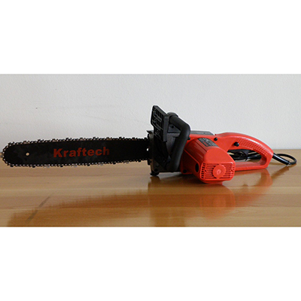
18-Apr-2024 | Hungary | Plastic Doll Set | Toys and Childcare Products | Chemical Hazard | 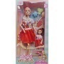
18-Apr-2024 | Hungary | Plastic Doll | Toys and Childcare Products | Chemical Hazard | 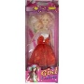
18-Apr-2024 | Sweden | Cable Adaptor | Electrical Appliances | Environmental Hazard | 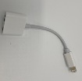
18-Apr-2024 | Sweden | USB Adaptor | Electrical Appliances | Environmental Hazard | 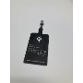
18-Apr-2024 | Sweden | Wireless Charger | Electrical Appliances | Environmental Hazard | 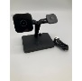
18-Apr-2024 | Sweden | Charging Station | Electrical Appliances | Environmental Hazard | 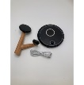
19-Apr-2024 | Sweden | Earrings | Jewelry | Chemical Hazard | 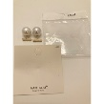
19-Apr-2024 | France | Soft Toy | Toys and Childcare Products | Choking Hazard | 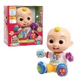
19-Apr-2024 | Germany | Soap | Bodycare / Cosmetics | Chemical Hazard | 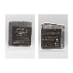
19-Apr-2024 | Hungary | Perfume | Bodycare / Cosmetics | Chemical Hazard | 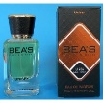
19-Apr-2024 | Sweden | Bluetooth Speaker with Projector | Computer / Audio / Video / Other Electronics & Accessories | Chemical Hazard, Environmental Hazard | 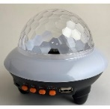
19-Apr-2024 | Poland | Plastic Ball | Toys and Childcare Products | Chemical Hazard | 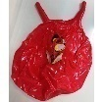
19-Apr-2024 | Poland | Plastic Ball | Toys and Childcare Products | Chemical Hazard | 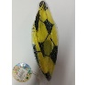
19-Apr-2024 | Czechia | Shampoo | Bodycare / Cosmetics | Chemical Hazard | 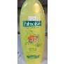
19-Apr-2024 | Czechia | Shower Gel | Bodycare / Cosmetics | Chemical Hazard | 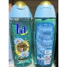
19-Apr-2024 | Czechia | Shampoo | Bodycare / Cosmetics | Chemical Hazard | 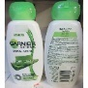
19-Apr-2024 | Czechia | Lighting Chain | Electrical Appliances | Electric Shock Hazard | 
19-Apr-2024 | Czechia | Lighting Chain | Electrical Appliances | Electric Shock Hazard | 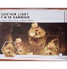
22-Apr-2024 | The Netherlands | Fireworks | Outdoor Living Items | Burn Hazard, Damage to Hearing, Injury Hazard | 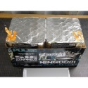
22-Apr-2024 | Germany | Electric Lunch Box | Electrical Appliances | Electric Shock Hazard | 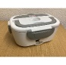
22-Apr-2024 | Finland | Ring Set | Jewelry | Chemical Hazard, Environmental Hazard | 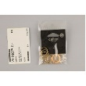
23-Apr-2024 | France | Plastic Bath Toy Set | Toys and Childcare Products | Choking Hazard | 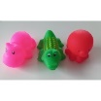
23-Apr-2024 | Denmark | Attachment for Brush Cutter | Machinery | Injury Hazard | 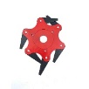
23-Apr-2024 | Denmark | Attachment for Brush Cutter | Machinery | Injury Hazard | 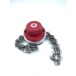
23-Apr-2024 | Sweden | LED Remote Control | Electrical Appliances | Environmental Hazard | 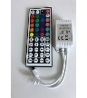
23-Apr-2024 | Sweden | Cable | Electrical Appliances | Environmental Hazard | 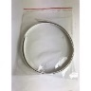
23-Apr-2024 | Sweden | Mini Drone | Electrical Appliances | Environmental Hazard | 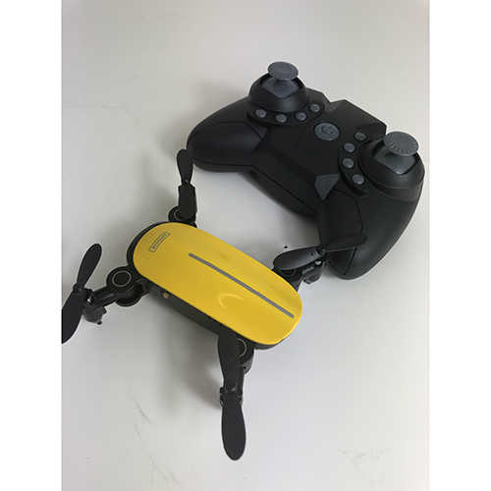
23-Apr-2024 | Czechia | Hand Gel | Bodycare / Cosmetics | Chemical Hazard | 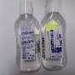
23-Apr-2024 | Czechia | Shower Gel | Bodycare / Cosmetics | Chemical Hazard | 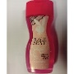
23-Apr-2024 | Czechia | Shower Gel | Bodycare / Cosmetics | Chemical Hazard | 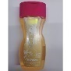
23-Apr-2024 | Czechia | Body Lotion | Bodycare / Cosmetics | Chemical Hazard | 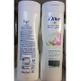
23-Apr-2024 | Czechia | Hair Gel | Bodycare / Cosmetics | Chemical Hazard | 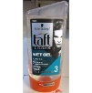
23-Apr-2024 | Czechia | Shower Gel | Bodycare / Cosmetics | Chemical Hazard | 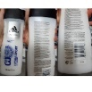
23-Apr-2024 | Czechia | Shower Gel | Bodycare / Cosmetics | Chemical Hazard | 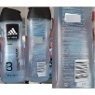
23-Apr-2024 | Czechia | Eau De Toilette | Bodycare / Cosmetics | Chemical Hazard | 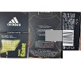
23-Apr-2024 | Czechia | Shower Gel | Bodycare / Cosmetics | Chemical Hazard | 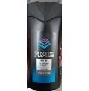
23-Apr-2024 | Lithuania | Wooden Toy | Toys and Childcare Products | Choking Hazard | 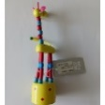
23-Apr-2024 | Czechia | Shower Gel | Bodycare / Cosmetics | Chemical Hazard | 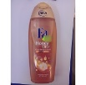
23-Apr-2024 | Czechia | Perfume | Bodycare / Cosmetics | Chemical Hazard | 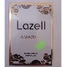
23-Apr-2024 | Romania | Perfume | Bodycare / Cosmetics | Chemical Hazard | 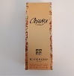
23-Apr-2024 | Romania | Perfume | Bodycare / Cosmetics | Chemical Hazard | 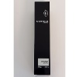
23-Apr-2024 | Romania | Perfume | Bodycare / Cosmetics | Chemical Hazard | 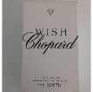
23-Apr-2024 | Romania | Eau De Toilette | Bodycare / Cosmetics | Chemical Hazard | 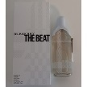
23-Apr-2024 | Romania | Perfume | Bodycare / Cosmetics | Chemical Hazard | 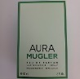
24-Apr-2024 | Czechia | Shampoo | Bodycare / Cosmetics | Chemical Hazard | 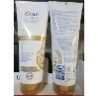
24-Apr-2024 | Belgium | Children's Jacket | Fabric / Textile / Garment / Home Textile | Entrapment Hazard, Injury Hazard, Strangulation Hazard | 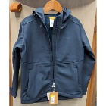
24-Apr-2024 | Norway | Skin Serum | Bodycare / Cosmetics | Chemical Hazard | 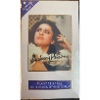
24-Apr-2024 | Norway | Skin Cream | Bodycare / Cosmetics | Chemical Hazard | 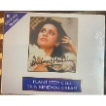
24-Apr-2024 | Norway | Skin Mask | Bodycare / Cosmetics | Chemical Hazard | 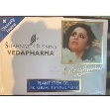
24-Apr-2024 | Lithuania | Car Windscreen Washing Fluid | Chemicals | Chemical Hazard | 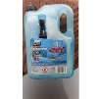
25-Apr-2024 | The Netherlands | Fireworks | Outdoor Living Items | Burn Hazard, Injury Hazard | 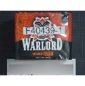
25-Apr-2024 | The Netherlands | Fireworks | Outdoor Living Items | Burn Hazard, Damage to Hearing, Injury Hazard | 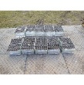
25-Apr-2024 | France | LED Balloons | Toys and Childcare Products | Chemical Hazard, Choking Hazard | 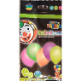
25-Apr-2024 | Germany | Plastic Ball Set | Toys and Childcare Products | Chemical Hazard | 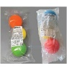
25-Apr-2024 | Czechia | Pest Control Product | Chemicals | Chemical Hazard | 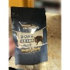
25-Apr-2024 | Cyprus | Toy Gun Set | Toys and Childcare Products | Choking Hazard | 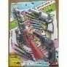
25-Apr-2024 | Czechia | Pest Control Product | Chemicals | Chemical Hazard | 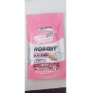
25-Apr-2024 | Sweden | Nightlamp | Home Electrical Appliances | Chemical Hazard, Environmental Hazard | 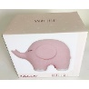
25-Apr-2024 | Croatia | Pendant | Jewelry | Chemical Hazard, Environmental Hazard | 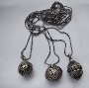
25-Apr-2024 | Estonia | Mixture for Permanent Makeup | Chemicals | Chemical Hazard | 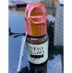
25-Apr-2024 | Sweden | LED Strip Lights | Electrical Appliances | Chemical Hazard, Environmental Hazard | 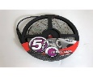
25-Apr-2024 | Poland | Plastic Ball | Toys and Childcare Products | Chemical Hazard | 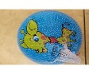
25-Apr-2024 | Germany | Motorcycle Top Box | Car Accessories | Injury Hazard | 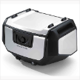
25-Apr-2024 | Lithuania | Glue | Chemicals | Chemical Hazard | 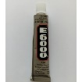
25-Apr-2024 | Poland | Plastic Toy | Toys and Childcare Products | Chemical Hazard | 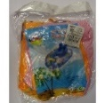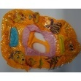
25-Apr-2024 | Czechia | Shower Gel | Bodycare / Cosmetics | Chemical Hazard | 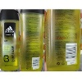
25-Apr-2024 | Czechia | After-Shave Lotion | Bodycare / Cosmetics | Chemical Hazard | 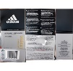
25-Apr-2024 | Germany | Body Powder | Bodycare / Cosmetics | Chemical Hazard | 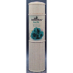
25-Apr-2024 | France | Keyring with Soft Toy | Toys and Childcare Products | Choking Hazard | 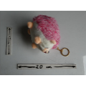
25-Apr-2024 | France | Soft Toy | Toys and Childcare Products | Choking Hazard | 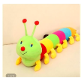
25-Apr-2024 | Germany | Massage Balls | Toys and Childcare Products | Chemical Hazard | 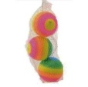
25-Apr-2024 | Lithuania | Children's Hoodie | Fabric / Textile / Garment / Home Textile | Injury Hazard, Strangulation Hazard | 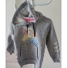
25-Apr-2024 | France | Pencil | Stationery | Choking Hazard | 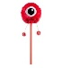
25-Apr-2024 | Sweden | Charger | Electrical Appliances | Environmental Hazard | 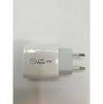
25-Apr-2024 | Sweden | USB Cable | Electrical Appliances | Environmental Hazard | 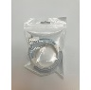
25-Apr-2024 | Sweden | USB Cable | Electrical Appliances | Environmental Hazard | 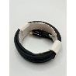
25-Apr-2024 | Romania | Perfume | Bodycare / Cosmetics | Chemical Hazard | 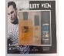
25-Apr-2024 | Romania | Eau De Toilette | Bodycare / Cosmetics | Chemical Hazard | 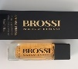
25-Apr-2024 | Romania | Cleansing Milk | Bodycare / Cosmetics | Chemical Hazard | 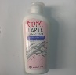
25-Apr-2024 | Hungary | Perfume | Bodycare / Cosmetics | Chemical Hazard | 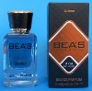
26-Apr-2024 | Ireland | Bath Screen | Household Items | Injury Hazard | 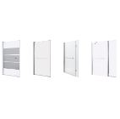
26-Apr-2024 | Czechia | Shower Gel | Bodycare / Cosmetics | Chemical Hazard | 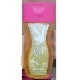
26-Apr-2024 | Czechia | Shampoo | Bodycare / Cosmetics | Chemical Hazard | 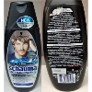
26-Apr-2024 | Czechia | Hair Gel | Bodycare / Cosmetics | Chemical Hazard | 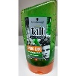
26-Apr-2024 | Czechia | Hair Dye | Bodycare / Cosmetics | Chemical Hazard | 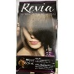
26-Apr-2024 | Cyprus | Toy Set | Toys and Childcare Products | Choking Hazard | 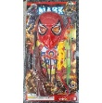
30-Apr-2024 | Sweden | LED Projector | Electrical Appliances | Environmental Hazard | 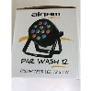
30-Apr-2024 | France | Nesting Toy Dolls | Toys and Childcare Products | Choking Hazard | 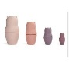  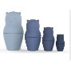
30-Apr-2024 | France | Changing Table | Toys and Childcare Products | Entrapment Hazard | 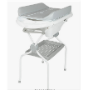
30-Apr-2024 | France | Toy Gun | Toys and Childcare Products | Injury Hazard | 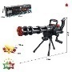
30-Apr-2024 | France | Soft Toy | Toys and Childcare Products | Choking Hazard | 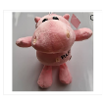
30-Apr-2024 | Estonia | Magnetic Toy | Toys and Childcare Products | Injury Hazard | 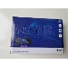
30-Apr-2024 | Germany | Electric Lunch Box | Electrical Appliances | Electric Shock Hazard | 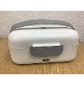
30-Apr-2024 | Germany | Particle Filter Mask | Protective Equipment | Health Risk Hazard | 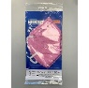
30-Apr-2024 | Germany | Disposable Electronic Cigarette | Chemicals | Chemical Hazard | 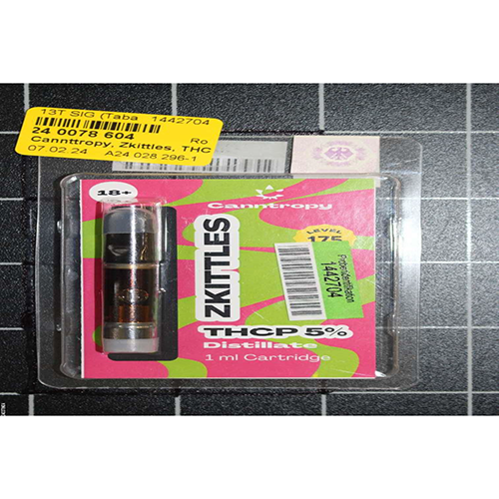  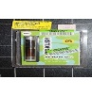
30-Apr-2024 | Czechia | Hairspray | Bodycare / Cosmetics | Chemical Hazard | 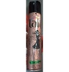
30-Apr-2024 | Czechia | Hair Dye | Bodycare / Cosmetics | Chemical Hazard | 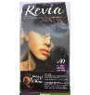
30-Apr-2024 | Czechia | Hair Dye | Bodycare / Cosmetics | Chemical Hazard | 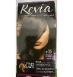
30-Apr-2024 | Lithuania | Children's Sweatpants | Fabric / Textile / Garment / Home Textile | Injury Hazard | 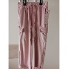
30-Apr-2024 | France | Soft Toy with Keyring | Toys and Childcare Products | Choking Hazard, Suffocation Hazard | 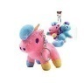
30-Apr-2024 | Czechia | Plastic Doll | Toys and Childcare Products | Chemical Hazard | 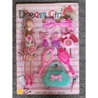
30-Apr-2024 | Czechia | Lighting Chain | Electrical Appliances | Electric Shock Hazard | 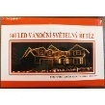
30-Apr-2024 | Czechia | Pest Control Product | Chemicals | Chemical Hazard | 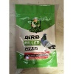
30-Apr-2024 | Czechia | Pest Control Product | Chemicals | Chemical Hazard | 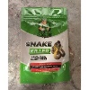
30-Apr-2024 | Lithuania | Extension Cord | Electrical Appliances | Electric Shock Hazard | 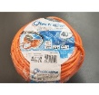
30-Apr-2024 | Poland | Baby Sleeping Bag | Fabric / Textile / Garment / Home Textile | Suffocation Hazard | 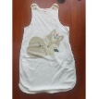
30-Apr-2024 | Germany | Soap | Bodycare / Cosmetics | Chemical Hazard | 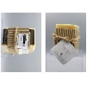
30-Apr-2024 | Czechia | Disposable Electronic Cigarette | Chemicals | Chemical Hazard | 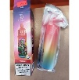
30-Apr-2024 | Czechia | Liquid Hand Soap | Bodycare / Cosmetics | Chemical Hazard | 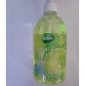
30-Apr-2024 | Czechia | Hair Dye | Bodycare / Cosmetics | Chemical Hazard | 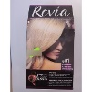
30-Apr-2024 | Lithuania | Plastic Bath Toy Set | Toys and Childcare Products | Choking Hazard | 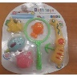
30-Apr-2024 | Czechia | Shower Gel | Bodycare / Cosmetics | Chemical Hazard | 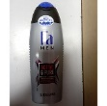
30-Apr-2024 | Lithuania | USB Charger | Electrical Appliances | Electric Shock Hazard | 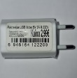
30-Apr-2024 | Czechia | Disposable Electronic Cigarette | Chemicals | Chemical Hazard | 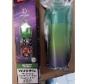
30-Apr-2024 | Romania | Lighting Chain | Electrical Appliances | Electric Shock Hazard | 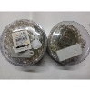
30-Apr-2024 | Czechia | Disposable Electronic Cigarette | Chemicals | Chemical Hazard | 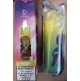
30-Apr-2024 | Czechia | Disposable Electronic Cigarette | Chemicals | Chemical Hazard | 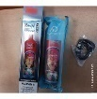
30-Apr-2024 | Czechia | After-Shave Lotion | Bodycare / Cosmetics | Chemical Hazard | 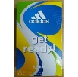
30-Apr-2024 | Czechia | Shower Gel | Bodycare / Cosmetics | Chemical Hazard | 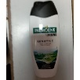
30-Apr-2024 | Czechia | Shower Gel | Bodycare / Cosmetics | Chemical Hazard | 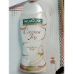
30-Apr-2024 | Lithuania | Toy Rattles | Toys and Childcare Products | Choking Hazard | 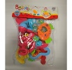
30-Apr-2024 | Czechia | Shower Gel | Bodycare / Cosmetics | Chemical Hazard | 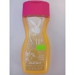
30-Apr-2024 | Czechia | Shower Gel | Bodycare / Cosmetics | Chemical Hazard | 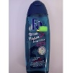
30-Apr-2024 | Hungary | Perfume | Bodycare / Cosmetics | Chemical Hazard | 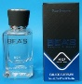
30-Apr-2024 | Romania | Soap | Bodycare / Cosmetics | Chemical Hazard | 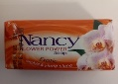
30-Apr-2024 | Romania | Perfume | Bodycare / Cosmetics | Chemical Hazard | 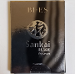
30-Apr-2024 | Sweden | Power Bank | Electrical Appliances | Environmental Hazard | 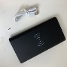
30-Apr-2024 | Czechia | Pest Control Product | Chemicals | Chemical Hazard | 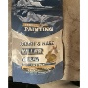
30-Apr-2024 | Czechia | Pest Control Product | Chemicals | Chemical Hazard | 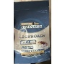
30-Apr-2024 | Romania | Perfume | Bodycare / Cosmetics | Chemical Hazard | 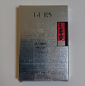
30-Apr-2024 | Sweden | Emergency Crank Radio | Electrical Appliances | Environmental Hazard | 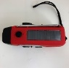
30-Apr-2024 | Czechia | Pest Control Product | Chemicals | Chemical Hazard | 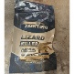
30-Apr-2024 | Hungary | Perfume | Bodycare / Cosmetics | Chemical Hazard | 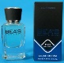
30-Apr-2024 | Hungary | Perfume | Bodycare / Cosmetics | Chemical Hazard | 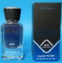
30-Apr-2024 | Sweden | Thinner | Chemicals | Chemical Hazard | 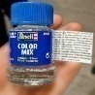
30-Apr-2024 | Lithuania | Hair Mask | Bodycare / Cosmetics | Chemical Hazard | 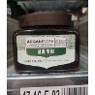
30-Apr-2024 | Romania | Hand Mixer | Home Electrical Appliances | Burn Hazard | 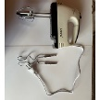
30-Apr-2024 | Romania | Immersion Electric Water Heater | Home Electrical Appliances | Electric Shock Hazard | 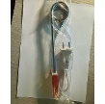
30-Apr-2024 | Lithuania | Doll | Toys and Childcare Products | Chemical Hazard | 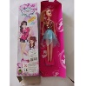
30-Apr-2024 | Romania | Hair Straighteners | Home Electrical Appliances | Electric Shock Hazard | 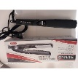
30-Apr-2024 | Romania | Perfume and Deodorant | Bodycare / Cosmetics | Chemical Hazard | 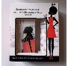
30-Apr-2024 | Romania | Hair Trimmer | Electrical Appliances | Electric Shock Hazard | 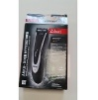
30-Apr-2024 | Romania | Lighting Chain | Electrical Appliances | Electric Shock Hazard | 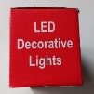
30-Apr-2024 | Lithuania | Eye Lift Gel | Bodycare / Cosmetics | Chemical Hazard | 