Recall Cases Summary – US (Last Update Date: 30 April 2024)

Date | Product | Categories | Hazard | Image
4-Apr-2024 | RideAlong Rear-Mounted Child Bike Seats | Sporting Goods / Equipment | Chemical Hazard | 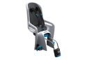
4-Apr-2024 | Children’s Pajamas | Fabric / Textile / Garment / Home Textile | Burn Hazard, Injury Hazard | 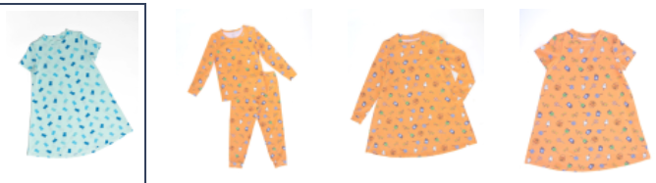  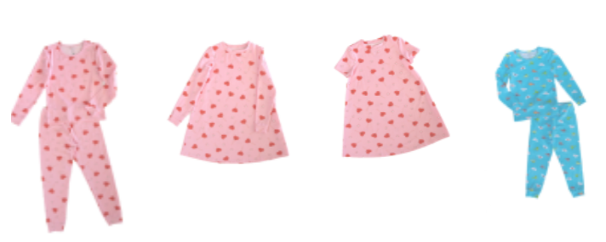  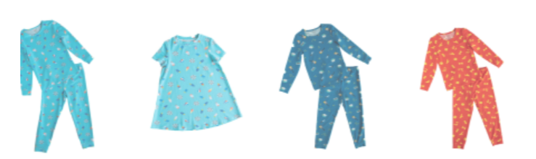
4-Apr-2024 | Mainstays Electric Mini Choppers | Food Contact Material | Laceration Hazard | 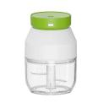
4-Apr-24 | Adult Portable Bed Rails | Furniture | Entrapment Hazard, Risk of Death, Suffocation Hazard | 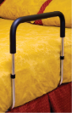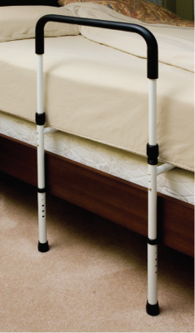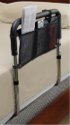
4-Apr-2024 | C2 Crank Cocking Aids for Excalibur Crossbows | Sporting Goods / Equipment | Impact Injury, Laceration Hazard | 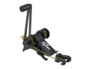
4-Apr-2024 | Garment Steamers | Home Electrical Appliances | Burn Hazard | 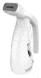  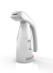  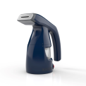
4-Apr-2024 | Grão de Gente Crib Bumpers | Toys and Childcare Products | Suffocation Hazard |       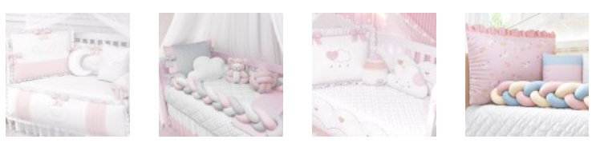  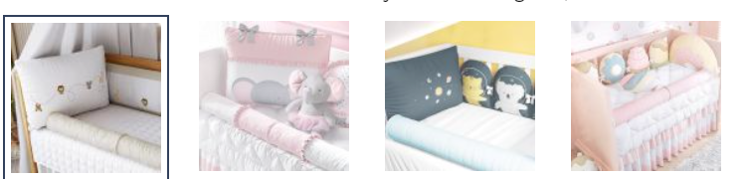  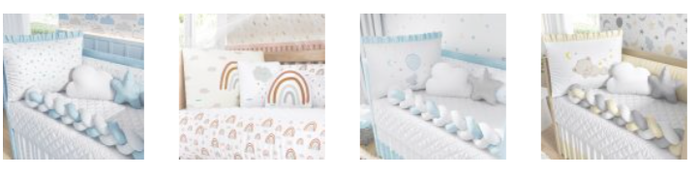    
4-Apr-2024 | Grão de Gente Baby Nests | Toys and Childcare Products | Suffocation Hazard, Fall Hazard, Entrapment Hazard | 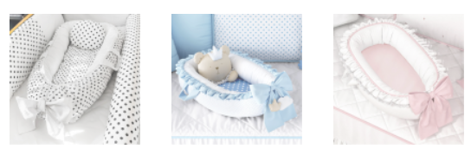  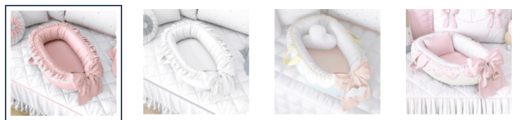  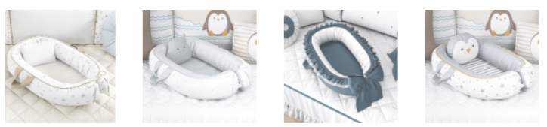    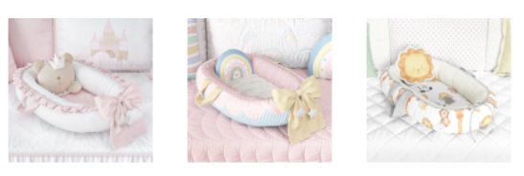  
5-Apr-2024 | Defective Bags of Tide, Gain, Ace and Ariel Laundry Detergent Packets | Chemicals | Injury Hazard, Damage to Skin, Risk of Death | 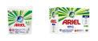  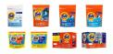  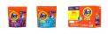  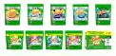
11-Apr-2024 | Yoto Mini Speakers | Computer / Audio / Video / Other Electronics & Accessories | Burn Hazard, Fire Hazard | 
11-Apr-2024 | Junior Ski Boots | Sporting Goods / Equipment | Fall Hazard, Injury Hazard | 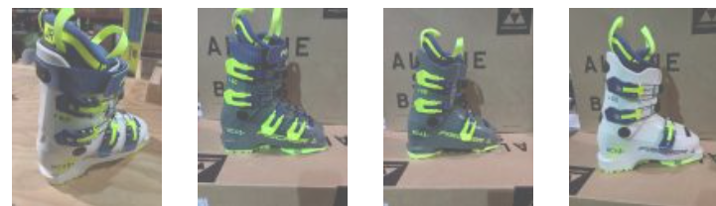  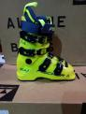
11-Apr-2024 | BRS Liquid Fuel Bottles | Outdoor Living Items | Poisoning Hazard, Burn Hazard | 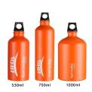
11-Apr-2024 | Touchat Area Rugs | Fabric / Textile / Garment / Home Textile | Fire Hazard | 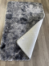
11-Apr-2024 | Quilts and Shams | Fabric / Textile / Garment / Home Textile | Laceration Hazard |     
11-Apr-2024 | Bicycle Stem Raisers | Tools and Hardware | Fall Hazard | 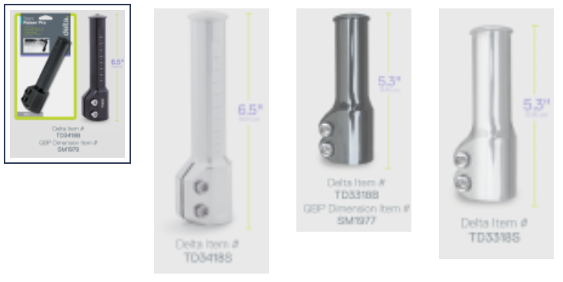
11-Apr-2024 | GhostBed Natural Mattresses | Fabric / Textile / Garment / Home Textile | Fire Hazard | 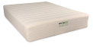
11-Apr-2024 | Zipline Kits | Tools and Hardware | Fall Hazard | 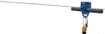
11-Apr-2024 | Matrix T1 and T3 Commercial Treadmills | Sporting Goods / Equipment | Fire Hazard |   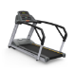  
18-Apr-2024 | Gasaciods Children’s Helmets | Protective Equipment | Injury Hazard | 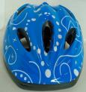  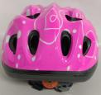
18-Apr-2024 | Randder Liquid Fuel Bottles | Outdoor Living Items | Burn Hazard, Poisoning Hazard | 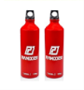
18-Apr-2024 | Gossamer Pro AGX+ Cranksets | Sporting Goods / Equipment | Fall Hazard, Injury Hazard | 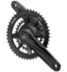  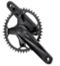
25-Apr-2024 | Children’s Pajamas | Fabric / Textile / Garment / Home Textile | Burn Hazard | 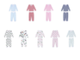  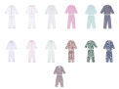
25-Apr-2024 | Peltor X4 Series Earmuffs | Protective Equipment | Damage to Hearing | 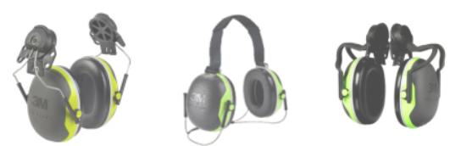  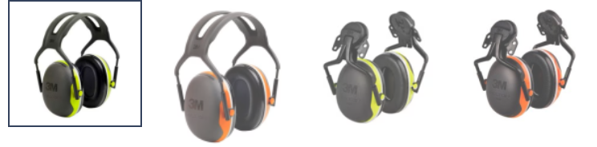
25-Apr-24 | Log Splitters and Cylinder Kits | Machinery | Injury Hazard | 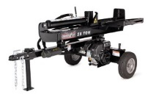
25-Apr-2024 | Hampshire Cribs | Furniture | Fall Hazard | 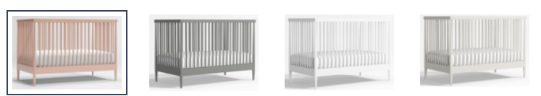  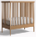
25-Apr-2024 | Children’s Mario Kart Ride-On Racer Car Toys | Toys and Childcare Products | Crash Hazard | 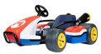
25-Apr-2024 | Multi-Purpose Kids’ Bike Helmets | Protective Equipment | Injury Hazard | 