Recall Cases Summary – Australia (Last Update Date: 31 May 2024)

Date | Product | Categories | Hazard | Image
2-May-2024 | Homespun Pottery Mountain Mug | Food Contact Material | Cut Hazard, Burn Hazard | 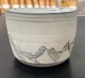
2-May-2024 | Base Rack — Fit Kit Brackets | Tools and Hardware | Injury Hazard | 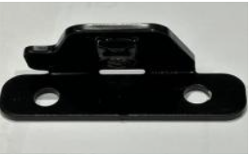
9-May-2024 | Fortis Heavy Duty Adjustable FID Weight Bench | Sporting Goods / Equipment | Injury Hazard | 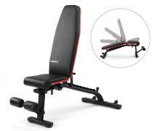
10-May-2024 | Novelty Projector Torches and Seven in One Whistle | Toys and Childcare Products | Injury Hazard, Swallowing Risk, Choking Hazard | 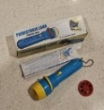  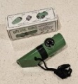  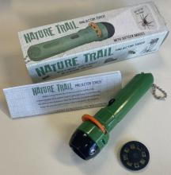
14-May-2024 | 240V 12Hour Programmable Mains Timer | Electrical Appliances | Electric Shock Hazard, Injury Hazard, Risk of Death | 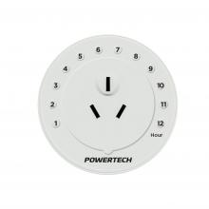
14-May-2024 | Subaru Fuel Additive SA 718 | Chemicals | Skin Irritation Risk, Eye Irritation Risk | 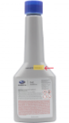  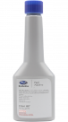
16-May-2024 | Camping Cooking Pot | Food Contact Material | Burn Hazard | 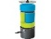  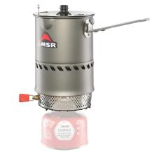  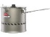  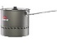  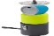  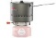  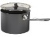  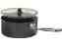
16-May-2024 | Ryobi Model RA-NBS1832-S Airwave 2-in-1 Brad Nailer/Stapler | Tools and Hardware | Laceration Hazard | 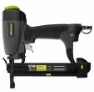
17-May-2024 | Teddy Matte and Vogue Sunglasses | Toys and Childcare Products | Damage to Sight | 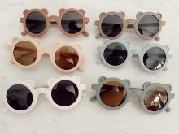  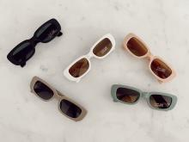
17-May-2024 | Children’s Bamboo Pyjama Set | Fabric / Textile / Garment / Home Textile | Burn Hazard | 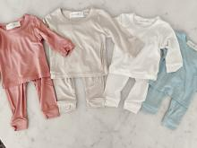
17-May-2024 | Fingerless Glove Mittens | Fabric / Textile / Garment / Home Textile | Choking Hazard, Suffocation Hazard, Risk of Death | 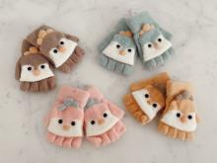
17-May-2024 | Various Rattles, Teethers and Wooden Shaker Toys | Toys and Childcare Products | Choking Hazard, Suffocation Hazard, Risk of Death |   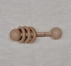  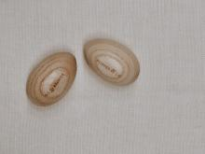    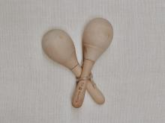
20-May-2024 | Lip Light Shine Gloss | Bodycare / Cosmetics | Choking Hazard, Injury Hazard, Swallowing Risk | 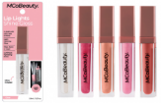
23-May-2024 | China Tea Cups and Trinket Trays | Food Contact Material | Burn Hazard, Fire Hazard | 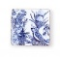  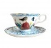  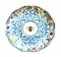  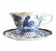  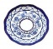  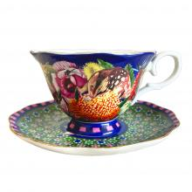  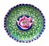  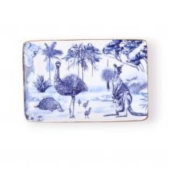
24-May-2024 | RideAlong Child Bike Seat | Toys and Childcare Products | Health Risk Hazard | 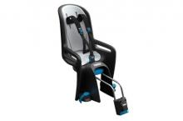
24-May-2024 | Baby Bracelet Jewelry | Jewelry | Choking Hazard, Suffocation Hazard, Risk of Death | 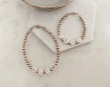  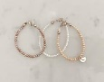  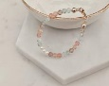
24-May-2024 | Rattles and Teething Rings | Toys and Childcare Products | Choking Hazard, Suffocation Hazard, Risk of Death | 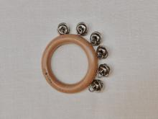    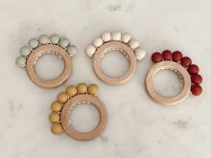  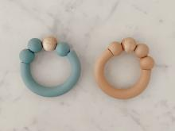
24-May-2024 | Silicone Star and Nordic Hanging Toys | Toys and Childcare Products | Choking Hazard, Suffocation Hazard, Risk of Death |   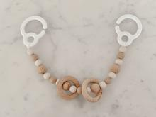
24-May-2024 | Beaded Dummy Chain | Toys and Childcare Products | Choking Hazard, Suffocation Hazard, Risk of Death | 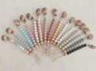
29-May-2024 | Can-Am Audio Roof Kit Remote Control | Computer / Audio / Video / Other Electronics & Accessories | Choking Hazard, Burn Hazard, Risk of Death, Swallowing Risk | 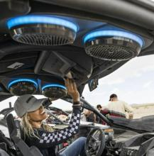
30-May-2024 | Peter Rabbit Newborn Unisex Faux Fur Bunnysuit | Fabric / Textile / Garment / Home Textile | Entanglement Hazard, Injury Hazard | 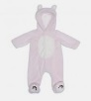
31-May-2024 | WU-ES7 Electronic Countdown Ballast used in WU-UV Water Filtering Systems | Electrical Appliances | Injury Hazard, Risk of Death, Fire Hazard | 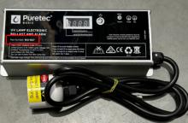
31-May-2024 | Gossamer Pro AGX+ CK-6037 Cranksets | Tools and Hardware | Injury Hazard | 