Recall Cases Summary – Europe (Last Update Date: 31 May 2024)

Date | Notifying Country | Product | Categories | Hazard | Image
2-May-2024 | France | Electric Bicycle | Sporting Goods / Equipment | Injury Hazard | 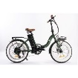
2-May-2024 | France | Soft Toy | Toys and Childcare Products | Choking Hazard | 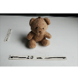
2-May-2024 | France | Soft Toy with Keyring | Toys and Childcare Products | Choking Hazard | /
2-May-2024 | Ireland | Heating Pad | Home Electrical Appliances | Burn Hazard, Electric Shock Hazard, Fire Hazard | 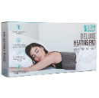
2-May-2024 | Germany | Disposable Electronic Cigarette | Chemicals | Chemical Hazard | 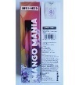  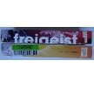
2-May-2024 | Denmark | Attachment for Brush Cutter | Machinery | Injury Hazard | 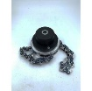
2-May-2024 | Czechia | Hand Cream | Bodycare / Cosmetics | Chemical Hazard | 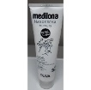
2-May-2024 | Czechia | Hair Dye | Bodycare / Cosmetics | Chemical Hazard | 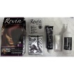
2-May-2024 | Czechia | Pest Control Product | Chemicals | Chemical Hazard | 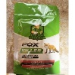
2-May-2024 | Czechia | Pest Control Product | Chemicals | Chemical Hazard | 
2-May-2024 | Hungary | Perfume | Bodycare / Cosmetics | Chemical Hazard | 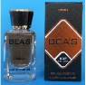
2-May-2024 | Czechia | Liquid Hand Soap | Bodycare / Cosmetics | Chemical Hazard | 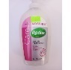
2-May-2024 | Czechia | Shower Gel | Bodycare / Cosmetics | Chemical Hazard | 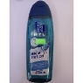
2-May-2024 | Czechia | Herbal Ointment | Bodycare / Cosmetics | Chemical Hazard | 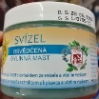
2-May-2024 | Lithuania | Soft Toy | Toys and Childcare Products | Choking Hazard | 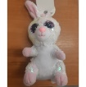
2-May-2024 | Romania | Eau De Toilette | Bodycare / Cosmetics | Chemical Hazard | 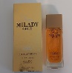
2-May-2024 | Czechia | Hair Dye | Bodycare / Cosmetics | Chemical Hazard | 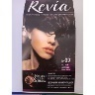
2-May-2024 | Czechia | Hair Dye | Bodycare / Cosmetics | Chemical Hazard | 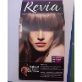
2-May-2024 | Czechia | Hair Dye | Bodycare / Cosmetics | Chemical Hazard | 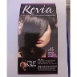
2-May-2024 | Slovakia | Body Protectors Set | Protective Equipment | Injury Hazard | 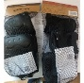
2-May-2024 | United Kingdom in Respect of Northern Ireland | Eyeshadow Palette | Bodycare / Cosmetics | Chemical Hazard | 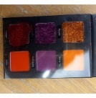
2-May-2024 | United Kingdom in Respect of Northern Ireland | Eyeshadow Palette | Bodycare / Cosmetics | Chemical Hazard | 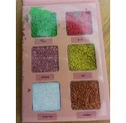
2-May-2024 | Romania | Children's Trousers | Fabric / Textile / Garment / Home Textile | Injury Hazard | 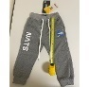
2-May-2024 | Ireland | Domestic Gas Boiler | Household Items | Burn Hazard, Fire Hazard, Explosion Hazard | 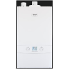
3-May-2024 | Cyprus | Set of Mini Toy Motorcycles | Toys and Childcare Products | Choking Hazard | 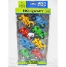
3-May-2024 | Czechia | Soap | Bodycare / Cosmetics | Chemical Hazard | 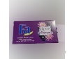
3-May-2024 | Ireland | Baby Self-feeding Pillow | Toys and Childcare Products | Choking Hazard | 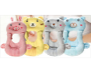
3-May-2024 | Ireland | Baby Self-feeding Pillow | Toys and Childcare Products | Choking Hazard | 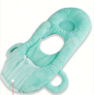
3-May-2024 | Lithuania | Rattle Toy Set | Toys and Childcare Products | Choking Hazard | 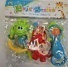
3-May-2024 | Sweden | Home Anti-Theft Alarm | Home Electrical Appliances | Environmental Hazard | 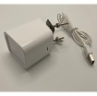
3-May-2024 | Romania | Deodorant | Bodycare / Cosmetics | Chemical Hazard | 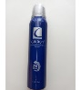
6-May-2024 | Czechia | Shower Gel | Bodycare / Cosmetics | Chemical Hazard | 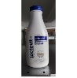
6-May-2024 | Czechia | Shower Gel | Bodycare / Cosmetics | Chemical Hazard | 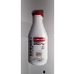
6-May-2024 | Czechia | Eau De Toilette | Bodycare / Cosmetics | Chemical Hazard | 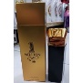
6-May-2024 | Czechia | Soap | Bodycare / Cosmetics | Chemical Hazard | 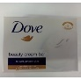
6-May-2024 | Czechia | Shower Gel | Bodycare / Cosmetics | Chemical Hazard | 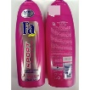
6-May-2024 | Czechia | Shower Gel | Bodycare / Cosmetics | Chemical Hazard | 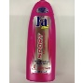
7-May-2024 | Italy | Eau De Toilette | Bodycare / Cosmetics | Chemical Hazard | 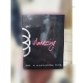
7-May-2024 | Italy | Shampoo | Bodycare / Cosmetics | Chemical Hazard | 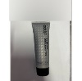
7-May-2024 | Italy | Perfume | Bodycare / Cosmetics | Chemical Hazard | 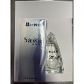
7-May-2024 | Italy | Skin Treatment Drops | Bodycare / Cosmetics | Chemical Hazard | 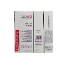
7-May-2024 | Italy | Shower Foam | Bodycare / Cosmetics | Chemical Hazard | 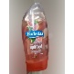
7-May-2024 | Italy | Aftershave Emulsion | Bodycare / Cosmetics | Chemical Hazard | 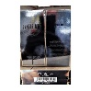
7-May-2024 | Italy | Eau De Toilette | Bodycare / Cosmetics | Chemical Hazard | 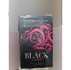
7-May-2024 | Italy | Aftershave Emulsion | Bodycare / Cosmetics | Chemical Hazard | 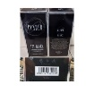
7-May-2024 | Italy | Eau De Toilette | Bodycare / Cosmetics | Chemical Hazard | 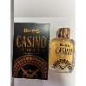
7-May-2024 | Italy | Shower Gel | Bodycare / Cosmetics | Chemical Hazard | 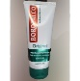
7-May-2024 | Italy | Deodorant | Bodycare / Cosmetics | Chemical Hazard | 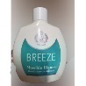
7-May-2024 | Italy | Varnish | Bodycare / Cosmetics | Chemical Hazard | 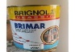  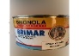
7-May-2024 | Sweden | Night Light | Electrical Appliances | Electric Shock Hazard, Fire Hazard | 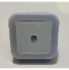  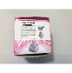
7-May-2024 | Cyprus | Set of Toy Vehicles | Toys and Childcare Products | Choking Hazard | 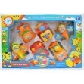
7-May-2024 | Czechia | Shower Gel | Bodycare / Cosmetics | Chemical Hazard | 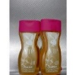
7-May-2024 | France | Plastic Soother Holder | Toys and Childcare Products | Choking Hazard | 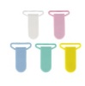
7-May-2024 | Czechia | Disposable Electronic Cigarette | Chemicals | Chemical Hazard | 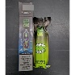
7-May-2024 | Ireland | Toy Pottery Wheel Set | Toys and Childcare Products | Chemical Hazard | 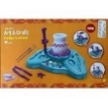
7-May-2024 | Czechia | Disposable Electronic Cigarette | Chemicals | Chemical Hazard | 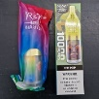
7-May-2024 | Lithuania | Multiplug Socket | Electrical Appliances | Electric Shock Hazard | 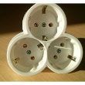
7-May-2024 | Czechia | Shower Gel | Bodycare / Cosmetics | Chemical Hazard | 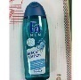
7-May-2024 | Czechia | Hair Dye | Bodycare / Cosmetics | Chemical Hazard | 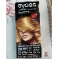
7-May-2024 | Czechia | Disposable Electronic Cigarette | Chemicals | Chemical Hazard | 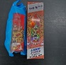
7-May-2024 | Czechia | Hair Dye | Bodycare / Cosmetics | Chemical Hazard | 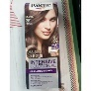
7-May-2024 | Czechia | Hair Dye | Bodycare / Cosmetics | Chemical Hazard | 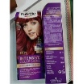
7-May-2024 | Czechia | Hair Dye | Bodycare / Cosmetics | Chemical Hazard | 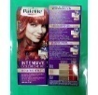
7-May-2024 | Czechia | Eau De Toilette | Bodycare / Cosmetics | Chemical Hazard | 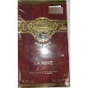
7-May-2024 | Czechia | Hair Dye | Bodycare / Cosmetics | Chemical Hazard | 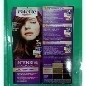
7-May-2024 | Czechia | Shampoo | Bodycare / Cosmetics | Chemical Hazard | 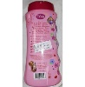
7-May-2024 | Czechia | Hair Dye | Bodycare / Cosmetics | Chemical Hazard | 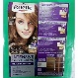
7-May-2024 | Poland | Plastic Ball | Toys and Childcare Products | Chemical Hazard | 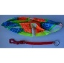
7-May-2024 | Lithuania | Dress | Fabric / Textile / Garment / Home Textile | Strangulation Hazard | 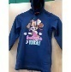
7-May-2024 | Sweden | Flashlight | Electrical Appliances | Environmental Hazard | 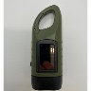
8-May-2024 | Italy | Tanning Drops | Bodycare / Cosmetics | Chemical Hazard | 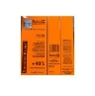
8-May-2024 | France | Torch Oil | Chemicals | Chemical Hazard | 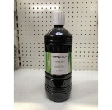
8-May-2024 | France | Eraser | Stationery | Choking Hazard | 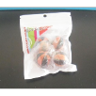
8-May-2024 | France | Charger | Electrical Appliances | Electric Shock Hazard | 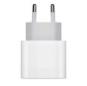
8-May-2024 | France | Disposable Electronic Cigarette | Chemicals | Chemical Hazard | 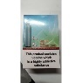
8-May-2024 | France | Electric Bicycle | Sporting Goods / Equipment | Injury Hazard | 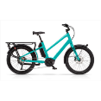
8-May-2024 | France | Extension Lead | Electrical Appliances | Electric Shock Hazard, Fire Hazard | 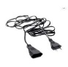
8-May-2024 | Czechia | Disposable Electronic Cigarette | Chemicals | Chemical Hazard | 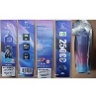
8-May-2024 | Luxembourg | Bicycle Helmet | Protective Equipment | Injury Hazard | 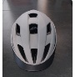
8-May-2024 | France | Soother Holder | Toys and Childcare Products | Choking Hazard | 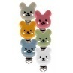
8-May-2024 | Lithuania | Toy Pushchair | Toys and Childcare Products | Injury Hazard, Suffocation Hazard | 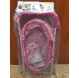
8-May-2024 | Romania | Deodorant and Shower Foam | Bodycare / Cosmetics | Chemical Hazard | 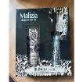
8-May-2024 | Czechia | Pest Control Product | Chemicals | Chemical Hazard | 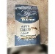
8-May-2024 | Czechia | Pest Control Product | Chemicals | Chemical Hazard | 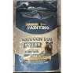
8-May-2024 | Czechia | Pest Control Product | Chemicals | Chemical Hazard | 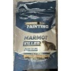
8-May-2024 | Czechia | Pest Control Product | Chemicals | Chemical Hazard | 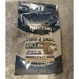
8-May-2024 | Poland | Magnetic Puzzle Set | Toys and Childcare Products | Injury Hazard | 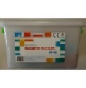
8-May-2024 | Sweden | Pendant | Jewelry | Chemical Hazard | 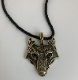
8-May-2024 | Czechia | Shower Gel | Bodycare / Cosmetics | Chemical Hazard | 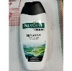
8-May-2024 | Czechia | Disposable Electronic Cigarette | Chemicals | Chemical Hazard | 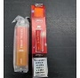
14-May-2024 | Italy | Deodorant | Bodycare / Cosmetics | Chemical Hazard | 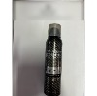
14-May-2024 | Italy | Eau De Toilette | Bodycare / Cosmetics | Chemical Hazard | 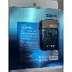
14-May-2024 | Italy | Baby Wipes | Bodycare / Cosmetics | Chemical Hazard | 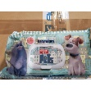
14-May-2024 | Italy | Baby Wipes | Bodycare / Cosmetics | Chemical Hazard | 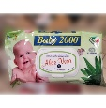
14-May-2024 | Italy | Eau De Toilette | Bodycare / Cosmetics | Chemical Hazard | 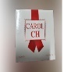
14-May-2024 | Italy | Body Milk | Bodycare / Cosmetics | Chemical Hazard | 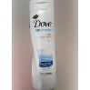
14-May-2024 | Italy | Liquid Soap | Bodycare / Cosmetics | Chemical Hazard | 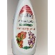
14-May-2024 | Italy | Soap | Bodycare / Cosmetics | Chemical Hazard | 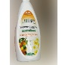
14-May-2024 | Italy | Varnish | Chemicals | Chemical Hazard | 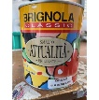
14-May-2024 | Italy | Eau De Toilette | Bodycare / Cosmetics | Chemical Hazard | 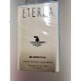
14-May-2024 | Italy | Perfume | Bodycare / Cosmetics | Chemical Hazard | 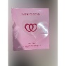
14-May-2024 | Italy | Hair Dye | Bodycare / Cosmetics | Chemical Hazard | 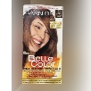
14-May-2024 | Italy | Facial Toner | Bodycare / Cosmetics | Chemical Hazard | 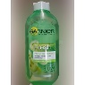
14-May-2024 | Italy | Shampoo | Bodycare / Cosmetics | Chemical Hazard | 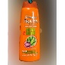
14-May-2024 | Italy | Travel Adaptor | Electrical Appliances | Electric Shock Hazard | 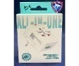  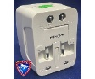
14-May-2024 | Italy | Travel Adaptor | Electrical Appliances | Electric Shock Hazard | 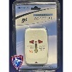
14-May-2024 | Italy | Hair Conditioner | Bodycare / Cosmetics | Chemical Hazard | 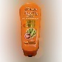
14-May-2024 | Italy | Conditioner | Bodycare / Cosmetics | Chemical Hazard | 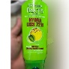
14-May-2024 | Italy | Shampoo | Bodycare / Cosmetics | Chemical Hazard | 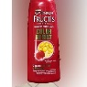
14-May-2024 | Italy | Soft Toy | Toys and Childcare Products | Chemical Hazard | 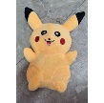
14-May-2024 | Italy | Hair Gel | Bodycare / Cosmetics | Chemical Hazard | 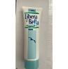
14-May-2024 | Italy | Tattoo Ink | Chemicals | Chemical Hazard | 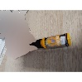
14-May-2024 | Italy | Perfume | Bodycare / Cosmetics | Chemical Hazard | 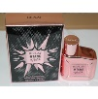  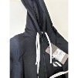
14-May-2024 | Italy | Children's Sweatshirt | Fabric / Textile / Garment / Home Textile | Injury Hazard, Strangulation Hazard
14-May-2024 | Italy | Children's Sweatshirt | Fabric / Textile / Garment / Home Textile | Injury Hazard, Strangulation Hazard | 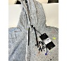
14-May-2024 | Italy | Perfume | Bodycare / Cosmetics | Chemical Hazard | 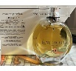
14-May-2024 | France | Playground with Slide and Swing | Toys and Childcare Products | Entrapment Hazard, Injury Hazard, Strangulation Hazard | 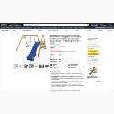
14-May-2024 | France | Teething Ring | Toys and Childcare Products | Choking Hazard | 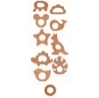
14-May-2024 | Germany | Electric Lunch Box | Electrical Appliances | Electric Shock Hazard | 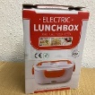  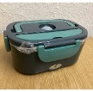
14-May-2024 | Germany | Vehicle Part | Car Accessories | Injury Hazard | 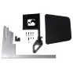
14-May-2024 | Hungary | Perfume | Bodycare / Cosmetics | Chemical Hazard | 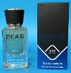
14-May-2024 | Poland | Toy Gun Set | Toys and Childcare Products | Injury Hazard | 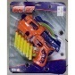
14-May-2024 | Czechia | Shampoo | Bodycare / Cosmetics | Chemical Hazard | 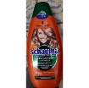
14-May-2024 | Czechia | Shampoo | Bodycare / Cosmetics | Chemical Hazard | 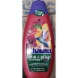
14-May-2024 | Czechia | Hair Mousse | Bodycare / Cosmetics | Chemical Hazard | 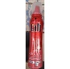
14-May-2024 | Czechia | Hair Conditioner | Bodycare / Cosmetics | Chemical Hazard | 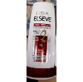
14-May-2024 | Lithuania | Plastic Doll | Toys and Childcare Products | Chemical Hazard | 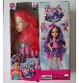
14-May-2024 | Lithuania | Plastic Doll | Toys and Childcare Products | Chemical Hazard | 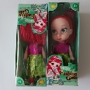
14-May-2024 | Czechia | Lavender Shower Gel | Bodycare / Cosmetics | Chemical Hazard | 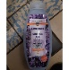
14-May-2024 | Poland | Purse | Fabric / Textile / Garment / Home Textile | Chemical Hazard, Environmental Hazard | 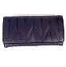
15-May-2024 | Italy | Moisturizing Cream | Bodycare / Cosmetics | Chemical Hazard | 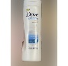
15-May-2024 | Italy | Hairspray | Bodycare / Cosmetics | Chemical Hazard | 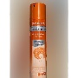
15-May-2024 | Italy | Shampoo | Bodycare / Cosmetics | Chemical Hazard | 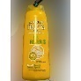
15-May-2024 | Italy | Hand Cream | Bodycare / Cosmetics | Chemical Hazard | 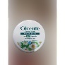
15-May-2024 | Italy | Eau De Toilette | Bodycare / Cosmetics | Chemical Hazard | 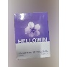
15-May-2024 | Italy | Hair Mousse | Bodycare / Cosmetics | Chemical Hazard | 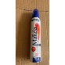
15-May-2024 | Italy | Shampoo | Bodycare / Cosmetics | Chemical Hazard | 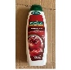
15-May-2024 | Ireland | Liquid for Electronic Cigarette | Chemicals | Chemical Hazard | 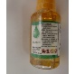
15-May-2024 | Czechia | Chainsaw Blade | Tools and Hardware | Injury Hazard | 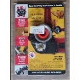
15-May-2024 | Italy | Perfume | Bodycare / Cosmetics | Chemical Hazard | 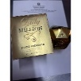
15-May-2024 | Italy | Eau De Toilette | Bodycare / Cosmetics | Chemical Hazard | 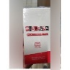
15-May-2024 | Italy | Eau De Toilette | Bodycare / Cosmetics | Chemical Hazard | 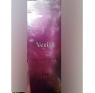
15-May-2024 | Italy | Eau De Toilette | Bodycare / Cosmetics | Chemical Hazard | 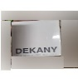
15-May-2024 | Italy | Eau De Toilette | Bodycare / Cosmetics | Chemical Hazard | 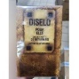
15-May-2024 | Italy | Flip Flops | Footwear | Chemical Hazard | 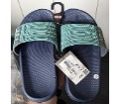
15-May-2024 | Poland | Inflatable Toy | Toys and Childcare Products | Chemical Hazard | 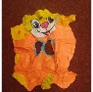
15-May-2024 | Italy | Soap | Bodycare / Cosmetics | Chemical Hazard | 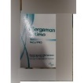
16-May-2024 | Italy | Liquid Soap | Bodycare / Cosmetics | Chemical Hazard | 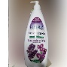
16-May-2024 | Italy | USB Charger | Electrical Appliances | Electric Shock Hazard | 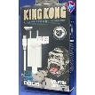
16-May-2024 | Italy | Pencil Case | Stationery | Chemical Hazard | 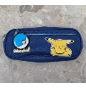
16-May-2024 | Belgium | Hoodie | Fabric / Textile / Garment / Home Textile | Injury Hazard, Strangulation Hazard | 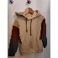
16-May-2024 | Sweden | Water Sprinkler for Trampoline | Toys and Childcare Products | Injury Hazard | 
16-May-2024 | Belgium | Children's Hoodie | Fabric / Textile / Garment / Home Textile | Injury Hazard, Strangulation Hazard | 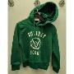
16-May-2024 | Czechia | Shampoo | Bodycare / Cosmetics | Chemical Hazard | 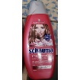
16-May-2024 | Poland | Pencil Set | Stationery | Chemical Hazard | 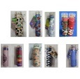
16-May-2024 | Italy | Hair Conditioner | Bodycare / Cosmetics | Chemical Hazard | 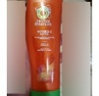
16-May-2024 | Italy | Deodorant | Bodycare / Cosmetics | Chemical Hazard | 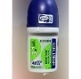
16-May-2024 | Italy | Shower Foam | Bodycare / Cosmetics | Chemical Hazard | 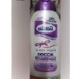
16-May-2024 | Italy | Eau De Toilette | Bodycare / Cosmetics | Chemical Hazard | 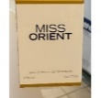
16-May-2024 | Italy | Hair Mask | Bodycare / Cosmetics | Chemical Hazard | 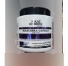
16-May-2024 | Italy | Shampoo | Bodycare / Cosmetics | Chemical Hazard | 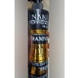
16-May-2024 | Italy | Shampoo | Bodycare / Cosmetics | Chemical Hazard | 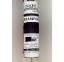
16-May-2024 | Italy | Perfume | Bodycare / Cosmetics | Chemical Hazard | 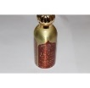
16-May-2024 | Italy | Shower Gel | Bodycare / Cosmetics | Chemical Hazard | 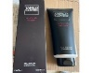
16-May-2024 | Italy | Body Shampoo | Bodycare / Cosmetics | Chemical Hazard | 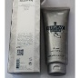
16-May-2024 | Italy | Deodorant | Bodycare / Cosmetics | Chemical Hazard | 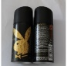
16-May-2024 | Italy | Children's Shorts | Fabric / Textile / Garment / Home Textile | Injury Hazard | 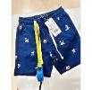
16-May-2024 | Italy | Children's Shorts | Fabric / Textile / Garment / Home Textile | Injury Hazard | 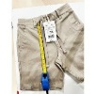
16-May-2024 | Italy | Children's Trousers | Fabric / Textile / Garment / Home Textile | Injury Hazard | 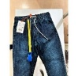
16-May-2024 | Italy | Children's Shorts | Fabric / Textile / Garment / Home Textile | Choking Hazard, Injury Hazard | 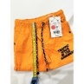
16-May-2024 | Italy | Children's Hoodie | Fabric / Textile / Garment / Home Textile | Injury Hazard, Strangulation Hazard | 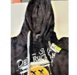
16-May-2024 | Italy | Children's Hoodie | Fabric / Textile / Garment / Home Textile | Injury Hazard, Strangulation Hazard | 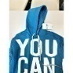
16-May-2024 | Italy | Children's Hoodie | Fabric / Textile / Garment / Home Textile | Injury Hazard, Strangulation Hazard | 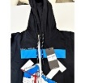
16-May-2024 | Italy | Children's Hoodie | Fabric / Textile / Garment / Home Textile | Injury Hazard, Strangulation Hazard | 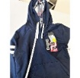
16-May-2024 | Italy | Hair Mousse | Bodycare / Cosmetics | Chemical Hazard | 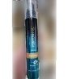
16-May-2024 | Italy | Eau De Toilette | Bodycare / Cosmetics | Chemical Hazard | 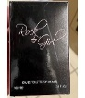
16-May-2024 | Italy | Hair Conditioner | Bodycare / Cosmetics | Chemical Hazard | 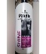
16-May-2024 | Italy | Tattoo Ink | Chemicals | Chemical Hazard | 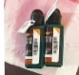
16-May-2024 | Italy | Eau De Toilette | Bodycare / Cosmetics | Chemical Hazard | 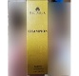
16-May-2024 | Italy | Perfume | Bodycare / Cosmetics | Chemical Hazard | 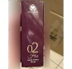
16-May-2024 | Italy | Perfume | Bodycare / Cosmetics | Chemical Hazard | 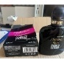
16-May-2024 | Italy | Shampoo | Bodycare / Cosmetics | Chemical Hazard | 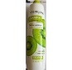
16-May-2024 | Italy | Soap | Bodycare / Cosmetics | Chemical Hazard | 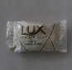
16-May-2024 | Italy | Perfume | Bodycare / Cosmetics | Chemical Hazard | 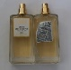
16-May-2024 | Italy | Body Lotion | Bodycare / Cosmetics | Chemical Hazard | 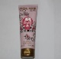
16-May-2024 | Italy | Perfume | Bodycare / Cosmetics | Chemical Hazard | 
16-May-2024 | Italy | Hair Mousse | Bodycare / Cosmetics | Chemical Hazard | 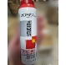
16-May-2024 | Italy | Perfume | Bodycare / Cosmetics | Chemical Hazard | 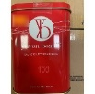
16-May-2024 | Italy | Eau De Toilette | Bodycare / Cosmetics | Chemical Hazard | 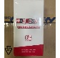
16-May-2024 | Italy | Shower Gel | Bodycare / Cosmetics | Chemical Hazard | 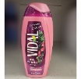
16-May-2024 | Italy | Deodorant | Bodycare / Cosmetics | Chemical Hazard | 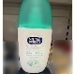
16-May-2024 | Italy | Bath Foam | Bodycare / Cosmetics | Chemical Hazard | 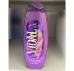
16-May-2024 | Belgium | Children's Trousers | Fabric / Textile / Garment / Home Textile | Injury Hazard | 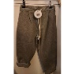
16-May-2024 | Ireland | Wooden Bed | Furniture | Suffocation Hazard, Burn Hazard, Fire Hazard | 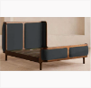
16-May-2024 | Ireland | Babies' Clothing | Fabric / Textile / Garment / Home Textile | Choking Hazard | 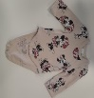
16-May-2024 | Poland | Toy Scooter | Toys and Childcare Products | Injury Hazard | 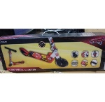
16-May-2024 | Poland | Babies' Clothing | Fabric / Textile / Garment / Home Textile | Choking Hazard | 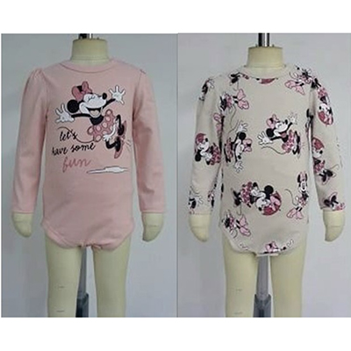  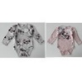
16-May-2024 | Croatia | Soft Toy | Toys and Childcare Products | Choking Hazard | 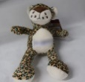
16-May-2024 | Poland | Inflatable Toy | Toys and Childcare Products | Chemical Hazard | 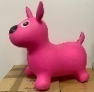
16-May-2024 | Poland | Inflatable Ball | Toys and Childcare Products | Chemical Hazard | 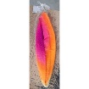
21-May-2024 | Italy | Hair Conditioner | Bodycare / Cosmetics | Chemical Hazard | 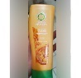
21-May-2024 | Italy | Shampoo | Bodycare / Cosmetics | Chemical Hazard | 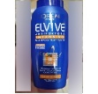
21-May-2024 | Italy | Hair Mousse | Bodycare / Cosmetics | Chemical Hazard | 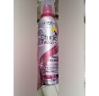
21-May-2024 | Italy | Hair Mousse | Bodycare / Cosmetics | Chemical Hazard | 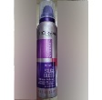
21-May-2024 | Italy | Hair Mousse | Bodycare / Cosmetics | Chemical Hazard | 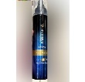
21-May-2024 | Italy | Shampoo | Bodycare / Cosmetics | Chemical Hazard | 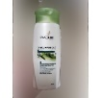
21-May-2024 | Italy | Liquid Soap | Bodycare / Cosmetics | Chemical Hazard | 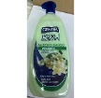
21-May-2024 | Italy | Hair Dye | Bodycare / Cosmetics | Chemical Hazard | 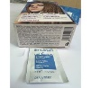
21-May-2024 | Italy | Perfume | Bodycare / Cosmetics | Chemical Hazard | 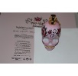
21-May-2024 | Italy | Make-up Remover Wipes | Bodycare / Cosmetics | Chemical Hazard | 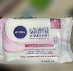
21-May-2024 | Poland | Electric Toy | Toys and Childcare Products | Environmental Hazard | 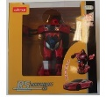
21-May-2024 | Poland | Electric Toy | Toys and Childcare Products | Environmental Hazard | 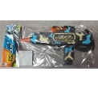
22-May-2024 | Italy | Shampoo | Bodycare / Cosmetics | Chemical Hazard | 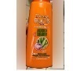
22-May-2024 | Italy | Hair Conditioner | Bodycare / Cosmetics | Chemical Hazard | 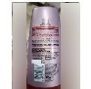
22-May-2024 | Italy | Eau De Toilette | Bodycare / Cosmetics | Chemical Hazard | 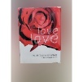
22-May-2024 | Italy | Eau De Toilette | Bodycare / Cosmetics | Chemical Hazard | 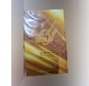
22-May-2024 | Italy | Hand Cream | Bodycare / Cosmetics | Chemical Hazard | 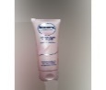
22-May-2024 | Italy | Shampoo | Bodycare / Cosmetics | Chemical Hazard | 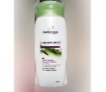
22-May-2024 | Italy | Hair Mousse | Bodycare / Cosmetics | Chemical Hazard | 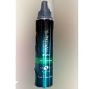
22-May-2024 | Italy | Hair Conditioner | Bodycare / Cosmetics | Chemical Hazard | 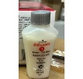
22-May-2024 | Italy | Perfume | Bodycare / Cosmetics | Chemical Hazard | 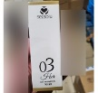
22-May-2024 | Italy | Hair Gel | Bodycare / Cosmetics | Chemical Hazard | 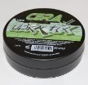
22-May-2024 | Italy | Perfume | Bodycare / Cosmetics | Chemical Hazard | 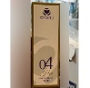
22-May-2024 | Italy | Shower Gel | Bodycare / Cosmetics | Chemical Hazard | 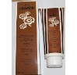
22-May-2024 | Italy | Bath Cream | Bodycare / Cosmetics | Chemical Hazard | 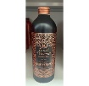
22-May-2024 | Italy | Bath Foam | Bodycare / Cosmetics | Chemical Hazard | 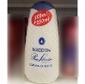
22-May-2024 | Romania | Sweatshirt and Trousers | Fabric / Textile / Garment / Home Textile | Strangulation Hazard | 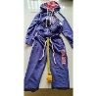
22-May-2024 | France | Soft Toy | Toys and Childcare Products | Choking Hazard | 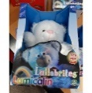
22-May-2024 | Belgium | Trousers | Fabric / Textile / Garment / Home Textile | Injury Hazard | 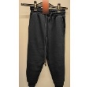
22-May-2024 | Ireland | Magnetic Gemstones | Toys and Childcare Products | Choking Hazard, Injury Hazard | 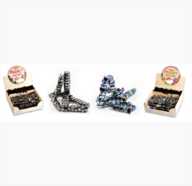
22-May-2024 | Germany | Dot Marker Set | Toys and Childcare Products | Chemical Hazard | 
22-May-2024 | Finland | Gloves | Fabric / Textile / Garment / Home Textile | Chemical Hazard | 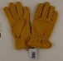
22-May-2024 | Italy | Perfume | Bodycare / Cosmetics | Chemical Hazard | 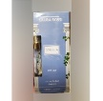
22-May-2024 | Italy | Perfume | Bodycare / Cosmetics | Chemical Hazard | 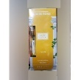
22-May-2024 | Italy | Deodorant | Bodycare / Cosmetics | Chemical Hazard | 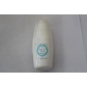
22-May-2024 | Ireland | Soother Holder | Toys and Childcare Products | Choking Hazard | 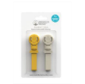
22-May-2024 | France | Insect Killer | Electrical Appliances | Choking Hazard, Electric Shock Hazard | 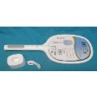
22-May-2024 | France | Electric Fly Swatter | Electrical Appliances | Electric Shock Hazard | 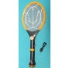
22-May-2024 | France | Electric Fly Swatter with Battery | Electrical Appliances | Electric Shock Hazard | 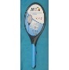
22-May-2024 | Sweden | Video Signal Converter | Computer / Audio / Video / Other Electronics & Accessories | Environmental Hazard | 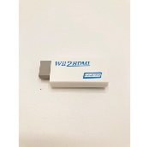
22-May-2024 | Sweden | Digital Voice Recorder | Computer / Audio / Video / Other Electronics & Accessories | Environmental Hazard | 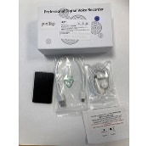
23-May-2024 | Italy | Perfume | Bodycare / Cosmetics | Chemical Hazard | 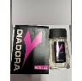
23-May-2024 | Italy | Perfume | Bodycare / Cosmetics | Chemical Hazard | 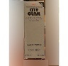
23-May-2024 | Italy | Children’s Flip Flops | Footwear | Chemical Hazard | 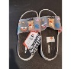
23-May-2024 | Italy | Bath Foam | Bodycare / Cosmetics | Chemical Hazard | 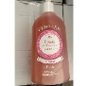
23-May-2024 | Italy | Eau De Toilette | Bodycare / Cosmetics | Chemical Hazard | 
23-May-2024 | Italy | Perfume | Bodycare / Cosmetics | Chemical Hazard | 
23-May-2024 | Italy | Skin Cream | Bodycare / Cosmetics | Chemical Hazard | 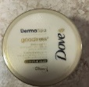
23-May-2024 | Germany | Learning Tower | Furniture | Injury Hazard | 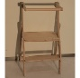
23-May-2024 | Germany | Child Safety Seat | Car Accessories | Injury Hazard | 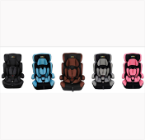
23-May-2024 | Austria | Toy Squid | Toys and Childcare Products | Choking Hazard | 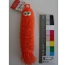
23-May-2024 | Bulgaria | Baby Bottle | Toys and Childcare Products | Health Risk Hazard | 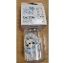
23-May-2024 | Finland | Hair Serum | Bodycare / Cosmetics | Environmental Hazard | 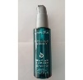
23-May-2024 | Finland | Hair Protector Spray | Bodycare / Cosmetics | Environmental Hazard | 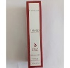
23-May-2024 | Finland | Eyeliner | Bodycare / Cosmetics | Environmental Hazard | 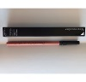  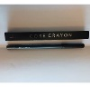  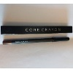
23-May-2024 | Finland | Eyeliner | Bodycare / Cosmetics | Environmental Hazard
23-May-2024 | Finland | Lip Liner | Bodycare / Cosmetics | Environmental Hazard
23-May-2024 | Finland | Lip Liner | Bodycare / Cosmetics | Environmental Hazard | 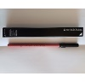
23-May-2024 | Finland | Lip Liner | Bodycare / Cosmetics | Environmental Hazard | 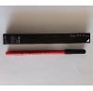
23-May-2024 | Romania | Magnetic Toy Set | Toys and Childcare Products | Choking Hazard, Injury Hazard | 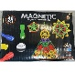
23-May-2024 | France | Electric Fly Swatter | Electrical Appliances | Electric Shock Hazard | 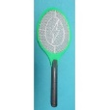
23-May-2024 | Czechia | Pest Control Product | Chemicals | Chemical Hazard | 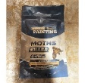
23-May-2024 | Czechia | Pest Control Product | Chemicals | Chemical Hazard | 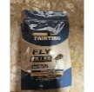
23-May-2024 | Czechia | Pest Control Product | Chemicals | Chemical Hazard | 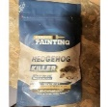
23-May-2024 | Czechia | Pest Control Product | Chemicals | Chemical Hazard | 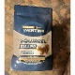
23-May-2024 | Czechia | Pest Control Product | Chemicals | Chemical Hazard | 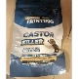
23-May-2024 | Sweden | Video Signal Converter | Computer / Audio / Video / Other Electronics & Accessories | Environmental Hazard | 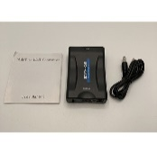
23-May-2024 | Czechia | Lighting Chain | Electrical Appliances | Electric Shock Hazard | 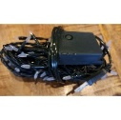
23-May-2024 | Sweden | Flying Ball Toy | Toys and Childcare Products | Environmental Hazard | 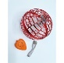
23-May-2024 | Sweden | Controller for Nintendo | Computer / Audio / Video / Other Electronics & Accessories | Environmental Hazard | 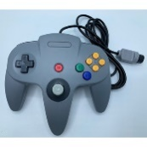
23-May-2024 | Czechia | Lighting Chain | Electrical Appliances | Electric Shock Hazard | 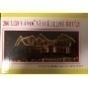
23-May-2024 | Czechia | Lighting Chain | Electrical Appliances | Electric Shock Hazard | 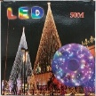
23-May-2024 | Sweden | Car Hood LED Light | Electrical Appliances | Environmental Hazard | 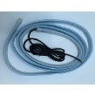
23-May-2024 | Sweden | Ring | Jewelry | Chemical Hazard | 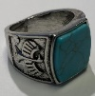
23-May-2024 | Sweden | Charger | Electrical Appliances | Environmental Hazard | 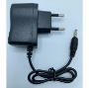
23-May-2024 | Sweden | Recording Pen | Computer / Audio / Video / Other Electronics & Accessories | Environmental Hazard | 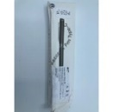
23-May-2024 | Lithuania | Beauty Set | Bodycare / Cosmetics | Chemical Hazard | 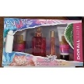
23-May-2024 | The Netherlands | Soother Holder | Toys and Childcare Products | Choking Hazard | 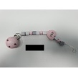
24-May-2024 | Italy | Toy Ball with Pokémon | Toys and Childcare Products | Chemical Hazard | 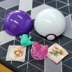
24-May-2024 | Italy | Children's Sweatshirt | Fabric / Textile / Garment / Home Textile | Injury Hazard, Strangulation Hazard | 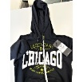
24-May-2024 | Denmark | Toy Gun Set | Toys and Childcare Products | Choking Hazard, Injury Hazard | 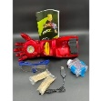
28-May-2024 | Italy | Hair Gel | Bodycare / Cosmetics | Chemical Hazard | 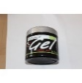
28-May-2024 | Italy | Beauty Bath and Shower | Bodycare / Cosmetics | Chemical Hazard | 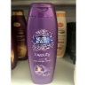
28-May-2024 | Italy | Hair Conditioner | Bodycare / Cosmetics | Chemical Hazard | 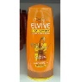
28-May-2024 | France | Toy Kitchen Set | Toys and Childcare Products | Choking Hazard | 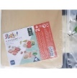
28-May-2024 | France | Children's Balance Bike | Sporting Goods / Equipment | Injury Hazard | 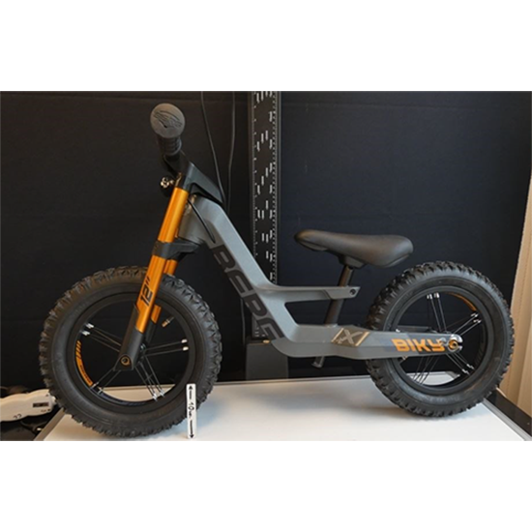
28-May-2024 | Ireland | Ireland | Furniture | Cut Hazard | 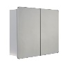
28-May-2024 | Bulgaria | Baby Bottle | Toys and Childcare Products | Choking Hazard, Cut Hazard | 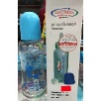
28-May-2024 | Germany | Liquid for Electronic Cigarette | Chemicals | Chemical Hazard | 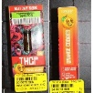
28-May-2024 | France | Fancy-dress Costume | Fabric / Textile / Garment / Home Textile | Burn Hazard | 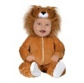
28-May-2024 | Czechia | Lighting Chain | Electrical Appliances | Electric Shock Hazard | 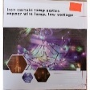
28-May-2024 | France | Fancy-dress Accessories | Toys and Childcare Products | Chemical Hazard | 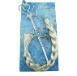
28-May-2024 | Czechia | Disposable Electronic Cigarette | Chemicals | Chemical Hazard | 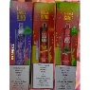
28-May-2024 | Czechia | Hair Conditioner | Bodycare / Cosmetics | Chemical Hazard | 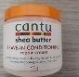
28-May-2024 | Czechia | Hair Conditioner | Bodycare / Cosmetics | Chemical Hazard | 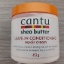
28-May-2024 | Belgium | Swim Shorts | Fabric / Textile / Garment / Home Textile | Injury Hazard | 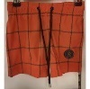
28-May-2024 | Ireland | Disposable Electronic Cigarette | Chemicals | Chemical Hazard | 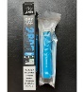  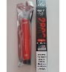
28-May-2024 | Bulgaria | Children's Clothing Set | Fabric / Textile / Garment / Home Textile | Injury Hazard, Strangulation Hazard | 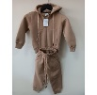  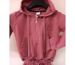  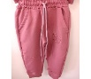
28-May-2024 | Bulgaria | Children's Clothing Set | Fabric / Textile / Garment / Home Textile | Injury Hazard, Strangulation Hazard | 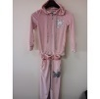
28-May-2024 | Czechia | Inflatable Ball | Toys and Childcare Products | Chemical Hazard | 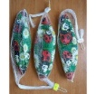
28-May-2024 | Belgium | Children's Hoodie | Fabric / Textile / Garment / Home Textile | Injury Hazard, Strangulation Hazard | 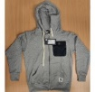
28-May-2024 | Belgium | Trousers | Fabric / Textile / Garment / Home Textile | Injury Hazard | 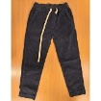
28-May-2024 | Lithuania | Car Windscreen Washing Fluid | Chemicals | Chemical Hazard | 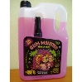
28-May-2024 | Lithuania | Car Windscreen Washing Fluid | Chemicals | Chemical Hazard | 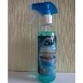
28-May-2024 | Hungary | Children's Dress Set | Fabric / Textile / Garment / Home Textile | Choking Hazard | 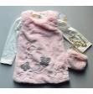
28-May-2024 | Belgium | Children's Hoodie | Fabric / Textile / Garment / Home Textile | Injury Hazard, Strangulation Hazard | 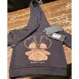
29-May-2024 | Germany | Soft Ball | Toys and Childcare Products | Chemical Hazard | 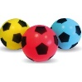
29-May-2024 | Lithuania | Glue | Chemicals | Chemical Hazard | 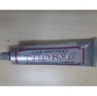
29-May-2024 | Lithuania | Glue | Chemicals | Chemical Hazard | 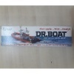
29-May-2024 | Lithuania | Car Windscreen Washing Fluid | Chemicals | Chemical Hazard | 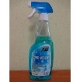
29-May-2024 | Germany | Electronic Cigarette | Chemicals | Chemical Hazard | 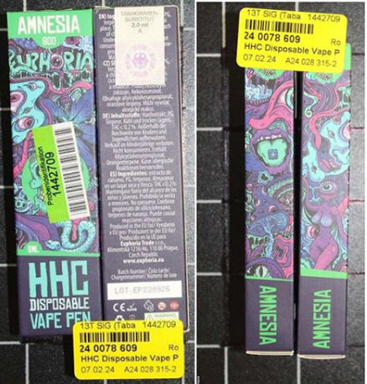
29-May-2024 | France | Toy Train | Toys and Childcare Products | Choking Hazard | 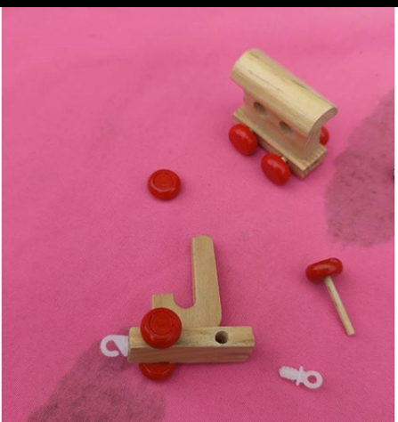
29-May-2024 | France | Soother Holder | Toys and Childcare Products | Choking Hazard | 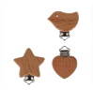
29-May-2024 | France | Toy Rattle | Toys and Childcare Products | Choking Hazard | 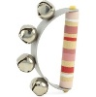  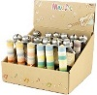
29-May-2024 | Poland | Plastic Ball | Toys and Childcare Products | Chemical Hazard | 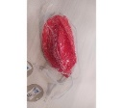
30-May-2024 | Ireland | Teether with Clip | Toys and Childcare Products | Choking Hazard | 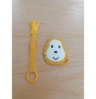
30-May-2024 | Sweden | Necklace | Jewelry | Chemical Hazard | 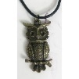
30-May-2024 | Belgium | Trousers | Fabric / Textile / Garment / Home Textile | Injury Hazard | 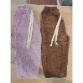
30-May-2024 | Austria | Toy Car with Sweets | Toys and Childcare Products | Choking Hazard | 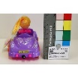
30-May-2024 | The Netherlands | Wooden Toy | Toys and Childcare Products | Choking Hazard | 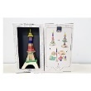
30-May-2024 | Austria | Toy Airplane with Sweets | Toys and Childcare Products | Choking Hazard | 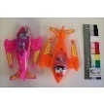
30-May-2024 | Czechia | Disposable Electronic Cigarette | Chemicals | Chemical Hazard | 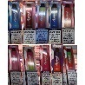
30-May-2024 | Germany | USB Charger | Electrical Appliances | Electric Shock Hazard | 
30-May-2024 | Czechia | Disposable Electronic Cigarette | Chemicals | Chemical Hazard | 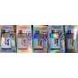
30-May-2024 | Sweden | Inflatable Ball | Toys and Childcare Products | Chemical Hazard, Environmental Hazard | 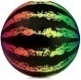
30-May-2024 | Sweden | USB Cable | Electrical Appliances | Environmental Hazard | 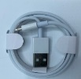
30-May-2024 | Latvia | Cleaner | Chemicals | Chemical Hazard | 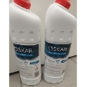
30-May-2024 | The Netherlands | Bead Track | Toys and Childcare Products | Choking Hazard | 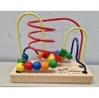
30-May-2024 | The Netherlands | Baby Walker | Toys and Childcare Products | Injury Hazard | 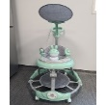
30-May-2024 | Lithuania | Car Windscreen Washing Fluid | Chemicals | Chemical Hazard | 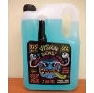
30-May-2024 | Lithuania | Plastic Doll | Toys and Childcare Products | Chemical Hazard | 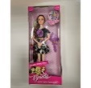
30-May-2024 | Cyprus | Toy Set | Toys and Childcare Products | Choking Hazard | 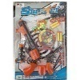
30-May-2024 | Poland | LED Luminaire | Electrical Appliances | Electric Shock Hazard | 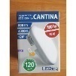
30-May-2024 | Poland | Plastic Swing | Toys and Childcare Products | Injury Hazard | 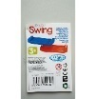
30-May-2024 | Czechia | Deodorant | Bodycare / Cosmetics | Chemical Hazard | 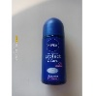
30-May-2024 | France | Soft Toy | Toys and Childcare Products | Choking Hazard | 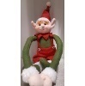
30-May-2024 | Poland | Plastic Swing | Toys and Childcare Products | Entrapment Hazard, Injury Hazard | 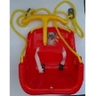
30-May-2024 | Hungary | Plastic Baby Doll | Toys and Childcare Products | Chemical Hazard | 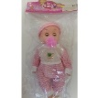
30-May-2024 | France | Teething Ring | Toys and Childcare Products | Choking Hazard | 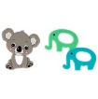
30-May-2024 | Lithuania | Extension Lead | Electrical Appliances | Electric Shock Hazard | 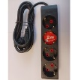
30-May-2024 | Lithuania | Toy Rabbit | Toys and Childcare Products | Choking Hazard | 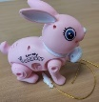
30-May-2024 | Lithuania | Toy Dog | Toys and Childcare Products | Choking Hazard | 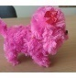
30-May-2024 | Austria | Electronic Cigarette Cartridge | Chemicals | Health Risk Hazard | 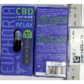
31-May-2024 | Malta | Electronic Cigarette | Chemicals | Chemical Hazard | 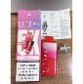
31-May-2024 | Finland | Hair Cream | Bodycare / Cosmetics | Environmental Hazard | 