Recall Cases Summary – US (Last Update Date: 31 May 2024)

Date | Product | Categories | Hazard | Image
2-May-2024 | Youth Sipper Bottle | Food Contact Material | Choking Hazard | 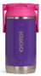
2-May-2024 | SKIMS Children’s Pajama Sets | Fabric / Textile / Garment / Home Textile | Burn Hazard, Injury Hazard | 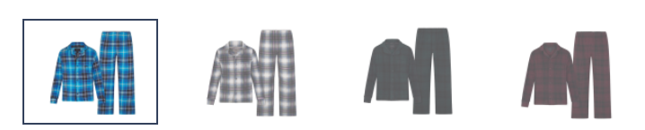
2-May-2024 | Children’s Dressers | Furniture | Tip-Over Hazard, Entrapment Hazard, Injury Hazard, Risk of Death | 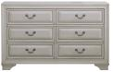  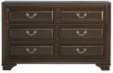
2-May-2024 | Creativity Street Foam Pattern Rollers | Tools and Hardware | Chemical Hazard, Health Risk Hazard | 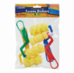
2-May-2024 | Leaf Blowers and Leaf Vacuums | Machinery | Laceration Hazard | 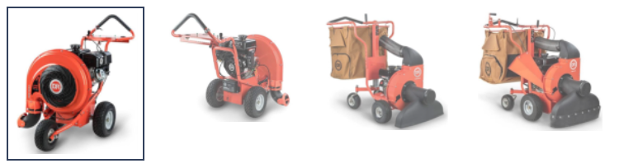  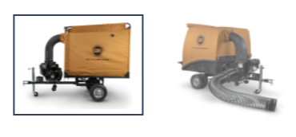
2-May-2024 | Eyelid Wipes for Dogs | Pet Items | Microbiological Hazard | 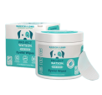
2-May-2024 | Lawnmowers and Pressure Washer Engines | Machinery | Injury Hazard | 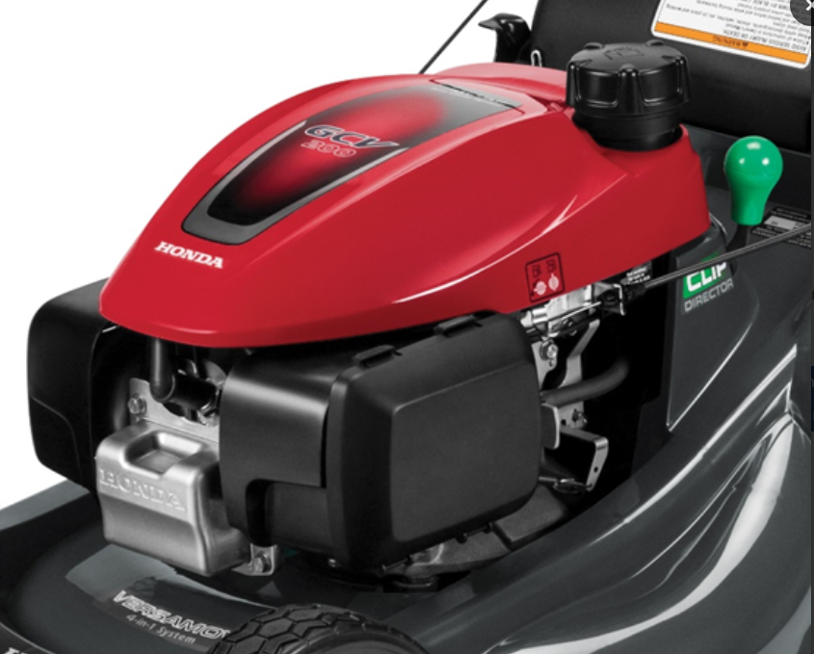
9-May-2024 | Built-In Electric Wall Ovens | Home Electrical Appliances | Impact Hazard, Injury Hazard | 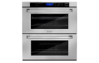  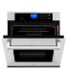
9-May-2024 | Toy Pinwheels | Toys and Childcare Products | Choking Hazard | 
9-May-2024 | Children’s Robes | Fabric / Textile / Garment / Home Textile | Burn Hazard, Injury Hazard | 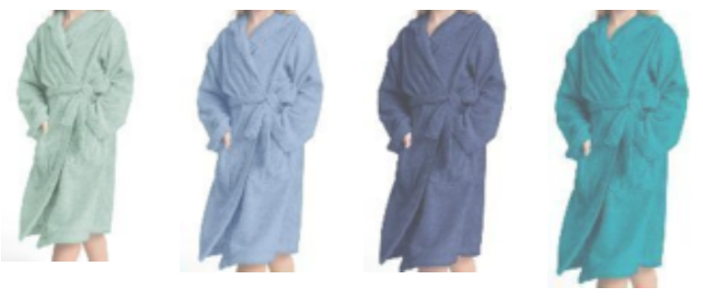  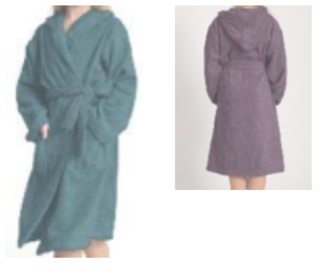  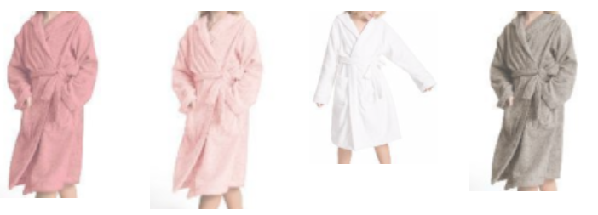
9-May-2024 | Korimefa Multi-Purpose Helmets | Protective Equipment | Injury Hazard | 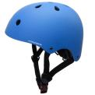
9-May-2024 | Spin Swivel Chairs | Furniture | Fall Hazard | 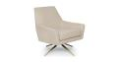  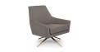  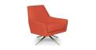  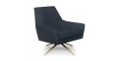
9-May-2024 | Children’s Nightgowns | Fabric / Textile / Garment / Home Textile | Burn Hazard | 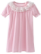  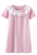  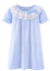
16-May-2024 | Frigidaire and Kenmore Electric Ranges | Home Electrical Appliances | Fire Hazard, Burn Hazard | 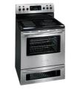
16-May-2024 | CHZHVAN Combination Smoke and Carbon Monoxide Detectors | Electrical Appliances | Fire Hazard | 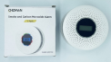
16-May-2024 | Super Lube® Products | Chemicals | Poisoning Hazard, Risk of Death, Swallowing Risk | 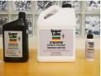
23-May-2024 | TOPINCN Pool Drain Covers | Tools and Hardware | Entrapment Hazard | 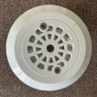
30-May-2024 | Super Vinegar All Natural Cleaner | Chemicals | Poisoning Hazard, Burn Hazard | 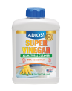
30-May-2024 | Adult Portable Bed Rails | Household Items | Entrapment Hazard, Suffocation Hazard, Risk of Death | 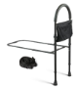
30-May-2024 | CRAFTSMAN V20 Cordless Tillers/Cultivators | Electrical Appliances | Laceration Hazard | 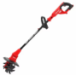
30-May-2024 | Crib Bumpers | Fabric / Textile / Garment / Home Textile | Suffocation Hazard | 