Recall Cases Summary – Australia (Last Update Date: 30 June 2024)

Date | Product | Categories | Hazard | Image
5-Jun-2024 | Two-Tone Demm Mug | Food Contact Material | Cut Hazard, Burn Hazard | 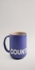  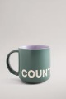  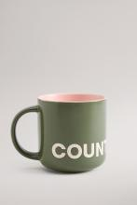  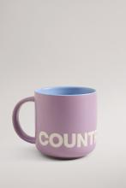
5-Jun-2024 | Wood Fire Stoves | Household Items | Fire Hazard, Injury Hazard, Risk of Death | 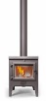  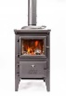  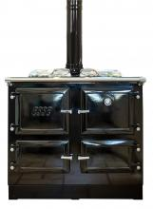
6-Jun-2024 | Pizza Maker | Home Electrical Appliances | Injury Hazard, Risk of Death, Electric Shock Hazard | 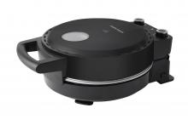
11-Jun-2024 | Garfield Toy | Toys and Childcare Products | Choking Hazard, Injury Hazard, Risk of Death, Swallowing Risk | 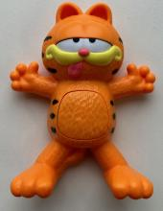
12-Jun-2024 | Pet Dryer | Electrical Appliances | Injury Hazard, Risk of Death, Electric Shock Hazard | 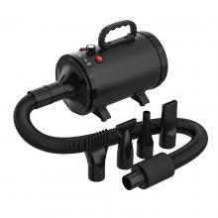
13-Jun-2024 | LED Writing Board | Electrical Appliances | Choking Hazard, Burn Hazard, Injury Hazard, Risk of Death, Swallowing Risk | 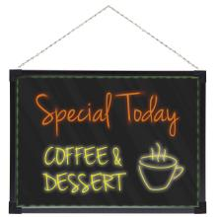  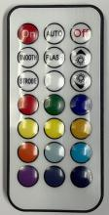
13-Jun-2024 | Invisible Spy Pens and Lightbulb Keyring | Stationery | Choking Hazard, Injury Hazard, Swallowing Risk | 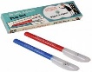  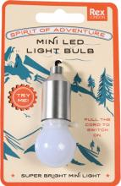
13-Jun-2024 | Magic UV Pen | Stationery | Choking Hazard, Injury Hazard, Swallowing Risk | 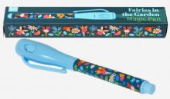
13-Jun-2024 | Yellow Hook Horizontal Brace | Tools and Hardware | Injury Hazard, Risk of Death, Fall Hazard | 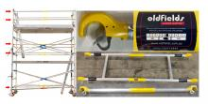
17-Jun-2024 | Dummy Chain/Toy Chain | Toys and Childcare Products | Choking Hazard, Suffocation Hazard, Risk of Death | 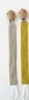  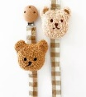
17-Jun-2024 | Hygiplas Triple Timer | Electrical Appliances | Choking Hazard, Burn Hazard, Injury Hazard, Risk of Death, Swallowing Risk | 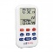
9-Jun-2024 | Chippers | Machinery | Injury Hazard, Laceration Hazard | 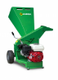  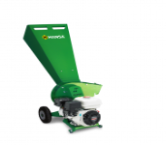
20-Jun-2024 | Chippers | Machinery | Injury Hazard, Laceration Hazard | 